Supplementary

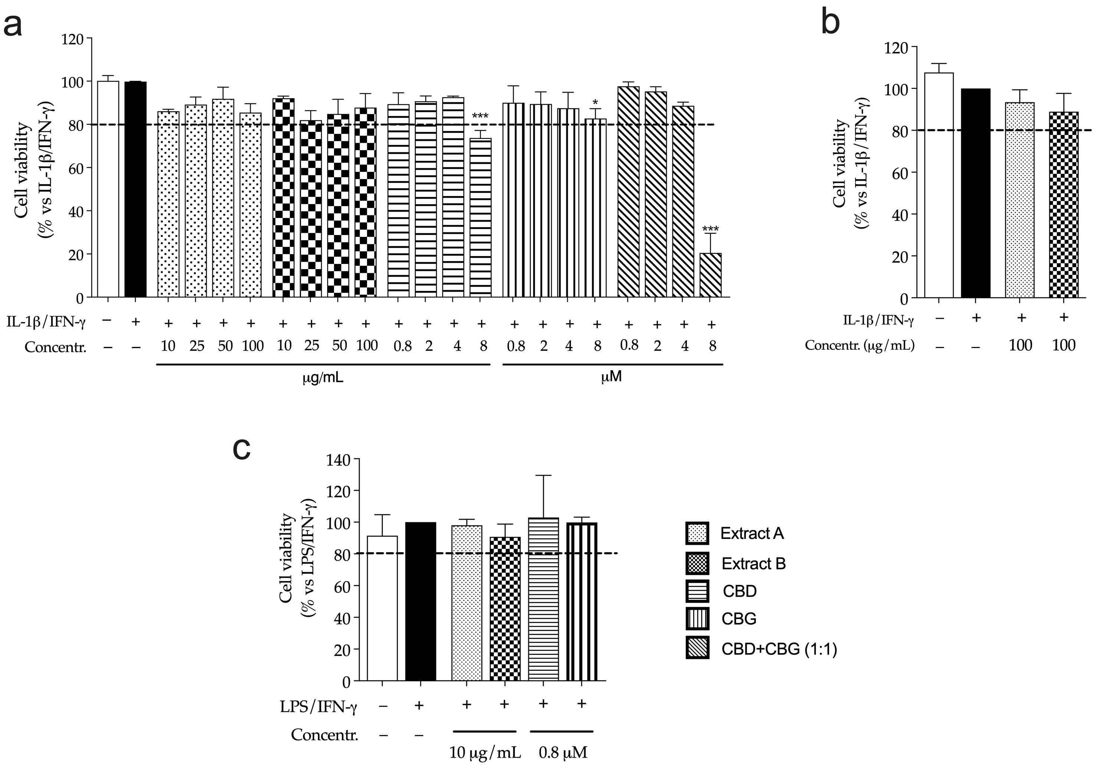
Figure S1. Effect of Cannabis extracts (Extract A, Extract B) and pure cannabinoids (CBD, CBG, CBD+CBG) on CaCo-2 (a, b) or THP-1 (c) cells viability measured by MTT assay. Extracts were evaluated before (a) or after (b, c) a simulated digestion. Cells were treated for 24 h with extracts or pure molecules in addition to inflammatory stimuli (IL-1β/IFN-γ), which value was arbitrarily assigned to 100 %. Data are expressed as average (%) ± SEM (n=3). Values of viability above 80 % were considered acceptable. *p<0.05, ***p<0.001 (Kruskal-Wallis test) vs IL-1β/IFN-γ.

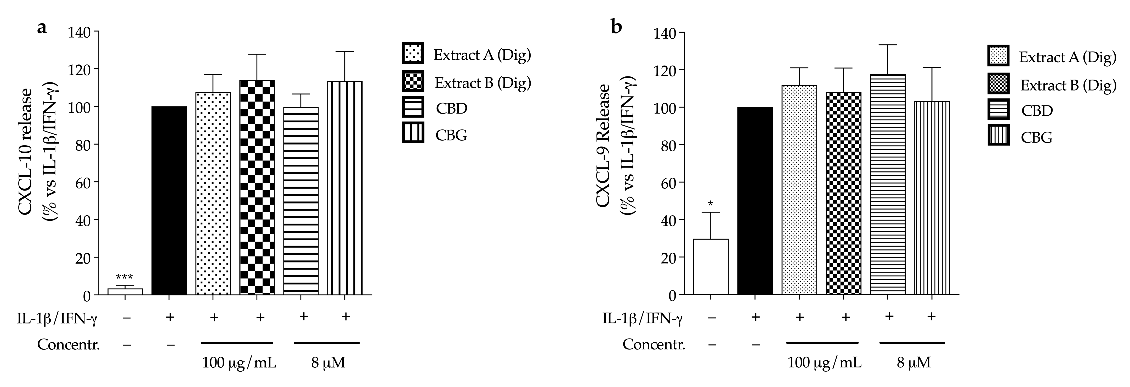
Figure S2. Effect of Cannabis extracts underwent to simulated digestion (A Dig., B Dig.) and cannabinoids (CBD, CBG) on the release of CXCL-10 (a), and CXCL-9 (b) in enterocytes (CaCo-2). Chemokine release was measured by ELISA (24 h). Cells were treated with extracts (100 μg/mL) or pure molecules (8 μM) in addition to inflammatory stimuli (IL-1β/IFN-γ), which value was arbitrarily assigned to 100%. Data are expressed as average (%) ± SEM (n=3). *p<0,05; ** p < 0,01; ***p<0,001 (Kruskal-Wallis test) vs IL-1β/IFN-γ.

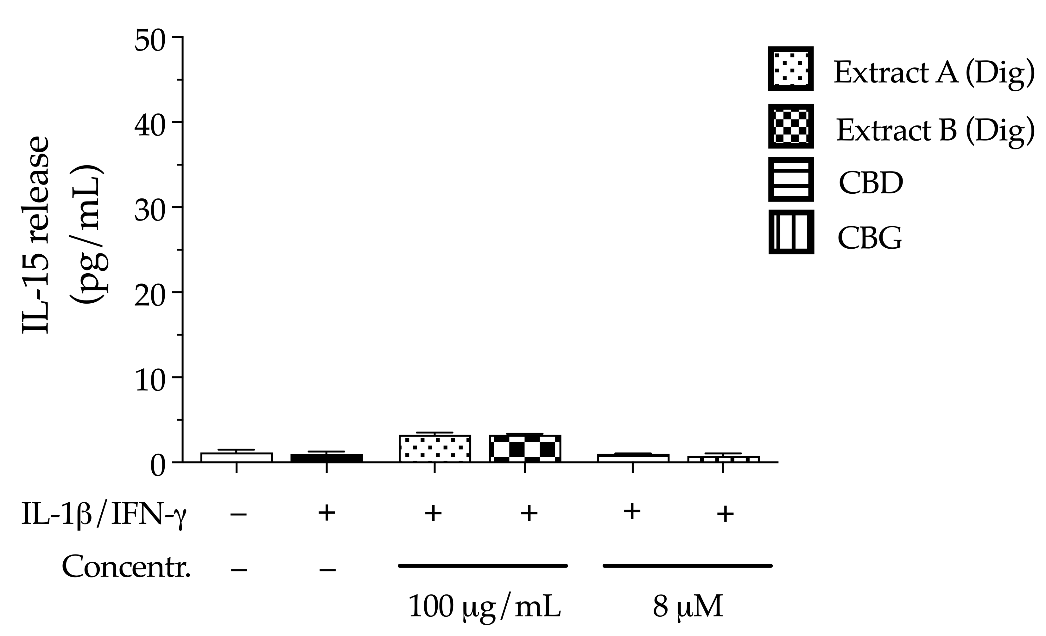
Figure S3. Effect of Cannabis extracts underwent to simulated digestion (A Dig., B Dig.) and cannabinoids (CBD, CBG) on the release of IL-15 in colonocytes (CaCo-2). IL-15 release was measured by ELISA (24 h). Cells were treated with extracts (100 μg/mL) or pure molecules (8 μM) in addition to inflammatory stimuli (IL-1β/IFN-γ). Data are expressed as average (pg/mL) ± SEM (n=3).

Table S1. HPLC-UV and GC/FID analysis of terpenes and cannabinoids from Cannabis extracts.

Cannabinoids |  |  | Cannabinoids
Cannabis extract A |  |  | Cannabis extract B
HPLC assay CBD eq. | 5.19% |  | HPLC assay CBD eq. | 5.20%
HPLC assay CBG eq. | 5.13% |  | HPLC assay CBG eq. | 5.11%
HPLC assay CBD as is | 5.15% |  | HPLC assay CBD as is | 5.20%
HPLC assay CBG as is | 4.88% |  | HPLC assay CBG as is | 5.11%
Related substances: CBNR | 0.07% |  | Related substances: CBNR | 0.07%
Related substances: CBDA | 0.05% |  | Related substances: CBC | 0.36%
Related substances: CBGA | 0.29% |  | Related substances: D9-THC | 0.16%
Related substances: CBC | 0.39%
Related substances: D9-THC | 0.21%
Related substances: D8-THC | 0.05%

Terpenes |  |  | Terpenes
Cannabis extract A |  |  | Cannabis extract B
α- Terpineol | 0.07% |  | α- Terpineol | --
β-Caryophyllene | 0.10% |  | β-Caryophyllene | 0.01%
α-Humulene | 0.03% |  | α-Humulene | 0.01%
Farnesene isomer 3 | 0.05% |  | Farnesene isomer 3 | --
Valencene | 0.02% |  | Valencene | --
Farnesene isomer 2 | 0.05% |  | Farnesene isomer 2 | --
Farnesene isomer 1 | 0.12% |  | Farnesene isomer 1 | 0.02%
trans-Nerolidol | 0.01% |  | trans-Nerolidol | 0.01%
Caryophyllene oxide | 0.04% |  | Caryophyllene oxide | 0.03%
α-Bisabolol | 0.12% |  | α-Bisabolol | 0.11%
Total Terpenes | 0.61% |  | Total Terpenes | 0.19%

Table S2. Summary of gene expression measured by PCR array in enterocytes (CaCo-2).

Genes over-expressed vs IL-1β/IFN-γ
Unstimulated control |  |  | Extract A Dig. |  |  |  | Extract B Dig.
Gene Symbol | Fold Reg. |  | Gene Symbol | Fold Reg. | p-Value |  | Gene Symbol | Fold Reg. | p-Value
CCL20 | 10.96 |  | AIMP1 | 3.24 | 0.516586 |  | AIMP1 | 7.83 | 0.181927
CCR6 | 6.40 |  | BMP2 | 2.29 | 0.025343 |  | BMP2 | 2.14 | 0.011355
CSF1 | 16.76 |  | CXCL1 | 2.12 | 0.427203 |  | CCL15 | 2.17 | 0.043512
CXCL1 | 3.81 |  | ACTB | 2.52 | 0.286321 |  | CCL16 | 2.42 | 0.015236
CXCL10 | 140.34 |  |  |  |  |  | CCL23 | 2.70 | 0.015861
CXCL11 | 3.89 |  |  |  |  |  | ACTB | 2.09 | 0.413070
CXCL2 | 4.35
CXCL3 | 4.13
CXCL9 | 217.51
IL15 | 4.57
CXCL8 | 6.32
LTB | 3.01
NAMPT | 3.65
TNFSF10 | 2.08
B2M | 4.09
Genes under-expressed vs IL-1β/IFN-γ
Unstimulated control |  |  | Extract A Dig. |  |  | Extract B Dig.
Gene Symbol | Fold Reg. |  | Gene Symbol | Fold Reg. | p-Value | Gene Symbol | Fold Reg. | p-Value
AIMP1 | -3.03 |  | / | / | / | IL1B | -2.73 | 0.281310
C5 | -2.95 |  |  |  |  | TNFRSF11B | -2.90 | 0.058164
CCL23 | -2.26 |  |  |  |  | TNFSF4 | -2.45 | 0.490659
IL1A | -2.53 |  |  |  |  | VEGFA | -6.01 | 0.766059
IL1R1 | -2.17
TNFSF4 | -2.46

Fold reg., fold regulation; Extract A Dig. and Extract B Dig., Cannabis extract underwent to gastrointestinal simulated digestion

