Supplemental Materials

Supplemental Table 1. Prevalence of medical conditions across different cannabis use frequencies in past 30 days
 | Never User | 1-15 days | 16-30 days
Angina | 0% | 0% | 2%
Atrial Fibrillation | 0% | 4% | 2%
Congestive Heart Failure | 0% | 0% | 0%
Coronary Artery Disease | 0% | 4% | 0%
Diabetes | 4% | 4% | 3%
High Blood Pressure | 10% | 11% | 17%
High Cholesterol | 12% | 15% | 16%
Heart Attack | 0% | 0% | 1%
Blood Clots | 2% | 0% | 2%
Macular Degeneration | 0% | 4% | 0%
Peripheral Vascular Disease | 0% | 4% | 0%
Transient Ischemic Attack | 0% | 0% | 1%
Stroke | 0% | 0% | 0%
Cognitive (memory) Disorder | 0% | 4% | 4%
Anemia | 10% | 15% | 12%
GERD | 8% | 11% | 18%
HIV/AIDS | 0% | 0% | 0%
Kidney Disease | 2% | 0% | 2%
Rheumatoid Arthritis | 0% | 4% | 2%
Osteoarthritis | 2% | 11% | 6%
Osteoporosis | 6% | 0% | 2%
Hip Fractures | 0% | 0% | 1%
Connective Tissue Disease (Lupus, Scleroderma) | 2% | 0% | 1%
Compression Fractures in back | 0% | 0% | 2%
Stomach Disease | 2% | 0% | 9%
Liver Disease | 2% | 4% | 2%

Supplemental Table 2. Frequency of medication use by class and medication names
Medication Class | Medication Names | Total Uses
Antidepressant - SSRI | Citalopram, Lexapro, Paroxetine, Prozac | 15
Antidepressant - SNRI | Cymbalta, Venlafaxine | 3
Antidepressant - NDRI | Bupropion | 3
Antidepressant - SARI | Trazodone | 3
Stimulant | Adderall, Amphetamine | 7
Benzodiazepine | Ativan, Diazepam, Lorazepam, Valium | 6
Mood stabilizer | Lamotrigine, Lithium | 3
Antipsychotic - Atypical | Abilify, Quetiapine, Risperdal | 2
Note. N=195.

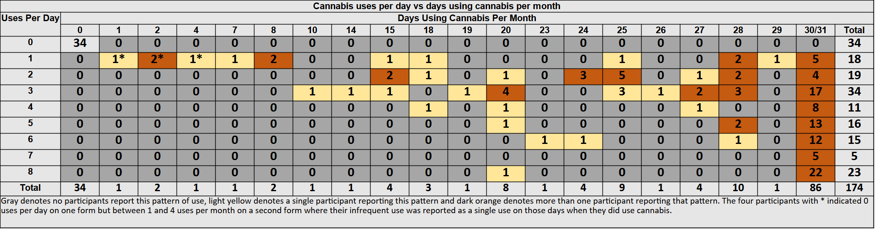
Supplemental Table 3. Self-reported patterns of cannabis use per day vs. days using per month

Supplemental Table 4. Examination of multicollinearity in regression models with Variance Inflation Factor (VIF) values
Variable | VIF | Tolerance | HighVIF_5 | HighVIF_10
FreqGroup | 1.031753 | 0.9692245 | FALSE | FALSE
age | 1.297083 | 0.7709605 | FALSE | FALSE
gender | 1.049270 | 0.9530432 | FALSE | FALSE
education_1 | 1.121342 | 0.8917882 | FALSE | FALSE
PSQI | 1.215325 | 0.8228254 | FALSE | FALSE
any_psychmed | 1.043877 | 0.9579677 | FALSE | FALSE
Note. N=195. Results show no concerns of multicollinearity.

Supplemental Figure 1. Frequent cannabis users have significantly higher urinary THC urinary compared to infrequent cannabis users (1.46 ± 3.09 ng/ml versus 9.58 ± 26.2 ng/ml; p = 0.0127). Urine was obtained from the first morning void and levels were adjusted by the plasma/urine creatine measurements. The y-axis is logged and thus subjects with no measurable THC (non-users) are not plotted.

