S1 Table: Grid box values for THCA synthase enzyme.

Ligands | Centre |  |  | Dimensions
 | X | Y | Z | X | Y | Z
CBGA | 40.12 | 39.992 | -27.502 | 126 | 126 | 88
Metribuzin | 41.44 | 42.887 | -27.502 | 126 | 126 | 88
Glyphosate | 40.29 | 43.683 | -27.502 | 126 | 126 | 88

S2 Table: Physicochemical properties comparison of CBGA, metribuzin, and glyphosate.
Name | Chemical formula | Structure | MW (g/mol) | HBD | HBA | RB | AR | TPSA | PubChem CID Reference
CBGA | C₂₂H₃₂O₄ |  | 360.5 | 3 | 4 | 13 | 1 | 77.8 | 6449999
Metribuzin | C₈H₁₄N₄OS |  | 214.29 | 1 | 5 | 3 | 1 | 96.4 | 30479
Glyphosate | C₃H₈NO₅P |  | 169.07 | 4 | 6 | 7 | 0 | 107 | 3496

Software (Force field) | Chem3D Pro (MM2) |  | Chem3D  (MM2) |  | Avogadro (MMFF94) |  | Chem3D (MMFF94)
Energy (kcal/mol) | Start | Minimized | Start | Minimized | Start | Minimized | Start | Minimized
CBGA | 1203.416 | 14.5137 | 17.446 | 14.5 | 72.0069 | 39.4885 | 39.462 | 39.462
Metribuzin | 383.008 | 11.131 | 102.9129 | 15.75 | 161.3568 | 112.6683 | 39.602 | 69.732
Glyphosate | 31.276 | 13.6115 | 18.4667 | 13.61 | -7.3735 | -23.961 | -23.945 | -23.9493
S3 Table: Start and minimized energy (kcal/mol) after optimizing sequentially in the given order using different softwares. The green highlight shows the most minimized energies of the ligands.

S4 Table: Ligand parameters obtained from Gaussian optimization.
Ligands | Start energy (kcal/mol) | Minimized energy (a.u.) | Dipole Moment (Debye)
CBGA | 14.5137 | -1158.837799 | 2.1327
Metribuzin | 11.131 | -1005.813539 | 9.2666
Glyphosate | -23.961 | -891.6263467 | 2.9354

S5 Table: Ground state configurations of CBGA, metribuzin, and glyphosate with every atom’s spatial arrangement: bond length and angle.
CBGA
Bond Length (Å) | Unoptimized | Optimized | Bond Angle (°) | Unoptimized | Optimized
C-C (17) | 1.54 | 1.54 | H-C-H (19) | 109.47125 | 109.47116
C=C (5) | 1.3552 | 1.3552 | C-C-H (43) | 109.47122 | 109.47113
C=O | 1.2584 | 1.2584 | C-C-C (9) | 109.47122 | 109.47122
C-O (3) | 1.43 | 1.43 | C=C-C (12) | 120 | 120
C-H (29) | 1.07 | 1.07 | C-C-O (2) | 120 | 120
O-H (3) | 0.96 | 0.96 | C-O-H (3) | 109.471 | 109.471
 |  |  | O=C-O | 120 | 120
 |  |  | C=C-H (3) | 119.99986 | 118.04065
 |  |  | C=C-O (2) | 120.00007 | 113.89094
 |  |  | C-C=O | 120.00008 | 128.23227

Metribuzin
Bond Length (Å) | Unoptimized | Optimized | Bond Angle (°) | Unoptimized | Optimized
C-C (5) | 1.54 | 1.54 | H-C-H (12) | 109.47122 | 109.47122
C=N (2) | 1.30531 | 1.30531 | H-S-C (3) | 109.47122 | 109.47122
C=O | 1.2584 | 1.2584 | C-C-C (7) | 109.47122 | 109.47122
C-H (12) | 1.07 | 1.07 | C-C=O | 120.00009 | 120.00009
N-N (2) | 1.40701 | 1.40701 | C-O-H | 109.47127 | 109.47127
C-N (1) | 1.47526 | 1.37124 | C-S-C | 109.47122 | 99.02128
N-C (1) | 1.46380 | 1.40647 | S-C=N | 119.04398 | 116.21160
C-S (2) | 1.78000 | 1.76828 | C=N-N (2) | 123.07735 | 118.50765
N-H (2) | 1.00000 | 1.01775 | C-C=N (2) | 118.92519 | 112.36916
 |  |  | C-N-N (2) | 123.07735 | 109.38199
 |  |  | C-N-C | 110.31853 | 110.31856
 |  |  | N-C-S | 119.03777 | 119.03777
 |  |  | O=C-N | 120.6129 | 120.6129
 |  |  | N-N-H (2) | 109.47122 | 106.98, 107.67

Glyphosate
Bond Length (Å) | Unoptimized | Optimized | Bond Angle (°) |  | Unoptimized | Optimized
P=O | 1.5048 | 1.47966 | O-P-O |  | 109.4712 | 104.6909
P-OH | 1.71 | 1.62665 |  |  | 109.4712 | 113.3118
P-OH | 1.71 | 1.62035 |  |  | 109.4712 | 114.4972
P-C | 1.82 | 1.82095 | O-P-C |  | 109.4712 | 120.4209
C-N | 1.47 | 1.45318 |  |  | 109.4712 | 99.88669
C-N | 1.47 | 1.45504 | O=P-C |  | 109.47122 | 120.42088
C-H | 1.07 | 1.10725 | P-C-N |  | 109.4712 | 109.93572
C-H | 1.07 | 1.10285 | C-N-C |  | 109.4712 | 113.29973
C-H | 1.07 | 1.09412 | N-C-C |  | 109.4712 | 112.89148
C-H | 1.07 | 1.09165 | C-C-O | 120 |  | 106.20121
C-C | 1.54 | 1.51562 | C-C=O | 120 |  | 124.92402
C=O | 1.2584 | 1.20155 | O=C-O |  | 120.0 | 123.07
C-OH | 1.43 | 1.35432
O-H (3) | 0.96000 | 0.96476

S6 Table: IUPAC, chemical formula, structure, and similarity index of identified Cannabis sativa L. compounds.
Sr.No. | Identified compound | IUPAC | Chemical Formula | Chemical Structure | Similarity Index
1. | Methyl palmitate | Methyl hexadecanoate | C₁₇H₃₄O₂ |  | 95%
2. | Methyl stearate | Methyl octadecanoate | C₁₉H₃₈O₂ |  | 95%
3. | 2,4-DTBP | 2,4-Di-tert-butylphenol | C₁₄H₂₂O |  | 93%
4. | Eicosane | Icosane | C₂₀H₄₂ |  | 91%
5. | Heptadecane | Heptadecane | C₁₇H₃₆ |  | 90%
6. | Cetane | Hexadecane | C₁₆H₃₄ |  | 90%
7. | delta.9-Tetrahydrocannabivarin | (6aR,10aR)-6,6,9-trimethyl-3-propyl-6a,7,8,10a-tetrahydrobenzo[c]chromen-1-ol | C₁₉H₂₆O₂ |  | 92%
8. | Dronabinol (THC) | (6aR,10aR)-6,6,9-trimethyl-3-pentyl-6a,7,8,10a-tetrahydrobenzo[c]chromen-1-ol | C₂₁H₃₀O₂ |  | 91%
9. | Cannabinol | 6,6,9-trimethyl-3-pentylbenzo[c]chromen-1-ol | C₂₁H₂₆O₂ |  | 94%
10. | Cannabidivarol | 2-[(1R,6R)-3-methyl-6-prop-1-en-2-ylcyclohex-2-en-1-yl]-5-propylbenzene-1,3-diol | C₁₉H₂₆O₂ |  | 92%
11. | Cannabidiol | 2-[(1R,6R)-3-methyl-6-prop-1-en-2-ylcyclohex-2-en-1-yl]-5-pentylbenzene-1,3-diol | C₂₁H₃₀O₂ |  | 90%
12. | Heneicosane | Henicosane | C₂₁H₄₄ |  | 90%
13. | Docosane | Docosane | C₂₂H₄₆ |  | 90%
14. | Tetracosane | Tetracosane | C₂₄H₅₀ |  | 91%

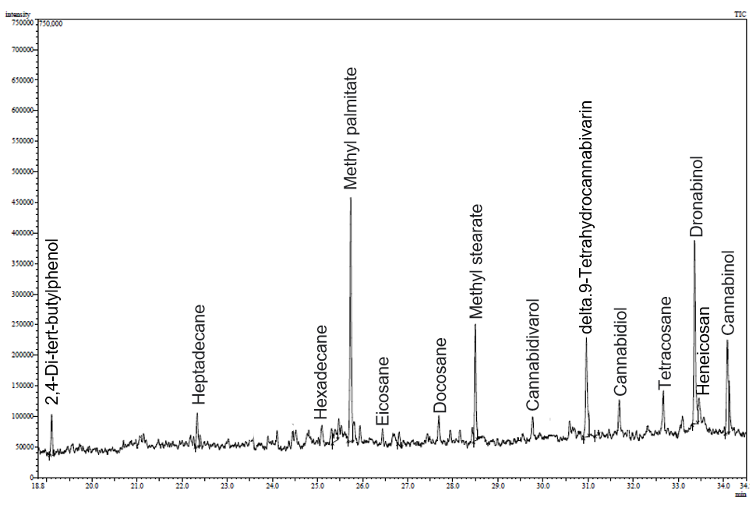
S1 Figure: Secondary metabolites identification in Cannabis sativa L. extract through GC-MS technique.

S2 Figure: Showing the energy minimization and RMS gradient normalization for CBGA with optimization stem number.

S3 Figure: Showing the energy minimization and RMS gradient normalization for metribuzin with optimization stem numbers.
S4 Figure: Showing the energy minimization and RMS gradient normalization for glyphosate with optimization stem numbers.

