Supplemental Table 1. Statistical analysis of cannabis aphid populations on high- and low-CBDVA hemp genotypes

 | Day 0 | Day 7 | Day 10 | Day 14
S1 | 5.00 ± 0.00ª | 16.50 ± 5.56^{b} | 14.17 ± 4.31^{c} | 12.58 ± 3.53^{b}
Carolina Dream | 5.00 ± 0.00ª | 31.11 ± 5.27^{ab} | 36.89 ± 6.21^{bc} | 85.78 ± 20.11ª
WI-M-H-19-00100 | 5.00 ± 0.00ª | 20.5 ± 2.06^{b} | 29.13 ± 5.13^{bc} | 65.75 ± 16.41^{ab}
WI-M-H-19-00101 | 5.00 ± 0.00ª | 30.14 ± 5.80^{ab} | 56.14 ± 4.65^{ab} | 101.71 ± 15.00ª
WI-M-H-19-00102 | 5.00 ± 0.00ª | 78.57 ± 10.59ª | 127.00 ± 23.82ª | 221.57 ± 37.27ª
Carmagnola OP | 5.00 ± 0.00ª | 30.00 ± 5.11^{ab} | 71.20 ± 15.30^{ab} | 162.90 ± 39.35ª
H-statistic | n/a | 22.67 | 32.76 | 31.04
P-value | n/a | 0.004 | <0.0001 | <0.0001

Overall model analysis was performed with Kruskal-Wallis at each time point. Comparisons in each timepoint were performed with Dunn’s post-hoc test. The different letters indicate significance at P < 0.05.

Supplemental Table 2. Statistical analysis of trichome density on high- and low-CBDVA genotypes
 | S1 | WI-M-H-19-00102 | t | P
Leaf 2 | 63.71 ± 3.48 | 48.29 ± 3.08 | 3.32 | 0.003
Leaf 3 | 85.86 ± 2.47 | 72.29 ± 5.57 | 2.23 | 0.023
Leaf 4 | 93.71 ± 3.12 | 71.57 ± 5.61 | 3.45 | 0.0024
Leaf 5 | 111.00 ± 9.42 | 71.67 ± 7.35 | 3.35 | 0.0043
Node 1 | 142.90 ± 13.20 | 122.10 ± 16.73 | 0.97 | 0.18
Node 2 | 216.40 ± 27.47 | 145.90 ± 16.68 | 2.20 | 0.024
Node 3 | 218.40 ± 10.84 | 111.90 ± 17.84 | 5.11 | 0.0001
Node 4 | 219.80 ± 34.75 | 120.60 ± 22.71 | 2.46 | 0.016

Analysis was performed using an unpaired one-tailed t-test Bold indicates significant differences between treatments at P < 0.05.
 | Day 1 |  | Day 2 |  | Day 3 |  | Day 4
 | Adults | Nymphs | Adults | Nymphs | Adults | Nymphs | Adults | Nymphs
Diet | 10.00 ± 0.00ª | 21.00 ± 3.00ª | 10.00 ± 0.00ª | 59.78 ± 4.49ª | 10.00 ± 0.00ª | 87.33 ± 5.01ª | 9.56 ± 0.44ª | 109.60 ± 10.01ª
DMSO | 9.89 ± 0.11ª | 11.78 ± 3.04^{ab} | 9.78 ± 0.15ª | 45.89 ± 6.15^{ab} | 9.78 ± 0.15ª | 59.56 ± 5.10^{b} | 9.00 ± 0.53ª | 52.67 ± 7.79^{b}
1 mM CBDVA | 9.79 ± 0.11ª | 2.14 ± 0.43^{c} | 8.79 ± 0.24^{b} | 9.71 ± 2.33^{c} | 7.5 ± 0.40^{b} | 18.79 ± 3.72^{c} | 6.57 ± 0.52^{b} | 18.71 ± 5.21^{c}
0.5 mM CBDVA | 10.00 ± 0.0ª | 15.44 ± 2.37^{ab} | 9.67 ± 0.17ª | 30.00 ± 5.41^{b} | 5.22 ± 0.91^{c} | 39.78 ± 8.64^{bc} | 5.22 ± 0.89^{b} | 31.44 ± 7.04^{bc}
0.1 mM CBDVA | 9.78 ± 0.22ª | 10.44 ± 2.71^{bc} | 9.56 ± 0.24^{ab} | 47.00 ± 5.03^{ab} | 9.44 ± 0.24ª | 65.78 ± 10.29^{ab} | 9.33 ± 0.24ª | 101.70 ± 7.25ª
F-statistic | 0.79 | 10.79 | 6.42 | 21.13 | 17.99 | 17.69 | 11.06 | 32.65
P-value | 0.54 | <0.0001 | 0.0004 | <0.0001 | <0.0001 | <0.0001 | <0.0001 | <0.0001
Supplemental Table 3. Statistical analysis of cannabis aphid performance on artificial diets
Overall model analysis was performed with one-way ANOVA at each timepoint. Comparisons in each timepoint were performed with Tukey’s HSD post-hoc test, different letters indicate significance at P < 0.05.

 | Day 1 |  | Day 2 |  | Day 3
 | Adults | Nymphs | Adults | Nymphs | Adults | Nymphs
Diet | 10.00 ± 0.00ª | 19.40 ± 3.38ª | 9.60 ± 0.22ª | 47.50 ± 5.40ª | 9.40 ± 0.27ª | 75.00 ± 6.92ª
DMSO | 9.90 ± 0.10ª | 14.10 ± 2.82ª | 9.40 ± 0.40ª | 45.10 ± 5.60ª | 9.30 ± 0.40ª | 72.50 ± 7.03ª
0.5 mM CBDVA | 9.40 ± 0.31ª | 1.80 ± 0.77^{b} | 7.00 ± 0.75^{b} | 5.20 ± 1.26^{b} | 6.10 ± 0.64^{b} | 11.60 ± 2.60^{b}
F-statistic | 3.00 | 12.24 | 8.22 | 27.26 | 16.57 | 37.17
P-value | 0.066 | 0.0002 | 0.0016 | <0.0001 | <0.0001 | <0.0001
Overall model analysis was performed with one-way ANOVA at each timepoint. Comparisons in each timepoint were performed with Tukey’s HSD post-hoc test, different letters indicate significance at P < 0.05.
Supplemental Table 4. Statistical analysis of green peach aphid performance on artificial diets

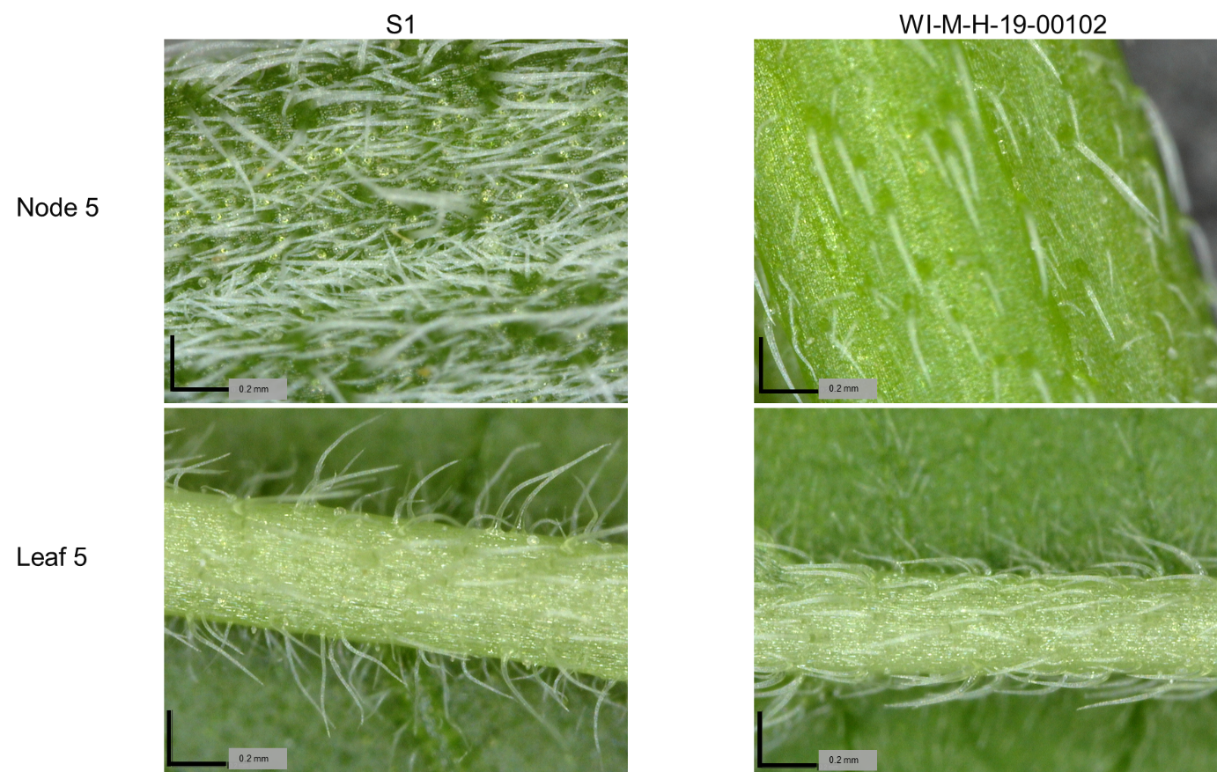

Supplemental Figure 1. Observed differences in trichome density and morphology between S1 and WI-M-H-00102 at leaf 5 and node 5 with a Dino-Lite handheld microscope at 225X magnification.

