Supplementary material

Chemical profiling and clustering of various dried cannabis flowers revealed by volatilomics and chemometric processing

Pannipa Janta ^{a,b} and Sornkanok Vimolmangkang ^{a,b,c,d*}

ª Department of Pharmacognosy and Pharmaceutical Botany, Faculty of Pharmaceutical Sciences, Chulalongkorn University, Bangkok 10330, Thailand
^{b} Phyto Analytica Testing Laboratory, Faculty of Pharmaceutical Sciences, Chulalongkorn University, Bangkok 10330, Thailand
^{c} Center of Excellence in Plant-Produced Pharmaceuticals, Faculty of Pharmaceutical Sciences, Chulalongkorn University, Bangkok 10330, Thailand
^{d} Research Cluster for Cannabis and its Natural Substances, Chulalongkorn University, Bangkok 10330, Thailand

* Corresponding author. Department of Pharmacognosy and Pharmaceutical Botany,
Faculty of Pharmaceutical Sciences, Chulalongkorn University, Bangkok, Thailand. Tel.:6622188358.
E-mail address: sornkanok.v@pharm.chula.ac.th (S. Vimolmangkang).

Table S1. The 19 dried cannabis flowers and their commercial data on feelings, aromas, and cannabinoid levels.
Cultivar | feelings | aromas | %THC | %CBD | %CBG
C. indica
Grand Daddy Purple (GDP)* | Sleepy,  Hungry,  Relaxed | Grape, Berry, Sweet | 17 | 0 | No data
Skywalker OG  (SW-OG)* | Sleepy,  Relaxed,  Tingly | Spicy/herbal, pungent, earthy | 20 | No data | 1
Northen Light  (NL)* | Sleepy,  Hungry,  relaxed | Pine, Spicy/herbal, earthy | 18 | No data | 1
Wedding Cake  (WC)* | Relaxed,  Aroused,  hungry | Vanilla, pepper, sweet | 24 | No data | 1
White Widow  (WW)* | Energetic,  Talkative,  uplifted | Woody, Spicy/herbal, earthy | 15 | No data | 1
Purple Punch  (PP)* | Sleepy,  Relaxed,  Hungry | Grape, Berry, blueberry | 18 | 0 | No data
Pure Michigan (PM)* | Aroused, Relaxed, Sleepy | Chestnut, ammonia, lime | 29 | No data | 1
Geta Fix (GF)**** | Euphoric, Relax, Tingly | Diesel, Fruity | 28 | No data | No data
C. sativa
Jack Herer  (JH)* | Energetic,  Creative,  Uplifted | Pine, Spicy/herbal, woody | 18 | No data | 1
Bruce Banner  (BB)* | Creative,  Energetic, euphoric | Strawberry, diesel, tea | 21 | No data | 1
Green Crack Punch (GCP)** | Calming,  Euphoric | Citrus, Fruity | 18 | Low | No data
Amnesia Haze (AH)* | Energetic,  Talkative,  giggly | Lemon, citrus, lime | 19 | No data | 1
Super Silver Haze (SH)* | Energetic,  Uplifted,  Creative | Spicy/herbal, citrus, skunk | 21 | No data | 1
Skunk Haze (SK)* | Focused,  Relaxed,  Talkative | Spicy/herbal, skunk, pungent | 13 | No data | 1
Banana Glue (BG)* | Euphoric, relaxed,  giggly | Earthy, woody, pine | 19 | 0 | No data
C. Hybrid
Frisian Duck  (FD)* | Hungry, talkative,  Giggly | Spicy/herbal, pine, sweet | 15***** | 1***** | No data
Dulce de Fresa (DDF)*** | mood enhancement,  creative  relaxed | Sweet, Fruity | 28.66 | 0.07 | No data
Critical Purple Kush (CPK)* | Happy,  Sleepy, relaxed | Plum, chestnut, citrus | 13 | No data | 1
Commercial data on feelings and aromas of Hang Over G (HOG) is not available.
* Data from www.leafly.com
** Data from http://www.royalqueenseeds.com
*** Data from https://herbalsolutions420.com/menu/?dtche%5Bproduct%5D=dulce-de-fresa-society-c
**** Data from https://nasha-genetics.com/product/getafix/
***** Data from https://weed.review/strains/frisian-duck/

Table S2. The figures-of-merit of each sample, analyzed in 5 replicates.
Dried cannabis flower | Average total peak area  (n = 5) | %RSD | Average total peak height  (n = 5) | %RSD | Average peak width  (n = 5) | %RSD
Grand Daddy Purple (GDP) | 38159987204 | 4.8 | 4888116193 | 3.9 | 0.23 | 2.8
Skywalker OG (SW-OG) | 52079455183 | 7.0 | 7489233731 | 5.5 | 0.19 | 2.1
Northen Light (NL) | 68773410179 | 5.7 | 10345570328 | 5.0 | 0.20 | 0.8
Wedding Cake (WC) | 49470931689 | 6.3 | 8114078178 | 5.4 | 0.19 | 1.8
White Widow (WW) | 49053749145 | 6.4 | 7665135706 | 4.2 | 0.20 | 2.7
Purple Punch (PP) | 33697723429 | 3.4 | 5509016048 | 2.8 | 0.20 | 1.4
Pure Michigan (PM) | 48761642302 | 8.8 | 6122624527 | 7.0 | 0.23 | 2.6
Geta Fix (GF) | 45844251212 | 7.2 | 6158732805 | 6.5 | 0.21 | 2.6
Jack Herer (JH) | 52061941676 | 9.1 | 8027732711 | 8.3 | 0.20 | 1.1
Bruce Banner (BB) | 47656602324 | 8.2 | 7812897499 | 8.2 | 0.19 | 2.2
Green Crack Punch (GCP) | 55619104582 | 4.0 | 7403815683 | 4.1 | 0.24 | 4.9
Amnesia Haze (AH) | 36057188593 | 3.5 | 5033556958 | 2.4 | 0.20 | 1.2
Super Silver Haze (SH) | 30001259113 | 6.1 | 4920539142 | 5.4 | 0.21 | 2.1
Skunk Haze (SK) | 18709493822 | 2.1 | 3456824318 | 2.3 | 0.19 | 1.9
Banana Glue (BG) | 44575195943 | 6.6 | 6113502366 | 3.8 | 0.21 | 2.5
Frisian Duck (FD) | 60555415581 | 2.9 | 6456806487 | 2.2 | 0.26 | 6.9
Dulce de Fresa (DDF) | 38262868262 | 11.0 | 5604166928 | 8.8 | 0.22 | 1.3
Critical Purple Kush (CPK) | 37303373759 | 3.5 | 5916183890 | 2.2 | 0.15 | 2.1
Hang Over G (HOG) | 35005699774 | 4.0 | 4674979175 | 3.2 | 0.22 | 1.8

Table S3. The variable importance in projection (VIP) scores of 75 variable compounds within the partial least-squares discriminate analysis (PLS-DA) model.
Variable | VIP scores
Eucalyptol | 3.128
(+)-2-Carene | 3.082
o-Cymene | 2.258
Terpinolene | 2.114
γ-Eudesmol | 2.085
α-Bisabolol | 1.903
1,2-Dimethyl-3-ethylbenzene | 1.806
α-Longipinene | 1.727
m-Ethylstyrene | 1.554
β-cis-Ocimene | 1.474
10-epi-γ-Eudesmol | 1.366
β-Phellandrene | 1.358
Humulene | 1.274
γ-Amorphene | 1.243
(+)-4-Carene | 1.222
cis-Geraniol | 1.220
p-Cymen-8-ol | 1.217
2-Carene | 1.197
β-Citral | 1.051
β-Eudesmol | 1.051
cis-Sabinene hydrate | 0.909
Longicyclene | 0.906
β-Eudesmol | 0.893
α-Muurolene | 0.869
n-Hexyl butanoate | 0.853
trans-α-Bisabolene | 0.840
Ethyl dimethylacrylate | 0.833
α-Dehydro-ar-himachalene | 0.803
1-Hexanol | 0.775
(-)-Aristolene | 0.755
cis-Linalool oxide | 0.736
1-Octanol | 0.694
(Z,E)-α-Farnesene | 0.608
E-5-Decen-1-yl acetate | 0.585
6-Methyl-5-heptene-2-one | 0.581
Di-epi-α-cedrene | 0.564
Benzyl alcohol | 0.562
β-Gurjunene | 0.553
trans-2-Pinanol | 0.547
Viridiflorene | 0.542
α-Bulnesene | 0.514
Selina-3,7(11)-diene | 0.393
L-α-Terpineol | 0.361
cis-α-Bergamotene | 0.307
Fenchone | 0.297
Copaene | 0.273
β-Caryophyllene | 0.273
Methyl caprylate | 0.265
Di-epi-1,10-cubenol | 0.261
Ylangene | 0.260
Linalool | 0.258
Ethyl caprylate | 0.254
Nerolidol | 0.224
δ-Selinene | 0.205
Germacrene B | 0.196
Guaiol | 0.191
(-)-β-Cadinene | 0.185
Citronellol | 0.183
Eremophila-1(10),11-diene | 0.169
Sesquisabinene | 0.167
β-Eudesmene | 0.148
β-Myrcene | 0.146
β-Maaliene | 0.137
Caryophyllene oxide | 0.113
β-Fenchol | 0.101
(E)-8-Dodecen-1-ol acetate | 0.091
Z-7-Tetradecenal | 0.090
1R-α-Pinene | 0.074
2-Methylbutyl caproate | 0.067
α-Cubebene | 0.061
Limonene | 0.059
Camphene | 0.033
γ-HIMACHALENE | 0.015
Hexyl caproate | 0.007
β-Pinene | 0.006

Figure S1. TIC of a representative cannabis flower sample in each cluster.
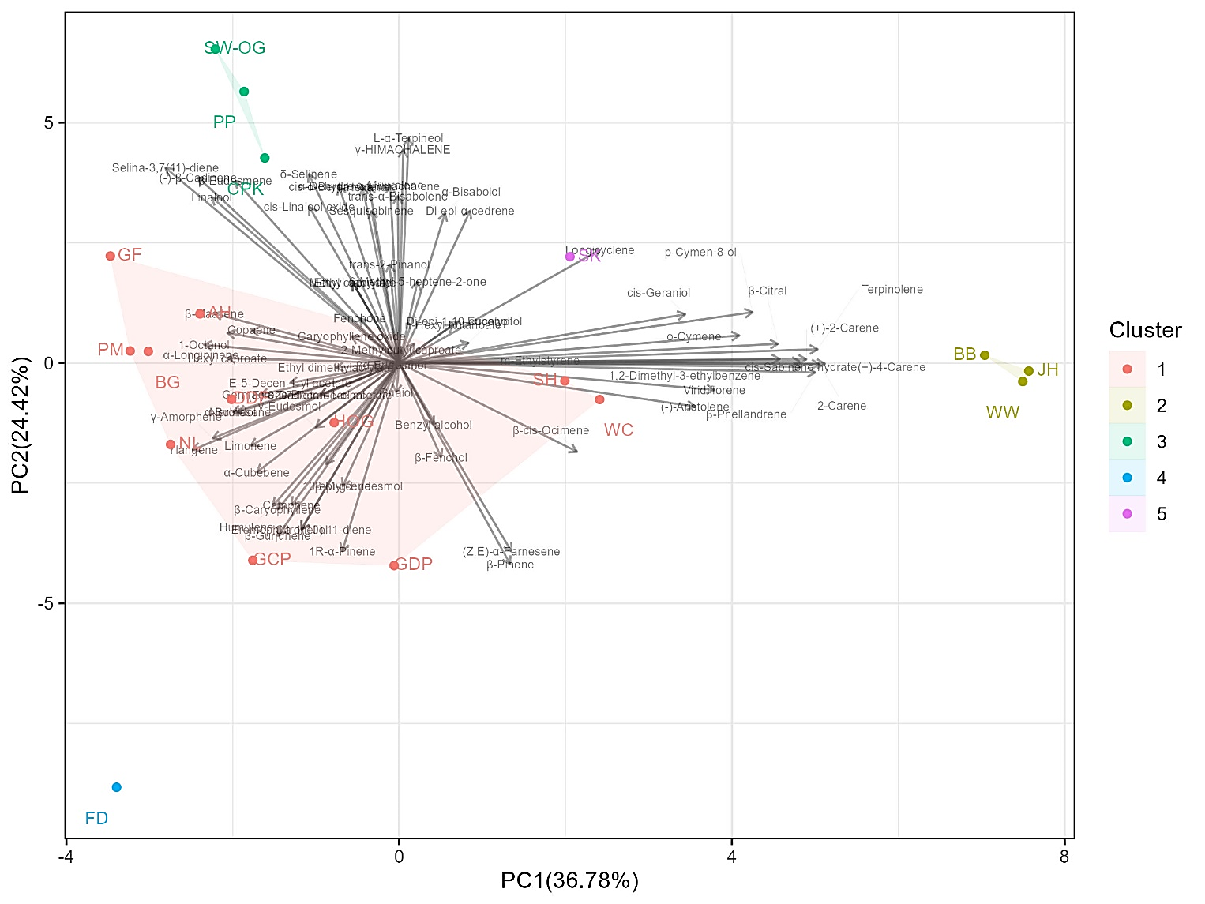
Figure S2. PCA biplot, showing main volatile compounds found in each cluster.

Figure S3. Bar plot based on Pearson Correlation Coefficient of 14 remaining correlated compounds; (1) (+)-2-carene, (2) o-cymene, (3) γ-eudesmol, (4) 1,2-dimethyl-3-ethylbenzene, (5) α-longipinene, (6) m-ethylstyrene,(7) 10-epi-γ-eudesmol, (8) γ-amorphene, (9) (+)-4-carene, (10) cis-geraniol, (11) p-cymen-8-ol, (12) 2-carene, (13) β-citral, and (14) β-eudesmol, respectively.

