Combined Ambient Ionization Mass Spectrometric and Chemometric Approach for the Differentiation of Hemp and Marijuana Varieties of Cannabis sativa

AUTHORS: Megan I. Chambers,ª Samira Beyramysoltan,ª Benedetta Garosiª and Rabi A. Musahª*

ªDepartment of Chemistry, University at Albany – State University of New York (SUNY), 1400 Washington Avenue, Albany, NY 12222, United States

*Corresponding author: rmusah@albany.edu

Supporting Information: Mass Spectral Data for C. sativa Materials

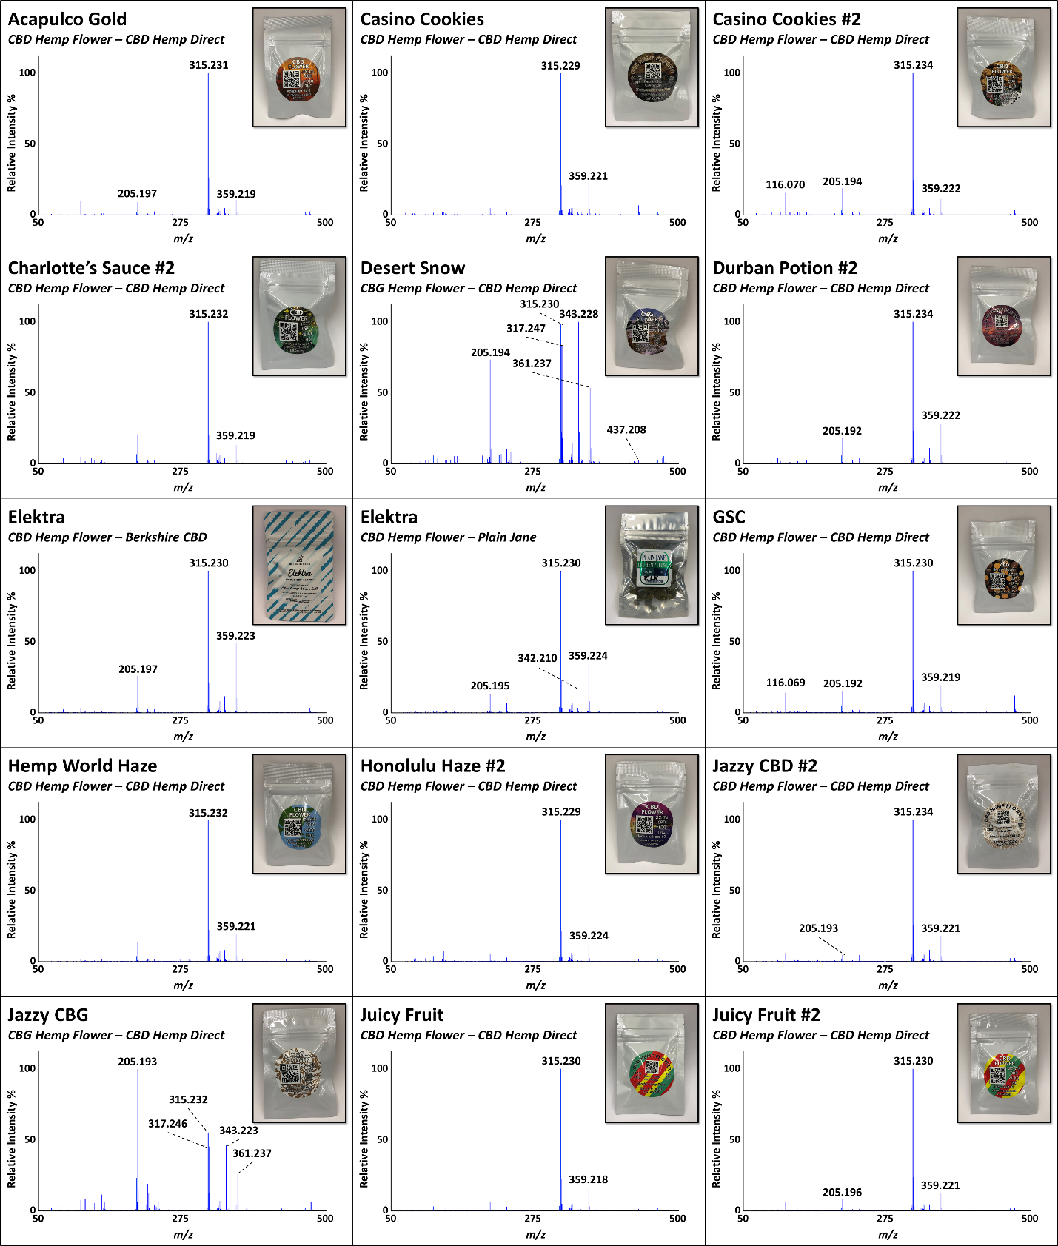
Figure S1. Representative DART high-resolution mass spectra of hemp samples used in the training set analyzed in positive-ion mode at 20 V. Images of the corresponding products in their packaging are shown in the insets.

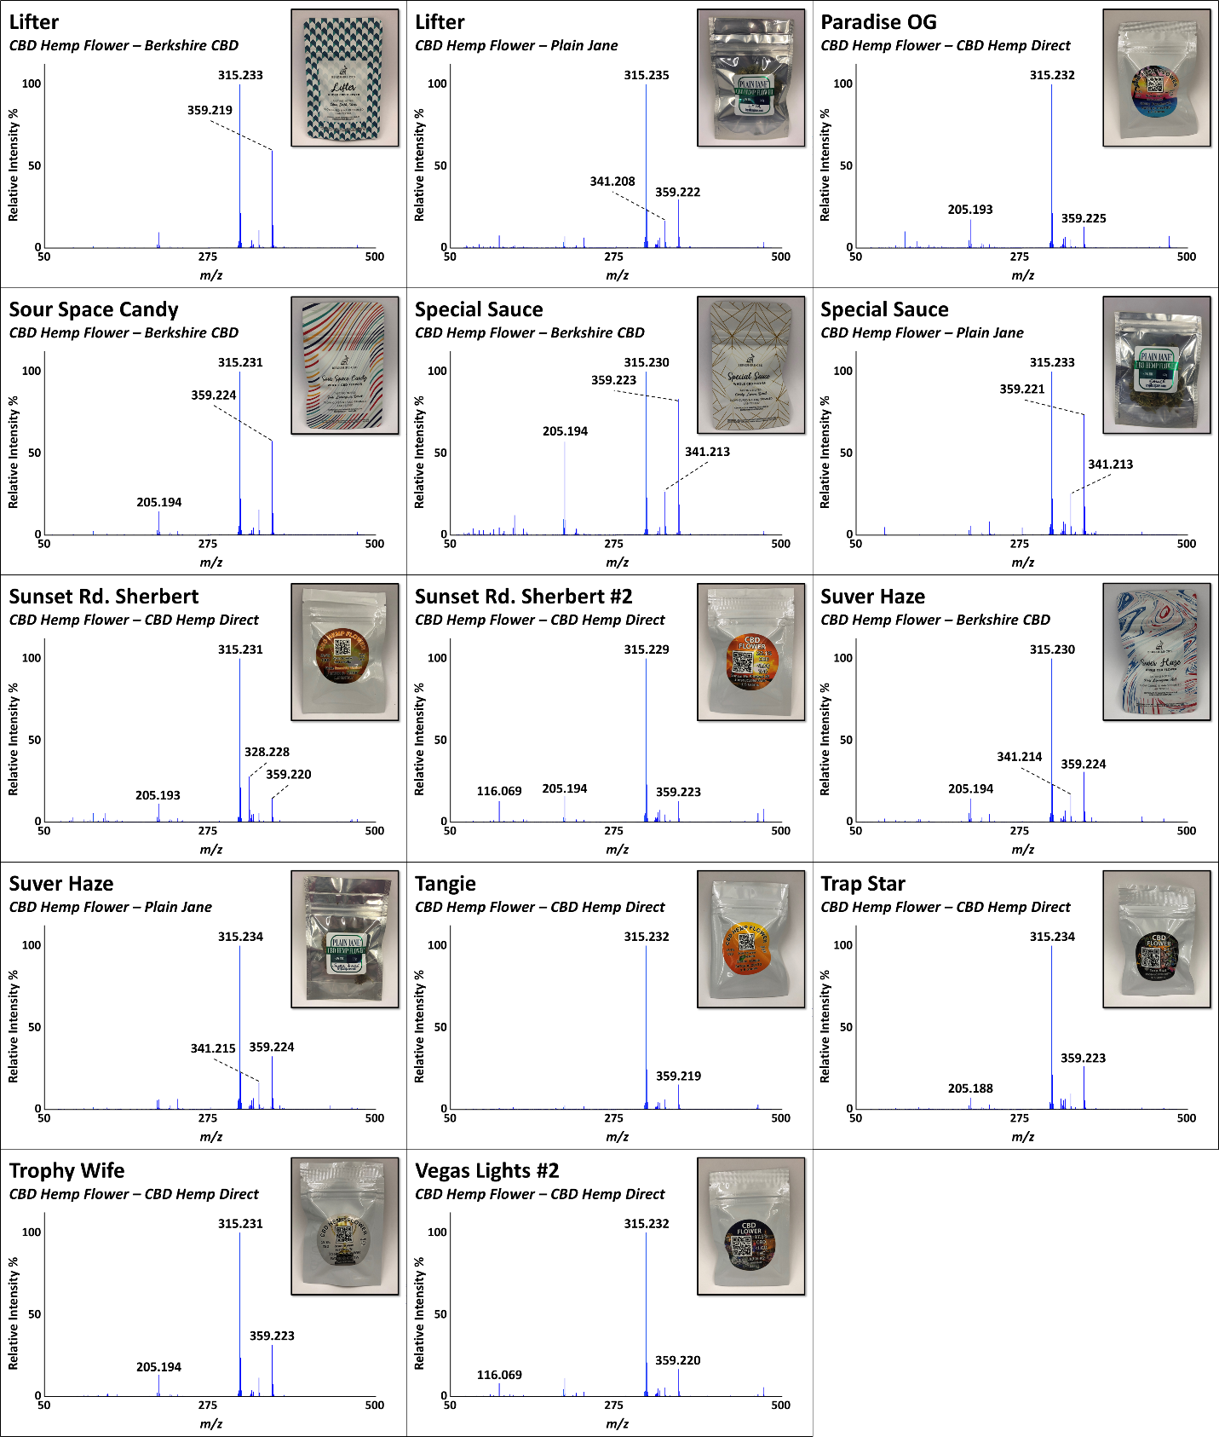
Figure S1 (continued). Representative DART high-resolution mass spectra of hemp samples used in the training set analyzed in positive-ion mode at 20 V. Images of the corresponding products in their packaging are shown in the insets.

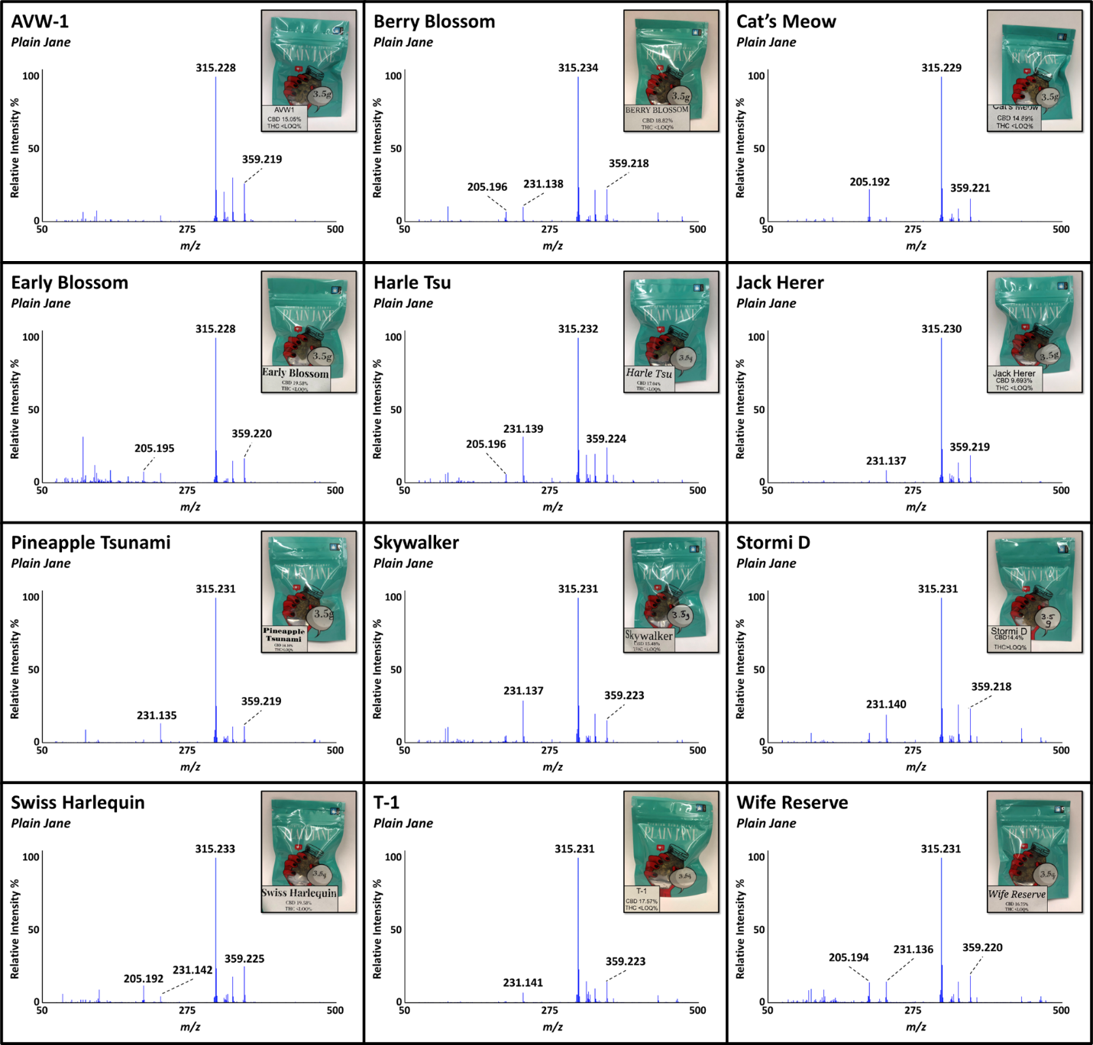
Figure S2. Representative DART high-resolution mass spectra of hemp flower samples from a commercial hemp vendor analyzed in positive-ion mode at 20 V. These samples were used to test the ability of the model to classify “unknowns”. Images of the corresponding packaging are shown in the insets.

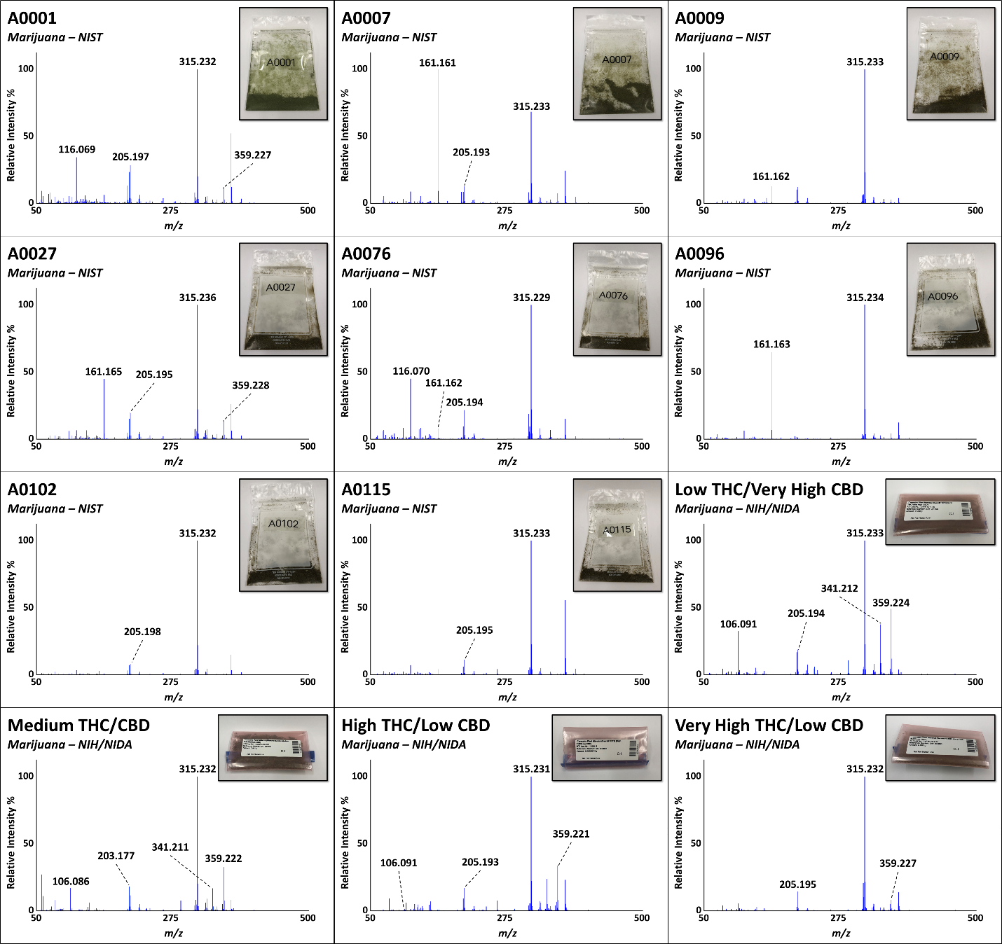
Figure S3. Representative DART high-resolution mass spectra of marijuana samples from DEA-registered suppliers analyzed in positive-ion mode at 20 V. Images of the corresponding packaging are shown in the insets.

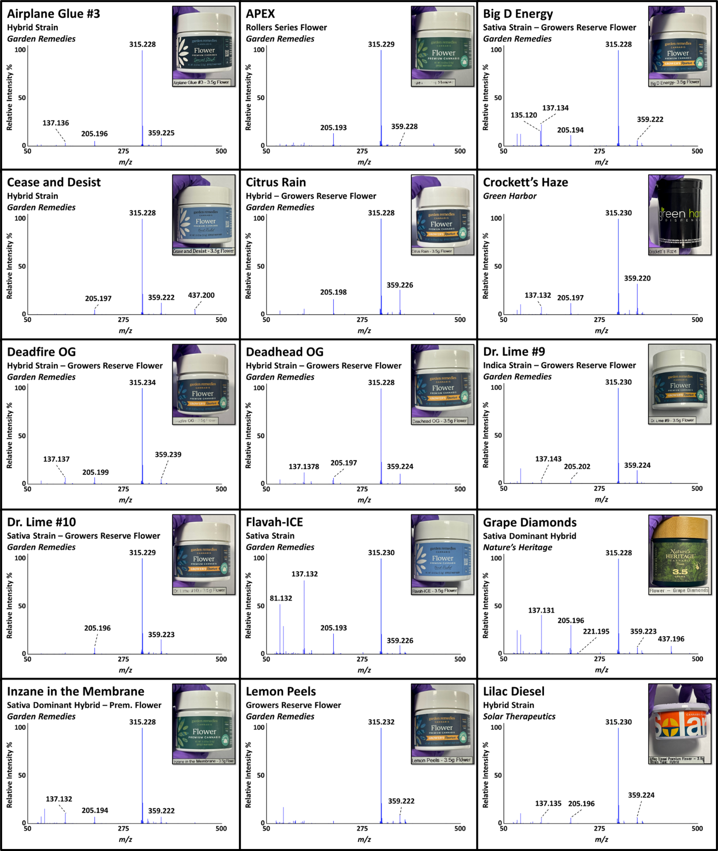
Figure S4. Representative DART high-resolution mass spectra of marijuana flower samples from a recreational Cannabis dispensary analyzed in positive-ion mode at 20 V. Images of the corresponding packaging are shown in the insets.

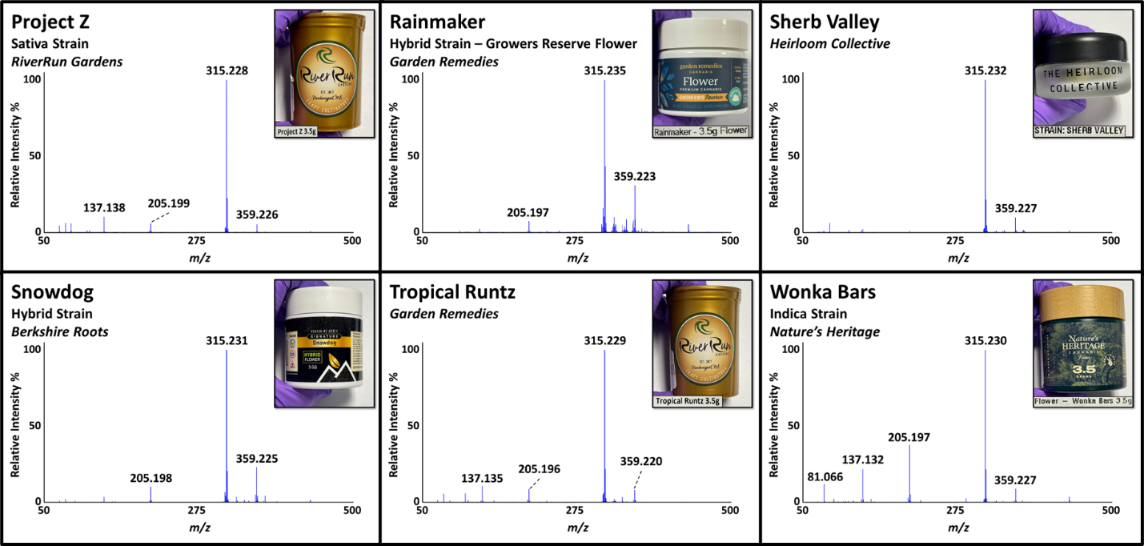
Figure S4 (continued). Representative DART high-resolution mass spectra of marijuana flower samples from a recreational Cannabis dispensary analyzed in positive-ion mode at 20 V. Images of the corresponding packaging are shown in the insets.

