SUPPLEMENTARY MATERIALS
TO ACCOMPANY:

A Smartphone App Intervention for Adult Cannabis Users Wanting to Quit or Reduce Their Use: A Pilot Evaluation

Table S1. Results from the GEE analyses using ITT (last case carried forward) approach.

Days – Poisson GEE (n=111)
 | B | SE | Wald Chi-Square | p
Time |  |  | 9.797 | .002
RCQ |  |  | 24.989 | .000
RCQ x Time |  |  | 11.255 | .004
Gender | .069 | .0679 | 1.020 | .313
Reduce vs Quit | .145 | .0911 | 2.515 | .113
Past attempt | .103 | .0613 | 2.818 | .093

DTCQ - Binary logistic GEE (n=111)
 | B | SE | Wald Chi-Square | p
RCQ |  |  | 7.089 | .008
Time |  |  | 1.847 | .397
RCQ x Time |  |  | .311 | .856
Gender | .184 | .3396 | .292 | .589
Past attempt | -.419 | .3645 | 1.323 | .250
Reduce vs Quit | -.440 | .3508 | 1.575 | .210
SDS – Negative Binomial GEE (n = 98)
 | B | SE | Wald Chi-Square | p
RCQ |  |  | 18.076 | <.001
Time |  |  | 18.168 | <.001
RCQ x Time |  |  | .753 | .686
Gender | -.022 | .1299 | .027 | .868
Past attempt | .285 | .1317 | 4.699 | .030
Reduce vs Quit | .441 | .1145 | 14.853 | <.001

CPQ - Linear GEE (n=111)
 | B | SE | Wald Chi-Square | p
RCQ | - | - | 3.130 | .077
Time | - | - | 54.088 | <.001
RCQ x Time | - | - | 6.302 | .043
Gender | -.170 | .6772 | .063 | .801
Past attempt | 1.457 | .7552 | 3.721 | .054
Reduce vs Quit | 1.095 | .7115 | 2.368 | .124

Bolded if p < .0125 (i.e., .05/4)

Table S2. Strategies by reason for use

To be liked/not feel left out
- Before going out, I will decide how many joints/cones I will allow myself to have
- I will let my friends know that I am trying to reduce/quit cannabis and ask them to support my decision
- If offered a smoke, I will simply say ‘no thanks, I don’t smoke anymore’
- I will identify friends who don’t use cannabis or who are also trying to reduce cannabis or quit and I will stick with them in social situations
- I will suggest activities that do not involve cannabis
- I will leave when people are using cannabis
- I will use strategies to fit in, such as listening and showing interest in what other people have to say
- I will avoid social situations where people are likely to be smoking
- I will engage in new social activities with people who do not smoke cannabis
- I will seek help for improving my social skills (e.g. toastmasters, self-help books)
To feel good/get high
- I will find other ways to have a good time (e.g. rock climbing, going to the movies, camping etc.)
- I will think about how good I will feel tomorrow knowing I am one step closer to reaching my goal
- I will tolerate not being high and deal with it by allowing myself time to learn that I can have a good time without cannabis
- I will fill up my spare time with enjoyable non-smoking activities
- I will take up a new hobby
- I will exercise to increase my levels of endorphins (the ‘feel-good’ chemicals)
- I will appreciate pleasant non-cannabis using experiences
- I will remind myself that over time not using will become less boring
- I will accept that life has ups and downs and that I don’t need to be up all the time
- I will think back to times I had fun without cannabis and find ways to increase those activities
To relax/sleep/forget problems
- I will remember that using cannabis only helps me feel better in the short-term, but makes me feel worse in the long-term
- I will challenge my interpretation of what is upsetting me by asking: what is the evidence? Am I imaging the worst? Is there a more realistic way of interpreting the situation?
- I will problem-solve: I will define the problem, list all possible solutions, decide on a course of action, and carry it out
- I will seek professional help for concerns that contribute to my cannabis use
- I will use healthy coping strategies (e.g. go for a walk, call a friend etc.)
- I will visit the mindhealth connect website [http://www.mindhealthconnect.org.au/] for advice on coping with depression and anxiety
- I will practice deep breathing and relaxation exercises
- I will practice good sleep habits such as: getting up at the same time every day regardless of how much I slept, not napping, avoiding caffeine after midday, going to bed only when I am sleepy, avoiding light, especially from computers, tablets and phones during sleeping hours
- I will remind myself that change might not happen overnight but that if I stick to good sleeping habits, my sleep will improve
- I will visit the sleep health foundation’s website [http://www.sleephealthfoundation.org.au/] for advice on good sleep habits and dealing with sleep problems
- I will keep a notepad by my bed to write down worries or reminders of things to address the next day
- I will exercise regularly as exercise increases levels of endorphins and serotonin, which can lift my mood, regulate sleep, and reduce pain
- I will visit the Australian pain management association’s website [http://www.painmanagement.org.au/] for advice on dealing with pain
- I will use guided imagery to relax: I will close my eyes, imaging being somewhere enjoyable, and use all my senses to be fully immersed in the experience
- I will think of a time in my life when I overcame a major problem/challenge and remind myself of the strength I have within me
To boost awareness/creativity
- I will remind myself that repeated cannabis use will limit my ability to think creatively
- I will remind myself that true creativity does not depend on cannabis
- I will practice being creative without using cannabis
- I will remind myself of the times I have achieved creativity without using cannabis
- I will find other ways to enhance my creativity, like using my non-dominant had to increase communication in different areas of my brain
- I will avoid creative activities in which I use cannabis until I am confident that I can do them without cannabis
- I will engage in creative activities in which I used cannabis only when I am with non-smokers
- When engaging in creative activities. I will ensure that cannabis is not available to me
- When encountering a problem, I will think of a least 5 solutions before acting on one, which will foster creativity
- If I am stuck for ideas, I will open a book to a random page, pick a random word, and come up with ideas using this word
To be sociable/more confident
- Before going out, I will decide how many joints/cones I will allow myself to have and stick to it
- I will schedule something important after the social event to encourage myself not to use
- I will engage in social activities where cannabis use is not OK (e.g. visiting family, playing a sport etc.)
- I will identify friends who don’t use cannabis and stick with them in social situations
- I will keep myself engaged at events by listening and showing interest in what other people are saying
- I will remind myself that, with time and practice, I will enjoy social events even more without using cannabis
- I will remind myself of the times my cannabis use has ruined a social event
- I will accept that the type of fun I will have without cannabis will be different
- I will remind myself that chronic cannabis use leads to decreased sociability
- I will avoid cannabis using situations
General
- I will focus on the negative consequences of my cannabis use
- I will focus on the reasons why I want to reduce/quit using cannabis
- I will tell others about my goal and ask them to support me in achieving it
- I will get rid of all cannabis and cannabis-related objects in my home
- I will distract myself and do something else (like go for a walk, call a friend, etc.)
- I will delay my decision to smoke by 30 minutes
- I will think about the money I can save as a result of reducing/quitting cannabis
- I will remind myself that I can choose to overcome using cannabis
- I will fill up my spare time in advance with enjoyable non-smoking activities
- I will avoid situations and places associated with cannabis
- I will visualise being a non-cannabis user and start to be that person
- I will remind myself that cravings are time-limited to less than 30 minutes
- I will focus on knowing that making it through one craving will make dealing with future cravings easier
- I will remind myself that although cravings are unpleasant, they are not intolerable
- I will develop a plan to manage the short-term (1-2 weeks) distress associated with withdrawal
- I will remind myself that withdrawal symptoms are positive signs that my body is adjusting to life without cannabis
- I will remember a time when I was successful in not using cannabis and use what I did then to help me succeed
- I will reward myself when I reach my reduction goal
- I will think about how my cannabis use is hurting the people I care about

Figure S1. Additional example screenshots from APTT

a) Assess module
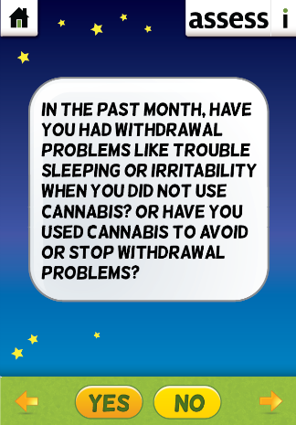
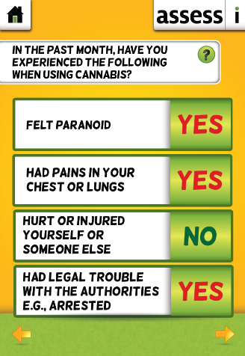
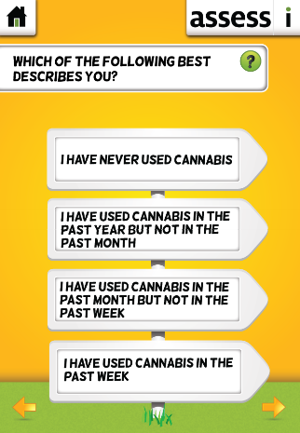

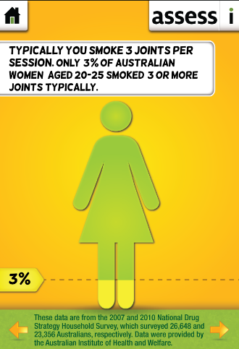
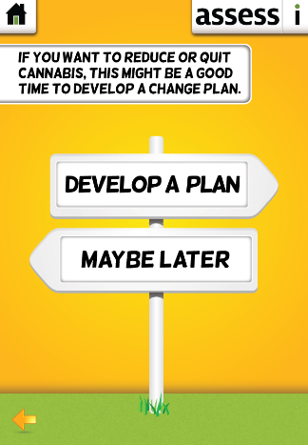
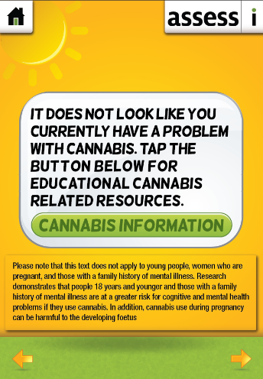

b) Plan module
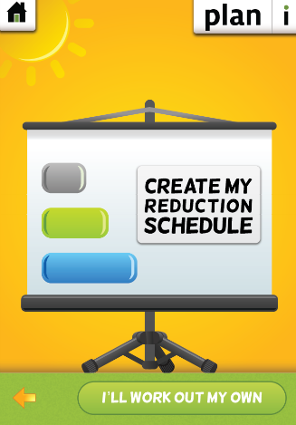
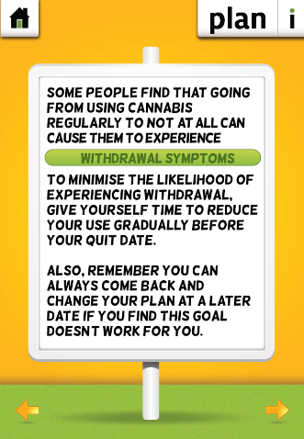
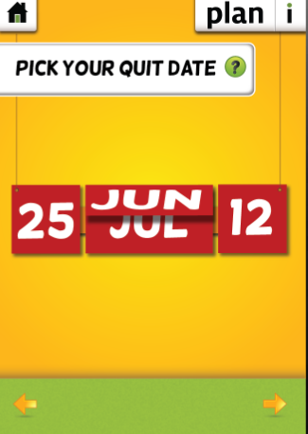

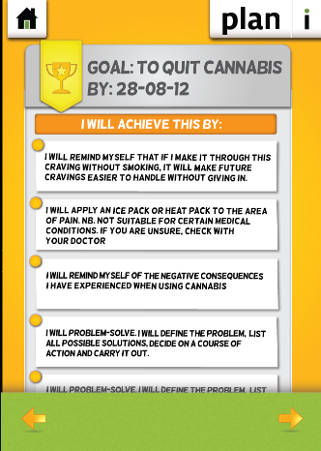
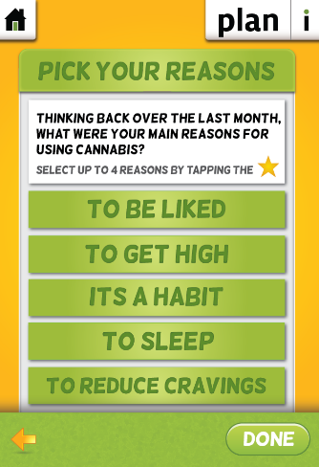
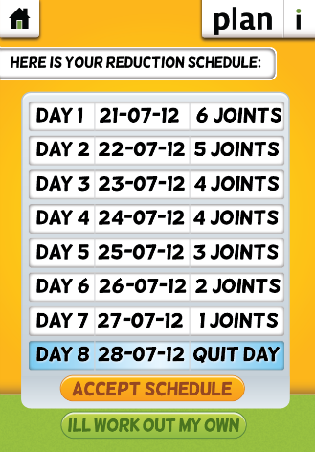

c) Track module
