Maternal dietary DHA and EPA supplementation ameliorates the adverse cardiac outcomes in rat offspring exposed to THC in gestation

Kendrick Lee, Mohammed H. Sarikahya, Samantha L. Cousineau, Ken K.-C. Yeung, Amica Lucas, Kara Loudon, Thane Tomy, Gregg T. Tomy, David R.C. Natale, Steven R. Laviolette and Daniel B. Hardy

Supplementary Information

Supplementary Table S1. Composition of the Control and Omega-3 Diets

Class description | Ingredients |  | Control Diet | Omega-3 Diet
Protein | Casein, Lactic, 30 Mesh |  | 200.00 g | 200.00 g
Protein | Cystine, L |  | 3.00 g | 3.00 g
Carbohydrate | Starch, Corn |  | 381.00 g | 381.00 g
Carbohydrate | Dextrose, Monohydrate |  | 150.00 g | 150.00 g
Carbohydrate | Lodex 10 |  | 110.00 g | 110.00 g
Carbohydrate | Sucrose, Fine Granulated |  | 4.00 g | 4.00 g
Fiber | Solka Floc, FCC200 |  | 75.00 g | 75.00 g
Fiber | Raftiline HP |  | 25.00 g | 25.00 g
Fat | Soybean Oil, USP
 | Composition: | 51% linoleic acid | 35.7g | 35.7g
 |  | 7-10% α-linolenic acid | 4.9-7g | 4.9-7g
 |  | 23% oleic acid | 16.1g | 16.1g
 |  | 10% palmitic acid | 7g | 7g
 |  | 4% stearic acid | 2.8g | 2.8g
Fat | Algae, Algarithm Inc.
 | Composition: | 70% Docosahexaenoic acid | 0.00 g | 0.906 g
 |  | 30% Eicosopentanoic Acid | 0.00 g | 0.282 g
Mineral | S10026B |  | 50.00 g | 50.00 g
Vitamin | Choline Bitartrate |  | 2.00 g | 2.00 g
Vitamin | V10001C |  | 1.00 g | 1.00 g
Dye | Dye, Blue FD&C #1, Alum. Lake 35-42% |  | 0.03 g | 0.00 g
Dye | Dye, Yellow FD&C #5, Alum. Lake 35-42% |  | 0.03 g | 0.00 g
Dye | Yellow FD&C #5, Alum. Lake 35-42% |  | 0.00 g | 0.04 g
Dye | Red FD&C #40, Alum. Lake 35-42% |  | 0.00 g | 0.01 g
Protein | Casein, Lactic, 30 Mesh |  | 200.00 g | 200.00 g
Protein | Cystine, L |  | 3.00 g | 3.00 g

Supplementary Table S2. Forward and reverse rat primer sequences for real-time qPCR

Gene | Forward  (5’ to 3’) | Reverse  (5’ to 3’) | GenBank
Ptgs1 (Cox-1) | CTTAGGCCATGGGGTAGACCT | GACGCCTGTTCTACGGAAGG | NM_017043.4
Ptgs2 (Cox-2) | ACGTGTTGACGTCCAGATCA | GGCCCTGGTGTAGTAGGAGA | NM_017232.4
Alox15 (12/15 Lox) | CTGTCGGGACTCGGAAGCA | GCCCTGAACCCATCGGTAAC | NM_031010.2
Tnfα | ATGGGCTCCCTCTCATCAGT | GCTTGGTGGTTTGCTACGAC | NM_012675.3
Ccl2 | CCCAGAAACCAGCCAACTCT | GGGCATTAACTGCATCTGGC | NM_031530.1
Ccl3 | CATATGGAGCTGACACCCCG | CTCTTGGTCAGGAAAATGACACC | NM_013025.2
Il-6 | TCATTCTGTCTCGAGCCCAC | TGGCTGGAAGTCTCTTGCG | NM_012589.2
Il-1b | TAGCAGCTTTCGACAGTGAGG | CTCCACGGGCAAGACATAGG | NM_031512.2
Cnr1 (CB1) | CATTTCAAGCAAGGAGCACCC | GGTCTGTGGTGATGGTACGG | NM_012784.5
Cnr2 (CB2) | AGGTTGCATTCCCAACAGAC | TTAGTTCCTCTGGGCAATGG | NM_001164143.3
Faah | GTTCACCTTGGACCCTACCG | AGAAGGGAATCAGCGTGTGG | NM_001369126.1
Napepld | AGCTTATGAGCCAAGGTGGT | AGCTAAGGCAAAAGTCCCCC | NM_199381.2
Mgll (MGL) | ACCAACCCACTTTTCTGGCA | CAACCTCCGACTTGTTCCGA | NM_001398597.1
Daglα | CAGTACGTGCTCTACGTGCG | AGACGACCATCCCGAGAGT | NM_001005886.2
Beta actin | CGCGAGTACAACCTTCTTGC | CGCAGCGATATCGTCATCCA | NM_031144.3
Gapdh | CTCTCTGCTCCTCCCTGTTC | CGATACGGCCAAATCCGTTC | NM_017008.4

Supplementary Table S3. Primary and Secondary Antibodies for Immunoblots

Antibody | Source | Dilution | Catalog No. and Company
Collagen Type I (COL-1A1) | Rabbit Recombinant Monoclonal | 1:2000 | AB260043; Abcam
Collagen Type III (COL-3) | Rabbit Polyclonal | 1:500 | 22734-1-AP; Proteintech
MMP1 | Rabbit Polyclonal | 1:2000 | 103712AP; Proteintech
MMP2 | Rabbit Monoclonal | 1:1000 | D204T; Cell Signalling Technology
Cannabinoid Receptor 1 (CB1) | Rabbit Recombinant Monoclonal | 1:2000 | ab259323; Abcam
Cannabinoid Receptor 2 (CB2) | Rabbit Polyclonal | 1:2000 | ab3561; Abcam
Anti-rabbit secondary IgG HRP-linked (H + L chain) | Goat | 1:10,000 | 7074P2; Cell Signaling Technology
Anti-mouse secondary IgG HRP-linked (H + L chain) | Horse | 1:10,000 | 7076S; Cell Signaling Technology

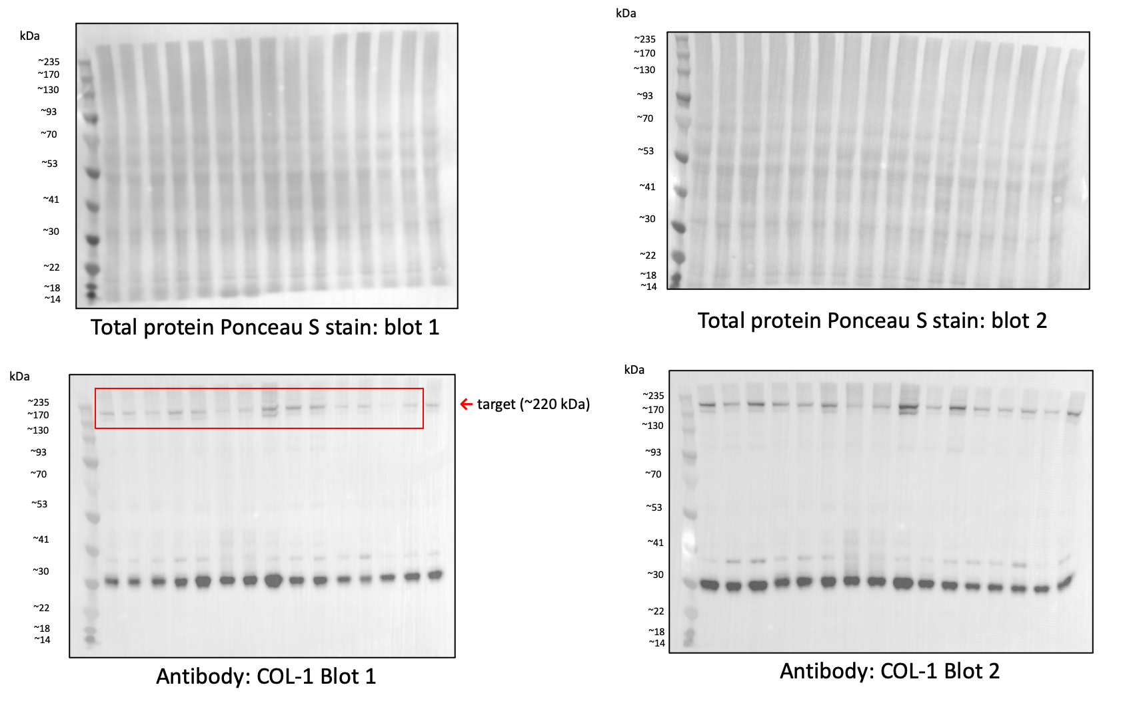

Supplementary Figure S1. Full immunoblots for COL-1 in male PND21 hearts. Red boxes indicate cropped portions of each immunoblot displayed in the manuscript figures. All targets were normalized to total protein Ponceau S staining. Last lane (far right) of each immunoblot was loaded with a pooled sample to normalize for semi-quantitative comparison between blots.

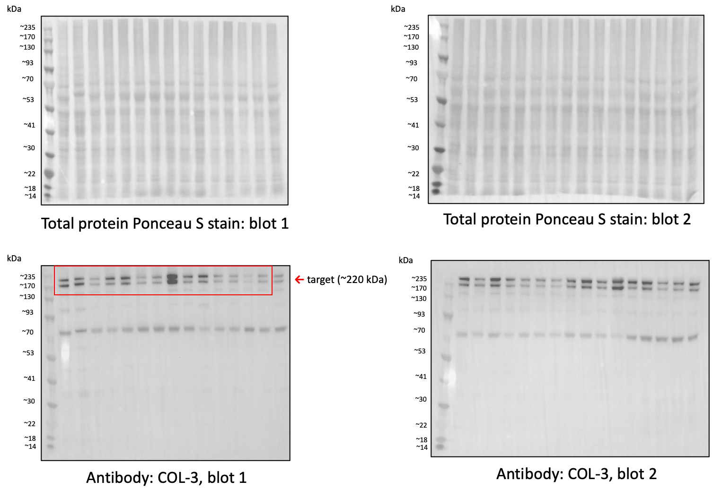

Supplementary Figure S2. Full immunoblots for COL-3 in male PND21 hearts. Red boxes indicate cropped portions of each immunoblot displayed in the manuscript figures. All targets were normalized to total protein Ponceau S staining. Last lane (far right) of each immunoblot was loaded with a pooled sample to normalize for semi-quantitative comparison between blots.

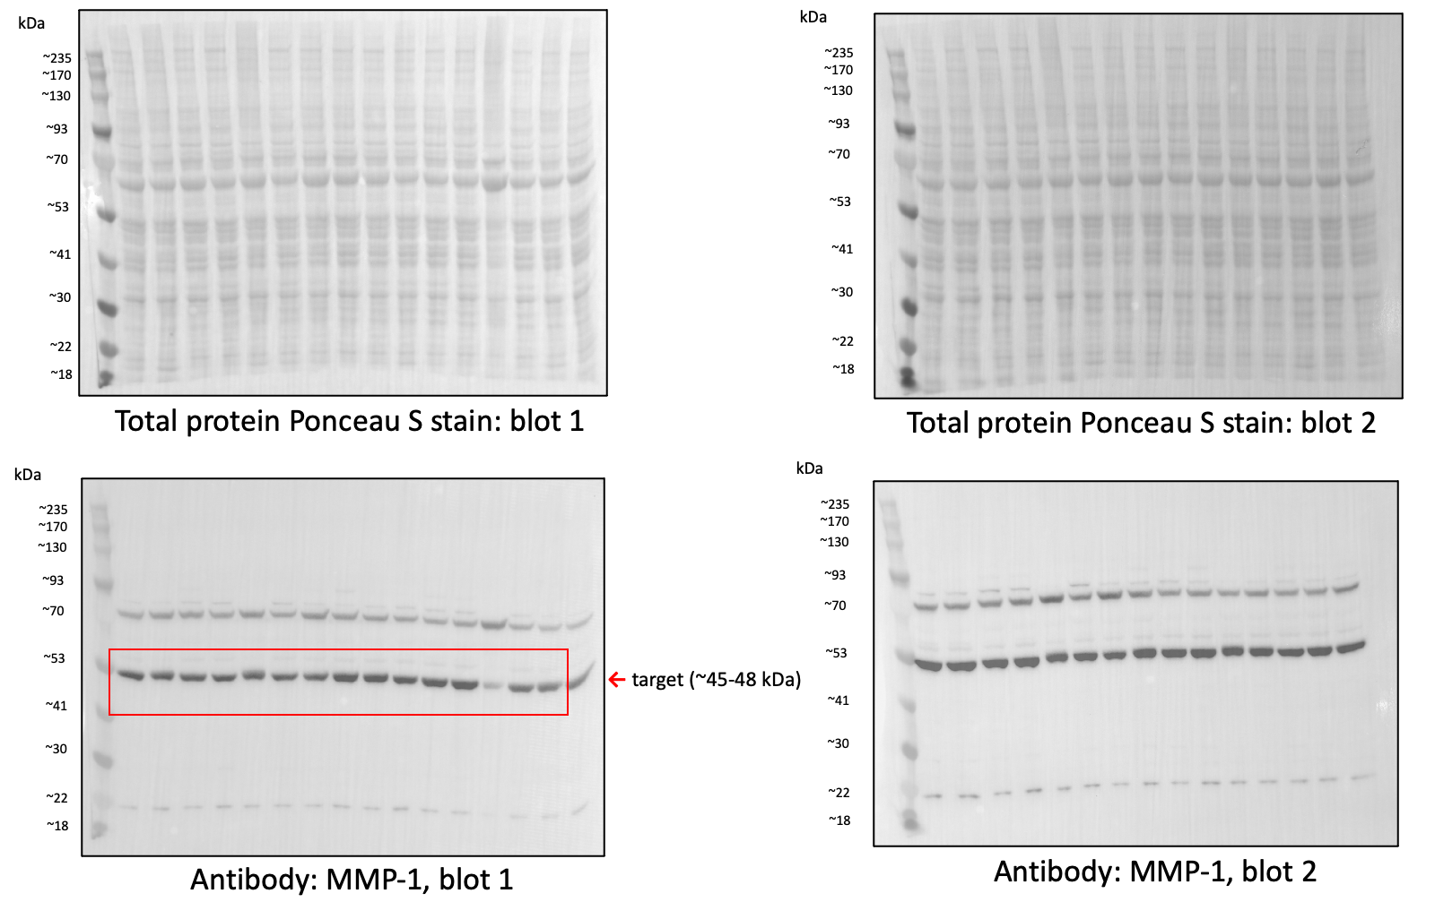

Supplementary Figure S3. Full immunoblots for MMP-1 in male PND21 hearts. Red boxes indicate cropped portions of each immunoblot displayed in the manuscript figures. All targets were normalized to total protein Ponceau S staining. Last lane (far right) of each immunoblot was loaded with a pooled sample to normalize for semi-quantitative comparison between blots.

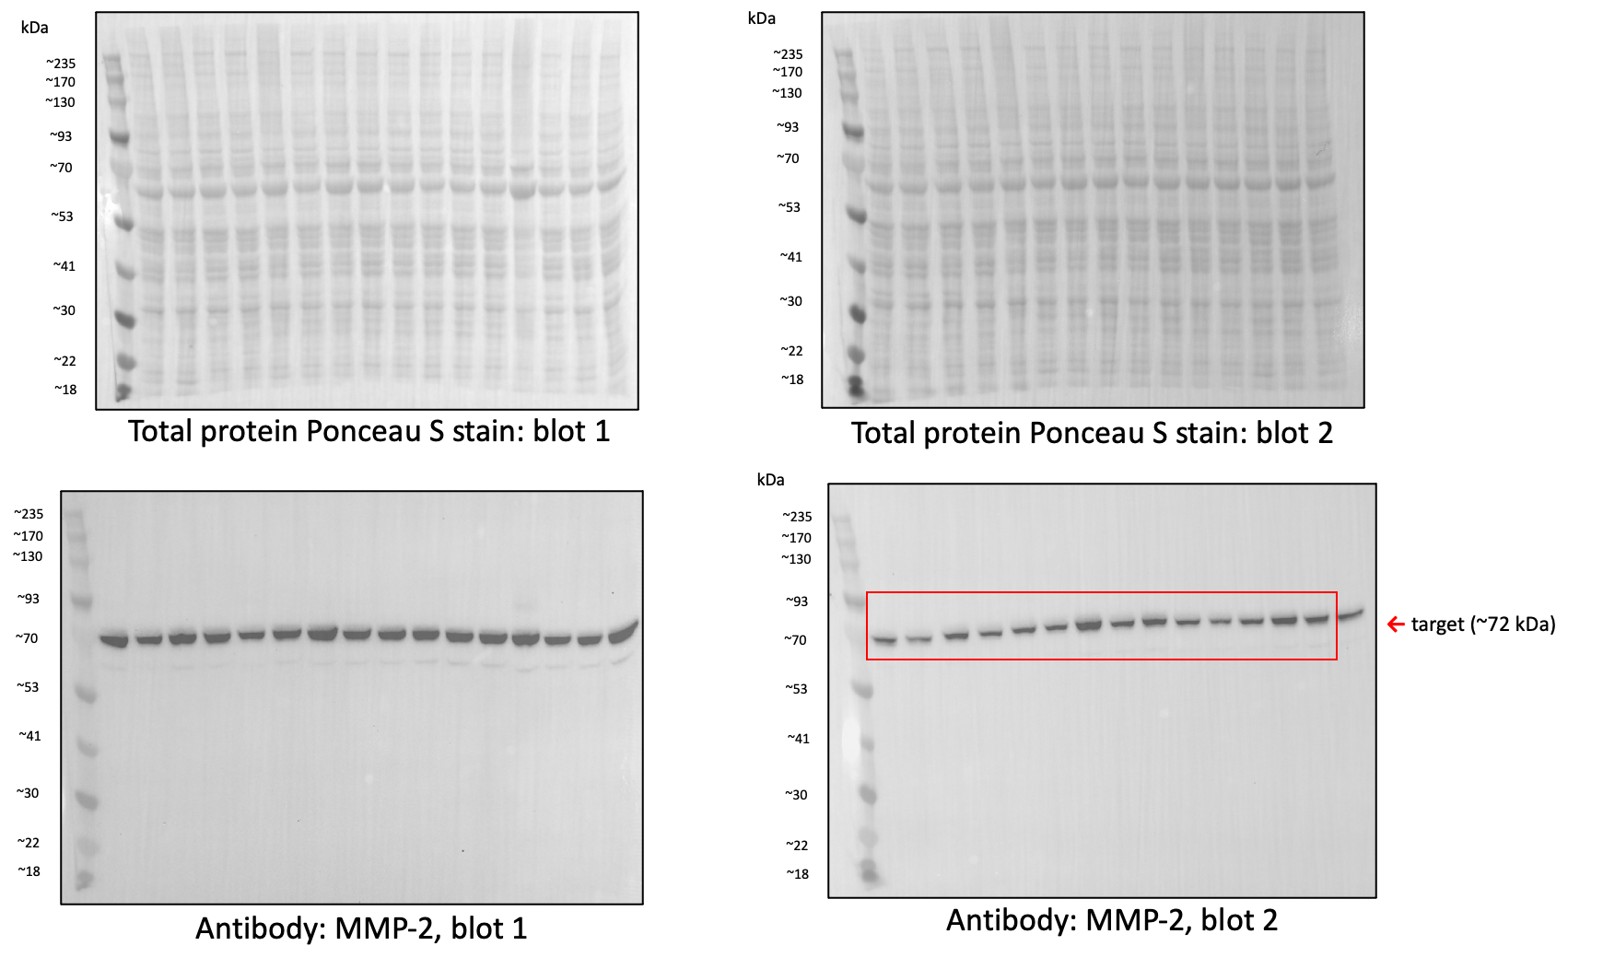

Supplementary Figure S4. Full immunoblots for MMP-2 in male PND21 hearts. Red boxes indicate cropped portions of each immunoblot displayed in the manuscript figures. Blots from MMP-1 were stripped and re-probed with MMP-2 primary antibody, hence targets were normalized to total protein Ponceau S staining from the previous blot (Supplementary Figure S5). Last lane (far right) of each immunoblot was loaded with a pooled sample to normalize for semi-quantitative comparison between blots.

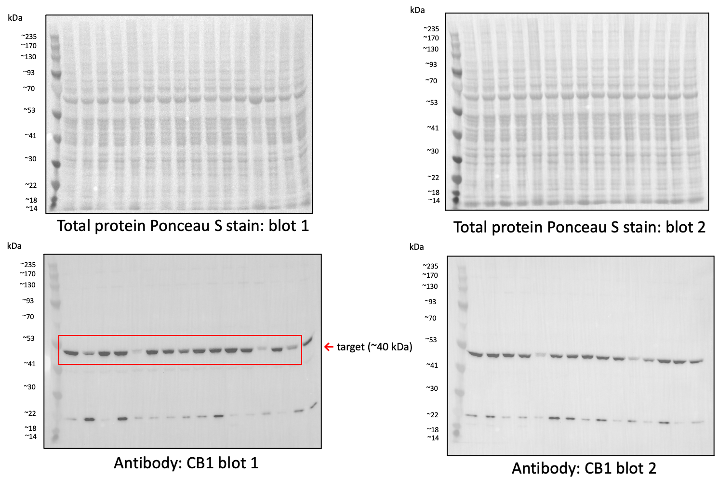

Supplementary Figure S5. Full immunoblots for CB1 in male PND21 hearts. Red boxes indicate cropped portions of each immunoblot displayed in the manuscript figures. All targets were normalized to total protein Ponceau S staining. Last lane (far right) of each immunoblot was loaded with a pooled sample to normalize for semi-quantitative comparison between blots.

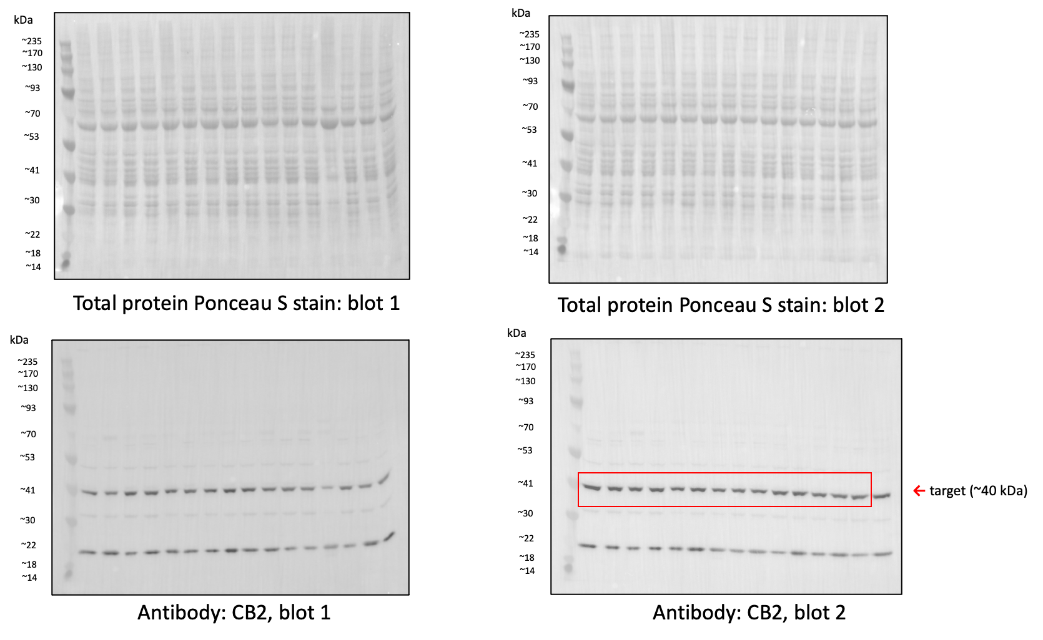

Supplementary Figure S6. Full immunoblots for CB2 in male PND21 hearts. Red boxes indicate cropped portions of each immunoblot displayed in the manuscript figures. All targets were normalized to total protein Ponceau S staining. Last lane (far right) of each immunoblot was loaded with a pooled sample to normalize for semi-quantitative comparison between blots.

