Supplement file
Table S1 Correlation analysis of ptpn6 expression and immune infiltration levels in 32 tumors.

Figure S1 The forest plot of the correlation between ptpn6 expression and OS of 12 types of tumor (all p<0.05).

Figure S2 Correlation analysis of ptpn6 expression and OS in pan-cancer by Kaplan-Meier (A-E) and GEPIA2 (F-K) database.

Figure S3 The ROC curves of correlation between ptpn6 expression and OS. The area under the curve (AUC) values of KIRC, LGG, TGCT, UCS and UVM (AUC =0.619, 0.572, 0.606, 0.442, 0.617, respectively) were computed.

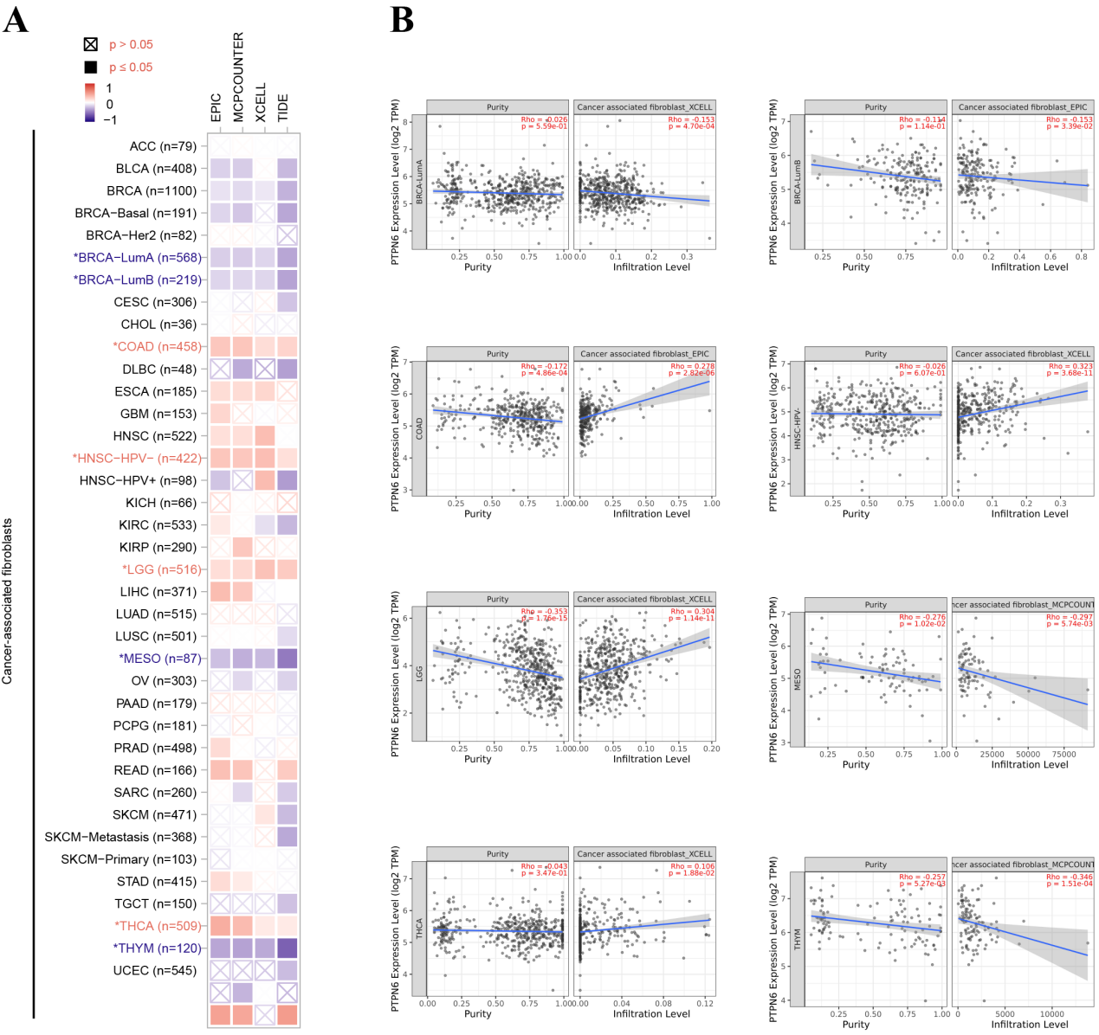
Figure S4 Relationships between ptpn6 and cancer-associated fibroblasts (CAFs) in the tumor microenvironment. (A) The EPIC, MCPCOUNTER, XCELL and TIDE algorithms were used to correlate the CAF scores of different tumors with the expression of ptpn6 gene. (B) The correlation of ptpn6 expression and CAFs infiltration level in BRCA-LumA, BRCA-LumB, COAD, HNSC-HPV-, LGG, MESO, THCA, and THYM.

Figure S5: Representative IHC images of key immune markers in various cancers and their normal tissues, and their correlation analysis with ptpn6 expression. (A) Representative IHC images showing the expression of HIF1A, AFP, IDH1 and VIM in kidney cancer, testicular cancer, brain glioma and uterine carcinoma, respectively. (B) The correlation of the expression between ptpn6 and the immune markers HIF1A and IDH1 (R=-0.035, -0.046).

