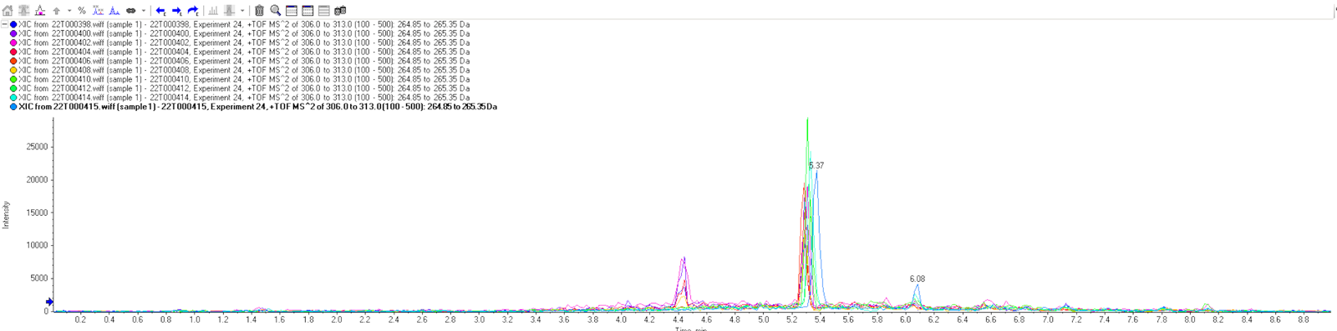
Figure S1 Image from Peakview illustrating the presence of Methadone in each sample

