Supplementary Material
Pan-cancer analysis and the oncogenic role of Glypican 1 in hepatocellular carcinoma
Li Cao ^{2, †}, Fang Li^{2, †}, Shuang Cai², Jinyuan Zhang², Chen Guo², Sadiq Ali², Jing Zhou², Xintao Jing², Xiaofei Wang^{3, *}, Yannan Qin ^{2, *}, Fei Wu^{1, 2, *}
¹ Department of Oncology, The Second Affiliated Hospital of Xi’an Jiaotong University, Xi’an, Shaanxi, 710061, P. R. China
² Department of Cell Biology and Genetics, School of Basic Medical Sciences, Xi’an Jiaotong University, Xi’an, Shaanxi, 710061, P. R. China
³ Biomedical Experimental Center of Xi'an Jiaotong University, Xi’an, Shaanxi, 710061, P. R. China

*Corresponding authors
Address correspondence to:
Fei Wu, Comprehensive Breast Care Center, The Second Affiliated Hospital of Xi’an Jiaotong University, Xi’an, Shaanxi, 710061, P. R. China. E-mail:wufei931105@xjtu.edu.cn. ORCID ID: https://orcid.org/0000-0001-5388-0003.

Table S1 Sequences of siRNA
Name | Sequence
negative siRNA (NC-siRNA) sense | 5′-UUCUCCGAACGUGUCACGUTT-3′
negative siRNA (NC-siRNA) antisense | 5′- ACGUGACACGUUCGGAGAATT-3′
GPC1 siRNA-1 sense | 5′- AGCAGAUCAUGCAGCUGAATT-3′
GPC1 siRNA-1 antisense | 5′- UUCAGCUGCAUGAUCUGCUTT-3′
GPC1 siRNA-2 sense | 5'- AGCUGAAGAUCAUGACCAATT-3'
GPC1 siRNA-2 antisense | 5'- UUGGUCAUGAUCUUCAGCUTT-3'

Table S2 Primer sequence used for qRT-PCR
Gene | Sequence
GPC1-F | 5'- TGAAGCTGGTCTACTGTGCTC-3'
GPC1-R | 5'- CCCAGAACTTGTCGGTGATGA-3'
GAPDH-F | 5'-GCCGTATCGCTCAGACAC-3'
GAPDH-R | 5'-GCCTAATACGACCAAATCC-3'

Table S3 Information on antibodies used for the correlation analysis

Antibody | WB | Specificity | Company | Cat No.
GPC1 | 1:5000 | Rabbit Monoclonal | Sigma | ZRB1374-4X25UL
β-actin | 1:5000 | Rabbit Monoclonal | Proteintech | 81115-1-RR
Bax | 1:4000 | Rabbit Monoclonal | Proteintech | 50599-2-Ig
Bcl-2 | 1:1000 | Mouse | Cell Signaling Technology | 15071
AKT | 1:1000 | Rabbit Monoclonal | Proteintech Group, | 60203-2-Ig
p-AKT(Ser473) | 1:1000 | Rabbit Monoclonal | Cell Signaling Technology | 4060S
HRP-conjugated Affinipure Goat Anti-Rabbit IgG(H+L) | 1:10000 |  | Proteintech | SA00001-2
HRP-conjugated Affinipure Goat Anti-Mouse IgG(H+L) | 1:50000 |  | Proteintech | SA00001-1

Figure S1 The correlation between GPC-1 expression and COX regression in pan-cancer. (A) OS, (B) DSS, (C) DFI, and (D) PFI. (*P < 0.05, **P < 0.01, ***P < 0.001).
Figure S2 Summary of GPC-1 expression of 33 cell types in 176 single cell datasets

Figure S3 GPC-1 analysis based on HCCDB database. (A) GPC-1 expression in HCC samples compared with adjacent tissues. (B) The correlation between GPC-1 expression and survival in HCCDB database.

Figure S4 97H (A) and HUH7(B) cells wound assays

Figure S5 Functional Enrichment and Pathway Analysis from WGCNA. (A)Determination of soft-threshold power in the WGCNA. (B) Clustering dendrogram of genes, with dissimilarity based on topological overlap, together with assigned module colors.

Figure S6 The uncropped images of western blotting.
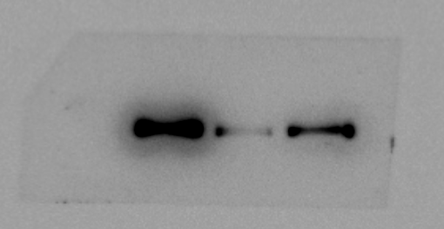
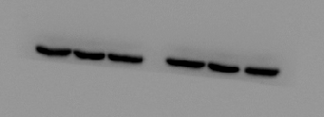
FIGURE 7C
150KD
70KD
100KD
β-actin
97H
siGPC1-2
siGPC1-1-1
siCtrl
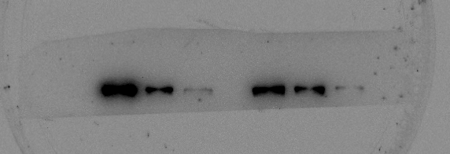
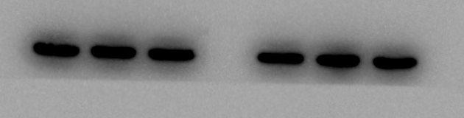
150KD
70KD
100KD
GPC1
40KD
70KD
50KD
β-actin
97H
siGPC1-2
siGPC1-1-1
siCtrl

42KD

GPC1

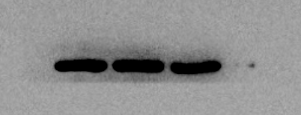
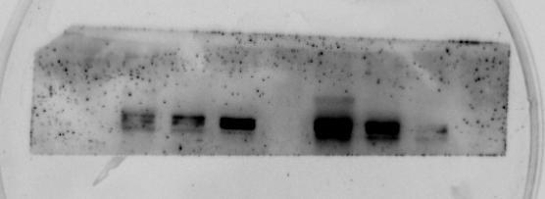
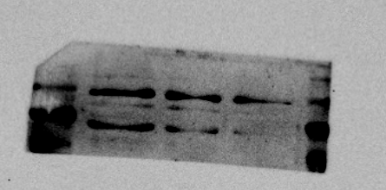
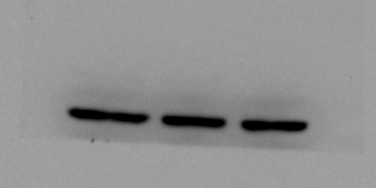
siCtrl
siGPC1-1-1
siGPC1-2
HUH7
β-actin
50KD
40KD
70KD
100KD
150KD
250KD
GPC1
GPC1
150KD
70KD
100KD
β-actin
42KD
97H
siGPC1-2
siGPC1-1-1
siCtrl

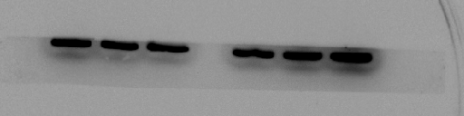
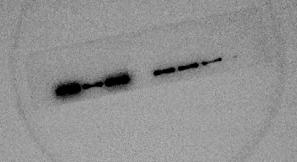
siGPC1-1-1
siGPC1-2
β-actin
42KD
GPC1
86KD
siCtrl
β-actin
siCtrl
siGPC1-1-1
siGPC1-2
GPC1

HUH7
HUH7

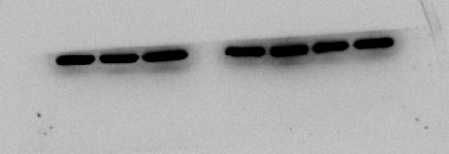
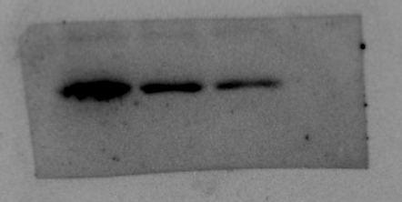
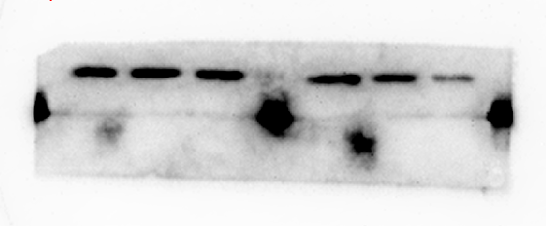
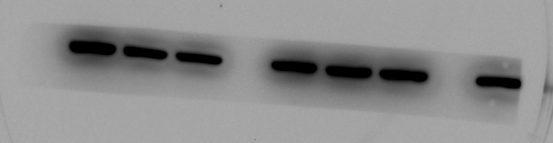
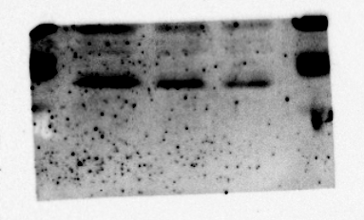
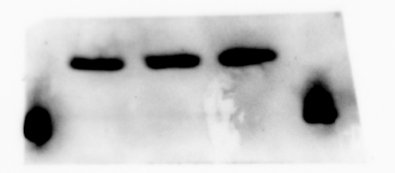
FIGURE 7F
42KD
β-actin
Bcl-2
25KD
40KD
35KD
Bax
97H
siGPC1-2
siGPC1-1-1
siCtrl
15KD
25KD
20KD
siCtrl
50KD
40KD
β-actin
Bcl-2
25KD
40KD
35KD
Bax
15KD
25KD
20KD
97H
siGPC1-2
siGPC1-1-1

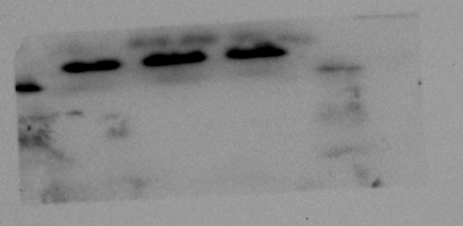
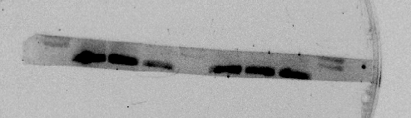
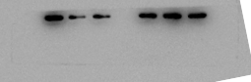
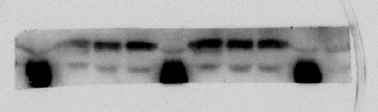
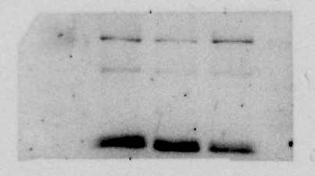
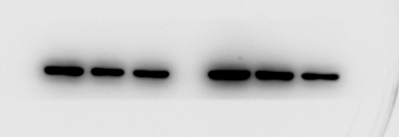
Bax
siCtrl
siGPC1-1-1
siGPC1-2
HUH7
20KD
25KD
15KD
25KD
35KD
Bcl-2
β-actin
50KD
40KD
Bcl-2
Bax
20KD
25KD
siCtrl
siGPC1-1-1
siGPC1-2
97H
35KD
40KD
25KD
50KD
70KD
50KD
40KD
70KD
β-actin
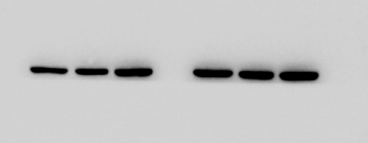
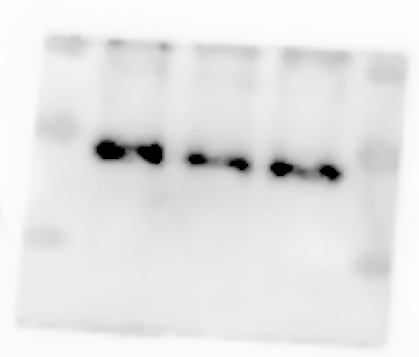
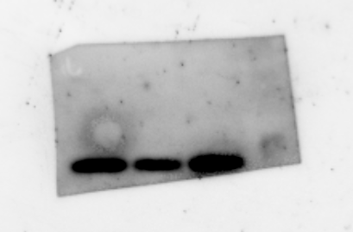
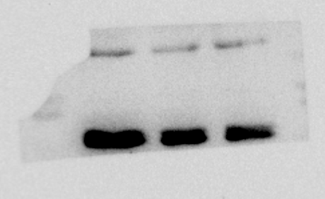
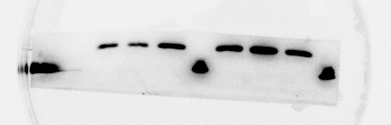
42KD
β-actin
40KD
35KD
25KD
Bcl-2
HUH7
siGPC1-2
siGPC1-1-1
siCtrl
25KD
20KD
Bax
Bax
42KD
β-actin
Bcl-2
25KD
35KD
40KD
50KD
HUH7
siGPC1-2
siGPC1-1-1
siCtrl
15KD
25KD
20KD

FIGURE 8A
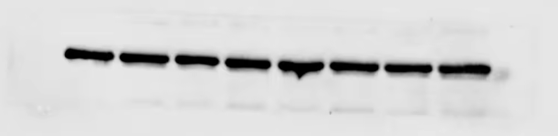
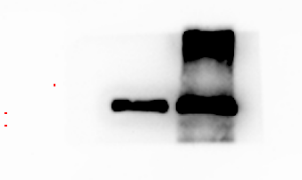
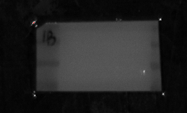
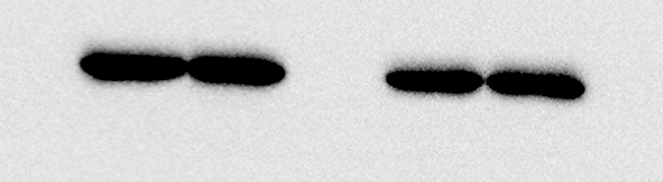
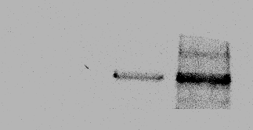
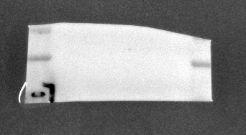
Ctrl
97H
β-actin
40KD
50KD
GPC1
GPC1
70KD
Ctrl
97H
42KD
β-actin
GPC1
70KD
100KD
150KD
GPC1

150KD
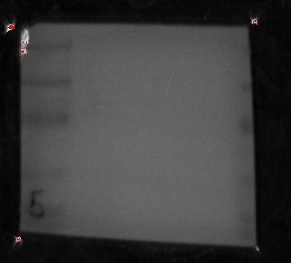
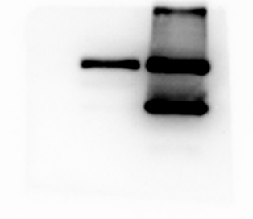
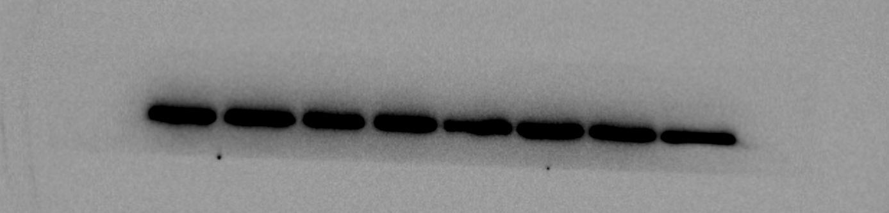
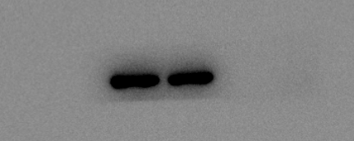
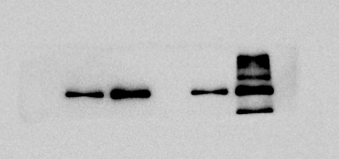
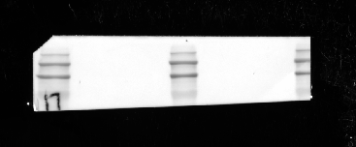
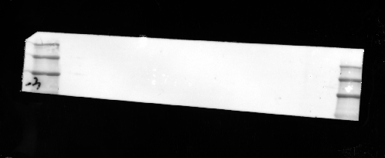
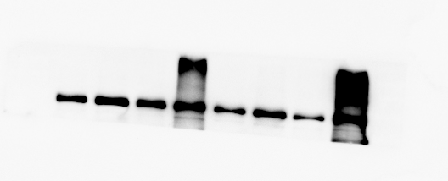
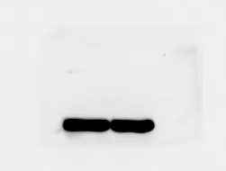
40KD
50KD
70KD
100KD
GPC1
HUH7
Ctrl
50KD
40KD
β-actin
Ctrl
HUH7
GPC1
β-actin
250KD
150KD
100KD
70KD
GPC1
100KD
70KD
150KD
250KD
GPC1
β-actin
100KD
70KD
50KD
40KD
GPC1
97H
Ctrl
100KD

GPC1

250KD
150KD
70KD
100KD
β-actin
40KD
50KD
Ctrl
HUH7
GPC1
GPC1
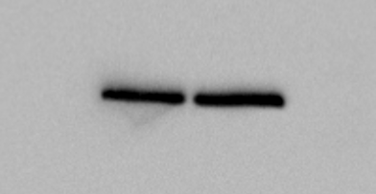
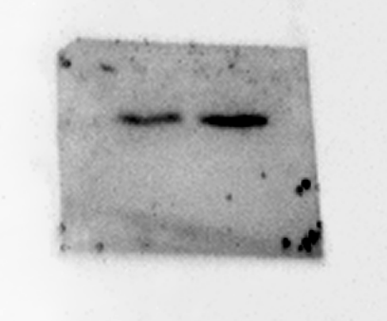
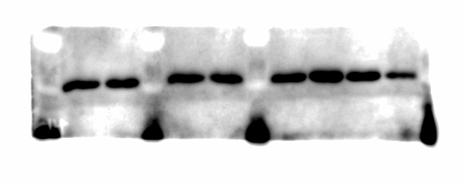
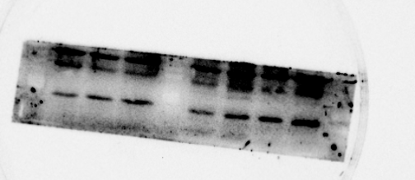
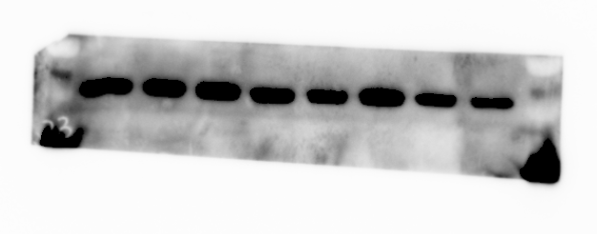
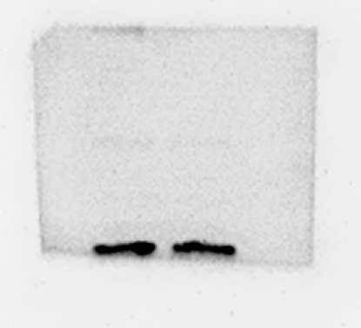
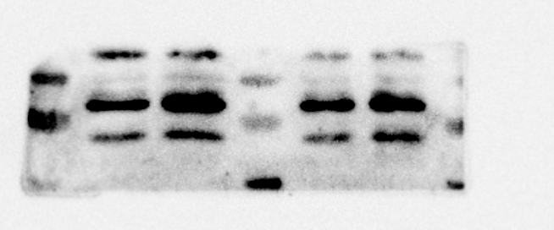
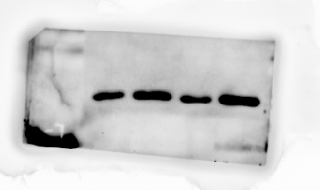
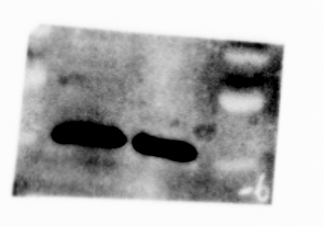
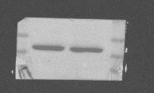
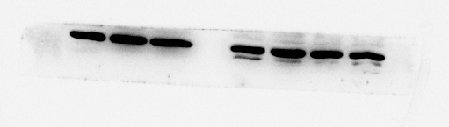
FIGURE 8D
42KD
β-actin
Bcl-2
30KD
25KD
20KD
15KD
20KD
25KD
Bax
GPC1
HUH7
Ctrl
Ctrl
97H
GPC1
20KD
25KD
30KD
Bcl-2
Bax
25KD
20KD
15KD
β-actin
42KD
97H
GPC1
Ctrl
97H
GPC1
20KD
25KD
30KD
Bcl-2
20KD
25KD
30KD
Bcl-2
35KD
25KD
20KD
Bax
25KD
20KD
15KD
Bax
β-actin
40KD
50KD
35KD
70KD
β-actin
42KD
Ctrl

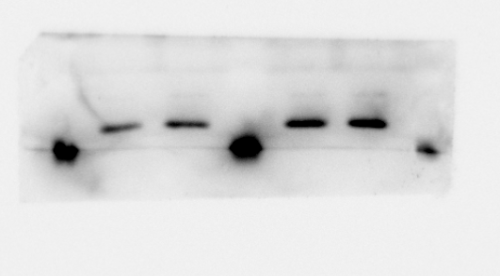
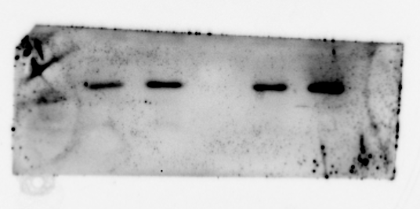
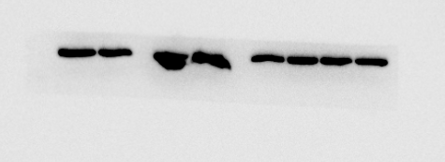
Bax
25KD
20KD
15KD
Ctrl
HUH7
GPC1
Bax
25KD
20KD
Ctrl
HUH7
GPC1
20KD
25KD
30KD
Bcl-2
20KD
25KD
30KD
Bcl-2
β-actin
40KD
50KD
β-actin
42KD

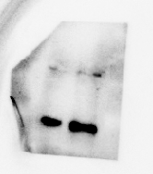
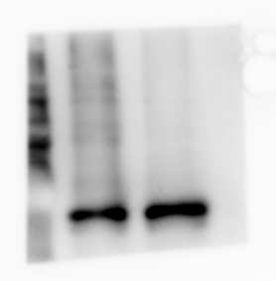
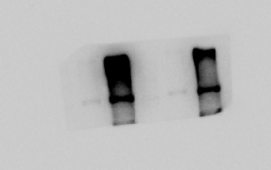
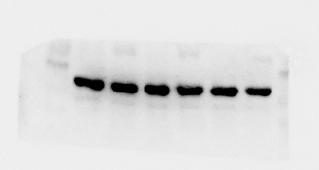
FIGURE 9G(1)
50KD
70KD
P-AKT(ser473)
100KD
50KD
70KD
AKT
86KD
GPC1
97H
Ctrl
42KD
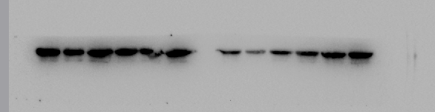
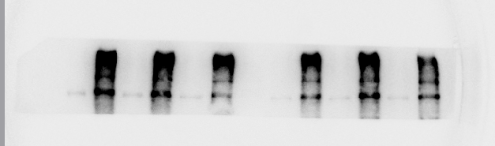
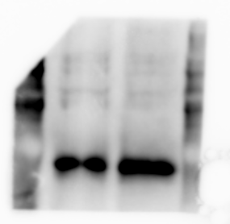
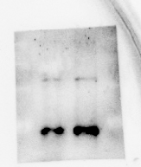
Ctrl
97H
GPC1
42KD
86KD
70KD
50KD
100KD
70KD
50KD
100KD
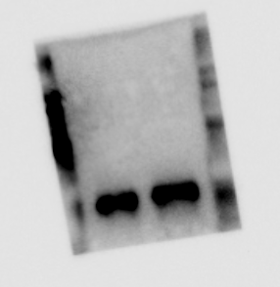
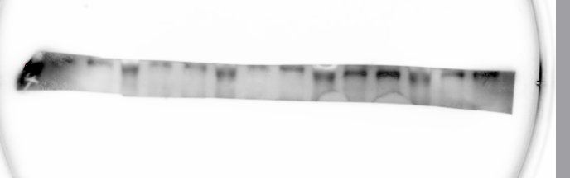
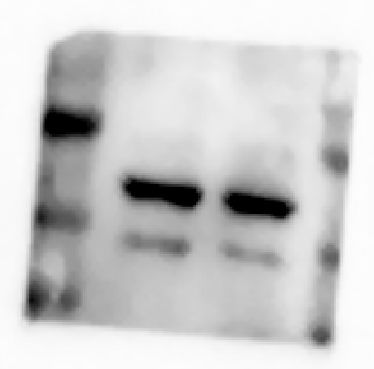
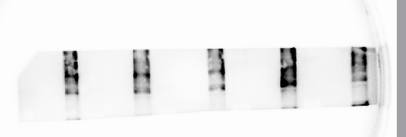
97H
GPC1
Ctrl
AKT
56KD
50KD
70KD
42KD
β-actin
GPC1
86KD
Ctrl
97H
GPC1
P-AKT (ser473)
GPC1
β-actin
P-AKT(ser473)
β-actin
GPC1
AKT
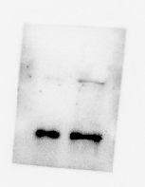
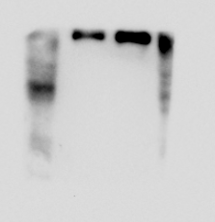
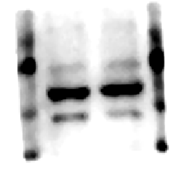
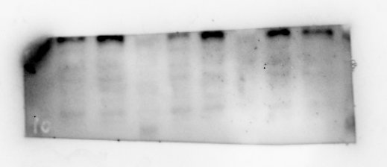
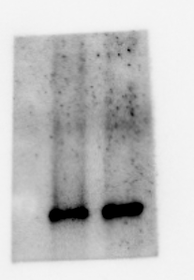
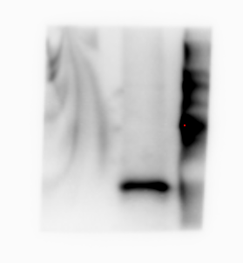
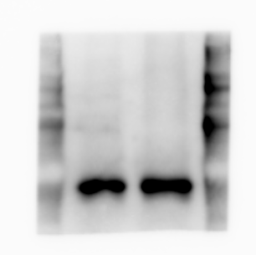
β-actin
GPC1
Ctrl
HUH7
GPC1
Ctrl
42KD
86KD
P-AKT(ser473)
50KD
70KD
50KD
70KD
AKT
GPC1
HUH7
Ctrl
42KD
β-actin
42KD
β-actin
86KD
GPC1
86KD
GPC1
50KD
70KD
P-AKT(ser473)
50KD
70KD
P-AKT(ser473)
50KD
70KD
AKT
50KD
70KD
AKT
GPC1
HUH7
Ctrl
GPC1
HUH7
Ctrl

FIGURE 9G (2)
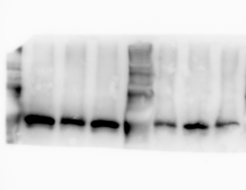
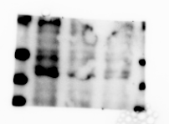
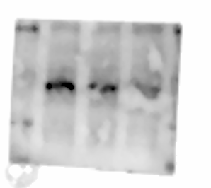
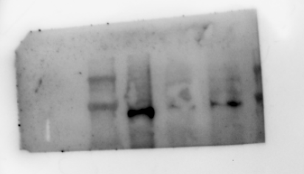
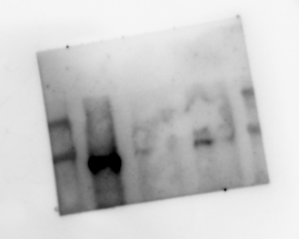
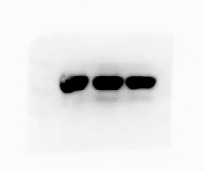
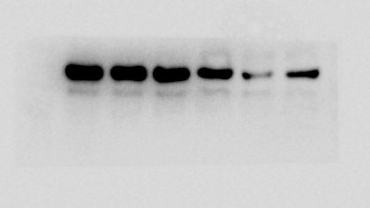
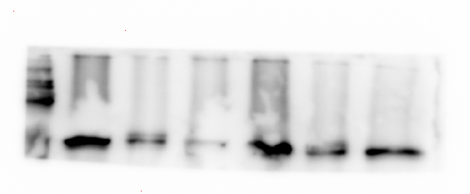
P-AKT(ser473)
P-AKT(ser473)
siCtrl
siGPC1-1-1
siGPC1-2
97H
AKT
70KD
50KD
AKT
70KD
50KD
siCtrl
siGPC1-1-1
siGPC1-2
97H
70KD
50KD
40KD
100KD
70KD
50KD
40KD
100KD
GPC1
86KD
GPC1
86KD
β-actin
42KD
β-actin
42KD
97H

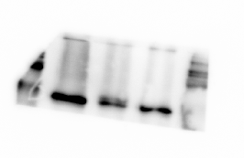
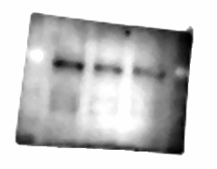
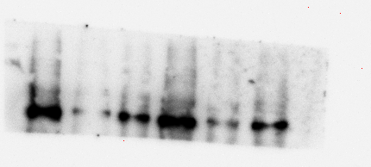
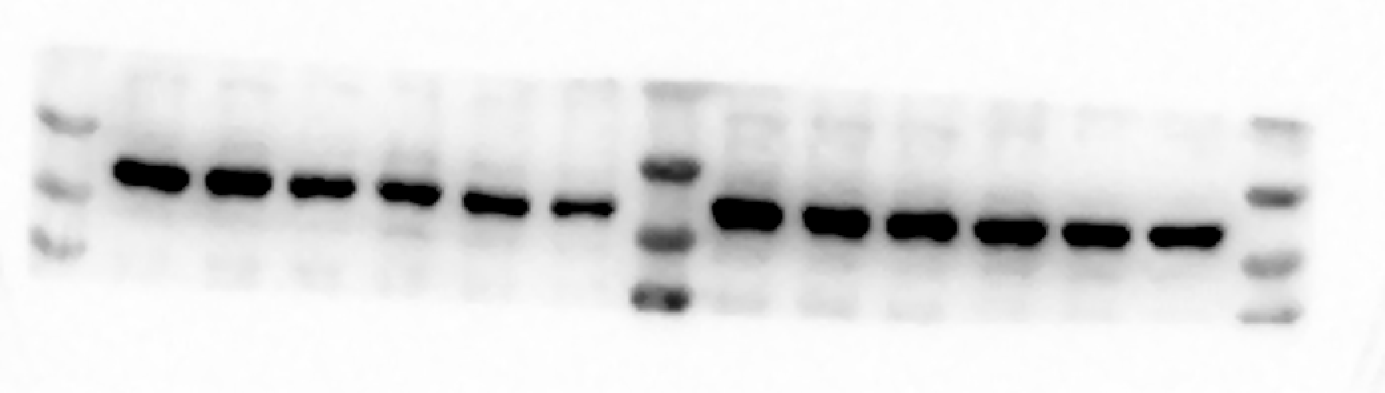
97H
70KD
50KD
56KD
86KD
42KD
siCtrl
siGPC1-1-1
siGPC1-2
97H
AKT
P-AKT(ser473)
GPC1
β-actin
siCtrl
siGPC1-1-1
siGPC1-2

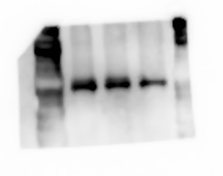
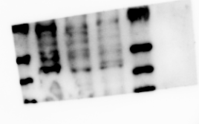
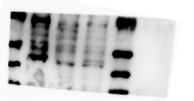
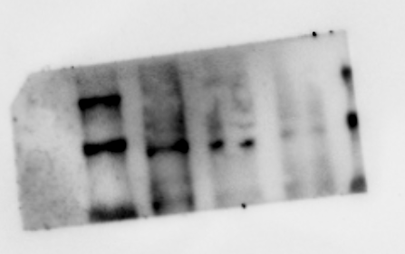
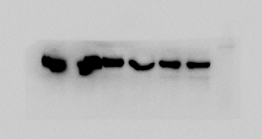
siCtrl
siGPC1-1-1
siGPC1-2
HUH7
AKT
siCtrl
siGPC1-1-1
siGPC1-2
HUH7
P-AKT(ser473)
70KD
50KD
40KD
100KD
70KD
50KD
40KD
100KD
GPC1
86KD
150KD
β-actin
42KD
40KD
50KD
70KD
35KD
100KD
70KD
70KD
50KD
100KD
AKT
P-AKT(ser473)
GPC1
β-actin

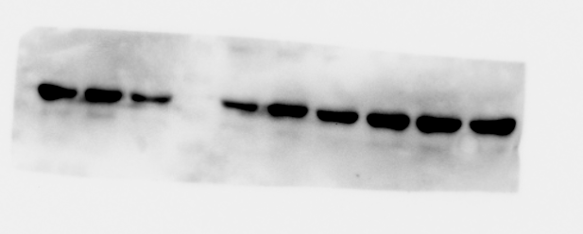
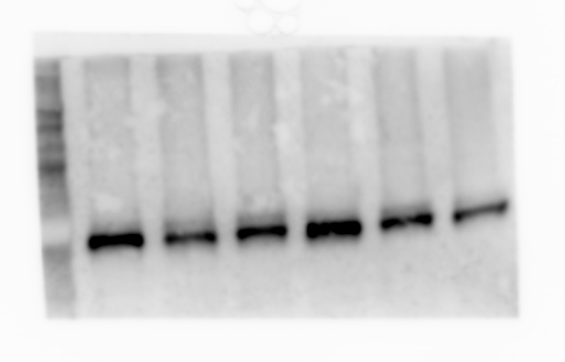
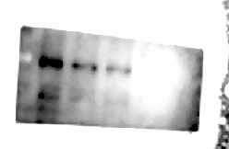
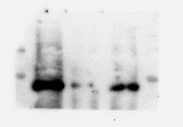
HUH7
HUH7
56KD
siCtrl
siGPC1-1-1
siGPC1-2
70KD
86KD
42KD
AKT
P-AKT(ser473)
GPC1
β-actin
siCtrl
siGPC1-1-1
siGPC1-2

