The Role of Distinct APOBEC/ADAR mRNA Levels in Mutational Signatures
Linked to Aging and Ultraviolet Radiation - Supplementary Information

Ahmadreza Niavarani^{1*}
¹ Digestive Oncology Research Center, Digestive Disease Research Institute, Tehran University of Medical Sciences, Tehran, Iran
* Corresponding author; Tel: +98 21 8241 5290; FAX: +98 21 8241 5400; email: arniavarani@gmail.com

Supplementary Table S1. The number of APOBEC/ADAR mutations among individual TCGA cancers, as well as the ratio of total mutations per exome.
Cohort | Exomes | Total/exome | mut-A1 | mut-A2 | mut-A3A | mut-A3B | mut-A3C | mut-A3D | mut-A3F | mut-A3G | mut-A3H | mut-A4 | mut-AICDA | mut-ADAR | mut-ADARB1 | mut-ADARB2
PCPG | 184 | 0 | 0 | 0 | 0 | 0 | 0 | 0 | 0 | 0 | 0 | 0 | 0 | 0 | 0 | 0
TGCT | 151 | 0 | 0 | 0 | 0 | 0 | 0 | 0 | 0 | 0 | 0 | 0 | 0 | 0 | 0 | 0
THYM | 123 | 0 | 0 | 0 | 0 | 0 | 0 | 0 | 0 | 0 | 0 | 0 | 0 | 0 | 0 | 0
UVM | 80 | 0 | 0 | 0 | 0 | 0 | 0 | 0 | 0 | 0 | 0 | 0 | 0 | 0 | 0 | 0
CHOL | 36 | 0.056 | 0 | 0 | 0 | 0 | 0 | 1 | 0 | 0 | 0 | 1 | 0 | 0 | 0 | 0
MESO | 82 | 0.024 | 1 | 0 | 0 | 0 | 0 | 0 | 0 | 0 | 0 | 0 | 0 | 0 | 1 | 0
KICH | 66 | 0.045 | 0 | 0 | 0 | 0 | 0 | 0 | 0 | 1 | 0 | 0 | 2 | 0 | 0 | 0
ACC | 92 | 0.033 | 0 | 0 | 0 | 0 | 1 | 0 | 0 | 0 | 0 | 0 | 0 | 0 | 2 | 0
DLBC | 37 | 0.081 | 0 | 0 | 0 | 0 | 0 | 1 | 0 | 0 | 0 | 0 | 0 | 0 | 0 | 2
LAML | 141 | 0.028 | 0 | 0 | 0 | 0 | 1 | 0 | 0 | 1 | 0 | 0 | 0 | 1 | 1 | 0
UCS | 57 | 0.088 | 2 | 0 | 0 | 0 | 1 | 0 | 1 | 0 | 0 | 0 | 0 | 0 | 0 | 1
SARC | 239 | 0.033 | 0 | 0 | 0 | 1 | 0 | 0 | 0 | 1 | 0 | 0 | 1 | 1 | 0 | 4
THCA | 500 | 0.018 | 0 | 1 | 0 | 0 | 0 | 1 | 1 | 1 | 0 | 0 | 0 | 1 | 3 | 1
PAAD | 178 | 0.056 | 0 | 0 | 0 | 1 | 0 | 1 | 0 | 1 | 1 | 0 | 0 | 2 | 1 | 3
KIRC | 370 | 0.03 | 1 | 0 | 0 | 2 | 0 | 0 | 0 | 0 | 0 | 2 | 1 | 4 | 0 | 1
PRAD | 498 | 0.032 | 3 | 1 | 0 | 4 | 0 | 1 | 1 | 0 | 0 | 0 | 1 | 1 | 1 | 3
KIRP | 282 | 0.057 | 2 | 0 | 0 | 3 | 0 | 0 | 1 | 0 | 0 | 0 | 0 | 3 | 4 | 3
LGG | 526 | 0.038 | 2 | 0 | 0 | 1 | 0 | 1 | 2 | 2 | 2 | 1 | 2 | 1 | 2 | 4
ESCA | 185 | 0.108 | 2 | 1 | 0 | 0 | 0 | 1 | 0 | 3 | 1 | 0 | 3 | 4 | 2 | 3
OV | 412 | 0.056 | 2 | 0 | 1 | 1 | 0 | 2 | 2 | 1 | 0 | 1 | 2 | 7 | 3 | 1
LIHC | 365 | 0.077 | 0 | 1 | 1 | 1 | 1 | 0 | 2 | 1 | 1 | 3 | 3 | 3 | 4 | 7
GBM | 403 | 0.084 | 2 | 0 | 1 | 2 | 2 | 1 | 3 | 3 | 3 | 1 | 5 | 2 | 2 | 7
HNSC | 509 | 0.067 | 1 | 0 | 0 | 5 | 1 | 4 | 0 | 1 | 1 | 0 | 2 | 6 | 2 | 11
CESC | 291 | 0.134 | 3 | 1 | 0 | 3 | 4 | 0 | 3 | 8 | 1 | 3 | 2 | 6 | 3 | 2
BRCA | 1026 | 0.038 | 3 | 2 | 2 | 7 | 1 | 0 | 2 | 4 | 0 | 1 | 3 | 4 | 4 | 6
BLCA | 411 | 0.139 | 2 | 2 | 1 | 4 | 3 | 3 | 2 | 2 | 3 | 7 | 2 | 14 | 3 | 9
LUAD | 569 | 0.141 | 2 | 1 | 4 | 3 | 2 | 7 | 0 | 5 | 4 | 7 | 5 | 9 | 15 | 16
STAD | 439 | 0.182 | 7 | 3 | 1 | 7 | 4 | 4 | 3 | 3 | 1 | 2 | 4 | 16 | 14 | 11
LUSC | 485 | 0.179 | 12 | 2 | 2 | 6 | 2 | 4 | 7 | 3 | 2 | 3 | 10 | 12 | 5 | 17
COADREAD | 559 | 0.279 | 11 | 7 | 7 | 8 | 7 | 9 | 6 | 13 | 4 | 11 | 10 | 18 | 24 | 21
SKCM | 468 | 0.357 | 9 | 9 | 11 | 12 | 6 | 12 | 14 | 9 | 5 | 4 | 8 | 19 | 21 | 28
UCEC | 531 | 0.616 | 22 | 20 | 9 | 24 | 11 | 26 | 25 | 16 | 12 | 15 | 24 | 43 | 43 | 37

Supplementary Table S2. The median and mean number of single-nucleotide (SNV) and indel variants in exomes with wild-type versus mutant APOBEC/ADAR genes.
Gene mutation | Wild-type/ Mutant | Median SNV |  | Median Indel |  | Mean SNV |  |  |  | Mean Indel
Gene mutation | Wild-type/ Mutant | Wild-type | Mutant | Wild-type | Mutant | Wild-type | Mutant | P* | FDR | Wild-type | Mutant | P* | FDR
APOBEC1 | 10185/89 | 88 | 1286 | 4 | 20 | 284.2 ±10 | 5200.3 ±894.5 | 3.7e-07 | 5.24e-06 | 15.3 ±0.7 | 182.1 ±54.4 | 2.9e-03 | 4.0e-02
APOBEC2 | 10226/51 | 88 | 2402 | 4 | 30 | 286.9 ±9.9 | 7327.4 ±1509.6 | 2.3e-05 | 3.29e-04 | 15.9 ±0.8 | 156.7 ±36.4 | 3.1e-04 | 4.4e-03
APOBEC3A | 10240/40 | 89 | 1264 | 4 | 16 | 315.3 ±13.2 | 3847.3 ±850 | 1.7e-04 | 2.40e-03 | 16.6 ±0.8 | 65.5 ±18.1 | 1.0e-02 | 1.4e-01
APOBEC3B | 10181/95 | 88 | 1188 | 4 | 20 | 290.4 ±10.9 | 4467.7 ±827.6 | 2.2e-06 | 3.06e-05 | 15.3 ±0.7 | 176.3 ±41.9 | 2.2e-04 | 3.1e-03
APOBEC3C | 10237/47 | 89 | 1573 | 4 | 34 | 311.6 ±12.6 | 4810 ±1163.8 | 3.5e-04 | 4.85e-03 | 16.3 ±0.8 | 130 ±31.9 | 8.7e-04 | 1.2e-02
APOBEC3D | 10176/79 | 88 | 1549 | 4 | 21 | 274.1 ±10.5 | 5349.4 ±854.1 | 7.5e-08 | 1.04e-06 | 15.4 ±0.8 | 142.9 ±27.2 | 1.1e-05 | 1.6e-04
APOBEC3F | 10184/75 | 88 | 2065 | 4 | 32 | 264.5 ±8.2 | 6321.6 ±827 | 2.4e-10 | 3.40e-09 | 15.6 ±0.8 | 129.9 ±26.4 | 4.7e-05 | 6.6e-04
APOBEC3G | 10196/79 | 88 | 1596 | 4 | 14 | 292.8 ±11.1 | 4397.3 ±705.4 | 1.3e-07 | 1.75e-06 | 15.9 ±0.8 | 106.5 ±22.3 | 1.2e-04 | 1.6e-03
APOBEC3H | 10244/41 | 89 | 1144 | 4 | 30 | 303.1 ±11.8 | 6845.3 ±1496.8 | 8.6e-05 | 1.20e-03 | 16.4 ±0.8 | 123.9 ±29.9 | 8.8e-04 | 1.2e-02
APOBEC4 | 10219/62 | 88 | 1059 | 4 | 22 | 291.8 ±11.6 | 5383 ±910.4 | 5.6e-07 | 7.84e-06 | 15.9 ±0.8 | 128.1 ±32.5 | 1.0e-03 | 1.4e-02
AICDA | 10179/90 | 88 | 937 | 4 | 14 | 282.8 ±10 | 5351.6 ±960.1 | 9.1e-07 | 1.27e-05 | 15.8 ±0.8 | 93.4 ±19.5 | 1.4e-04 | 1.9e-03
ADAR | 10066/177 | 87 | 984 | 4 | 18 | 254.2 ±8.2 | 4049.1 ±558.1 | 1.6e-10 | 2.21e-09 | 14.2 ±0.8 | 152 ±19 | 1.3e-11 | 1.8e-10
ADARB1 | 10085/160 | 87 | 1225 | 4 | 27 | 248.7 ±7.5 | 4686.8 ±548.4 | 1.4e-13 | 1.99e-12 | 13.8 ±0.6 | 157.1 ±20.7 | 9.6e-11 | 1.3e-09
ADARB2 | 10022/198 | 87 | 504 | 4 | 12 | 250.4 ±7.5 | 3482.3 ±494.5 | 5.3e-10 | 7.45e-09 | 14.7 ±0.8 | 105.2 ±16.8 | 2.0e-07 | 2.8e-06

* Unpaired two-tailed Student’s t test.
Supplementary Table S3. The mean number of single-nucleotide variant (SNV) and indel (Ind) variant classes among exomes with synonymous versus nonsynonymous APOBEC/ADAR mutations. Those exomes with nonsynonymous A3C, AICDA, and ADARB1 mutations were enriched in T>N and/or C>N variants compared to exomes with synonymous ones, and those exomes with any nonsynonymous A1, A3B, A3C, A3H, and ADAR mutations were enriched in Ind-T and/or Ind-C variants.
Gene mutation | Synonymous/ Non-synonymous | T>N |  |  |  | C>N |  |  |  | Ind-T |  |  |  | Ind-C
Gene mutation | Synonymous/ Non-synonymous | Synonymous | Non-synonymous | P* | FDR | Synonymous | Non-synonymous | P* | FDR | Synonymous | Non-synonymous | P* | FDR | Synonymous | Non-synonymous | P* | FDR
APOBEC1 | 21/89 | 441 ±272.5 | 1029.4 ±181.6 | 8.0e-02 | NS | 2884.7 ±1601.7 | 4171 ±787.5 | 4.8e-01 | NS | 18.6 ±9.9 | 111.8 ±29 | 3.0e-03 | 4.2e-02 | 11.4 ±6 | 70.3 ±26.3 | 3.1e-02 | NS
APOBEC2 | 18/51 | 1063.7 ±330.1 | 1295.7 ±233.8 | 5.7e-01 | NS | 5630.6 ±1650.5 | 6031.7 ±1361.3 | 8.5e-01 | NS | 129.9 ±66.7 | 105.9 ±23.5 | 7.4e-01 | NS | 18.1 ±6.7 | 50.9 ±15.4 | 5.5e-02 | NS
APOBEC3A | 15/40 | 549.1 ±346.1 | 879.3 ±254.2 | 4.5e-01 | NS | 2483.1 ±1394.2 | 2968.1 ±609.8 | 7.5e-01 | NS | 31.9 ±18 | 42.3 ±12.2 | 6.4e-01 | NS | 21.4 ±13.4 | 23.2 ±7.3 | 9.1e-01 | NS
APOBEC3B | 19/94 | 498.4 ±229.3 | 794.1 ±159.1 | 3.0e-01 | NS | 1950.5 ±688.4 | 3673.5 ±736 | 9.2e-02 | NS | 22.7 ±7.7 | 113.7 ±25.1 | 7.7e-04 | 1.1e-02 | 12.2 ±4.6 | 62.7 ±17.7 | 6.7e-03 | NS
APOBEC3C | 11/47 | 202.8 ±166.4 | 767.1 ±186.9 | 3.0e-02 | NS | 851 ±500.3 | 4042.8 ±987.1 | 5.6e-03 | NS | 4.1 ±1.7 | 91 ±25.8 | 1.6e-03 | 2.2e-02 | 2.3 ±0.6 | 39 ±8.4 | 7.6e-05 | 1.1e-03
APOBEC3D | 40/79 | 1143.6 ±267.4 | 985.8 ±172.2 | 6.2e-01 | NS | 4261.8 ±785.9 | 4363.5 ±703.2 | 9.2e-01 | NS | 89.5 ±22.6 | 94.8 ±17.1 | 8.5e-01 | NS | 41.3 ±11.6 | 48.1 ±11.2 | 6.8e-01 | NS
APOBEC3F | 36/75 | 989.6 ±311.8 | 1200.3 ±182.3 | 5.6e-01 | NS | 6227.7 ±1887.7 | 5121.3 ±668.5 | 5.8e-01 | NS | 90.2 ±32.7 | 92.2 ±19.8 | 9.6e-01 | NS | 28.1 ±14.5 | 37.7 ±9 | 5.7e-01 | NS
APOBEC3G | 20/79 | 480.2 ±278.7 | 813.7 ±158 | 3.1e-01 | NS | 4280.2 ±2674.9 | 3583.5 ±563 | 8.0e-01 | NS | 70.8 ±48.2 | 77.6 ±17.1 | 8.9e-01 | NS | 53.1 ±31.5 | 28.8 ±6.5 | 4.6e-01 | NS
APOBEC3H | 10/41 | 702.3 ±332.8 | 1332.3 ±313.1 | 1.8e-01 | NS | 3529.4 ±1799.3 | 5513 ±1214 | 3.7e-01 | NS | 25.7 ±11.7 | 91.9 ±23.3 | 1.4e-02 | NS | 10.8 ±7.3 | 32 ±8.9 | 7.3e-02 | NS
APOBEC4 | 14/62 | 1805.2 ±590.3 | 1133.8 ±208.4 | 3.0e-01 | NS | 6175 ±1667.4 | 4249.2 ±726.2 | 3.0e-01 | NS | 112.1 ±35.1 | 85.9 ±20.8 | 5.3e-01 | NS | 44.1 ±19.5 | 42.2 ±14 | 9.4e-01 | NS
AICDA | 26/90 | 371.4 ±138.2 | 867.2 ±148.6 | 1.7e-02 | NS | 2216.5 ±550.9 | 4484.4 ±850.6 | 2.7e-02 | NS | 98.8 ±38.5 | 67.2 ±13.9 | 4.4e-01 | NS | 50.5 ±21.9 | 26.2 ±6.7 | 3.0e-01 | NS
ADAR | 52/177 | 558.6 ±145.6 | 712.1 ±98.8 | 3.8e-01 | NS | 2371.7 ±532.2 | 3337 ±487.1 | 1.8e-01 | NS | 44.3 ±9.9 | 100.7 ±12.5 | 5.1e-04 | 7.1e-03 | 23.9 ±5.3 | 51.2 ±7.4 | 3.1e-03 | 4.4e-02
ADARB1 | 50/151 | 346.3 ±92.2 | 967.5 ±126.3 | 1.0e-04 | 1.4e-03 | 3053.7 ±1158.5 | 3719.3 ±442.6 | 5.9e-01 | NS | 105 ±44.9 | 103.6 ±13.9 | 9.8e-01 | NS | 78.5 ±43.9 | 53.4 ±7.8 | 5.8e-01 | NS
ADARB2 | 75/198 | 504.9 ±121.9 | 645.3 ±100.3 | 3.8e-01 | NS | 2541.8 ±593.8 | 2837 ±423.1 | 6.9e-01 | NS | 39.5 ±12.4 | 70.8 ±11.7 | 6.8e-02 | NS | 27.3 ±9.7 | 34.3 ±5.9 | 5.4e-01 | NS

* Unpaired two-tailed Student’s t test.
FDR: Benjamini–Hochberg false discovery rate.
NS: statistically not significant.

Supplementary Table S4. The rotated component matrix resulted from principal component (PC) analysis of the covariates potentially implicated in mutations across exomes/genomes. Varimax rotation with Kaiser normalization was used in order to extract the components. The cut-off for the correlation between the covariate and the estimated component was considered to be 0.4, shown in bold.

No. | Component | 1 | 2 | 3 | 4 | 5 | 6 | 7 | 8
1 | Age | .048 | .058 | .067 | .033 | .703 | .007 | .057 | -.001
2 | UV | .095 | .080 | .768 | -.029 | -.069 | -.007 | -.038 | -.078
3 | mutBER | .900 | .038 | -.004 | .004 | .005 | .037 | .026 | .030
4 | mutNER | .939 | .027 | -.012 | .006 | -.001 | .047 | .003 | .035
5 | mutMMR | .916 | .019 | -.030 | .011 | .000 | .027 | .001 | .039
6 | mutHR | .921 | .033 | -.023 | .024 | .014 | .056 | -.002 | .034
7 | mutNHEJ | .807 | .031 | .012 | .000 | .020 | .066 | .019 | .018
8 | mutFATLS | .937 | .036 | -.002 | .020 | .011 | .050 | -.003 | .045
9 | mutRepl | .930 | .022 | -.008 | .007 | .010 | .043 | .000 | .021
10 | A1-mRNA | .004 | -.055 | -.069 | -.114 | .575 | .000 | .009 | -.161
11 | A2-mRNA | -.025 | .189 | -.184 | -.186 | -.065 | .062 | .126 | -.480
12 | A3A-mRNA | .006 | .024 | -.063 | .775 | -.059 | -.002 | .038 | -.074
13 | A3B-mRNA | .037 | .288 | -.031 | .689 | .076 | .011 | .000 | .045
14 | A3C-mRNA | .017 | .634 | .464 | .236 | .083 | .016 | .020 | -.035
15 | A3D-mRNA | .024 | .852 | .117 | .100 | .071 | .003 | -.008 | .046
16 | A3F-mRNA | .008 | .822 | .092 | .072 | .045 | .023 | .003 | .098
17 | A3G-mRNA | .025 | .855 | .078 | .072 | -.010 | -.025 | -.009 | -.015
18 | A3H-mRNA | .020 | .765 | -.053 | -.046 | -.046 | -.027 | -.013 | .005
19 | A4-mRNA | -.020 | .070 | -.173 | -.179 | .043 | .136 | .160 | .552
20 | AICDA-mRNA | -.007 | .081 | -.001 | -.036 | -.058 | -.086 | -.077 | .405
21 | ADAR-mRNA | -.024 | .190 | .406 | .167 | .130 | .038 | .053 | .340
22 | ADARB1-mRNA | -.049 | .129 | .715 | -.166 | -.099 | .015 | .022 | .013
23 | ADARB2-mRNA | -.051 | -.078 | .105 | -.107 | -.529 | .002 | .071 | -.216
24 | mutA1 | .385 | -.007 | .005 | -.007 | -.033 | -.050 | .389 | -.048
25 | mutA2 | .367 | .006 | -.003 | -.024 | .000 | .213 | -.206 | -.071
26 | mutA3A | .218 | -.002 | .046 | -.027 | .010 | -.125 | -.535 | .014
27 | mutA3B | .332 | -.023 | .081 | .007 | .081 | -.125 | .508 | -.105
28 | mutA3C | .331 | .011 | -.052 | -.050 | -.064 | -.615 | -.127 | .139
29 | mutA3D | .331 | .009 | .016 | -.023 | .046 | .430 | -.068 | -.022
30 | mutA3F | .423 | -.010 | .025 | -.013 | -.017 | .183 | -.167 | -.113
31 | mutA3G | .293 | -.006 | .010 | -.005 | -.004 | .419 | -.037 | -.004
32 | mutA3H | .299 | -.021 | -.022 | .011 | -.110 | .244 | .227 | .202
33 | mutA4 | .327 | -.001 | -.037 | -.002 | -.032 | .259 | -.242 | -.021
34 | mutAICDA | .306 | -.010 | -.046 | -.016 | -.100 | .338 | .034 | .207
35 | mutADAR | .427 | .022 | .035 | -.002 | .091 | -.036 | .100 | -.064
36 | mutADARB1 | .462 | -.026 | .028 | -.005 | .055 | .032 | -.307 | -.050
37 | mutADARB2 | .358 | -.030 | .038 | .036 | .012 | .059 | .080 | .062

Supplementary Table S5. The rotated component matrix resulted from principal component (PC) analysis of the covariates potentially implicated in mutations across cancer types. Varimax rotation with Kaiser Normalization was used in order to extract the components. The cut-off for the correlation between the covariate and the estimated component was considered to be 0.4, as shown in bold.

No. | Component | 1 | 2 | 3 | 4 | 5
1 | Age | .268 | .103 | -.006 | -.029 | .642
2 | UV | .168 | .065 | .915 | .024 | -.038
3 | mutBER | .981 | .009 | .008 | .099 | .113
4 | mutNER | .982 | .029 | -.013 | .087 | .089
5 | mutMMR | .983 | -.023 | -.053 | .063 | .092
6 | mutHR | .967 | .021 | -.034 | .134 | .137
7 | mutNHEJ | .958 | .009 | .044 | .151 | .169
8 | mutFATLS | .968 | .104 | -.003 | .138 | .125
9 | mutRepl | .982 | -.007 | -.007 | .101 | .128
10 | A1-mRNA | .113 | -.169 | -.204 | -.120 | .501
11 | A2-mRNA | -.138 | .211 | -.179 | -.332 | .004
12 | A3A-mRNA | .022 | .061 | -.147 | .841 | -.063
13 | A3B-mRNA | .253 | .178 | -.184 | .861 | .094
14 | A3C-mRNA | .011 | .517 | .641 | .363 | .145
15 | A3D-mRNA | -.050 | .918 | .133 | .118 | .049
16 | A3F-mRNA | .119 | .775 | .188 | -.023 | .234
17 | A3G-mRNA | -.041 | .936 | .083 | .062 | .029
18 | A3H-mRNA | -.013 | .954 | -.037 | -.040 | -.072
19 | A4-mRNA | .799 | .010 | -.191 | -.168 | .029
20 | AICDA-mRNA | -.045 | .742 | -.166 | -.047 | -.235
21 | ADAR-mRNA | .063 | .036 | .147 | .131 | .735
22 | ADARB1-mRNA | -.135 | .094 | .804 | -.190 | .096
23 | ADARB2-mRNA | -.157 | -.128 | .513 | -.235 | -.239
24 | mutA1 | .803 | -.146 | -.086 | -.035 | -.013
25 | mutA2 | .970 | .001 | .067 | -.020 | .063
26 | mutA3A | .832 | .015 | .317 | -.007 | .163
27 | mutA3B | .915 | -.007 | .104 | .122 | .111
28 | mutA3C | .763 | -.091 | -.110 | .194 | -.106
29 | mutA3D | .767 | .374 | -.093 | -.045 | .192
30 | mutA3F | .935 | -.052 | .093 | -.013 | -.078
31 | mutA3G | .733 | -.178 | -.074 | .339 | .020
32 | mutA3H | .911 | -.043 | .009 | .034 | .122
33 | mutA4 | .654 | .090 | -.122 | .097 | .366
34 | mutAICDA | .793 | -.192 | -.131 | .081 | -.009
35 | mutADAR | .919 | .007 | -.005 | .166 | .215
36 | mutADARB1 | .927 | -.047 | .050 | -.015 | .126
37 | mutADARB2 | .817 | .302 | -.019 | .055 | .078

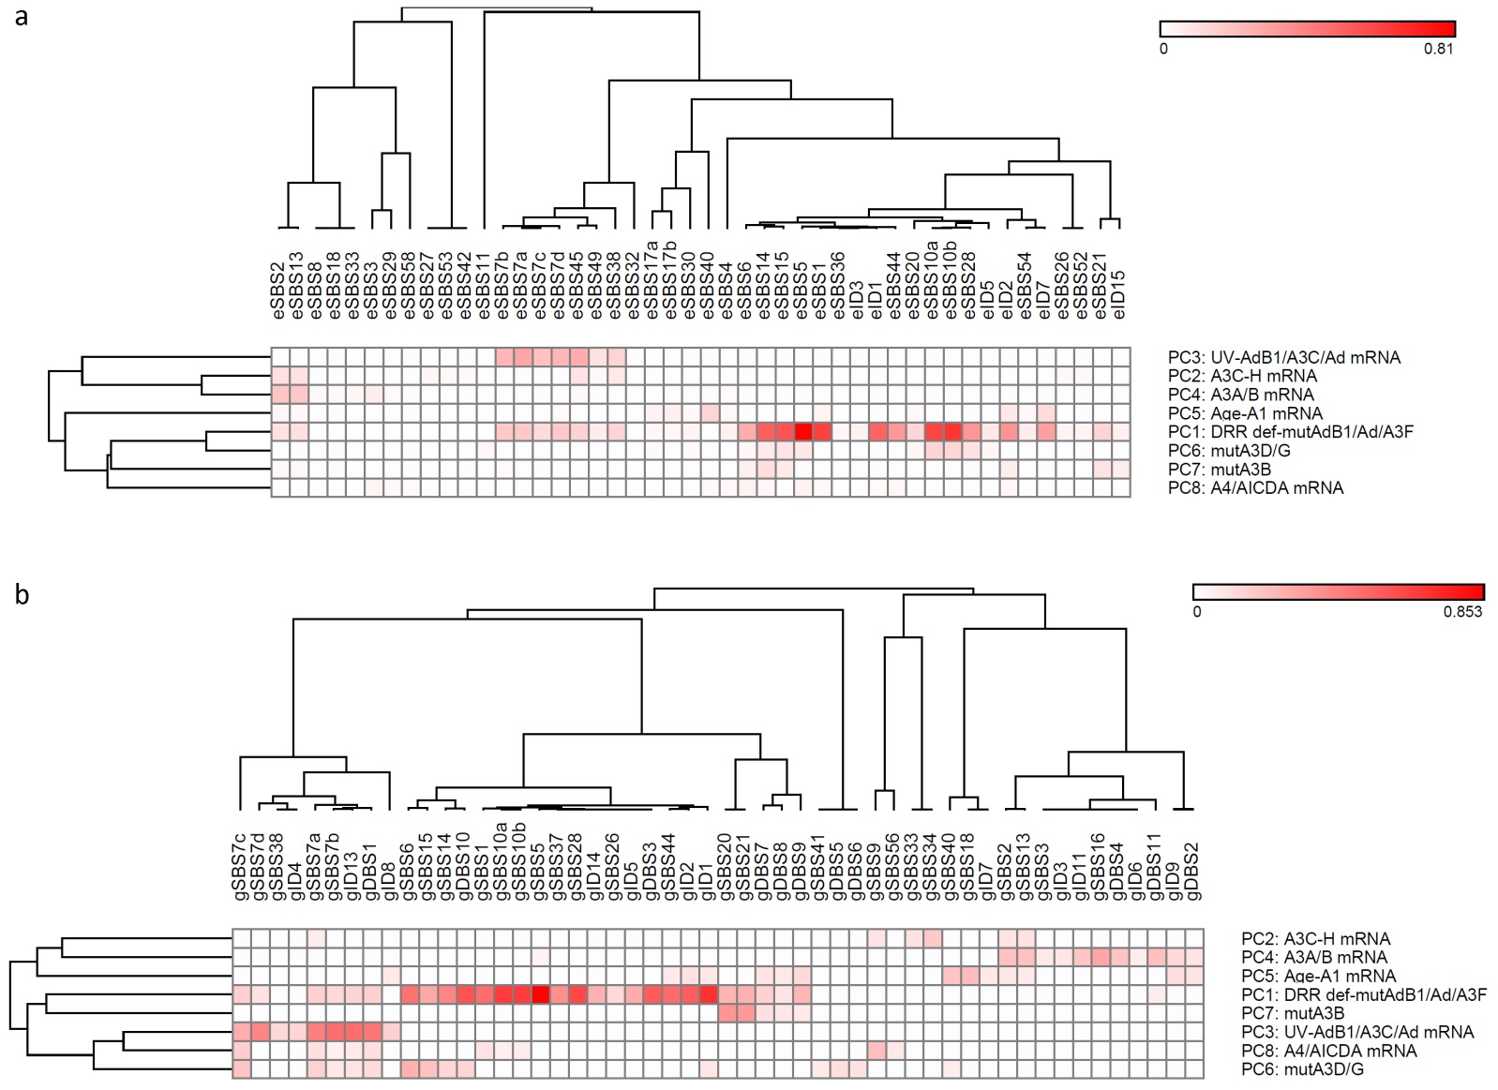
Supplementary Figure S1. Clustering analyses of the correlation (r coefficient) between pancancer signatures and principal components potentially contributing to positive impact on cancer mutagenesis. (a) Pancancer exome signatures. (b) Pancancer genome signatures. While the dominant components, including DRR defects, UV-ADARB1, and A3A/B mRNA levels (in genome analysis), generally shaped the clusters, the less prominent ones like age-A1 mRNA level, mutA3B, and mutA3D/G made small clusters or subclusters.
Abbreviations: A1, APOBEC1; A3, APOBEC3; Ad, ADAR; AdB1, ADARB1.

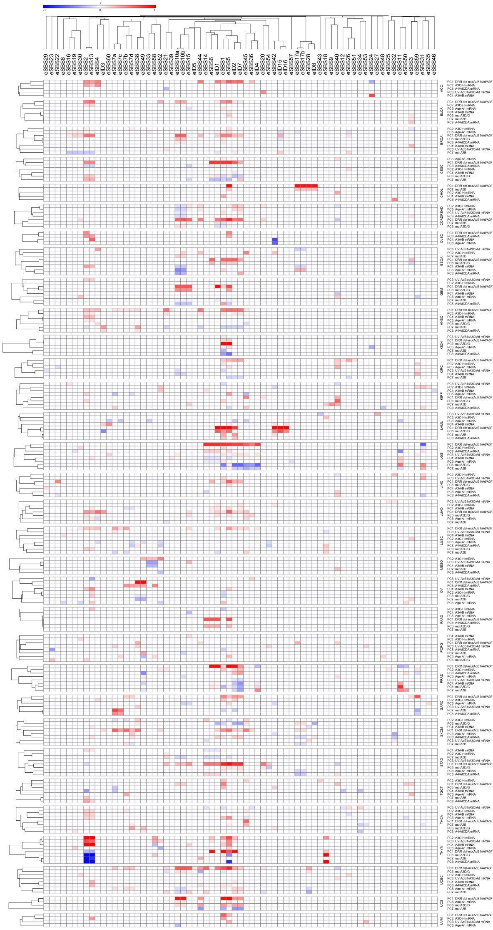
Supplementary Figure S2. Detailed correlation of the exome signatures with principal components (PCs) potentially implicated in cancer mutagenesis in individual cancers, as stratified by cancers and clustered using Pearson regression r coefficient.
Abbreviations: A1, APOBEC1; A3, APOBEC3; Ad, ADAR; AdB1, ADARB1.

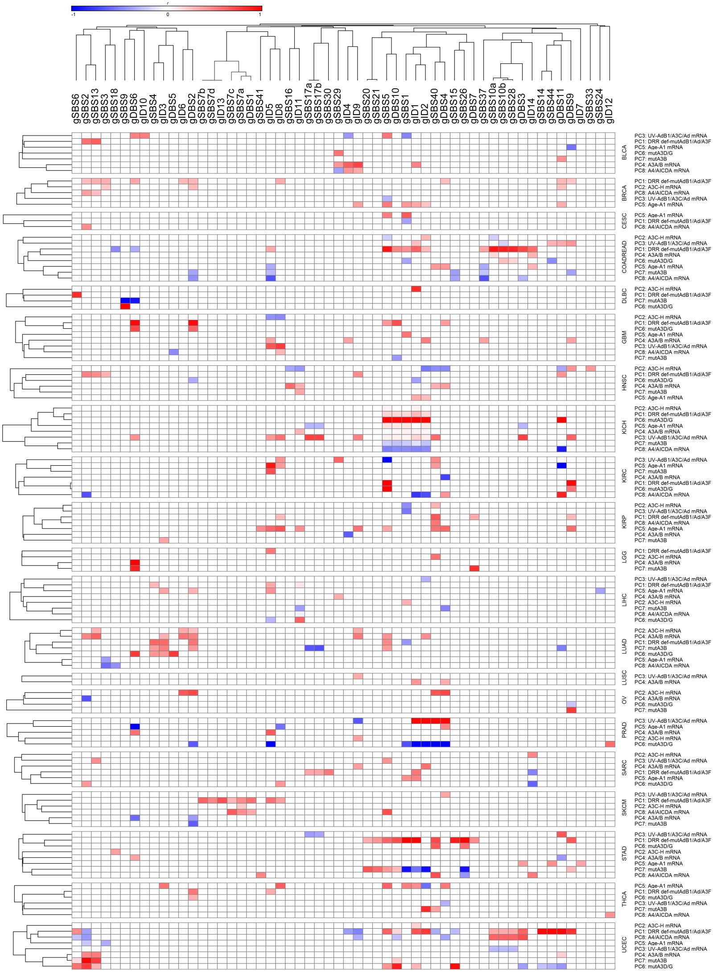
Supplementary Figure S3. Detailed correlation of the genome signatures with principal components (PCs) potentially implicated in cancer mutagenesis in individual cancers, as stratified by cancers and clustered using Pearson regression r coefficient.
Abbreviations: A1, APOBEC1; A3, APOBEC3; Ad, ADAR; AdB1, ADARB1.

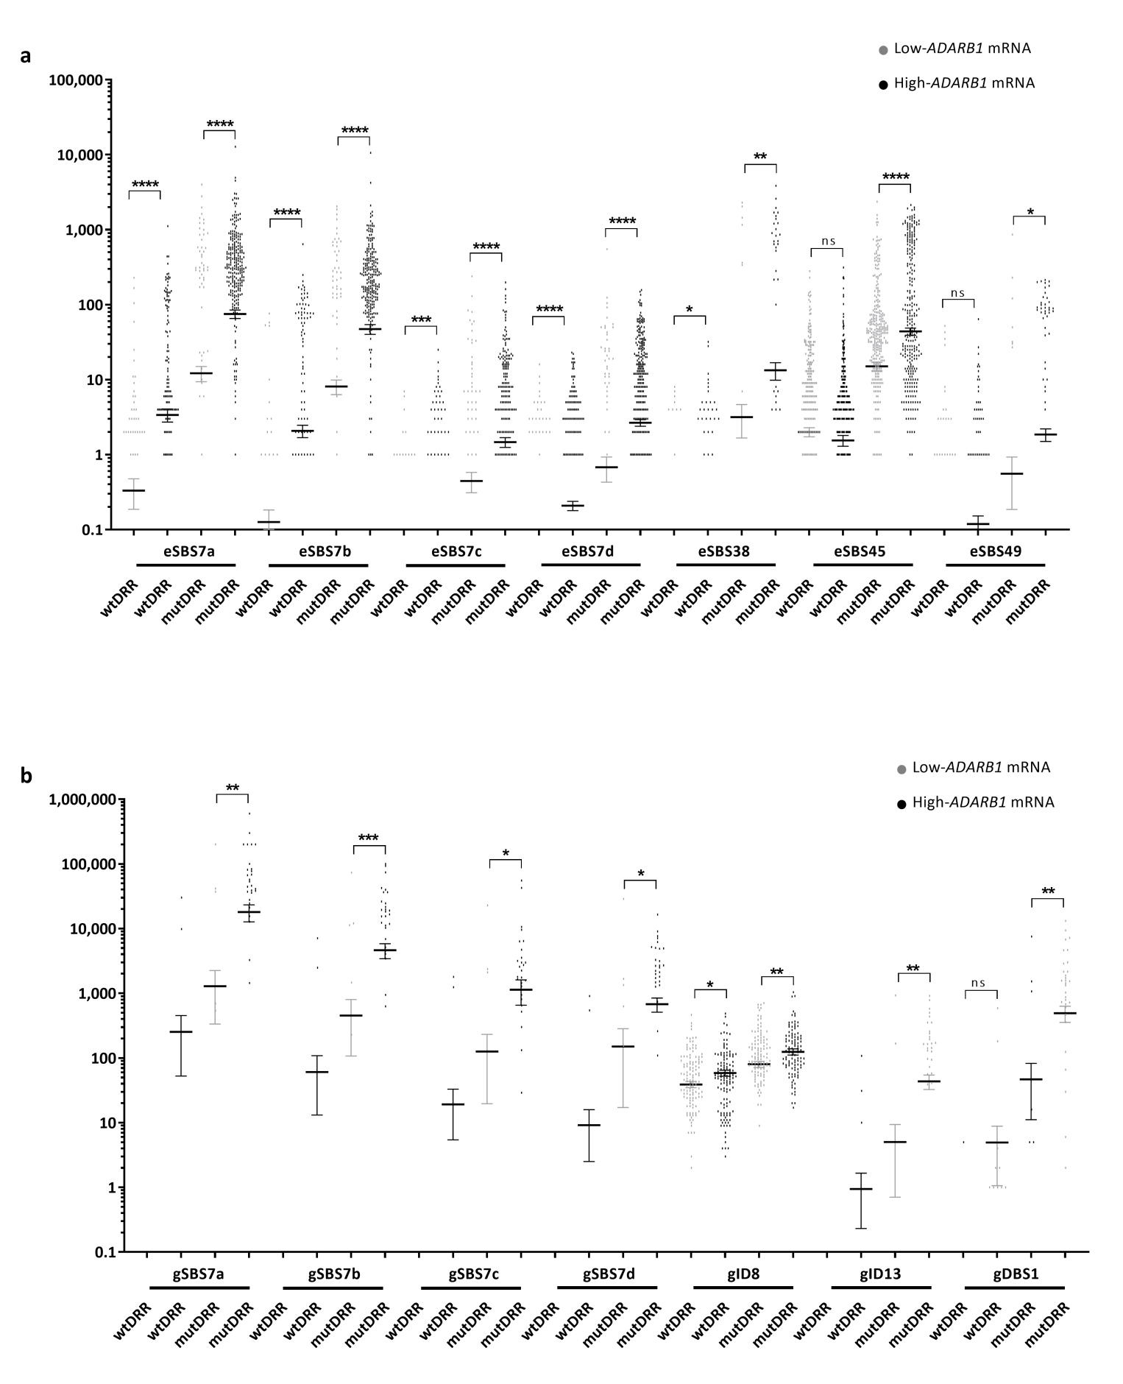
Supplementary Figure S4. The number of pancancer (a) exome and (b) genome mutational signatures correlated with ADBARB1 mRNA level, as classified by DRR mutational status. There were generally enough samples in the mutDRR class, allowing fair comparison between low- and high-ADARB1 mRNA level subclasses.
An unpaired two-tailed t-test with Welch's correction was used in order to test the statistical significance of low- vs. high-ADARB1 mRNA level subclasses. wt, wild type; mut, mutated.
ns, not significant; *, p < 0.05; **, p < 0.01; ***, p < 0.001; ****, p < 0.0001.
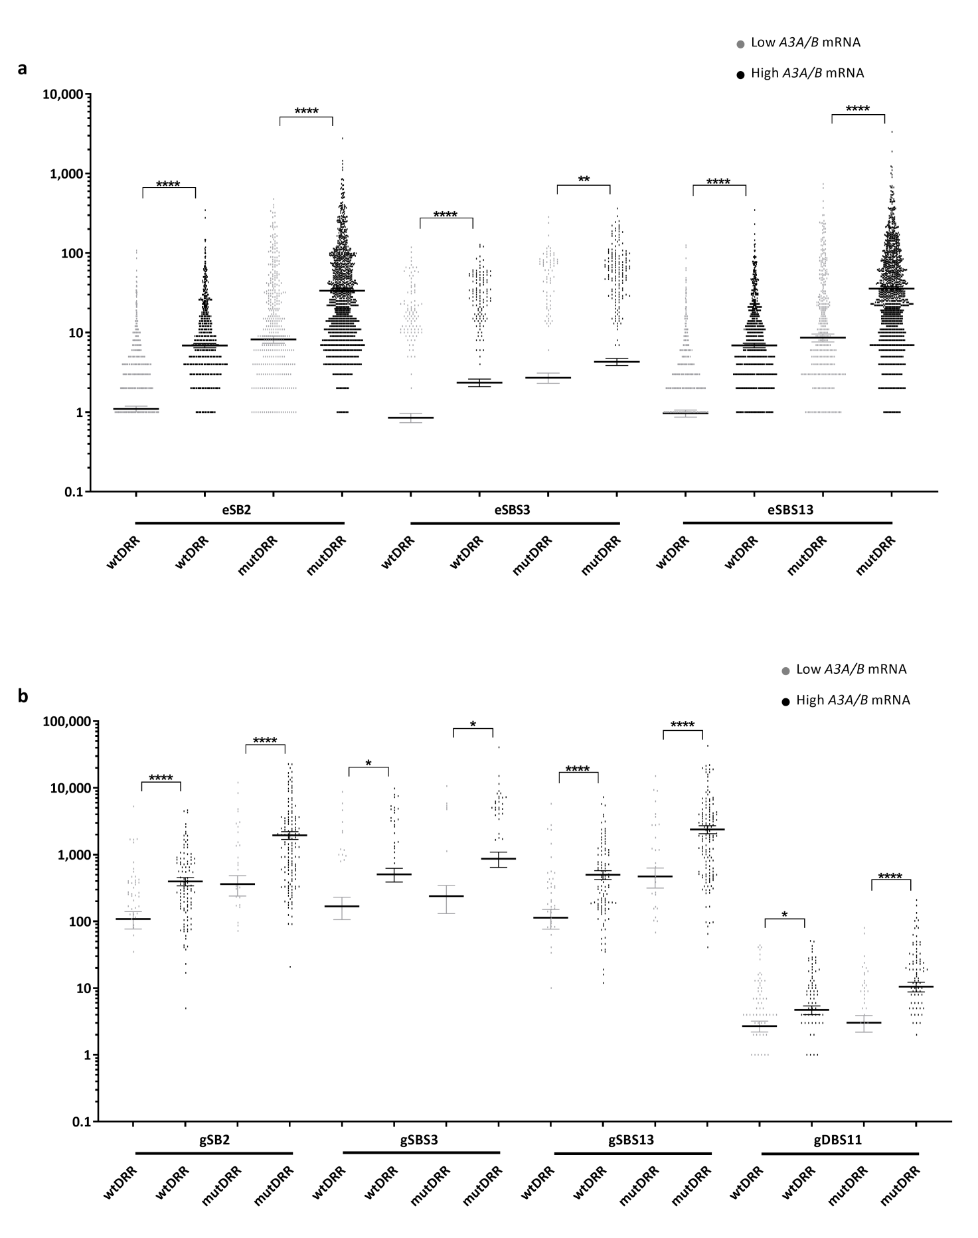
Supplementary Figure S5. The number of pancancer (a) exome and (b) genome mutational signatures correlated with A3A/B mRNA level, as classified by DRR mutational status. The number of all shown mutational signatures was significantly higher in the high-A3A/B mRNA level subclass across both wtDRR and mutDRR classes.
An unpaired two-tailed t-test with Welch's correction was used in order to test the statistical significance of low- vs. high-A3A/B mRNA level subclasses. wt, wild type; mut, mutated.
ns, not significant; *, p < 0.05; **, p < 0.01; ***, p < 0.001; ****, p < 0.0001.
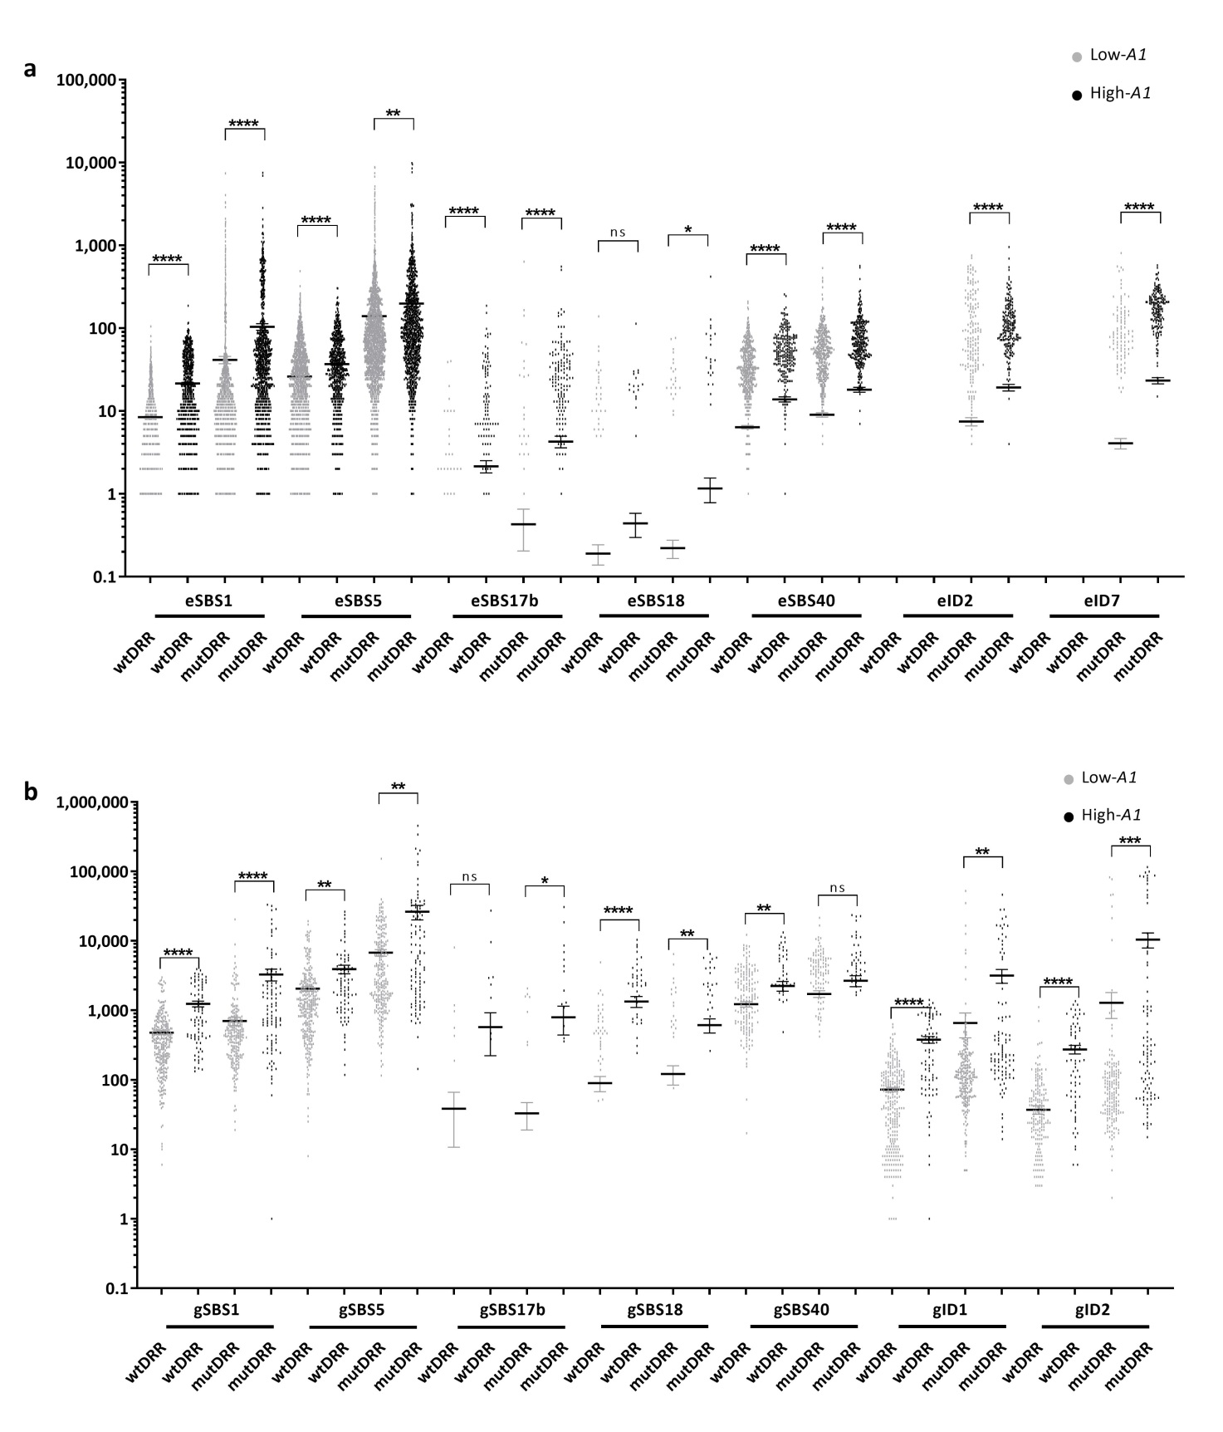
Supplementary Figure S6. The number of pancancer (a) exome and (b) genome mutational signatures correlated with the A1 mRNA level, as classified by DRR mutational status. The number of shown mutational signatures was significantly higher in the high-A1 mRNA level subclass across most wtDRR and mutDRR classes.
An unpaired two-tailed t-test with Welch's correction was used in order to test the statistical significance of low- vs. high-A1 mRNA level subclasses. wt, wild type; mut, mutated.
ns, not significant; *, p < 0.05; **, p < 0.01; ***, p < 0.001; ****, p < 0.0001.
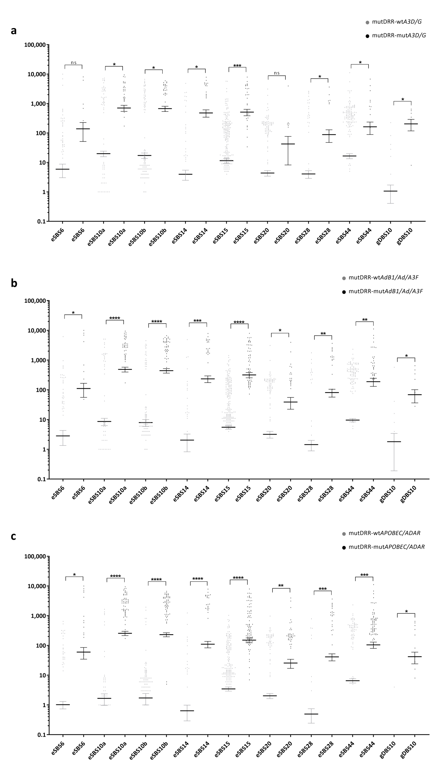
Supplementary Figure S7. The number of pancancer exome and genome mutational signatures correlated with (a) mutA3D/G, (b) mutA3F/ADARB1/ADAR, and (c) mutAPOBEC/ADAR, all in the mutant DRR class. While most mutational signatures showed significantly discrepant when the mutational status of A3D/G was used for further classification, all mutational signatures showed significantly higher in the mutA3F/ADARB1/ADAR and mutAPOBEC/ADAR subclasses.
An unpaired two-tailed t-test with Welch's correction was used in order to test the statistical significance of wild-type (wt) vs. mutated (mut) subclasses.
ns, not significant; *, p < 0.05; **, p < 0.01; ***, p < 0.001; ****, p < 0.0001.

