Supplementary Material
FIGURE S1
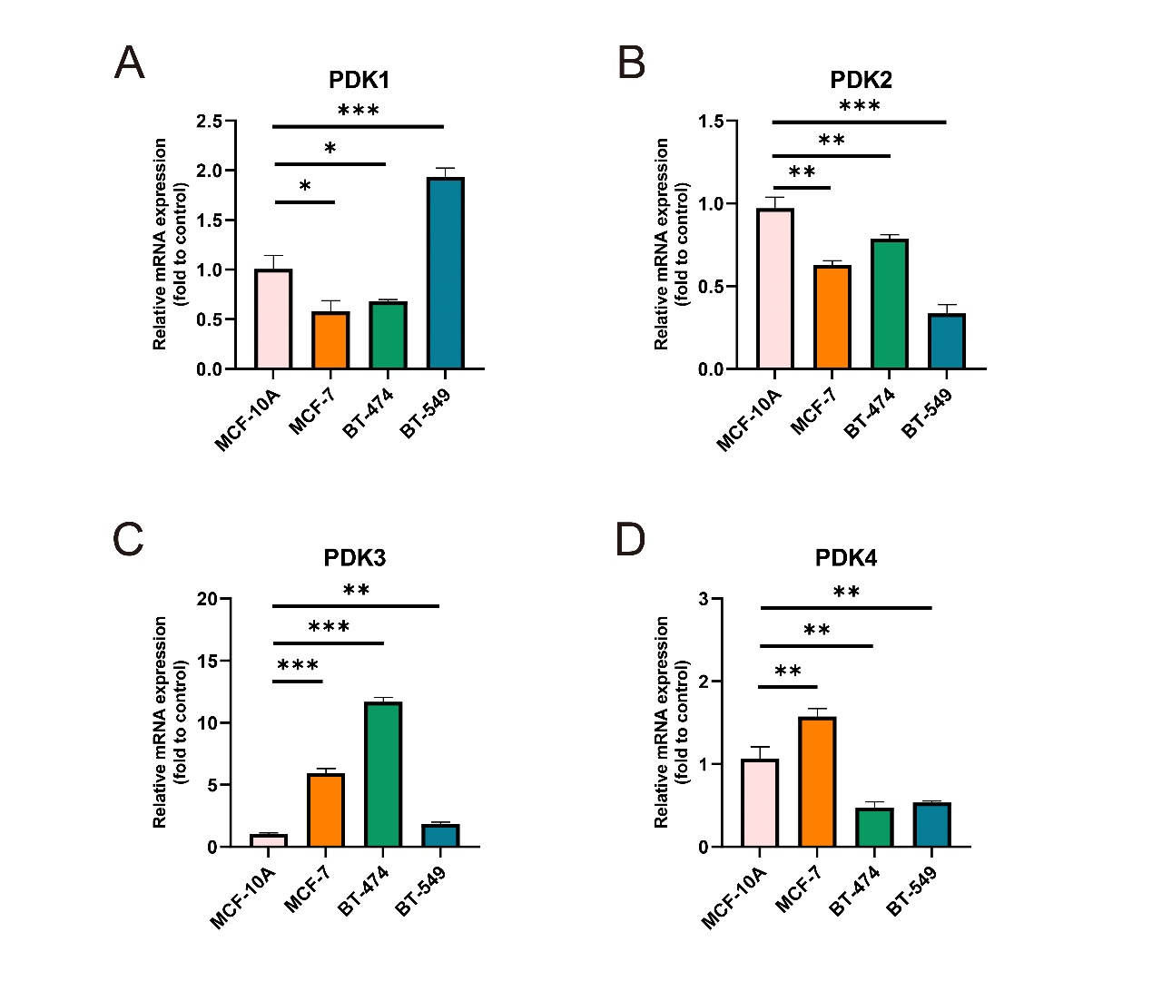

FIGURE S2
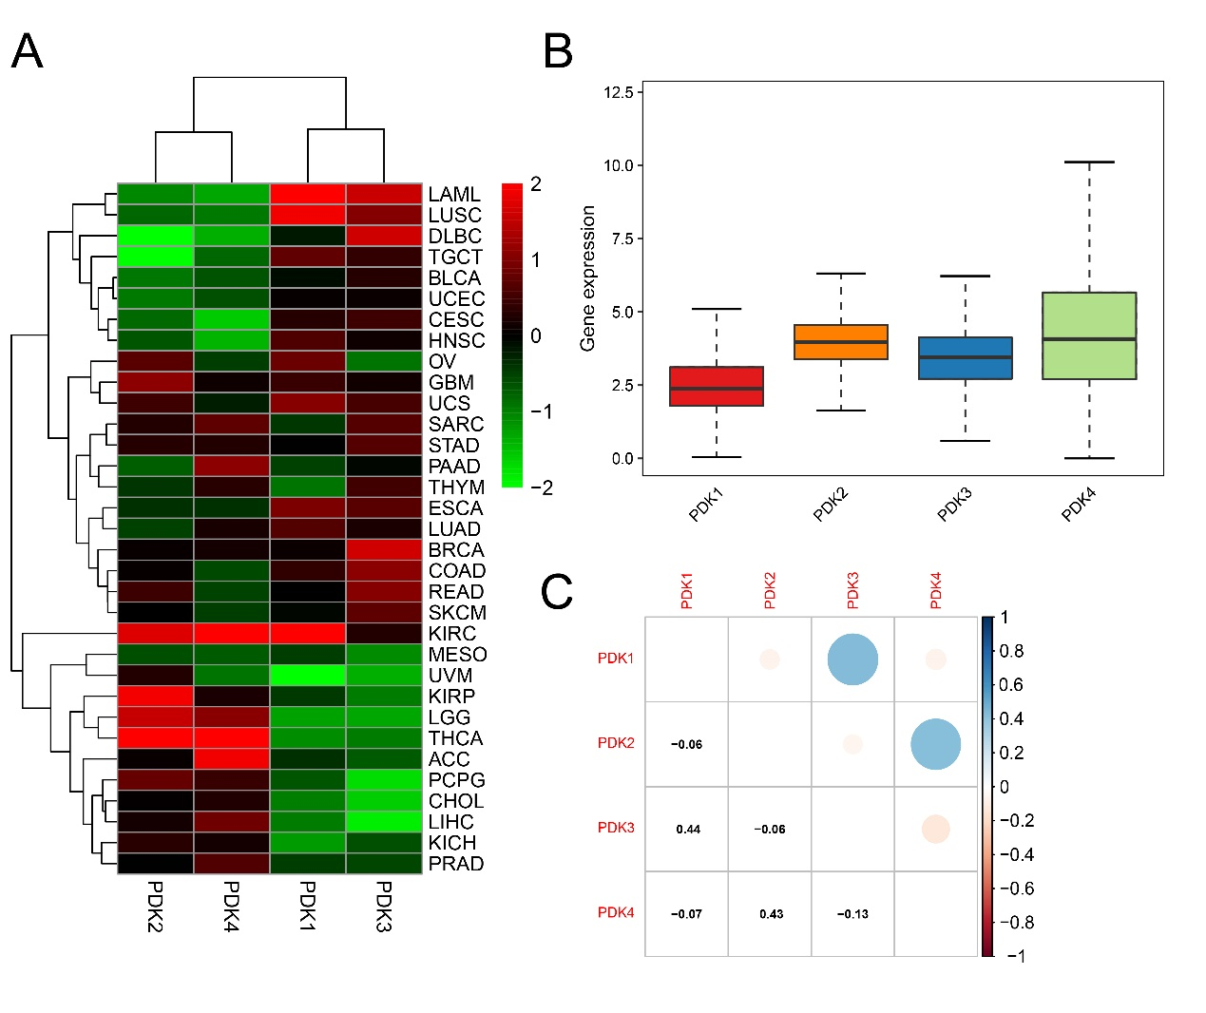

FIGURE S3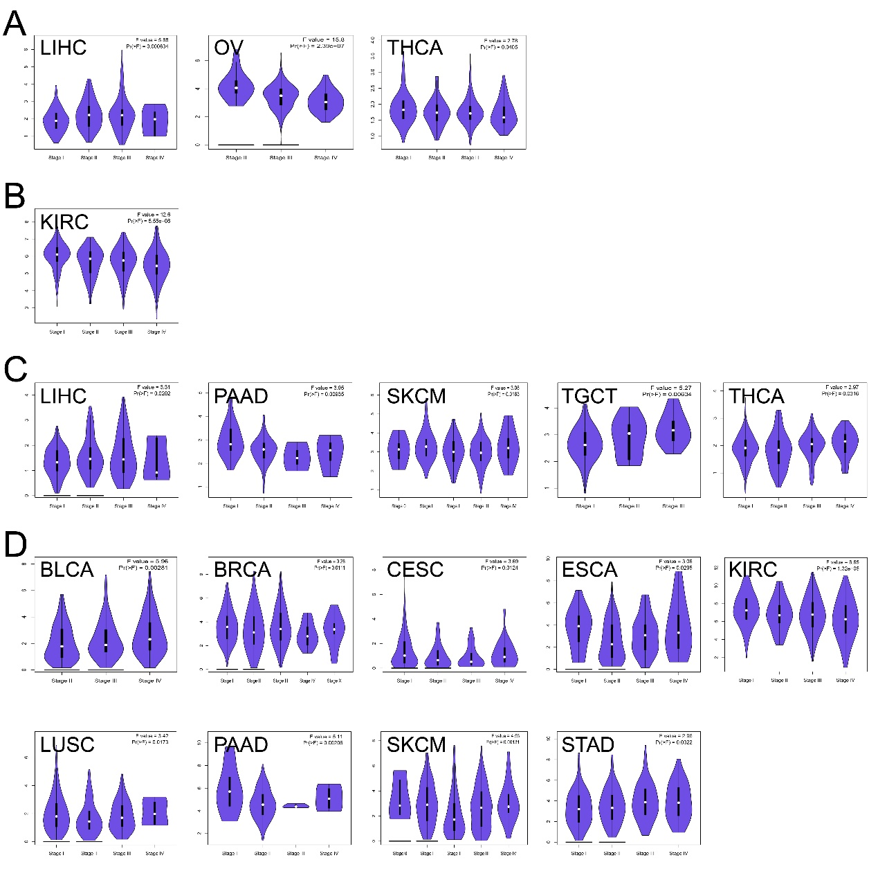

FIGURE S4
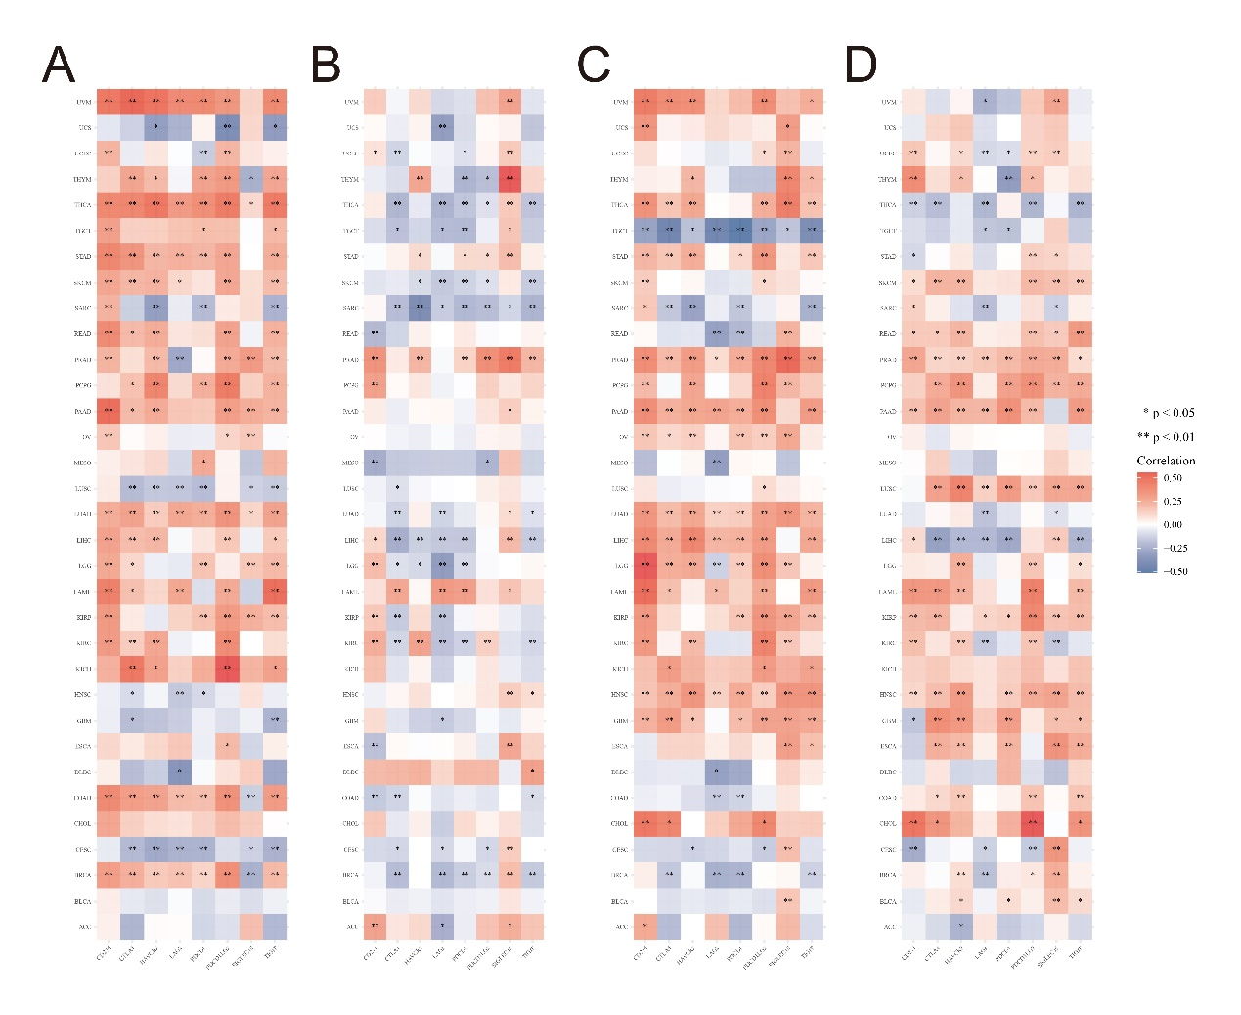

FIGURE S5
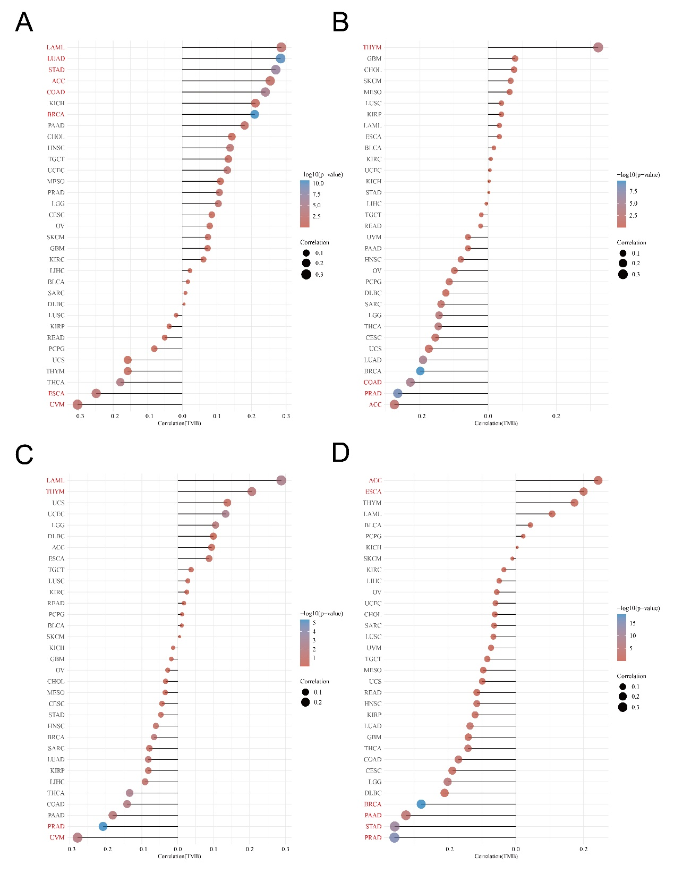

FIGURE S6
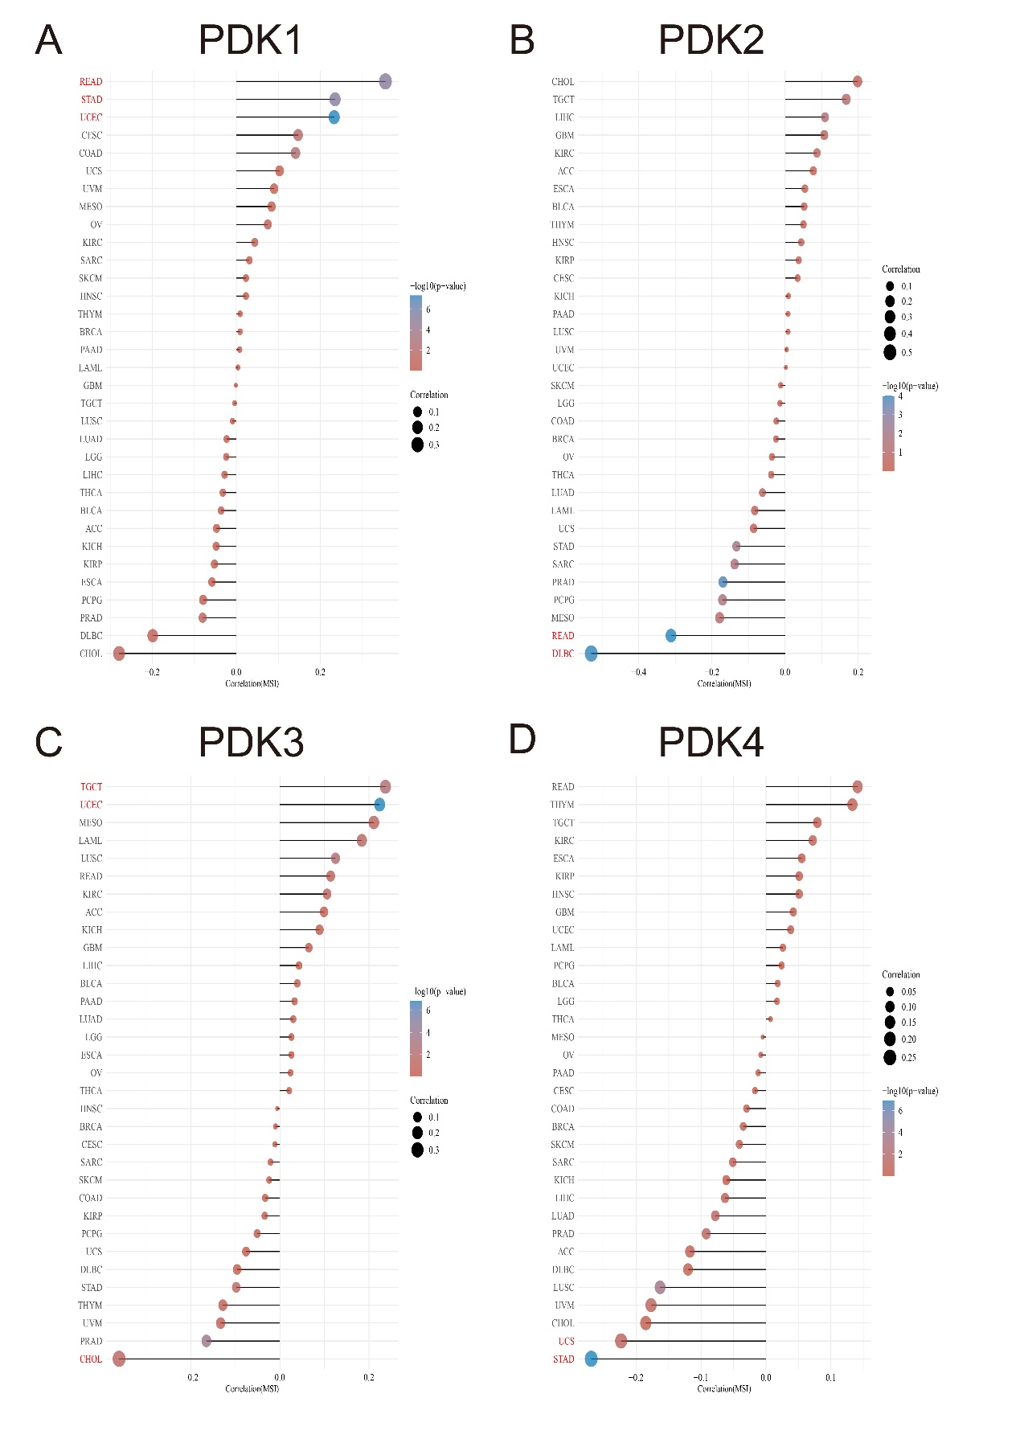

FIGURE S1
PDKs mRNA expression levels in breast cancer cell lines and human normal mammary epithelial cell quantified by real-time PCR. (A) PDK1, (B) PDK2, (C) PDK3, (D) PDK4. The experiments were repeated three times. *p < 0.05, **p < 0.01, ***p < 0.001.
FIGURE S2
PDKs differential expression in pan cancer and correlation analysis between PDKs expression. (A) The heatmap of PDKs differential expression in pan cancer. (B) Boxplot of PDKs expression in 33 TCGA cancer samples. (C) The correlation analysis of PDKs expression. The blue and red dots indicate that PDKs expression level had a negative and positive correlation, respectively.
FIGURE S3
Stage-dependent expression level of PDKs in different cancers. Main pathological stages of these cancers were assessed and compared using TCGA data. The log2(TPM + 1) for log-scale was used.
FIGURE S4
The correlation analysis between main immune checkpoint members and expression of (A) PDK1, (B) PDK2, (C) PDK3, (D) PDK4. *p < 0.05, **p < 0.01.
FIGURE S5
The relationship between TMB and expression of (A) PDK1, (B) PDK2, (C) PDK3, (D) PDK4 in different malignances.
FIGURE S6
The relationship between MSI and expression of (A) PDK1, (B) PDK2, (C) PDK3, (D) PDK4 in different cancers.

