Supplementary Figures and Tables
Blood and urine multi-omics analysis of the impact of e-vaping, smoking, and cessation – From exposome to molecular responses
Carine Poussin¹, Bjoern Titz¹, Yang Xiang^{1*}, Laurel Baglia^{2#}, Rachel Berg^{2#}, David Bornand^{1#}, Mohammed-Amin Choukrallah^{1#}, Timothy Curran^{2#}, Sophie Dijon^{1#}, Eric Dossin^{1#}, Remi Dulize^{1#}, Doris Etter^{1#}, Maria Fatarova^{1#}, Loyse Felber Medlin^{1#}, Adrian Haiduc^{1#}, Edina Kishazi^{1#}, Aditya R. Kolli^{1#}, Thanos Kondylis^{1#}, Emmanuel Kottelat^{1#}, Csaba Laszlo^{1#}, Oksana Lavrynenko^{1#}, Yvan Eb-Levadoux^{1#}, Catherine Nury^{1#}, Dariusz Peric^{1#}, Melissa Rizza^{1#}, Thomas Schneider^{1#}, Emmanuel Guedj¹, Florian Calvino¹, Nicolas Sierro¹, Philippe Guy^{1*}, Nikolai V. Ivanov^{1*}, Patrick Picavet¹, Sherry Spinelli², Julia Hoeng¹, Manuel C. Peitsch¹

¹PMI R&D, Philip Morris Products S.A., Quai Jeanrenaud 5, CH-2000 Neuchâtel, Switzerland
²University of Rochester Medical Center, Rochester, NY, USA

#By alphabetical order
*Corresponding authors:
Dr. Yang Xiang
Tel: +41 (58) 242 2277
Email: yang.xiang@pmi.com
Dr. Philippe Guy
Tel : +41 (58) 242 2622
Email: philippalexandre.guy@pmi.com
Dr. Nikolai V. Ivanov
Tel : +41 (79) 730 5690
Email: nikolai.ivanov@unine.ch

Supplementary Figures

Supplementary Figure 1. Plots of study subject demographics. (A) Scatterplot of study subject demographics stratified by sex and group: Subjects’ age (x-axis) and body mass index (y-axis, log₂ scale) are visualized on a scatterplot stratified by sex and group (CS, EV, FS, and NS). Colored lines correspond to the regression lines between age and BMI variables for each group. (B) Barplot of study subjects’ age (y-axis, years) stratified by sex (x-axis) and group (x-axis). Abbreviations: BMI, body mass index; CS, cigarette smokers; EV, e-vapor users; FS, former smokers; NS, never smokers.
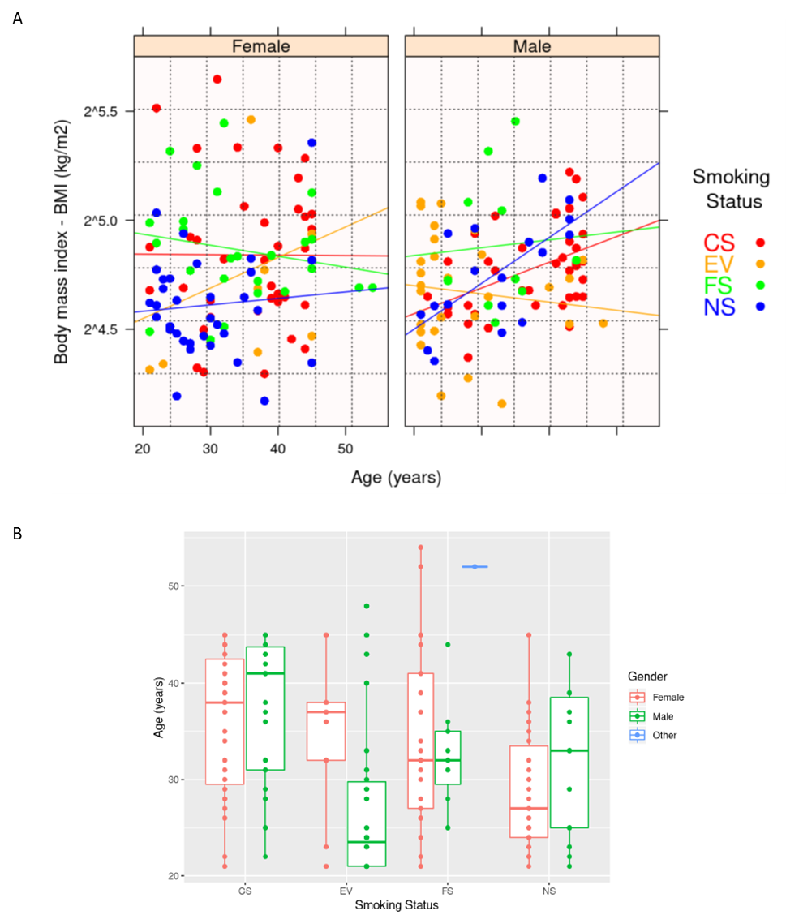

Supplementary Figure 2. Schematic description of sample processing workflow from collection to storage. After obtaining subject’s consent, blood and urine were collected in specific tubes depending on downstream processing and analysis. The diagram describes the different steps needed to obtain isolated blood cells and biofluids or fractions for further investigations. Abbreviations: WB, whole blood; S, serum; U, urine; WBM, whole blood methylation; E-WB, EDTA-whole blood; C-WB, sodium citrate-whole blood; E- or C-PRP-1/2, EDTA- or sodium citrate-platelet rich plasma-1/2; E- or C-PPP-1/2, EDTA- or sodium citrate-platelet poor plasma-1/2; E- or C-pellets, EDTA- or sodium citrate pellets; MPDP, microparticle and microparticle-depleted plasma; PMI, Philip Morris International; URMC, University of Rochester Medical Center.
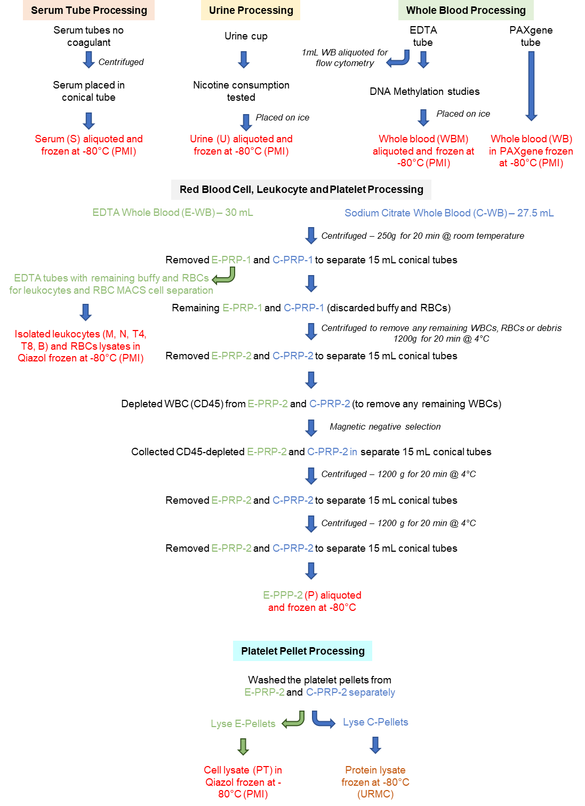

Supplementary Figure 3. Cumulative distribution for determining high and low concentration cutoffs for NNAL and CEMA. The cumulative distributions of urine NNAL (A) and CEMA (B) concentrations were generated, and NNAL and CEMA concentration cutoffs corresponding to the 100th percentile of NS distributions were determined as ln(40) and ln(25), respectively. NNAL and CEMA were quantified as pg per mg of creatinine and ng per mg of creatinine, respectively. To enhance understanding and insights, data points are shown using specific colors discriminating subjects within CS (red), EV (yellow), FS (green), and NS (blue) groups with low and high levels of NNAL and CEMA (e.g., for CS: pink color if subject has CEMA and NNAL below cutoffs, red color otherwise) using the cutoff values. Abbreviations: CDF, cumulative distribution function; CEMA, 2-cyanoethylmercapturic acid; NNAL, 4-(methylnitrosamino)-1-(3-pyridyl)-1-butanol.

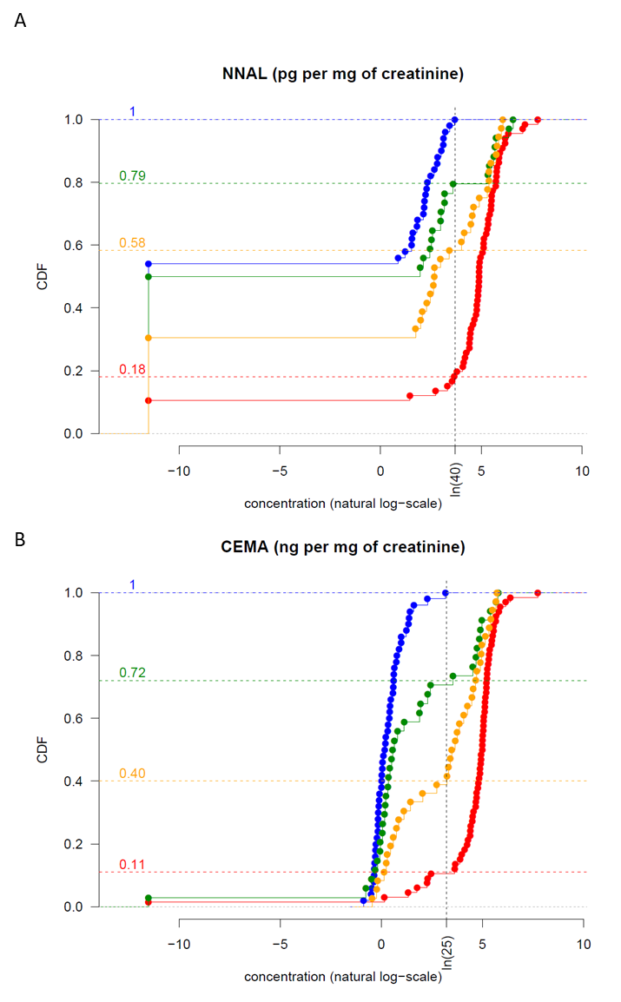

Supplementary Figure 4. BoE concentration boxplots stratified by low and high levels of NNAL and CEMA. Each data point on the boxplots correspond to a subject. The blue triangle indicates the mean of values within a box. Group subjects having with levels of NNAL and CEMA above and below cutoffs are stratified and labeled “hi” and “lo,” respectively. Abbreviations: BoE, biomarker of exposure; hi/lo, high/low; CS, cigarette smokers; EV, e-vapor users; FS, former smokers; NS, never smokers, NICOT, nicotine; COT, cotinine; 3OHCOT, 3-OH cotinine; CO, carbon monoxide; MHBMA, N-acetyl-[S-(2-hydroxymethyl)-3-propenyl)-L-cysteine; HPMA, N-acetyl-S-(3-hydroxypropyl)-L-cysteine; CEMA, N-acetyl-S-(2-cyanoethyl)-L-cysteine; HEMA, N-acetyl-S-(2-hydroxyethyl)-L-cysteine; HMPMA, N-acetyl-S-(3-hydroxypropyl-1-methyl)-L-cysteine; SPMA, N-acetyl-S-(phenyl)-L-cysteine; NNAL, 4-(methylnitrosamino)-1-(3-pyridyl)-1-butanol; MDA, malondialdehyde.

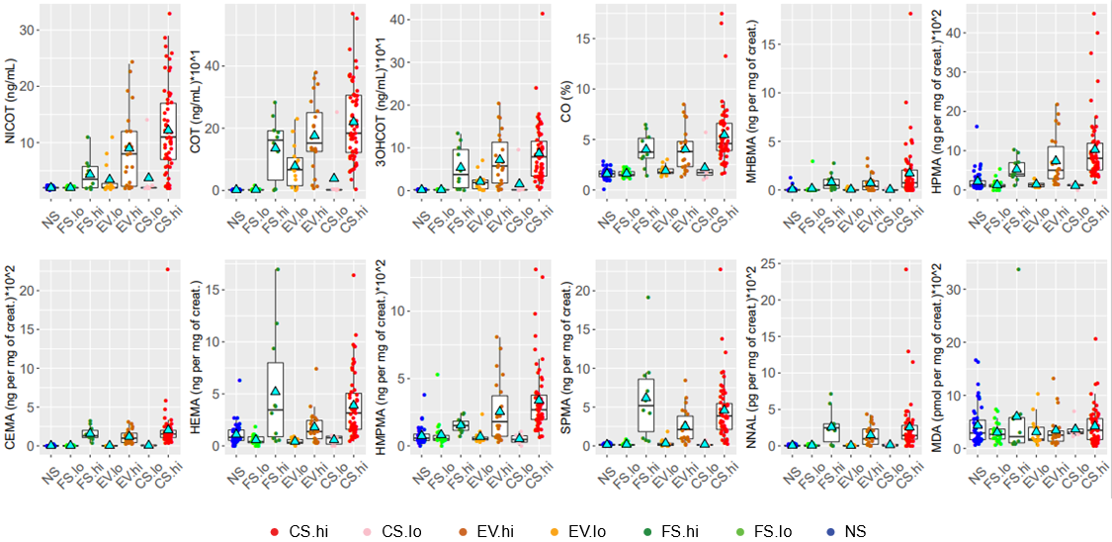

Supplementary Figure 5. Multivariate analysis for characterizing nicotine and nicotine-derived metabolites patterns associated with CS, EV, FS, and NS subjects. (A) Principal component analysis of nicotine and its metabolites: bar graph showing the contribution of each principal component to the overall variance (left) and loadings plot (right). (B) Scatterplot of scores showing the positioning of subjects in the first two principal component subspaces. Abbreviations: CS, cigarette smokers; EV, e-vapor users; FS, former smokers; NS, never smokers; Dim, dimension.
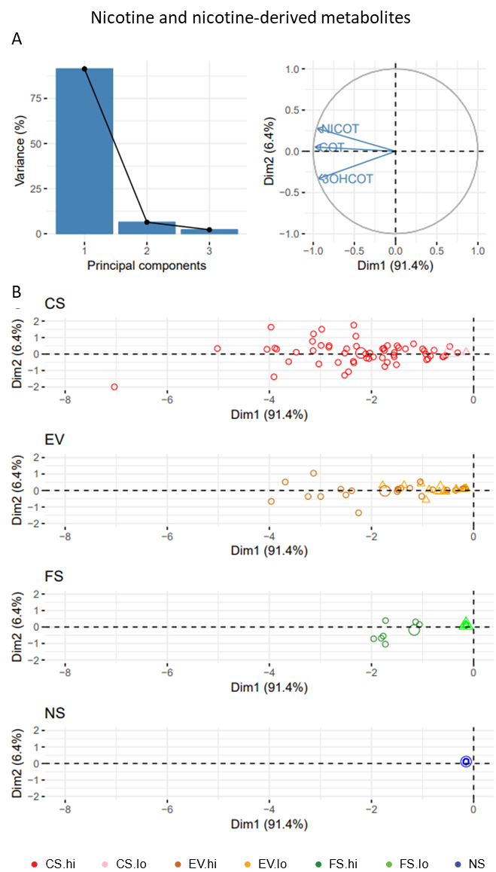

Supplementary Figure 6. Correlation of white blood cell counts and hemoglobin A1C with combustion marker PC1 scores. Linear fit (blue line) with 95%ile confidence bounds (grey area). BoPH, biomarker of potential harm; PC, principal component.

Supplementary Figure 7. Biomarker of potential harm boxplots stratified by low and high levels of NNAL and CEMA. Each data point on the boxplots correspond to a subject. The blue triangle indicates the mean of values within a box. Group subjects having with levels of NNAL and CEMA above and below cutoffs are stratified and labeled “hi” and “lo,” respectively. Abbreviations: hi/lo, high/low; CS, cigarette smokers; EV, e-vapor users; FS, former smokers; NS, never smokers; CEMA, N-acetyl-S-(2-cyanoethyl)-L-cysteine; NNAL, 4-(methylnitrosamino)-1-(3-pyridyl)-1-butanol.

Supplementary Figure 8. Complete blood cell counts boxplots stratified by low and high levels of NNAL and CEMA. Each data point on the boxplots corresponds to a subject. The blue triangle indicates the mean of values within a box. Group subjects with levels of NNAL and CEMA above and below cutoffs are stratified and labeled “hi” and “lo,” respectively. Abbreviations: hi/lo, high/low; CS, cigarette smokers; EV, e-vapor users; FS, former smokers; NS, never smokers.

Supplementary Figure 9. Heatmap of BoE abundance. The heatmap of BoE abundance (NS mean centering in log2 scale) is made available for magnification as part of Figure 1E. Abbreviations: BoE, biomarker of exposure; CS, cigarette smokers; EV, e-vapor users; FS, former smokers; NS, never smokers; PC, principal component; hi, high; lo, low; Dim, dimension.
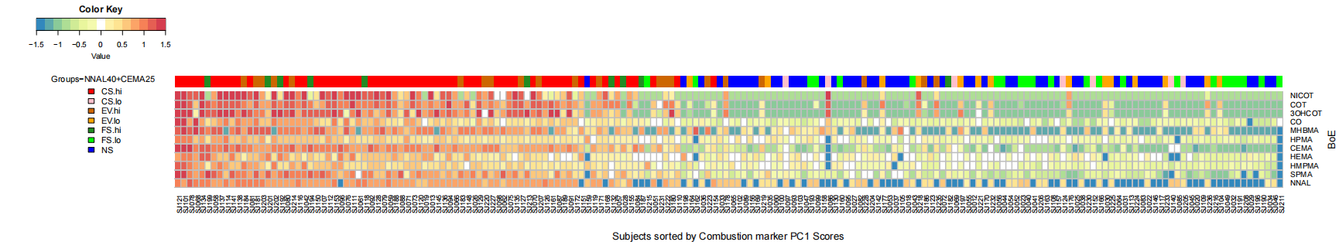

Supplementary Figure 10. Identification of potential novel biomarkers of exposure and deeper subjects’ exposome investigations in urine untargeted metabolomics. See description in the caption of Figure 2. Abbreviations: CS, cigarette smokers; EV, e-vapor users; FS, former smokers; NS, never smokers.

Supplementary Figure 11. Quantification value distributions for THC-/cannabinoid-related metabolites in plasma. Detection of delta-9-trans-THC for each subject is color coded (see color key). “Threshold high” corresponds to the general approach taken for the detection of drugs and their metabolites in this manuscript (i.e., intensity ratios above the 95th percentiles of the overall data distribution). “Threshold low” is more sensitive, so the interquartile-range approach for outlier detection was used: subjects with delta-9-trans-THC quantities above 1.5 x interquartile range + quartile 3 were flagged – in this case, corresponding to all subjects with actually quantified delta-9-trans-THC levels. Note that these subjects’ exposure to THC compounds is also supported by the other quantified metabolites. Abbreviations: CS, cigarette smokers; EV, e-vapor users; FS, former smokers; NS, never smokers.

Supplementary Figure 12. Volcano plots and heatmaps for omics data. For each omics data modality, six SRPs were computed by comparing all groups pairwise, and the results are visualized on volcano plots. The x- and y-axes represent the amplitude (log2 fold change) and statistical significance (-log10 of FDR) of change, respectively. Yellow and blue data points correspond respectively to differentially up- and down-regulated molecular entities for which log2 fold change is considered to be significant (FDR < 0.05). Heatmaps of differentially up-and down-regulated molecular entities (or hyper- and hypo-methylated CpGs) display log2 fold change for all six contrasts (Only the top 50 were displayed in the heatmaps when the number of differentially expressed or abundant molecular entities exceeded this limit). In principle, volcano plots and heatmap are available sequentially in the document for each omics data modality except for RBC (only volcano plots are available because of no DEG). Abbreviations: CS, cigarette smokers; EV, e-vapor users; FS, former smokers; NS, never smokers; FDR, false discovery rate; FC, fold change; GEX, gene expression; LIP-LM, lipidomics; PROT, proteomics; MET, metabolomics; MEY, methylation; WB, whole blood; M, monocyte; N, neutrophil; T4/T8/B, lymphocyte T4/T8/B; PT, platelet; RBC, red blood cells; P, plasma; U, urine; DMCs, differentially methylated CpGs.

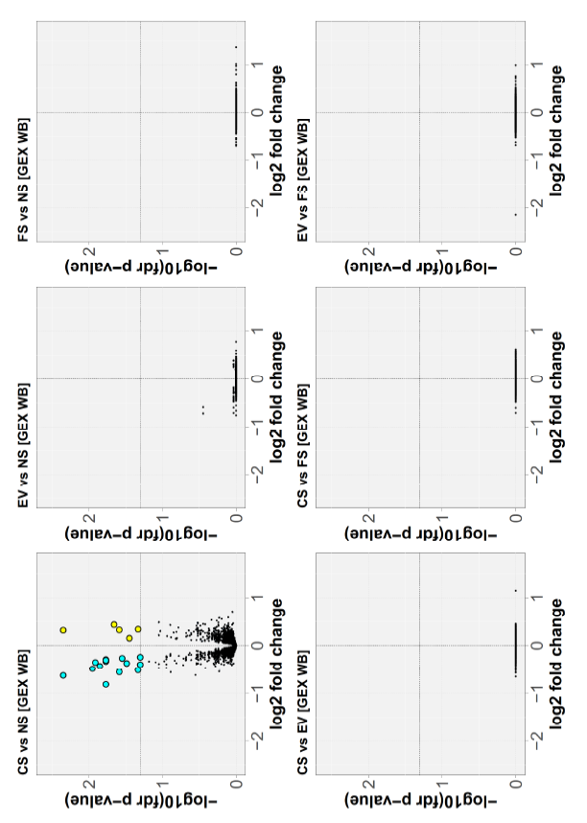
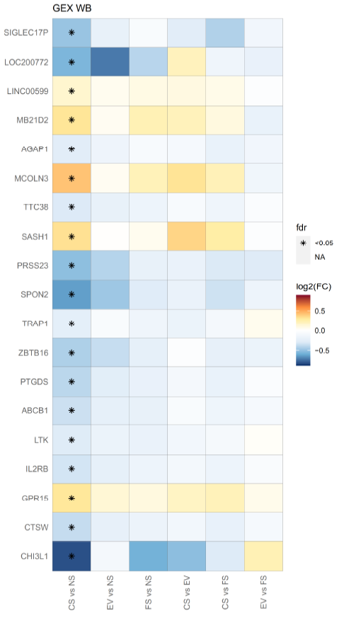
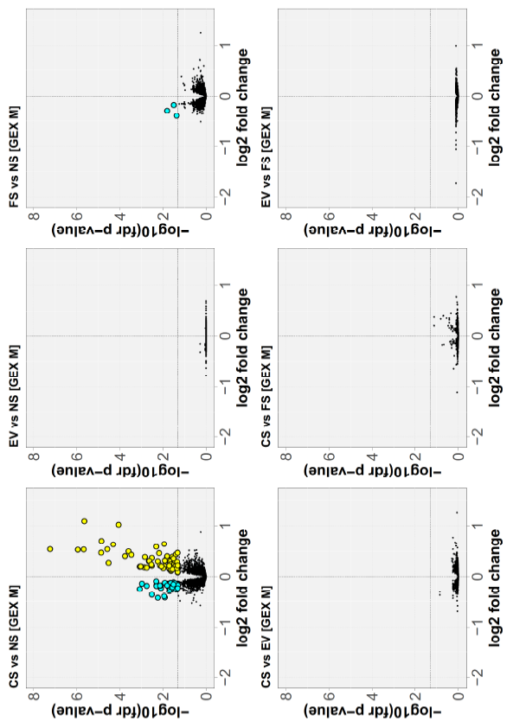

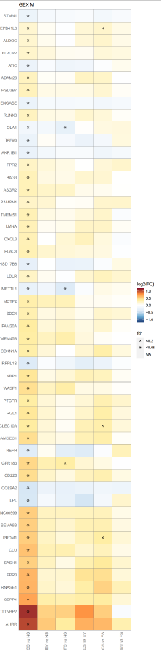

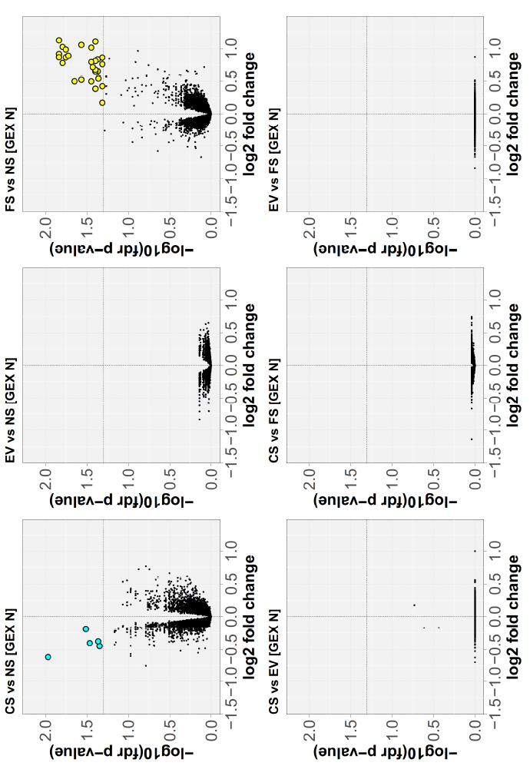
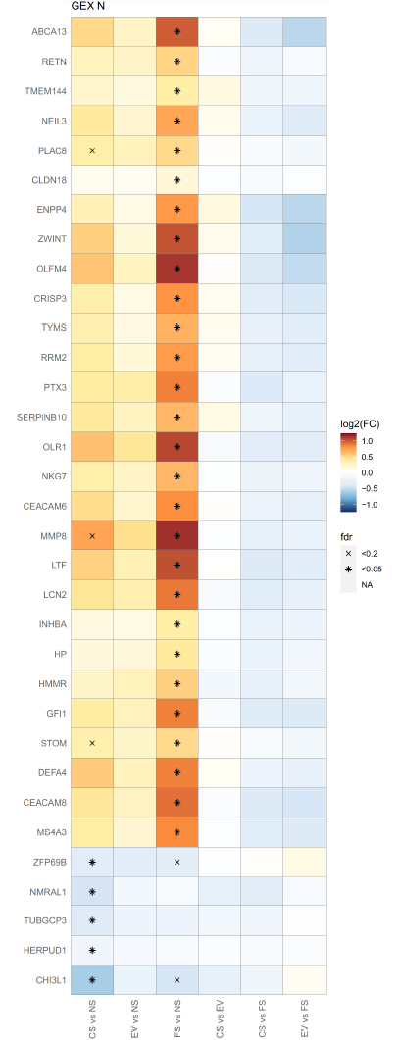

Supplementary Figure 13. Heatmap of probabilities and binary classification. The heatmaps visualize (A) sample probability of being CS made available for magnification as part of Figure 4D and (B) sample classification as CS (1) and NS (0) when binarizing matrix of probability of being CS using a probability cutoff of 0.5. Abbreviations: CS, cigarette smokers; NS, never smokers.
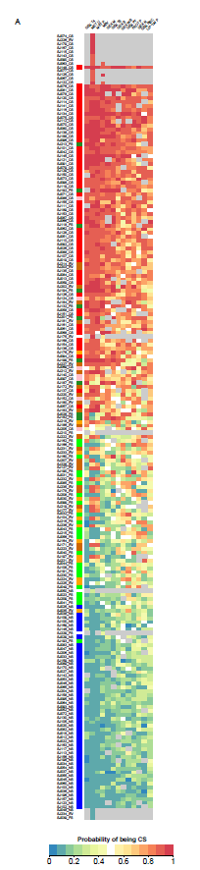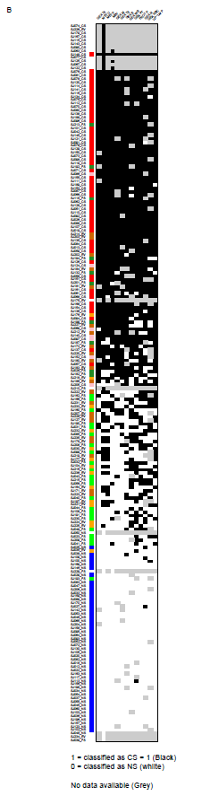

Supplementary Figure 14. Variable importance scores for the multi-omics prediction model.

Supplementary Figure 15. Heatmap of smoking signature core genes in whole blood and isolated blood cells. The heatmap displays expression fold change (in log2) of core genes found to overlap with previously reported blood smoking gene signatures. Data range truncated at -1 / +1 for color scale. Abbreviations: FDR, false discovery rate; FC, fold change. Genes overlapping with former published blood gene signatures from Belcastro et al. (SBV, [29]), Martin et al. (PMI11, [31]) and Huan et al. (HuanTop25, [30]). Abbreviations: CS, cigarette smokers; EV, e-vapor users; FS, former smokers; NS, never smokers; WB, whole blood; M, monocyte; N, neutrophil; T4/T8/B, lymphocyte T4/T8/B; PT, platelet; RBC, red blood cells; Pub, publications; FDR, false discovery rate; FC, fold-change.

Supplementary Tables

Supplementary Table 1. Summary of inclusion and exclusion criteria of study subjects.
INCLUSION
Age | 21-45 (extended to 55) years old
Weight | At least 110 lbs. (49.9 kg)
Group | CS | EV | FS | NS
Group | - Currently smoking ≥10 cigarettes/day for ≥3 years | - Used E-cigs ≥ 6 months | - Previously smoked ≥10 cigarettes/day for ≥3 years | - Never smoked
Group | - No other product use | - Previously smoked ≥10 cigarettes/day for ≥3 years | - Quit smoking for ≥2 years | - No other product use
Group |  | - Quit smoking for ≥6 months | - No other product use
Group |  | - No other product use
EXCLUSION
General | Pregnancy
Drugs | - Aspirin, ibuprofen, or a steroid medication within the last 10 days
 | - Any medication in the last 30 days
Health status | - Acute illness (e.g., viral infection)
 | - Pathologies which interfere with the scope of the study (listed in the study protocol)

Supplementary Table 2. Tobacco cigarette brand and usage by cigarette smokers
SubjectID | Brand | Cigarettes per day | Number of years | Pack years
PID070 | Camel Platinum | 17 | 7 | 5.95
PID073 | Seneca | 10 | 9 | 4.5
PID117 | Marlboro | 10 | 9 | 4.5
PID146 | Seneca | 15 | 26 | 19.5
PID115 | Marlboro and Seneca | 10 | 10 | 5
PID194 | Seneca | 10 | 7 | 3.5
PID080 | Marlboro | 10 | 20 | 10
PID081 | Eagle 20 or hand rolled | 20 | 4 | 4
PID011 | Marlboro Lite | 10 | 20 | 10
PID076 | Seneca | 15 | 20 | 15
PID179 | Seneca | 15 | 14 | 10.5
PID135 | Marlboro and hand rolled | 10 | 20 | 10
PID063 | Marlboro | 10 | 20 | 10
PID049 | Marlboro | 20 | 35 | 35
PID024 | Marlboro Lite | 10 | 15 | 7.5
PID106 | Seneca | 10 | 35 | 17.5
PID124 | Seneca | 20 | 30 | 30
PID150 | Seneca | 12 | 15 | 9
PID020 | Newport regulars | 20 | 16 | 16
PID137 | Seneca Red | 20 | 24 | 24
PID026 | Seneca | 12 | 30 | 18
PID051 | Seneca | 20 | 30 | 30
PID101 | Marlboro | 15 | 22 | 16.5
PID005 | Seneca | 10 | 27 | 13.5
PID143 | Seneca | 17 | 26 | 22.1
PID057 | Marlboro | 20 | 15 | 15
PID171 | Seneca | 20 | 28 | 28
PID180 | Marlboro | 20 | 30 | 30
PID059 | Marlboro Lite | 15 | 26 | 19.5
PID023 | Winston | 15 | 30 | 22.5
PID192 | Seneca | 10 | 8 | 4
PID134 | Seneca | 15 | 17 | 12.75
PID017 | Marlboro Lite | 17 | 10 | 8.5
PID056 | Lucky Strike | 17 | 13 | 11.05
PID078 | Marlboro | 50 | 30 | 75
PID060 | Marlboro Lite | 12 | 5 | 3
PID003 | Newport | 17 | 7 | 5.95
PID160 | Seneca | 40 | 25 | 50
PID177 | Seneca | 15 | 17 | 12.75
PID155 | Marlboro | 10 | 20 | 10
PID001 | Seneca | 20 | 9 | 9
PID082 | Marlboro Lite | 15 | 27 | 20.25
PID013 | Seneca | 20 | 22 | 22
PID139 | Newport nonmenthol | 10 | 8 | 4
PID170 | Seneca | 20 | 7 | 7
PID033 | Smokin Joes | 10 | 7 | 3.5
PID090 | Marlboro | 10 | 20 | 10
PID041 | Marlboro 100's | 20 | 25 | 25
PID104 | Marlboro and Seneca | 12 | 18 | 10.8
PID165 | Seneca | 15 | 5 | 3.75
PID002 | Seneca | 12 | 14 | 8.4
PID034 | Marlboro | 10 | 12 | 6
PID122 | Newport | 10 | 18 | 9
PID185 | Marlboro | 10 | 25 | 12.5
PID126 | Camel | 20 | 22 | 22
PID069 | Marlboro | 15 | 12 | 9
PID053 | Seneca Red | 20 | 20 | 20
PID018 | Camel | 20 | 12 | 12
PID097 | Marlboro | 20 | 25 | 25
PID191 | Seneca | 15 | 27 | 20.25
PID189 | Seneca Red | 12 | 25 | 15
PID205 | Marlboro | 20 | 15 | 15
PID093 | Seneca | 20 | 10 | 10
PID083 | Marlboro | 20 | 6 | 6
PID175 | Marlboro | 20 | 30 | 30
PID141 | Seneca | 15 | 22 | 16.5
PID166 | Seneca | 17 | 9 | 7.65
PID039 | Newport red | 20 | 10 | 10
PID077 | Newport | 17 | 9 | 7.65
PID162 | Seneca | 10 | 20 | 10
PID113 | Marlboro | 10 | 15 | 7.5
PID197 | Seneca | 20 | 25 | 25
PID035 | Seneca | 12 | 10 | 6
PID163 | Marlboro | 10 | 30 | 15
PID182 | Newport | 10 | 15 | 7.5
PID019 | Newport | 10 | 37 | 18.5
PID123 | Marlboro | 15 | 5 | 3.75

Supplementary Table 3. E-vapor products brand and usage by e-vapor users.
 |  |  |  |  | Main E-juice constituents |  | Flavoring
SubjectID | Brand | How often used | Average nicotine mg/mL or % |  | E-juice (1st) | E-juice (2nd) | First flavor | Average amount used | Second flavor | Average amount used | Type of heating element |  | Resis-tance level (ohms) |  | Power/ voltage applied to the atomizer (volts) |  | Notes
PID195 | Vaporgate, steam junk | 20-40 hits/day | 3 mg/mL |  | Vegetal glycol | Propylene glycol | Blue raspberry | Premixed | Raspberry | Premixed | Tank system |  | 0.40 |  | 4.20 |  | 50 watts
PID105 | Kbox by Kangor Tech | 4-6 times/day | 6 |  | Vegetal glycol | Propylene glycol | Tart (lemon) | Premixed | None | None | Tank system |  | 40.90 |  | 4.10 |  | -
PID187 | Endura T22 | 10/day | 6 |  | Propylene glycol | Vegetal glycol | Watermelon | Premixed | None | None | Re-chargeable |  | 1.50 |  | 220.00 |  | 14 watts
PID004 | Atmos Jewel | 10/day | 6 mg/mL |  | Propylene | NA | Mango | Premixed | None | None | Re-chargeable |  | NA |  | NA |  | No power indications on the unit or on the case
PID086 | E Leaf | 2-3 mL/day | 1.5 mg/mL |  | Vegetal glycerol | NA | Pomegranate | Premixed | Berry | Premixed | Adjustable |  | 0.30 |  | 3.30 |  | Vaped from 8 PM-3 AM; puffed every 5 minutes
PID096 | Revenger | 300 puffs/day | 3 mg/mL |  | Vegetal glycerol | Propylene glycol | Cotton candy | Premixed | Pecan pie | Premixed | Tank system |  | 0.16 |  | 4.69 |  | Vape system recorded each time a puff was taken
PID121 | NA | 3-4 times/day | 3 |  | Vegetal glycol | Propylene glycol | Cotton candy | Premixed | Raspberry | Premixed | NA |  | NA |  | NA |  | Did not bring vape apparatus
PID100 | Smok | 400 puffs/day | 6 |  | Vegetal glycol | NA | Bubble gum | Premixed | Watermelon | Premixed | Tank system |  | NA |  | NA |  | -
PID183 | Smok IPV5 | 30 puffs/day | 1 mg/mL |  | Vegetal glycol 80% | Propylene glycol 20% | Apple pie | Premixed | None | None | Tank system |  | 0.23 |  | 4.69 |  | -
PID007 | Voppop Drag | 10-15 mL/day | 6 |  | Vegetal glycol 70% | Propylene glycol 30% | Strawberry melon taffy | Premixed | None | None | Tank system |  | 0.14 |  | NA |  | 55 watts
PID029 | Smok AL85 | 927 puffs/day | 9 |  | Vegetal glycol 80% | Propylene glycol 20% | Pina colada | Premixed | Strawberry lemonade | Premixed | Tank system |  | 0.60 |  | NA |  | 41 watts, 0.565 amps
PID119 | Kangor | 15/day | 24 |  | Vegetal glycol | Propylene glycol | Menthol | Premixed | Lemon | Premixed | Tank system |  | NA |  | NA |  | Battery labeled 650, resistance and voltage unknown
PID147 | myBlu | 4/day | 6 |  | Liquid pod | NA | Cupcake | Premixed | Fruitbowl | Premixed | Re-chargeable |  | NA |  | NA |  | Resistance and power settings unknown
PID028 | Kangor | 5-7 times/day | 24 |  | Vegetal glycol | Propylene glycol | Menthol | Premixed | Lemon | Premixed | Tank system |  | NA |  | NA |  | Resistance and power settings unknown
PID079 | iJust S (eLeaf) | tank/day (cont-inuously) | 24 |  | Vegetal glycol | NA | Red tobacco | Premixed | Cappuccino | Premixed | Adjustable |  | NA |  | NA |  | 35 watts
PID048 | Smok mag 225W | 5-6 times/day | 1.5 |  | Vegetal glycol | Propylene glycol | Candy cane | Premixed | Coffee | Premixed | Re-chargeable |  | NA |  | NA |  | Vape unit capacity 230 watts, settings unknown.
PID148 | ELeaf | 30/day | 3 |  | Vegetal glycol 70% | Propylene glycol 30% | Apple pie | Premixed | None | None | Re-chargeable |  | 0.40 |  | 50.0 |  | 2 tanks/day used.
PID042 | Vaporfi | 12-15/day | 22 | Vegetal glycol |  | Propylene glycol | None | None | None | None | Re-chargeable |  | 0.50 |  | NA |  | Resistance and power settings unknown
PID130 | Aurora | Once or twice daily | 6 | Vegetal glycol |  | Propylene glycol | Sour patch | Premixed | Peach | Premixed | Re-chargeable |  | NA |  | NA |  | Resistance and power settings unknown
PID110 | iJoy | Constantly | 6 | Vegetal glycol |  | Propylene glycol | Watermelon | Premixed | Strawberry | Premixed | Tank system |  | 4.00 |  | 50.0 |  | 50 watts
PID120 | iJoy | 30 times/day | 6 | Vegetal glycol |  | Propylene glycol | Narly (fruity mix) | Premixed | None | None | Tank system |  | 0.31 |  | 3.88 |  | 30 times/day
PID159 | BB Tank | Const-antly | 3 | Vegetal glycerol |  | Propylene glycol | Black Cherry | Premixed | Vanilla | Premixed | Re-chargeable |  | 1.20 |  | 3.70 |  | -
PID015 | Reuleaux RX300 | 100-200 puffs/day | 3 | Vegetal glycol |  | Propylene glycol | Pink Bunny | Premixed | Strawberry Cake | Premixed | Tank system |  | 0.13 |  | 0.00 |  | 145 watts
PID064 | Smok | 10/day | 6 | Vegetal glycerol 70% |  | Propylene glycol, 30% | Strawberry | Premixed | Licorice | Premixed | Tank system |  | 0.17 |  | 0.00 |  | 41.3 watts
PID193 | Sigelei | 2-4/day | 12 | Vegetal glycerol |  | Propylene glycol | Dragonberry | Premixed | None | None | Tank system |  | 0.24 |  | 3.78 |  | -
PID031 | Juul | Daily | NA | Propylene glycol 30% |  | Glycerin 60% | Mango | Premixed | None | None | Re-chargeable |  | NA |  | NA |  | 1.6 ohms per Juul's website
PID156 | Juul | 50 puffs/day | 5% | Propylene glycol 60% |  | Glycerin 30% | Tobacco | Premixed | Mint | Premixed | Re-chargeable |  | NA |  | NA |  | 1.6 ohms per Juul's website. Usage: 2.5 days/pod
PID012 | Airizer Air | 3/week for 13/time | NA | None |  | None | None | None | None | None | Re-chargeable |  | NA |  | NA |  | Color settings on the device indicate the temperature used to vaporize tobacco. Donor uses straight tobacco and heated at a setting of orange (205°C). No juice or flavorings are used.
PID075 | Juul | 30 puffs/day | 5% | Propylene glycol 60% |  | Glycerin 30% | Mango | Premixed | Mint | Premixed | Re-chargeable |  | NA |  | NA |  | 1.6 ohms according to Juul's website
PID050 | Juul | 3/day | 5% | Propylene glycol 60% |  | Glycerin 30% | Apple | Premixed | Strawberry | Premixed | Re-chargeable |  | NA |  | NA |  | 1.6 ohms according to Juul's website
PID200 | myBlu | 2-3/day | 2.4 | NA |  | NA | Blueberry | Premixed | Strawberry | Premixed | Re-chargeable |  | NA |  | NA |  | -
PID022 | myBlu | 5/day | 2.4 | NA |  | NA | Cherry | Premixed | Strawberry | Premixed | Re-chargeable |  | NA |  | NA |  | -
PID014 | Juul | 1-1.5 pods/day | 5% | NA |  | NA | Mint | Premixed | Tobacco | Premixed | Re-chargeable |  | NA |  | NA |  | 1.6 ohms according to Juul's website
PID186 | Juul | 5/day | 5% | Propylene glycol 60% |  | Glycerin 30% | Mint | Premixed | None | None | Re-chargeable |  | NA |  | NA |  | 1.6 ohms according to Juul's website
PID201 | Juul | 15/day | 5% | Propylene glycol 60% |  | Glycerin 30% | Mint | Premixed | None | None | Re-chargeable |  | NA |  | NA |  | 1.6 ohms according to Juul's website
PID152 | Juul | 10/day | 5% | Propylene glycol 60% |  | Glycerin 30% | Mango | Premixed | Mint | Premixed | Re-chargeable |  | NA |  | NA |  | 1.6 ohms according to Juul's website
PID027 | Juul | 2/week | 5% | Propylene glycol 60% |  | Glycerin 30% | Mango | Premixed | Mint | Premixed | Re-chargeable |  | NA |  | NA |  | 1.6 ohms according to Juul's website
PID095 | Juul | 100 puffs/day | 5% | Propylene glycol 60% |  | Glycerin 30% | Mint | Premixed | None | None | Re-chargeable |  | NA |  | NA |  | 1.6 ohms according to Juul's website. Uses 1 pod/day
PID055 | Juul | 1 pod/4 days | 5% | Propylene glycol 60% |  | Glycerin 30% | Mango | Premixed | Cucumber | Premixed | Re-chargeable |  | NA |  | NA |  | 1.6 ohms according to Juul's website

Supplementary Table 4. Descriptive statistics of biomarkers of exposure. Estimates of mean, geometric mean, median, standard deviation (SD), relative standard deviation (RSD), standard error of the mean (SEM), and standard error of geometric mean (SEGM).
Endpoint | Study arm | Ns | Mean | Geo.Mean | Median | SD | RSD | SEM | SEGM
NICOT (ng/mL) | CS | 66(0) | 11.288 | 8.419 | 10 | 7.789 | 69.004 | 0.959 | 0.882
NICOT (ng/mL) | EV | 36(0) | 6.833 | 4.655 | 4 | 6.286 | 91.991 | 1.048 | 0.693
NICOT (ng/mL) | FS | 34(0) | 2.676 | 2.38 | 2 | 1.838 | 68.66 | 0.315 | 0.173
NICOT (ng/mL) | NS | 50(0) | 2 | 2 | 2 | 0 | 0 | 0 | 0
COT (ng/mL) | CS | 66(0) | 200.742 | 120.399 | 179 | 134.483 | 66.993 | 16.554 | 21.876
COT (ng/mL) | EV | 36(0) | 137.889 | 76.682 | 130 | 109.667 | 79.533 | 18.278 | 18.439
COT (ng/mL) | FS | 34(0) | 41.735 | 5.466 | 2 | 81.403 | 195.047 | 13.961 | 1.772
COT (ng/mL) | NS | 50(0) | 2.02 | 2.016 | 2 | 0.141 | 7.001 | 0.02 | 0.017
3OHCOT (ng/mL) | CS | 66(0) | 79.455 | 46.982 | 71 | 68.316 | 85.982 | 8.409 | 7.671
3OHCOT (ng/mL) | EV | 36(0) | 52.083 | 25.449 | 26 | 54.904 | 105.416 | 9.151 | 6.008
3OHCOT (ng/mL) | FS | 34(0) | 17.235 | 4.061 | 2 | 35.823 | 207.846 | 6.144 | 1.022
3OHCOT (ng/mL) | NS | 50(0) | 2 | 2 | 2 | 0 | 0 | 0 | 0
CO (%) | CS | 66(0) | 5.1 | 4.406 | 4.4 | 3.008 | 58.972 | 0.37 | 0.302
CO (%) | EV | 35(0) | 3.171 | 2.699 | 2.3 | 2.007 | 63.283 | 0.339 | 0.256
CO (%) | FS | 33(0) | 2.336 | 2.035 | 1.7 | 1.451 | 62.107 | 0.253 | 0.179
CO (%) | NS | 50(0) | 1.59 | 1.176 | 1.6 | 0.499 | 31.363 | 0.071 | 0.342
MHBMA (ng per mg of creatinine) | CS | 66(0) | 1.534 | 0.12 | 0.581 | 2.727 | 177.771 | 0.336 | 0.066
MHBMA (ng per mg of creatinine) | EV | 36(0) | 0.461 | 0.007 | 0.055 | 0.765 | 166.01 | 0.127 | 0.006
MHBMA (ng per mg of creatinine) | FS | 34(0) | 0.339 | 0.001 | 0.008 | 0.749 | 220.741 | 0.128 | 0.001
MHBMA (ng per mg of creatinine) | NS | 50(0) | 0.065 | 0.001 | 0 | 0.199 | 304.48 | 0.028 | 0
HPMA (ng per mg of creatinine) | CS | 66(0) | 926.272 | 513.56 | 716.578 | 861.567 | 93.014 | 106.052 | 151.09
HPMA (ng per mg of creatinine) | EV | 36(0) | 504.112 | 297.117 | 279.996 | 578.226 | 114.702 | 96.371 | 51.085
HPMA (ng per mg of creatinine) | FS | 34(0) | 244.454 | 36.191 | 116.517 | 262.445 | 107.36 | 45.009 | 33.578
HPMA (ng per mg of creatinine) | NS | 50(0) | 214.926 | 148.719 | 126.844 | 253.782 | 118.079 | 35.89 | 16.87
CEMA (ng per mg of creatinine) | CS | 66(0) | 182.692 | 87.423 | 147.127 | 281.918 | 154.313 | 34.702 | 25.09
CEMA (ng per mg of creatinine) | EV | 36(0) | 74.265 | 20.553 | 35.527 | 88.564 | 119.253 | 14.761 | 7.133
CEMA (ng per mg of creatinine) | FS | 34(0) | 48.387 | 4.301 | 1.821 | 86.553 | 178.878 | 14.844 | 2.357
CEMA (ng per mg of creatinine) | NS | 50(0) | 2.148 | 1.424 | 1.2 | 3.478 | 161.958 | 0.492 | 0.153
HEMA (ng per mg of creatinine) | CS | 66(0) | 3.529 | 1.732 | 2.281 | 3.19 | 90.387 | 0.393 | 0.499
HEMA (ng per mg of creatinine) | EV | 36(0) | 1.265 | 0.605 | 0.707 | 1.416 | 111.883 | 0.236 | 0.216
HEMA (ng per mg of creatinine) | FS | 34(0) | 1.929 | 0.337 | 0.663 | 3.655 | 189.509 | 0.627 | 0.203
HEMA (ng per mg of creatinine) | NS | 50(0) | 1.097 | 0.57 | 0.822 | 0.984 | 89.685 | 0.139 | 0.192
HMPMA (ng per mg of creatinine) | CS | 66(0) | 306.41 | 180.108 | 232.389 | 257.803 | 84.137 | 31.733 | 49.909
HMPMA (ng per mg of creatinine) | EV | 36(0) | 181.499 | 110.371 | 77.005 | 203.955 | 112.372 | 33.992 | 18.131
HMPMA (ng per mg of creatinine) | FS | 34(0) | 102.882 | 51.538 | 65.002 | 95.7 | 93.02 | 16.412 | 25.217
HMPMA (ng per mg of creatinine) | NS | 50(0) | 74.329 | 45.474 | 57.822 | 60.519 | 81.421 | 8.559 | 14.884
SPMA (ng per mg of creatinine) | CS | 66(0) | 4.115 | 2.122 | 3.632 | 3.751 | 91.146 | 0.462 | 0.515
SPMA (ng per mg of creatinine) | EV | 36(0) | 1.68 | 0.664 | 0.855 | 2.045 | 121.743 | 0.341 | 0.181
SPMA (ng per mg of creatinine) | FS | 34(0) | 1.949 | 0.214 | 0.178 | 4.036 | 207.068 | 0.692 | 0.114
SPMA (ng per mg of creatinine) | NS | 50(0) | 0.155 | 0.087 | 0.104 | 0.12 | 77.432 | 0.017 | 0.025
NNAL (pg per mg of creatinine) | CS | 66(0) | 228.608 | 26.676 | 132.404 | 354.314 | 154.988 | 43.613 | 17.289
NNAL (pg per mg of creatinine) | EV | 36(0) | 93.011 | 0.512 | 14.404 | 130.633 | 140.449 | 21.772 | 0.64
NNAL (pg per mg of creatinine) | FS | 34(0) | 81.219 | 0.023 | 3.557 | 170.902 | 210.423 | 29.309 | 0.033
NNAL (pg per mg of creatinine) | NS | 50(0) | 6.148 | 0.006 | 0 | 9.279 | 150.938 | 1.312 | 0.006
MDA (pmol per mg of creatinine) | CS | 66(0) | 413.876 | 306.852 | 331.691 | 341.422 | 82.494 | 42.026 | 30.675
MDA (pmol per mg of creatinine) | EV | 36(0) | 328.354 | 244.703 | 231.448 | 293.527 | 89.394 | 48.921 | 30.943
MDA (pmol per mg of creatinine) | FS | 34(0) | 389.688 | 258.776 | 265.463 | 562.182 | 144.265 | 96.413 | 37.228
MDA (pmol per mg of creatinine) | NS | 50(0) | 430.534 | 316.481 | 292.054 | 373.35 | 86.718 | 52.8 | 35.465
Abbreviations: CS, cigarette smokers; EV, e-vapor users; FS, former smokers; NS, never smokers; NICOT, nicotine; COT, cotinine; 3OHCOT, 3-OH cotinine; CO, carbon monoxide; MHBMA, N-acetyl-[S-(2-hydroxymethyl)-3-propenyl)-L-cysteine; HPMA, N-acetyl-S-(3-Hydroxypropyl)-L-cysteine; CEMA, N-acetyl-S-(2-cyanoethyl)-L-cysteine; HEMA, N-acetyl-S-(2-hydroxyethyl)-L-cysteine; HMPMA, N-acetyl-S-(3-hydroxypropyl-1-methyl)-L-cysteine; SPMA, N-acetyl-S-(phenyl)-L-cysteine; NNAL, 4-(methylnitrosamino)-1-(3-pyridyl)-1-butanol; MDA, malondialdehyde.

Supplementary Table 5. Biomarkers of exposure concentration pairwise group comparison. Estimates of differences ± standard errors are expressed on the log2 scale.
NICOT (ng/mL)
 | EV | FS | NS
CS | 0.829 ± 0.203 (***) | 1.831 ± 0.206 (***) | 2.085 ± 0.181 (***)
EV | - | 1.002 ± 0.243 (***) | 1.256 ± 0.22 (***)
FS | - | - | 0.254 ± 0.215 (ns)
COT (ng/mL)
 | EV | FS | NS
CS | 0.572 ± 0.411 (ns) | 4.468 ± 0.416 (***) | 5.936 ± 0.365 (***)
EV | - | 3.896 ± 0.49 (***) | 5.364 ± 0.443 (***)
FS | - | - | 1.468 ± 0.434 (**)
3OHCOT (ng/mL)
 | EV | FS | NS
CS | 0.755 ± 0.359 (ns) | 3.584 ± 0.363 (***) | 4.613 ± 0.318 (***)
EV | - | 2.829 ± 0.428 (***) | 3.858 ± 0.387 (***)
FS | - | - | 1.029 ± 0.378 (*)
CO (%)
 | EV | FS | NS
CS | 0.77 ± 0.361 (ns) | 1.082 ± 0.365 (*) | 1.879 ± 0.317 (***)
EV | - | 0.312 ± 0.432 (ns) | 1.109 ± 0.39 (*)
FS | - | - | 0.797 ± 0.38 (ns)
MHBMA (ng per mg of creatinine)
 | EV | FS | NS
CS | 3.567 ± 1.447 (ns) | 6.395 ± 1.466 (***) | 8.036 ± 1.284 (***)
EV | - | 2.828 ± 1.725 (ns) | 4.469 ± 1.562 (*)
FS | - | - | 1.641 ± 1.527 (ns)
HPMA (ng per mg of creatinine)
 | EV | FS | NS
CS | 0.527 ± 0.739 (ns) | 3.235 ± 0.748 (***) | 1.908 ± 0.656 (*)
EV | - | 2.709 ± 0.881 (*) | 1.382 ± 0.797 (ns)
FS | - | - | -1.327 ± 0.78 (ns)
CEMA (ng per mg of creatinine)
 | EV | FS | NS
CS | 1.821 ± 0.588 (*) | 3.951 ± 0.596 (***) | 6.063 ± 0.522 (***)
EV | - | 2.13 ± 0.701 (*) | 4.242 ± 0.635 (***)
FS | - | - | 2.112 ± 0.621 (**)
HEMA (ng per mg of creatinine)
 | EV | FS | NS
CS | 1.029 ± 0.728 (ns) | 2.22 ± 0.737 (*) | 1.825 ± 0.646 (*)
EV | - | 1.191 ± 0.868 (ns) | 0.796 ± 0.785 (ns)
FS | - | - | -0.395 ± 0.768 (ns)
HMPMA (ng per mg of creatinine)
 | EV | FS | NS
CS | 0.53 ± 0.571 (ns) | 1.243 ± 0.578 (ns) | 2.067 ± 0.507 (***)
EV | - | 0.713 ± 0.68 (ns) | 1.537 ± 0.616 (ns)
FS | - | - | 0.823 ± 0.602 (ns)
SPMA (ng per mg of creatinine)
 | EV | FS | NS
CS | 1.37 ± 0.615 (ns) | 3.074 ± 0.623 (***) | 4.748 ± 0.546 (***)
EV | - | 1.704 ± 0.734 (ns) | 3.378 ± 0.664 (***)
FS | - | - | 1.674 ± 0.649 (ns)
NNAL (pg per mg of creatinine)
 | EV | FS | NS
CS | 5.062 ± 2.049 (ns) | 10.224 ± 2.076 (***) | 12.442 ± 1.819 (***)
EV | - | 5.162 ± 2.443 (ns) | 7.381 ± 2.211 (**)
FS | - | - | 2.218 ± 2.163 (ns)
MDA (pmol per mg of creatinine)
 | EV | FS | NS
CS | 0.294 ± 0.243 (ns) | 0.313 ± 0.246 (ns) | -0.03 ± 0.216 (ns)
EV | - | 0.019 ± 0.29 (ns) | -0.324 ± 0.262 (ns)
NS | - | - | -
Significance is given in parentheses: ns: not significant, * p-value < 0.05, ** p-value < 0.01, *** p-value < 0.001. Abbreviations: CS, cigarette smokers; EV, e-vapor users; FS, former smokers; NS, never smokers; NICOT, nicotine; COT, cotinine; 3OHCOT, 3-OH cotinine; CO, carbon monoxide; MHBMA, N-acetyl-[S-(2-hydroxymethyl)-3-propenyl)-L-cysteine; HPMA, N-acetyl-S-(3-Hydroxypropyl)-L-cysteine; CEMA, N-acetyl-S-(2-cyanoethyl)-L-cysteine; HEMA, N-acetyl-S-(2-hydroxyethyl)-L-cysteine; HMPMA, N-acetyl-S-(3-hydroxypropyl-1-methyl)-L-cysteine; SPMA, N-acetyl-S-(phenyl)-L-cysteine; NNAL, 4-(methylnitrosamino)-1-(3-pyridyl)-1-butanol; MDA, malondialdehyde.

Supplementary Table 6. Descriptive statistics of blood biochemistry biomarkers (including BoPH). Estimates of mean, geometric mean, median, standard deviation (SD), relative standard deviation (RSD), standard error of the mean (SEM), and standard error of geometric mean (SEGM).
Endpoint | Study arm | n | Mean | Geo.  Mean | Median | SD | RSD | SEM | SEGM
Apolipoprotein B (mg/dL) | CS | 66(0) | 80.303 | 77.942 | 78 | 19.56 | 24.357 | 2.408 | 2.41
Apolipoprotein B (mg/dL) | EV | 35(0) | 78.371 | 76.14 | 79 | 19.222 | 24.526 | 3.249 | 3.2
Apolipoprotein B (mg/dL) | FS | 34(0) | 90.382 | 86.961 | 90 | 23.761 | 26.29 | 4.075 | 4.461
Apolipoprotein B (mg/dL) | NS | 50(0) | 78.52 | 76.339 | 76.5 | 19.621 | 24.989 | 2.775 | 2.571
C-reactive protein (mg/L) | CS | 66(0) | 3.005 | 1.79 | 1.75 | 3.422 | 113.885 | 0.421 | 0.234
C-Reactive Protein (mg/L) | EV | 34(0) | 2.309 | 1.255 | 1.3 | 2.58 | 111.732 | 0.442 | 0.257
C-reactive protein (mg/L) | FS | 34(0) | 2.947 | 1.481 | 1.05 | 3.54 | 120.114 | 0.607 | 0.316
C-reactive protein (mg/L) | NS | 50(0) | 1.742 | 1.043 | 1 | 1.761 | 101.08 | 0.249 | 0.158
Cholesterol (mg/dL) | CS | 66(0) | 167.576 | 164.247 | 161 | 33.899 | 20.229 | 4.173 | 4.121
Cholesterol (mg/dL) | EV | 35(0) | 162.371 | 159.634 | 158 | 31.222 | 19.229 | 5.278 | 5.07
Cholesterol (mg/dL) | FS | 34(0) | 186.912 | 182.858 | 183.5 | 40.679 | 21.764 | 6.976 | 6.728
Cholesterol (mg/dL) | NS | 50(0) | 167.66 | 165.063 | 167.5 | 30.532 | 18.211 | 4.318 | 4.181
HDL cholesterol (mg/dL) | CS | 66(0) | 49.682 | 46.974 | 46.5 | 18.955 | 38.153 | 2.333 | 1.877
HDL cholesterol (mg/dL) | EV | 35(0) | 50.886 | 48.325 | 47 | 18.084 | 35.539 | 3.057 | 2.631
HDL cholesterol (mg/dL) | FS | 34(0) | 51.294 | 49.271 | 49.5 | 14.891 | 29.03 | 2.554 | 2.482
HDL cholesterol (mg/dL) | NS | 50(0) | 58.86 | 56.66 | 57.5 | 16.348 | 27.775 | 2.312 | 2.283
Hemoglobin A1C (%) | CS | 66(0) | 5.521 | 5.485 | 5.4 | 0.667 | 12.087 | 0.082 | 0.078
Hemoglobin A1C (%) | EV | 36(0) | 5.425 | 5.301 | 5.2 | 1.43 | 26.359 | 0.238 | 0.179
Hemoglobin A1C (%) | FS | 34(0) | 5.479 | 5.442 | 5.4 | 0.71 | 12.965 | 0.122 | 0.108
Hemoglobin A1C (%) | NS | 50(0) | 5.126 | 5.108 | 5.1 | 0.454 | 8.864 | 0.064 | 0.061
Homocysteine (µmol/L) | CS | 66(0) | 10.909 | 10.314 | 11 | 3.976 | 36.445 | 0.489 | 0.422
Homocysteine (µmol/L) | EV | 36(0) | 10.5 | 6.41 | 10 | 5.39 | 51.338 | 0.898 | 2.937
Homocysteine (µmol/L) | FS | 34(0) | 8.029 | 7.802 | 8 | 2.067 | 25.741 | 0.354 | 0.325
Homocysteine (µmol/L) | NS | 50(0) | 8.62 | 8.351 | 8 | 2.156 | 25.012 | 0.305 | 0.308
LDL cholesterol (mg/dL) | CS | 66(0) | 111.182 | 97.062 | 92.5 | 78.379 | 70.496 | 9.648 | 5.625
LDL cholesterol (mg/dL) | EV | 35(0) | 97.2 | 84.999 | 88 | 60.374 | 62.113 | 10.205 | 8.29
LDL cholesterol (mg/dL) | FS | 34(0) | 110.971 | 101.233 | 101.5 | 59.477 | 53.597 | 10.2 | 7.316
LDL cholesterol (mg/dL) | NS | 50(0) | 88.08 | 84.896 | 87 | 24.561 | 27.885 | 3.473 | 3.329
Non-HDL cholesterol (mg/dL) | CS | 66(0) | 117.894 | 113.462 | 116 | 32.709 | 27.744 | 4.026 | 3.962
Non-HDL cholesterol (mg/dL) | EV | 35(0) | 111.486 | 107.453 | 108 | 32.155 | 28.843 | 5.435 | 5
Non-HDL cholesterol (mg/dL) | FS | 34(0) | 135.618 | 128.964 | 129.5 | 44.052 | 32.483 | 7.555 | 7.332
Non-HDL cholesterol (mg/dL) | NS | 50(0) | 108.8 | 104.585 | 104.5 | 31.682 | 29.12 | 4.481 | 4.223
Triglycerides (mg/dL) | CS | 66(0) | 147.621 | 111.272 | 95 | 163.397 | 110.686 | 20.113 | 9.019
Triglycerides (mg/dL) | EV | 35(0) | 117.8 | 98.292 | 87 | 102.644 | 87.134 | 17.35 | 8.956
Triglycerides (mg/dL) | FS | 34(0) | 189.735 | 130.852 | 120 | 281.672 | 148.455 | 48.306 | 16.718
Triglycerides (mg/dL) | NS | 50(0) | 103.62 | 87.68 | 84 | 69.143 | 66.727 | 9.778 | 6.976
White blood cell (#) | CS | 66(0) | 7.035 | 6.737 | 6.7 | 2.14 | 30.424 | 0.263 | 0.247
White blood cell (#) | EV | 36(0) | 7.219 | 6.939 | 6.95 | 2.157 | 29.884 | 0.36 | 0.33
White blood cell (#) | FS | 34(0) | 7.429 | 7.124 | 7 | 2.344 | 31.545 | 0.402 | 0.354
White blood cell (#) | NS | 50(0) | 6.096 | 5.968 | 5.8 | 1.282 | 21.034 | 0.181 | 0.177
Abbreviations: CS, cigarette smokers; EV, e-vapor users; FS, former smokers; NS, never smokers; HDL, high-density lipoprotein; LDL, low-density lipoprotein.

Supplementary Table 7. Blood biochemistry biomarkers concentration pairwise group comparison. Estimates of differences ± standard errors are expressed on the log2-scale.
Apolipoprotein B (mg/dL)
 | EV | FS | NS
CS | 0.061 ± 0.079 (ns) | -0.16 ± 0.079 (ns) | 0.019 ± 0.069 (ns)
EV | - | -0.221 ± 0.094 (ns) | -0.042 ± 0.085 (ns)
FS | - | - | 0.179 ± 0.082 (ns)
C-reactive protein (mg/L)
 | EV | FS | NS
CS | 0.417 ± 0.349 (ns) | 0.37 ± 0.346 (ns) | 0.821 ± 0.303 (*)
EV | - | -0.047 ± 0.414 (ns) | 0.404 ± 0.376 (ns)
FS | - | - | 0.451 ± 0.36 (ns)
Cholesterol (mg/dL)
 | EV | FS | NS
CS | 0.035 ± 0.061 (ns) | -0.143 ± 0.061 (ns) | -0.005 ± 0.053 (ns)
EV | - | -0.178 ± 0.072 (ns) | -0.04 ± 0.065 (ns)
FS | - | - | 0.139 ± 0.063 (ns)
HDL cholesterol (mg/dL)
 | EV | FS | NS
CS | -0.145 ± 0.09 (ns) | -0.014 ± 0.09 (ns) | -0.226 ± 0.079 (*)
EV | - | 0.131 ± 0.107 (ns) | -0.082 ± 0.097 (ns)
FS | - | - | -0.213 ± 0.093 (ns)
Hemoglobin A1C (%)
 | EV | FS | NS
CS | 0.03 ± 0.039 (ns) | 0.024 ± 0.04 (ns) | 0.111 ± 0.035 (**)
EV | - | -0.006 ± 0.047 (ns) | 0.081 ± 0.042 (ns)
FS | - | - | 0.087 ± 0.041 (ns)
Homocysteine (µmol/L)
 | EV | FS | NS
CS | 0.867 ± 0.371 (ns) | 0.292 ± 0.375 (ns) | 0.222 ± 0.329 (ns)
EV | - | -0.575 ± 0.442 (ns) | -0.645 ± 0.4 (ns)
FS | - | - | -0.071 ± 0.391 (ns)
LDL cholesterol (mg/dL)
 | EV | FS | NS
CS | 0.197 ± 0.136 (ns) | -0.047 ± 0.136 (ns) | 0.191 ± 0.119 (ns)
EV | - | -0.244 ± 0.162 (ns) | -0.006 ± 0.147 (ns)
FS | - | - | 0.238 ± 0.142 (ns)
Non-HDL cholesterol (mg/dL)
 | EV | FS | NS
CS | 0.113 ± 0.089 (ns) | -0.191 ± 0.089 (ns) | 0.103 ± 0.078 (ns)
EV | - | -0.304 ± 0.106 (*) | -0.01 ± 0.096 (ns)
FS | - | - | 0.294 ± 0.093 (**)
Triglycerides (mg/dL)
 | EV | FS | NS
CS | 0.266 ± 0.193 (ns) | -0.283 ± 0.193 (ns) | 0.306 ± 0.169 (ns)
EV | - | -0.549 ± 0.23 (ns) | 0.04 ± 0.208 (ns)
FS | - | - | 0.589 ± 0.201 (*)
White blood cell (#)
 | EV | FS | NS
CS | -0.072 ± 0.082 (ns) | -0.075 ± 0.083 (ns) | 0.188 ± 0.073 (ns)
EV | - | -0.003 ± 0.098 (ns) | 0.26 ± 0.089 (*)
FS | - | - | 0.263 ± 0.087 (*)
Significance is given in parentheses: ns: not significant, * p-value < 0.05, ** p-value < 0.01, *** p-value < 0.001. Abbreviations: CS, cigarette smokers; EV, e-vapor users; FS, former smokers; NS, never smokers; HDL, high-density lipoprotein; LDL, low-density lipoprotein.

Supplementary Table 8. Descriptive statistics of complete blood cell counts. Estimates of mean, geometric mean, median, standard deviation (SD), relative standard deviation (RSD), standard error of the mean (SEM), and standard error of geometric mean (SEGM).
Endpoint | Study arm | n | Mean | Geo.  Mean | Median | SD | RSD | SEM | SEGM
Basophil | CS | 66(0) | 0.039 | 0 | 0 | 0.049 | 124.953 | 0.006 | 0
Basophil | EV | 36(0) | 0.053 | 0.001 | 0.1 | 0.051 | 95.914 | 0.008 | 0.001
Basophil | FS | 34(0) | 0.041 | 0 | 0 | 0.05 | 121.291 | 0.009 | 0
Basophil | NS | 50(0) | 0.028 | 0 | 0 | 0.045 | 161.927 | 0.006 | 0
Basophil (%) | CS | 66(0) | 0.642 | 0.476 | 0.6 | 0.369 | 57.473 | 0.045 | 0.086
Basophil (%) | EV | 36(0) | 0.678 | 0.626 | 0.6 | 0.281 | 41.448 | 0.047 | 0.043
Basophil (%) | FS | 34(0) | 0.588 | 0.533 | 0.55 | 0.256 | 43.446 | 0.044 | 0.043
Basophil (%) | NS | 50(0) | 0.616 | 0.565 | 0.6 | 0.255 | 41.402 | 0.036 | 0.035
Eosinophil | CS | 66(0) | 0.223 | 0.126 | 0.2 | 0.144 | 64.846 | 0.018 | 0.034
Eosinophil | EV | 36(0) | 0.206 | 0.181 | 0.2 | 0.112 | 54.477 | 0.019 | 0.016
Eosinophil | FS | 34(0) | 0.194 | 0.125 | 0.2 | 0.154 | 79.14 | 0.026 | 0.038
Eosinophil | NS | 50(0) | 0.176 | 0.074 | 0.1 | 0.13 | 74.001 | 0.018 | 0.029
Eosinophil (%) | CS | 66(0) | 3.03 | 2.494 | 2.5 | 2.006 | 66.208 | 0.247 | 0.198
Eosinophil (%) | EV | 36(0) | 2.989 | 2.561 | 2.6 | 1.914 | 64.021 | 0.319 | 0.241
Eosinophil (%) | FS | 34(0) | 2.494 | 2.058 | 2.1 | 1.78 | 71.382 | 0.305 | 0.227
Eosinophil (%) | NS | 50(0) | 2.692 | 2.065 | 1.8 | 2.086 | 77.507 | 0.295 | 0.218
Hematocrit | CS | 66(0) | 40.682 | 40.533 | 41 | 3.469 | 8.528 | 0.427 | 0.436
Hematocrit | EV | 36(0) | 43.806 | 43.719 | 44 | 2.796 | 6.383 | 0.466 | 0.471
Hematocrit | FS | 34(0) | 39.794 | 39.632 | 40 | 3.506 | 8.809 | 0.601 | 0.645
Hematocrit | NS | 50(0) | 40.22 | 40.065 | 40 | 3.593 | 8.933 | 0.508 | 0.507
Hemoglobin | CS | 66(0) | 13.87 | 13.8 | 13.95 | 1.381 | 9.954 | 0.17 | 0.174
Hemoglobin | EV | 36(0) | 14.964 | 14.93 | 15 | 1.02 | 6.814 | 0.17 | 0.174
Hemoglobin | FS | 34(0) | 13.759 | 13.715 | 13.65 | 1.115 | 8.105 | 0.191 | 0.193
Hemoglobin | NS | 50(0) | 13.89 | 13.818 | 13.7 | 1.439 | 10.361 | 0.204 | 0.202
Imm. Granulocyte | CS | 66(0) | 0.009 | 0 | 0 | 0.029 | 318.301 | 0.004 | 0
Imm. Granulocyte | EV | 36(0) | 0.014 | 0 | 0 | 0.035 | 252.348 | 0.006 | 0
Imm. Granulocyte | FS | 34(0) | 0.015 | 0 | 0 | 0.036 | 244.287 | 0.006 | 0
Imm. Granulocyte | NS | 50(0) | 0 | 0 | 0 | 0 | 0 | 0 | 0
Imm. Granulocyte (%) | CS | 66(0) | 0.348 | 0.268 | 0.3 | 0.196 | 56.331 | 0.024 | 0.045
Imm. Granulocyte (%) | EV | 36(0) | 0.336 | 0.228 | 0.3 | 0.199 | 59.143 | 0.033 | 0.069
Imm. Granulocyte (%) | FS | 34(0) | 0.376 | 0.342 | 0.3 | 0.183 | 48.522 | 0.031 | 0.026
Imm. Granulocyte (%) | NS | 50(0) | 0.268 | 0.143 | 0.25 | 0.138 | 51.372 | 0.019 | 0.051
Lymphocyte | CS | 66(0) | 2.133 | 2.048 | 2.05 | 0.608 | 28.487 | 0.075 | 0.074
Lymphocyte | EV | 36(0) | 2.397 | 2.26 | 2.3 | 0.898 | 37.45 | 0.15 | 0.131
Lymphocyte | FS | 34(0) | 2.182 | 2.101 | 2.1 | 0.649 | 29.728 | 0.111 | 0.101
Lymphocyte | NS | 50(0) | 1.928 | 1.887 | 1.8 | 0.412 | 21.374 | 0.058 | 0.056
Lymphocyte (%) | CS | 66(0) | 31.736 | 30.405 | 30.35 | 9.019 | 28.417 | 1.11 | 1.144
Lymphocyte (%) | EV | 36(0) | 33.711 | 32.413 | 32.15 | 9.778 | 29.005 | 1.63 | 1.551
Lymphocyte (%) | FS | 34(0) | 30.435 | 29.459 | 31.05 | 7.6 | 24.971 | 1.303 | 1.369
Lymphocyte (%) | NS | 50(0) | 32.388 | 31.48 | 31.75 | 7.678 | 23.708 | 1.086 | 1.097
MC Hemoglobin | CS | 66(0) | 29.606 | 29.472 | 30 | 2.751 | 9.29 | 0.339 | 0.357
MC Hemoglobin | EV | 36(0) | 30.5 | 30.461 | 30 | 1.577 | 5.169 | 0.263 | 0.266
MC Hemoglobin | FS | 34(0) | 30.029 | 29.9 | 31 | 2.668 | 8.886 | 0.458 | 0.506
MC Hemoglobin | NS | 50(0) | 29.76 | 29.718 | 30 | 1.585 | 5.326 | 0.224 | 0.229
MC Hemoglobin conc. | CS | 66(0) | 33.5 | 33.471 | 34 | 1.384 | 4.131 | 0.17 | 0.174
MC Hemoglobin conc. | EV | 36(0) | 33.917 | 33.903 | 34 | 0.967 | 2.852 | 0.161 | 0.163
MC Hemoglobin conc. | FS | 34(0) | 33.971 | 33.953 | 34 | 1.114 | 3.28 | 0.191 | 0.195
MC Hemoglobin conc. | NS | 50(0) | 34 | 33.983 | 34 | 1.088 | 3.2 | 0.154 | 0.155
Mean corpuscular volume | CS | 66(0) | 88.409 | 88.188 | 89 | 6.182 | 6.992 | 0.761 | 0.79
Mean corpuscular volume | EV | 36(0) | 89.861 | 89.77 | 90 | 4.128 | 4.593 | 0.688 | 0.691
Mean corpuscular volume | FS | 34(0) | 88.353 | 88.067 | 88.5 | 6.844 | 7.746 | 1.174 | 1.292
Mean corpuscular volume | NS | 50(0) | 87.7 | 87.627 | 87 | 3.61 | 4.116 | 0.511 | 0.516
Mean platelet volume | CS | 66(0) | 10.344 | 10.303 | 10.25 | 0.933 | 9.023 | 0.115 | 0.113
Mean platelet volume | EV | 36(0) | 10.075 | 6.592 | 10.2 | 1.954 | 19.391 | 0.326 | 3.001
Mean platelet volume | FS | 34(0) | 10.003 | 6.393 | 10.1 | 1.935 | 19.347 | 0.332 | 3.082
Mean platelet volume | NS | 50(0) | 10.49 | 10.438 | 10.2 | 1.074 | 10.242 | 0.152 | 0.15
Monocyte | CS | 66(0) | 0.579 | 0.553 | 0.55 | 0.181 | 31.278 | 0.022 | 0.021
Monocyte | EV | 36(0) | 0.608 | 0.586 | 0.6 | 0.17 | 27.89 | 0.028 | 0.028
Monocyte | FS | 34(0) | 0.579 | 0.559 | 0.5 | 0.17 | 29.369 | 0.029 | 0.026
Monocyte | NS | 50(0) | 0.49 | 0.465 | 0.5 | 0.159 | 32.53 | 0.023 | 0.022
Monocyte (%) | CS | 66(0) | 8.391 | 8.195 | 8.35 | 1.817 | 21.658 | 0.224 | 0.225
Monocyte (%) | EV | 36(0) | 8.525 | 8.291 | 8.45 | 2.017 | 23.656 | 0.336 | 0.34
Monocyte (%) | FS | 34(0) | 7.95 | 7.729 | 7.95 | 1.907 | 23.991 | 0.327 | 0.325
Monocyte (%) | NS | 50(0) | 8.06 | 7.771 | 7.95 | 2.132 | 26.447 | 0.301 | 0.309
Neutrophil | CS | 66(0) | 4.042 | 3.696 | 3.75 | 1.823 | 45.085 | 0.224 | 0.193
Neutrophil | EV | 36(0) | 3.956 | 3.654 | 3.45 | 1.637 | 41.397 | 0.273 | 0.253
Neutrophil | FS | 34(0) | 4.424 | 4.099 | 4.1 | 1.853 | 41.888 | 0.318 | 0.278
Neutrophil | NS | 50(0) | 3.47 | 3.298 | 3.5 | 1.142 | 32.901 | 0.161 | 0.152
Neutrophil (%) | CS | 66(0) | 55.852 | 54.906 | 56.6 | 10.221 | 18.3 | 1.258 | 1.281
Neutrophil (%) | EV | 36(0) | 53.761 | 52.724 | 54.65 | 10.179 | 18.934 | 1.696 | 1.845
Neutrophil (%) | FS | 34(0) | 58.156 | 57.45 | 56.3 | 9.037 | 15.539 | 1.55 | 1.61
Neutrophil (%) | NS | 50(0) | 55.976 | 55.274 | 56.1 | 8.889 | 15.879 | 1.257 | 1.277
Platelet | CS | 66(0) | 248.985 | 182.567 | 237.5 | 72.101 | 28.958 | 8.875 | 54.155
Platelet | EV | 36(0) | 240.639 | 236.046 | 246 | 47 | 19.532 | 7.833 | 8.061
Platelet | FS | 34(0) | 256.588 | 248.548 | 247 | 66.649 | 25.975 | 11.43 | 11.098
Platelet | NS | 50(0) | 236.42 | 231.538 | 230.5 | 47.643 | 20.152 | 6.738 | 6.931
Red blood cell | CS | 66(0) | 4.615 | 4.589 | 4.65 | 0.503 | 10.899 | 0.062 | 0.061
Red blood cell | EV | 36(0) | 4.886 | 4.873 | 4.95 | 0.367 | 7.502 | 0.061 | 0.062
Red blood cell | FS | 34(0) | 4.544 | 4.511 | 4.5 | 0.542 | 11.933 | 0.093 | 0.099
Red blood cell | NS | 50(0) | 4.586 | 4.566 | 4.55 | 0.431 | 9.407 | 0.061 | 0.061
Red cell distribution width | CS | 66(0) | 13.341 | 13.276 | 13.1 | 1.36 | 10.191 | 0.167 | 0.161
Red cell distribution width | EV | 36(0) | 12.639 | 12.618 | 12.55 | 0.755 | 5.973 | 0.126 | 0.125
Red cell distribution width | FS | 34(0) | 12.947 | 12.879 | 12.7 | 1.426 | 11.017 | 0.245 | 0.227
Red cell distribution width | NS | 50(0) | 12.568 | 12.543 | 12.4 | 0.83 | 6.607 | 0.117 | 0.114
White blood cell | CS | 66(0) | 7.035 | 6.737 | 6.7 | 2.14 | 30.424 | 0.263 | 0.247
White blood cell | EV | 36(0) | 7.219 | 6.939 | 6.95 | 2.157 | 29.884 | 0.36 | 0.33
White blood cell | FS | 34(0) | 7.429 | 7.124 | 7 | 2.344 | 31.545 | 0.402 | 0.354
White blood cell | NS | 50(0) | 6.096 | 5.968 | 5.8 | 1.282 | 21.034 | 0.181 | 0.177
Abbreviations: CS, cigarette smokers; EV, e-vapor users; FS, former smokers; NS, never smokers; Imm., immature; MC, mean corpuscular.

Supplementary Table 9. Complete blood cell counts pairwise group comparison. Estimates of differences ± standard errors are expressed on the log2 scale.
Basophil #
 | EV | FS | NS
CS | -1.637 ± 1.378 (ns) | -0.494 ± 1.396 (ns) | 1.449 ± 1.223 (ns)
EV | - | 1.144 ± 1.643 (ns) | 3.087 ± 1.487 (ns)
FS | - | - | 1.943 ± 1.455 (ns)
Basophil %
 | EV | FS | NS
CS | -0.325 ± 0.289 (ns) | -0.222 ± 0.293 (ns) | -0.28 ± 0.256 (ns)
EV | - | 0.103 ± 0.344 (ns) | 0.045 ± 0.312 (ns)
FS | - | - | -0.058 ± 0.305 (ns)
Eosinophil #
 | EV | FS | NS
CS | -0.526 ± 0.635 (ns) | 0.033 ± 0.644 (ns) | 0.766 ± 0.564 (ns)
EV | - | 0.559 ± 0.758 (ns) | 1.292 ± 0.686 (ns)
FS | - | - | 0.733 ± 0.671 (ns)
Eosinophil %
 | EV | FS | NS
CS | 0.061 ± 0.198 (ns) | 0.23 ± 0.201 (ns) | 0.227 ± 0.176 (ns)
EV | - | 0.169 ± 0.236 (ns) | 0.166 ± 0.214 (ns)
FS | - | - | -0.003 ± 0.209 (ns)
Hematocrit
 | EV | FS | NS
CS | -0.061 ± 0.021 (*) | 0.005 ± 0.021 (ns) | -0.005 ± 0.018 (ns)
EV | - | 0.067 ± 0.025 (*) | 0.056 ± 0.022 (ns)
FS | - | - | -0.01 ± 0.022 (ns)
Hemoglobin
 | EV | FS | NS
CS | -0.058 ± 0.022 (*) | -0.023 ± 0.022 (ns) | -0.027 ± 0.019 (ns)
EV | - | 0.035 ± 0.026 (ns) | 0.03 ± 0.024 (ns)
FS | - | - | -0.005 ± 0.023 (ns)
Immature granulocyte #
 | EV | FS | NS
CS | -0.692 ± 0.788 (ns) | -0.77 ± 0.798 (ns) | 1.233 ± 0.699 (ns)
EV | - | -0.079 ± 0.94 (ns) | 1.925 ± 0.85 (ns)
FS | - | - | 2.003 ± 0.832 (ns)
Immature granulocyte %
 | EV | FS | NS
CS | 0.299 ± 0.53 (ns) | -0.372 ± 0.537 (ns) | 0.871 ± 0.471 (ns)
EV | - | -0.671 ± 0.632 (ns) | 0.572 ± 0.572 (ns)
FS | - | - | 1.242 ± 0.56 (ns)
Lymphocyte #
 | EV | FS | NS
CS | -0.141 ± 0.086 (ns) | -0.037 ± 0.087 (ns) | 0.118 ± 0.077 (ns)
EV | - | 0.105 ± 0.103 (ns) | 0.26 ± 0.093 (*)
FS | - | - | 0.155 ± 0.091 (ns)
Lymphocyte %
 | EV | FS | NS
CS | -0.061 ± 0.085 (ns) | 0.038 ± 0.086 (ns) | -0.064 ± 0.075 (ns)
EV | - | 0.099 ± 0.101 (ns) | -0.003 ± 0.092 (ns)
FS | - | - | -0.103 ± 0.09 (ns)
Mean corpuscular hemoglobin
 | EV | FS | NS
CS | -0.046 ± 0.025 (ns) | -0.019 ± 0.025 (ns) | -0.013 ± 0.022 (ns)
EV | - | 0.026 ± 0.029 (ns) | 0.033 ± 0.027 (ns)
FS | - | - | 0.006 ± 0.026 (ns)
Mean corpuscular hemoglobin concentration
 | EV | FS | NS
CS | -0.011 ± 0.011 (ns) | -0.025 ± 0.011 (ns) | -0.025 ± 0.009 (*)
EV | - | -0.014 ± 0.013 (ns) | -0.014 ± 0.012 (ns)
FS | - | - | 0 ± 0.011 (ns)
Mean corpuscular volume
 | EV | FS | NS
CS | -0.032 ± 0.019 (ns) | 0.009 ± 0.02 (ns) | 0.012 ± 0.017 (ns)
EV | - | 0.041 ± 0.023 (ns) | 0.044 ± 0.021 (ns)
FS | - | - | 0.003 ± 0.02 (ns)
Mean platelet volume
 | EV | FS | NS
CS | 0.653 ± 0.515 (ns) | 0.702 ± 0.522 (ns) | -0.023 ± 0.457 (ns)
EV | - | 0.049 ± 0.614 (ns) | -0.676 ± 0.556 (ns)
FS | - | - | -0.724 ± 0.544 (ns)
Monocyte #
 | EV | FS | NS
CS | -0.059 ± 0.092 (ns) | -0.036 ± 0.093 (ns) | 0.238 ± 0.081 (*)
EV | - | 0.023 ± 0.109 (ns) | 0.297 ± 0.099 (*)
FS | - | - | 0.274 ± 0.097 (*)
Monocyte %
 | EV | FS | NS
CS | 0.039 ± 0.073 (ns) | 0.053 ± 0.074 (ns) | 0.051 ± 0.065 (ns)
EV | - | 0.014 ± 0.088 (ns) | 0.012 ± 0.079 (ns)
FS | - | - | -0.002 ± 0.078 (ns)
Neutrophil #
 | EV | FS | NS
CS | -0.044 ± 0.118 (ns) | -0.129 ± 0.119 (ns) | 0.192 ± 0.105 (ns)
EV | - | -0.085 ± 0.14 (ns) | 0.237 ± 0.127 (ns)
FS | - | - | 0.322 ± 0.124 (ns)
Neutrophil %
 | EV | FS | NS
CS | 0.027 ± 0.055 (ns) | -0.053 ± 0.055 (ns) | 0.005 ± 0.048 (ns)
EV | - | -0.08 ± 0.065 (ns) | -0.022 ± 0.059 (ns)
FS | - | - | 0.058 ± 0.058 (ns)
Platelet
 | EV | FS | NS
CS | -0.29 ± 0.444 (ns) | -0.503 ± 0.449 (ns) | -0.38 ± 0.394 (ns)
EV | - | -0.212 ± 0.529 (ns) | -0.089 ± 0.479 (ns)
FS | - | - | 0.123 ± 0.468 (ns)
Red blood cell #
 | EV | FS | NS
CS | -0.032 ± 0.026 (ns) | -0.01 ± 0.026 (ns) | -0.018 ± 0.023 (ns)
EV | - | 0.022 ± 0.031 (ns) | 0.014 ± 0.028 (ns)
FS | - | - | -0.008 ± 0.027 (ns)
Red cell distribution width
 | EV | FS | NS
CS | 0.066 ± 0.026 (ns) | 0.048 ± 0.026 (ns) | 0.086 ± 0.023 (**)
EV | - | -0.017 ± 0.031 (ns) | 0.02 ± 0.028 (ns)
FS | - | - | 0.037 ± 0.027 (ns)
Abbreviations: CS, cigarette smokers; EV, e-vapor users; FS, former smokers; NS, never smokers. Significance is given in parentheses: ns: not significant, * p-value < 0.05, ** p-value < 0.01, *** p-value < 0.001.

Supplementary Table 10. Regression and correlation analysis of biomarkers of potential harm in relation with the Combustion Marker PC1 Scores.
BoPH | ESTIMATE ± SE (SIG.) | R2 (SIG.) | PEARSON COR (SIG.) | SPEARMAN COR (SIG.)
Apolipoprotein B (mg/dL) | -0.91 ± 0.828 (0.275) | 0.1% (ns)
C-Reactive Protein (mg/L) | 0.02 ± 0.119 (0.834) | -0.5% (ns)
White Blood Cell (#) | 0.23 ± 0.08 (0.006)** | 3.6% (**) | 20% (**) | 23% (**)
Hemoglobin A1C (%) | 0.1 ± 0.033 (0.003)** | 4.2% (**) | 22% (**) | 23% (**)
Homocysteine (µmol/L) | 0.18 ± 0.15 (0.221) | 0.3% (ns)
Triglycerides (mg/dL) | 7.48 ± 6.69 (0.265) | 0.1% (ns)
Cholesterol (mg/dL) | -0.78 ± 1.393 (0.574) | -0.4% (ns)
HDL Cholesterol (mg/dL) | -0.49 ± 0.711 (0.493) | -0.3% (ns)
LDL Cholesterol (mg/dL) | 3.09 ± 2.452 (0.209) | 0.3% (ns)
Non-HDL Cholesterol (mg/dL) | -0.3 ± 1.436 (0.837) | 0.5 (ns)
Abbreviations: BoPH, biomarker of potential harm; HDL, high-density lipoprotein; PC, principal component; Significance (sig.): ns: not significant, * p-value < 0.05, ** p-value < 0.01, *** p-value < 0.001.

Supplementary Table 11. Pairwise correlation of plasma and urine metabolites with Combustion Marker PC1 Scores and Nicotine and Metabolite PC1 Scores to unravel potential new exposure biomarkers.
Provided separately in Excel format

Supplementary Table 12. Numbers of quantified analytes and differentially expressed genes, differentially abundant proteins/metabolites, and differentially methylated CpGs.
Dataset | SRPs | Number of quantified analytes | Number of DE/DA analytes | Number of subjects
GEX WB | CS vs NS | 18,604 | 19 | 175
 | EV vs NS | 18,604 | 0 | 175
 | FS vs NS | 18,604 | 0 | 175
 | CS vs EV | 18,604 | 0 | 175
 | CS vs FS | 18,604 | 0 | 175
 | EV vs FS | 18,604 | 0 | 175
GEX M | CS vs NS | 18,604 | 107 | 174
 | EV vs NS | 18,604 | 0 | 174
 | FS vs NS | 18,604 | 3 | 174
 | CS vs EV | 18,604 | 0 | 174
 | CS vs FS | 18,604 | 0 | 174
 | EV vs FS | 18,604 | 0 | 174
GEX N | CS vs NS | 18,604 | 5 | 172
 | EV vs NS | 18,604 | 0 | 172
 | FS vs NS | 18,604 | 28 | 172
 | CS vs EV | 18,604 | 0 | 172
 | CS vs FS | 18,604 | 0 | 172
 | EV vs FS | 18,604 | 0 | 172
GEX T4 | CS vs NS | 18,604 | 120 | 179
 | EV vs NS | 18,604 | 1 | 179
 | FS vs NS | 18,604 | 1 | 179
 | CS vs EV | 18,604 | 5 | 179
 | CS vs FS | 18,604 | 1 | 179
 | EV vs FS | 18,604 | 0 | 179
GEX T8 | CS vs NS | 18,604 | 320 | 178
 | EV vs NS | 18,604 | 0 | 178
 | FS vs NS | 18,604 | 1 | 178
 | CS vs EV | 18,604 | 4 | 178
 | CS vs FS | 18,604 | 0 | 178
 | EV vs FS | 18,604 | 0 | 178
GEX B | CS vs NS | 18,604 | 1 | 174
 | EV vs NS | 18,604 | 0 | 174
 | FS vs NS | 18,604 | 0 | 174
 | CS vs EV | 18,604 | 0 | 174
 | CS vs FS | 18,604 | 0 | 174
 | EV vs FS | 18,604 | 0 | 174
GEX PT | CS vs NS | 18,604 | 0 | 181
 | EV vs NS | 18,604 | 0 | 181
 | FS vs NS | 18,604 | 0 | 181
 | CS vs EV | 18,604 | 0 | 181
 | CS vs FS | 18,604 | 1 | 181
 | EV vs FS | 18,604 | 0 | 181
GEX RBC | CS vs NS | 18,604 | 0 | 160
 | EV vs NS | 18,604 | 0 | 160
 | FS vs NS | 18,604 | 0 | 160
 | CS vs EV | 18,604 | 0 | 160
 | CS vs FS | 18,604 | 0 | 160
 | EV vs FS | 18,604 | 0 | 160
LIP-LM P | CS vs NS | 30 | 8 | 186
 | EV vs NS | 30 | 0 | 186
 | FS vs NS | 30 | 1 | 186
 | CS vs EV | 30 | 0 | 186
 | EV vs FS | 30 | 8 | 186
 | CS vs FS | 30 | 5 | 186
PROT P | CS vs NS | 252 | 21 | 186
 | EV vs NS | 252 | 0 | 186
 | FS vs NS | 252 | 3 | 186
 | CS vs EV | 252 | 0 | 186
 | EV vs FS | 252 | 0 | 186
 | CS vs FS | 252 | 0 | 186
MET P | CS vs NS | 1922 | 315 | 186
 | EV vs NS | 1922 | 54 | 186
 | FS vs NS | 1922 | 23 | 186
 | CS vs EV | 1922 | 46 | 186
 | EV vs FS | 1922 | 12 | 186
 | CS vs FS | 1922 | 96 | 186
MET U | CS vs NS | 3645 | 994 | 205
 | EV vs NS | 3645 | 170 | 205
 | FS vs NS | 3645 | 51 | 205
 | CS vs EV | 3645 | 72 | 205
 | EV vs FS | 3645 | 62 | 205
 | CS vs FS | 3645 | 399 | 205
MEY WB | CS vs NS | 3,252,785 | 449 | 191
 | EV vs NS | 3,252,785 | 31 | 191
 | FS vs NS | 3,252,785 | 67 | 191
 | CS vs FS | 3,252,785 | 67 | 191
 | EV vs FS | 3,252,785 | 11 | 191
Abbreviations: CS, cigarette smokers; EV, e-vapor users; FS, former smokers; NS, never smokers; SRP, systems response profile.

Supplementary Table 13. Gene set enrichment analysis of all SRPS for all cell types.
Abbreviations: ES, enrichment score; adj.p.value, adjusted P-value; CS, cigarette smokers; EV, e-vapor users; FS, former smokers; NS, never smokers; WB, whole blood; M, monocyte; N, neutrophil; T4, lymphocyte T4; T8, lymphocyte T8; B, lymphocyte B; PT, platelet; RBC, red blood cell.
Provided separately in Excel format

Supplementary Table 14. Performance of individual omics-based models and associated molecular signatures predictive of smoking status.
Provided separately in Excel format

Supplementary Table 15. Associated genes are assigned to each DMR based on the distance to the closest TSS.
Gene Symbol | SRP
ALPPL2 | CS vs NS
MYO1G | CS vs NS
AHRR | CS vs NS
GFI1 | CS vs NS
WWC2-AS2 | CS vs NS
AL603650.2 | CS vs NS
AL603650.2 | CS vs NS
SNORD58B | CS vs NS
GFI1 | CS vs NS
GNG7 | CS vs NS
NFE2L3 | CS vs NS
MIR4505 | CS vs NS
PIM1 | CS vs NS
GALC | CS vs NS
C7orf72 | CS vs NS
CHMP6 | CS vs NS
MGAT3 | CS vs NS
TNFRSF8 | CS vs NS
KIAA1671 | CS vs NS
SLC25A21 | CS vs NS
PAQR9 | CS vs NS
PTGER2 | CS vs NS
RARA | CS vs NS
SERPINA6 | CS vs NS
ALPPL2 | EV vs NS
AHRR | EV vs NS
ATG16L2 | FS vs NS
LRRC24 | FS vs NS
ALPPL2 | CS vs FS
TRIM71 | CS vs FS
Abbreviations: DMR, differentially methylated region; SRP, systems response profile; TSS, transcription starting site.

