Supplemental Information for: Characterization of cannabinoid plasma concentration, maternal health, and cytokine levels in a rat model of prenatal Cannabis smoke exposure

Tallan Black^{1,2}, Sarah L. Baccetto^{1,2}, Ilne L. Barnard², Emma Finch², Dan L. McElroy², Faith V. L. Austin-Scott², Quentin Greba², Deborah Michel¹, Ayat Zagzoog¹, John G. Howland^{2,*}, Robert B. Laprairie^{1,3,*}.

Abbreviated title: Rat prenatal Cannabis smoke exposure

¹College of Pharmacy and Nutrition, University of Saskatchewan, Saskatoon SK Canada
²Department of Anatomy, Physiology, and Pharmacology, College of Medicine, University of Saskatchewan, Saskatoon SK Canada
³Department of Pharmacology, College of Medicine, Dalhousie University, Halifax NS Canada

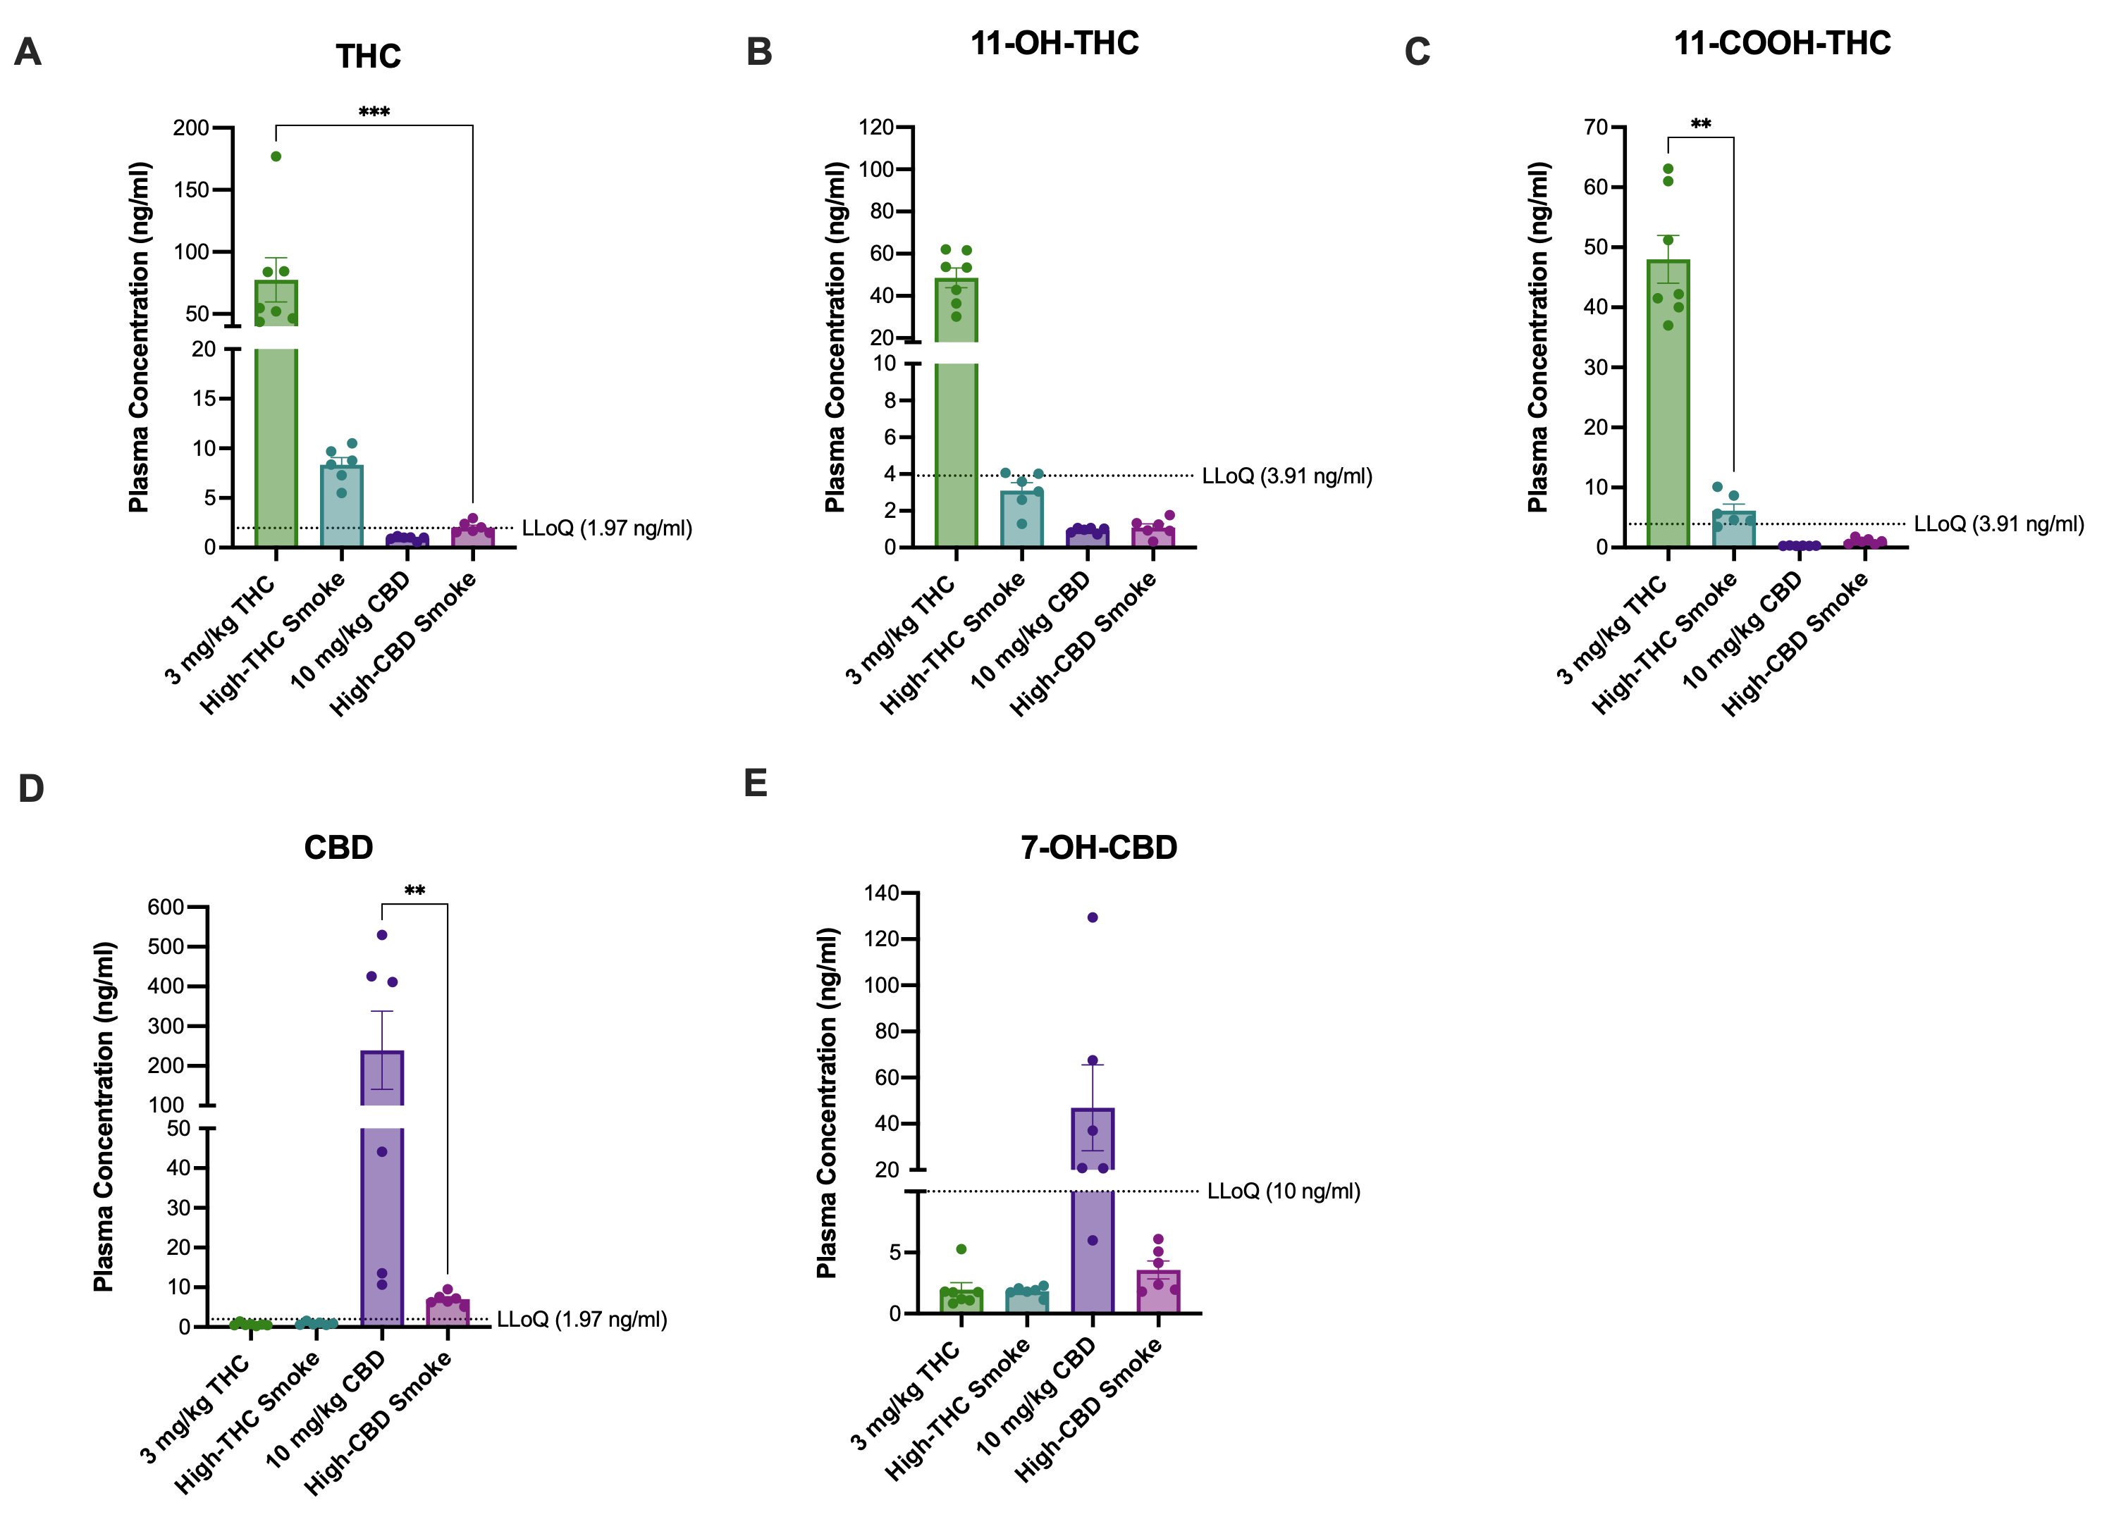
Figure S1. Comparison of THC, CBD, and metabolite levels among treatments in maternal plasma on GD6 after a single exposure to either 3 mg/kg/d THC i.p., high THC smoke, 10 mg/kg/d CBD i.p., or high CBD smoke. Mean maternal plasma concentrations of (A) THC, (B) 11-OH-THC, (C) 11-COOH-THC, (D) CBD, and (E) 7-OH-CBD. All samples were collected on GD6, 30 minutes following one treatment. Note the different scaling of the y-axes of the panels. Data are mean ± S.E.M. n=6-8 dams/treatment; *p<0.05, ** p<0.01, ***p<0.001 as determined by Kruskal-Wallis (KW) one-way ANOVA or Kolmogorov-Smirnov (KS) test.

Placenta
Cytokines and Chemokines | Statistical Analysis
Type | Test | F, H or W value | P value
EGF | Kruskal-Wallis | F (4,26) = 4.04 | P=0.011*
Eotaxin | ANOVA | F (4, 30) = 5.47 | P=0.0020*
Fracktalkine (CX3CL1) | ANOVA | F (4, 30) = 0.48 | P=0.74
G-CSF | ANOVA | F (4, 30) = 3.32 | P=0.023*
GM-CSF | ANOVA | F (4, 29) = 0.39 | P=0.81
GRO/KC (CXCL-1) | Kruskal-Wallis | H (4) =6.57 | P=0.16
IFNy | Welch's | W(4.00, 13.05)=10.66 | P=0.00050*
IL-1α | Kruskal-Wallis | H (4) =20.72 | P=0.00040*
IL-1β | ANOVA | F (4, 29) = 13.08 | P<0.00010*
IL-2 | ANOVA | F (4, 30) = 1.69 | P=0.18
IL-4 | Kruskal-Wallis | H (4) =12.46 | P=0.014*
IL-5 | ANOVA | F (4,30 ) = 1.88 | P=0.49
IL-6 | ANOVA | F (4, 30) = 57.78 | P<0.00020*
IL-10 | ANOVA | F (4, 40) = 3.23 | P=0.025*
IL-12p70 | ANOVA | F (4, 30) = 1.66 | P=0.19
IL-13 | ANOVA | F (4, 30) = 1.68 | P=0.18
IL-17A | ANOVA | F (4, 30) = 14.03 | P<0.00010*
IL-18 | ANOVA | F (4, 30) = 1.49 | P=0.23
IP-10 (CXCL10) | Kruskal-Wallis | H (4) = 12.3 | P=0.015*
Leptin | ANOVA | F (4, 30) = 0.51 | P=0.73
LIX (CXCL5) | Welch's | W(4.00, 14.04)=5.16 | P=0.047*
MCP-1 (CCL-2) | Kruskal-Wallis | H (4) = 4.16 | P=0.39
MIP-1α (CCL3) | Kruskal-Wallis | H (4) = 20.13 | P=0.00050*
MIP-2 (CXCL2) | ANOVA | F (4, 28) = 1.29 | P=0.30
RANTES (CCL5) | ANOVA | F (4, 28) = 3.47 | P=0.020*
TNFα | ANOVA | F (4, 29) = 4.20 | P=0.0083*
VEGF | ANOVA | F (4, 30) = 1.73 | P=0.17

Table S1. Statistical analysis for placenta multiplex assay.

Combined Male and Female Fetal Brains
Cytokines and Chemokines | Statistical Analysis
Type | Test | F, H or W value | P value
EGF | Kruskal-Wallis | H (4) = 13.55 | P=0.0089*
Eotaxin | Welch's | W (4.000, 29.72)=1.635 | P=0.19
Fracktalkine (CX3CL1) | Kruskal-Wallis | H (4) =1.59 | P=0.81
G-CSF | ANOVA | F (4, 58)= 0.72 | P=0.58
GM-CSF | Kruskal-Wallis | H (4) = 4.61 | P=0.33
GRO/KC (CXCL-1) | Kruskal-Wallis | W (4.000, 26.85)=3.64 | P=0.021
IFNy | ANOVA | F (4, 61) = 6.00 | P=0.00040*
IL-1α | ANOVA | F (4, 60) = 3.19 | P=0.019*
IL-1β | Welch's | (4.000, 27.14)=5.37 | P=0.0026*
IL-2 | ANOVA | F (4, 61) = 4.27 | P=0.0041*
IL-4 | ANOVA | F (4, 61) = 6.10 | P=0.00030*
IL-5 | ANOVA | F (4, 61) = 0.73 | P=0.57
IL-6 | Welch's | W (4.00, 39.43)=9.13 | P<0.00010*
IL-10 | Kruskal-Wallis | H(4) = 21.26 | P=0.0003*
IL-12p70 | ANOVA | F (4, 61) = 0.62 | P=0.65
IL-13 | ANOVA | F (4, 60) = 0.59 | P=0.67
IL-17A | ANOVA | F (4, 61) = 3.71 | P=0.0091*
IL-18 | Welch's | W (4.00, 29.19)=4.84 | P=0.0041*
IP-10 (CXCL10) | Welch's | W (4.00, 40.52)=4.05 | P=0.0075*
Leptin | ANOVA | F (4, 61) = 0.57 | P=0.68
LIX (CXCL5) | Welch's | W(4.00, 29.31)=3.61 | P=0.017*
MCP-1 (CCL-2) | Kruskal-Wallis | H (4) = 0.82 | P=0.93
MIP-1α (CCL3) | Welch's | W (4.00, 30.24)=5.10 | P=0.0029*
MIP-2 (CXCL2) | Kruskal-Wallis | H (4) = 1.70 | P=0.79
RANTES (CCL5) | Welch's | W (4.00, 29.92)=7.02 | P=0.0015*
TNFα | Welch's | W (4.00, 28.33)=6.84 | P=0.00060*
VEGF |  | F (4, 61) = 2.80 | P=0.034*

Table S2. Statistical analysis for male and female fetal brain multiplex assay.

