Comprehensive pan-cancer analysis of
Potassium Voltage-Gated Channel Q4（KCNQ4 ）gene
expression in human malignant tumors
Qing Zhao^{12＋} Yunxiang Zhang1*
*Correspondence:
Yunxiang Zhang
zhangbing199592@163.com
1 Pathology Department, First Affiliated Hospital of Weifang Medical University (Weifang People’s Hospital), Weifang, China
2 Department of Basic Medicine, Weifang Medical University, Weifang, China

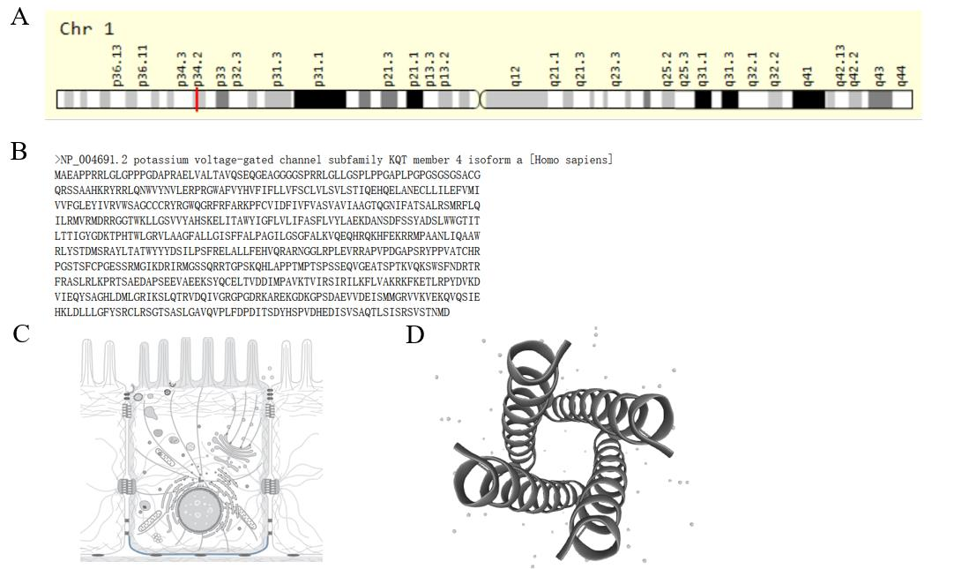Supplementary Figure1 |Genomic and protein features of KCNQ4
(Supplementary Figure 1A)The genetic characteristics of KCNQ4 were obtained via NCBI(https://www.ncbi.nlm.nih.gov/).(Supplementary Figure1B)The amino acid sequence of KCNQ4 via GeneCards(https://www.genecards.org/).(Supplementary Figure 1C)The location of KCNQ4 via UniProt(https://www.uniprot.org/).(Supplementary Figure 1D)The structure of KCNQ4 via UniProt(https://www.uniprot.org/).

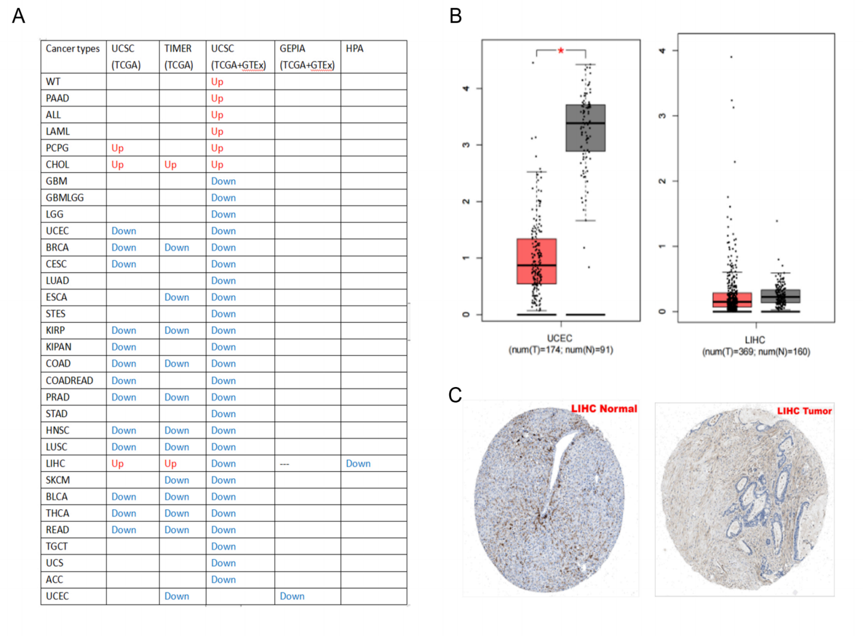
Supplementary Figure 2 |Expression and validation of KCNQ4 in different databases
(Supplementary Figure 2A)The expression of KCNQ4 in different cancer types from multiple databases.(Supplementary Figure 2B)The expression of KCNQ4 in UCEC and LIHC via Gene Expression Profiling Interactive Analysis(GEPIA，http://gepia.cancer-pku.cn/）（Supplementary Figure 2C）The protein expression of KCNQ4 in LIHC viaThe Human Protein Atlas(HPA,https://www.proteinatlas.org)
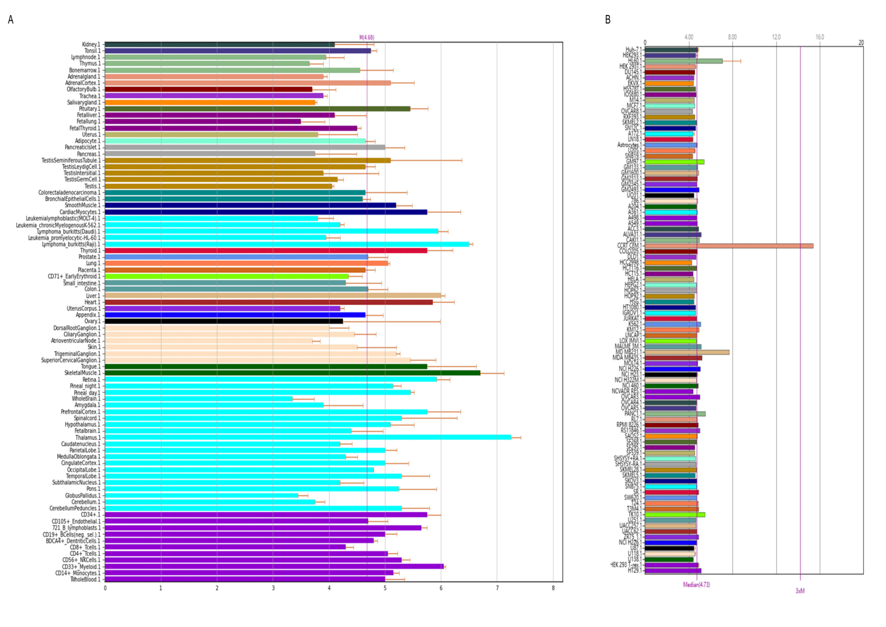Supplementary Figure 3 | The expression level of KCNQ4 in normal tissues and cancer cells via BioGPS
(Supplementary Figure 3A)The expression level of KCNQ4 in normal tissues and tumor cells.
(Supplementary Figure 3B)The expression level of KCNQ4 in tumor tissues and tumor cells.
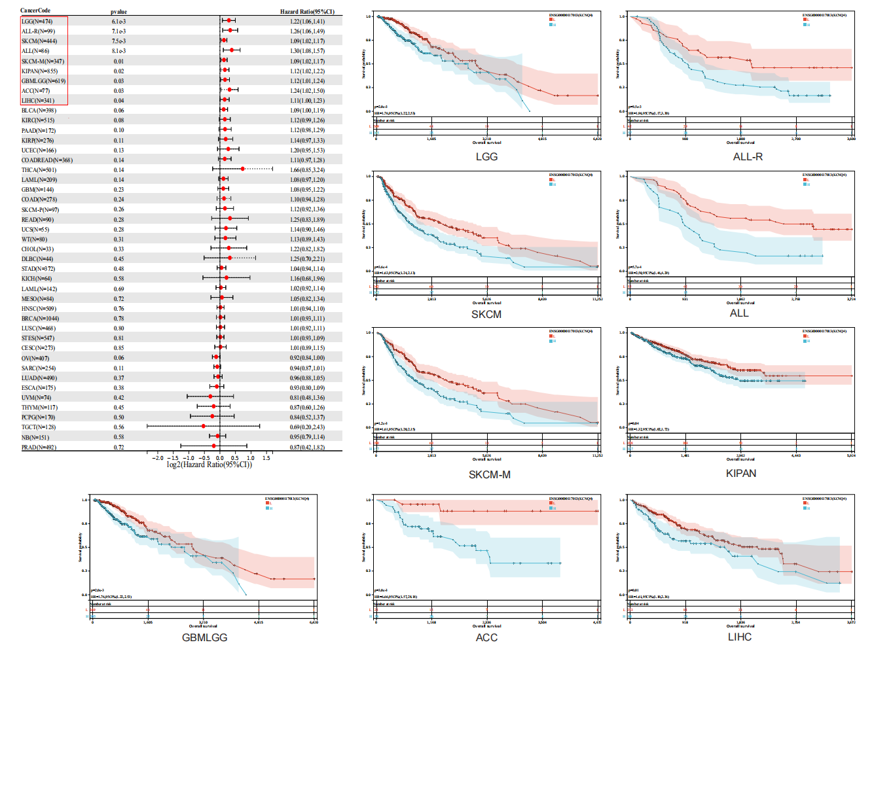Supplementary Figure 4 |OS of prognostic analysis of KCNQ4 from UCSC.
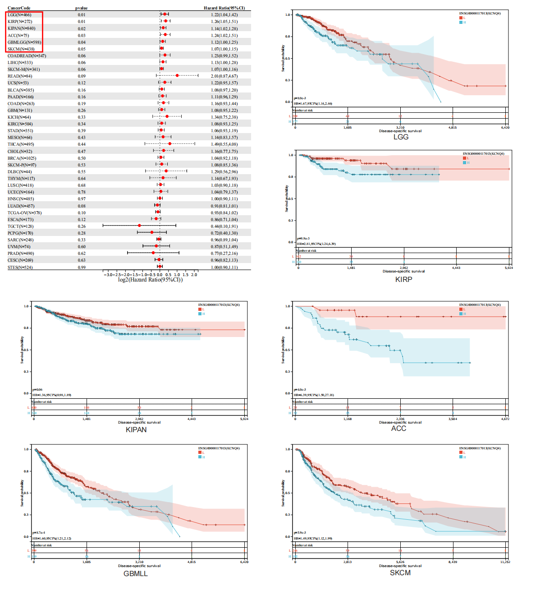Supplementary Figure 5 |DSS of prognostic analysis of KCNQ4 from UCSC.
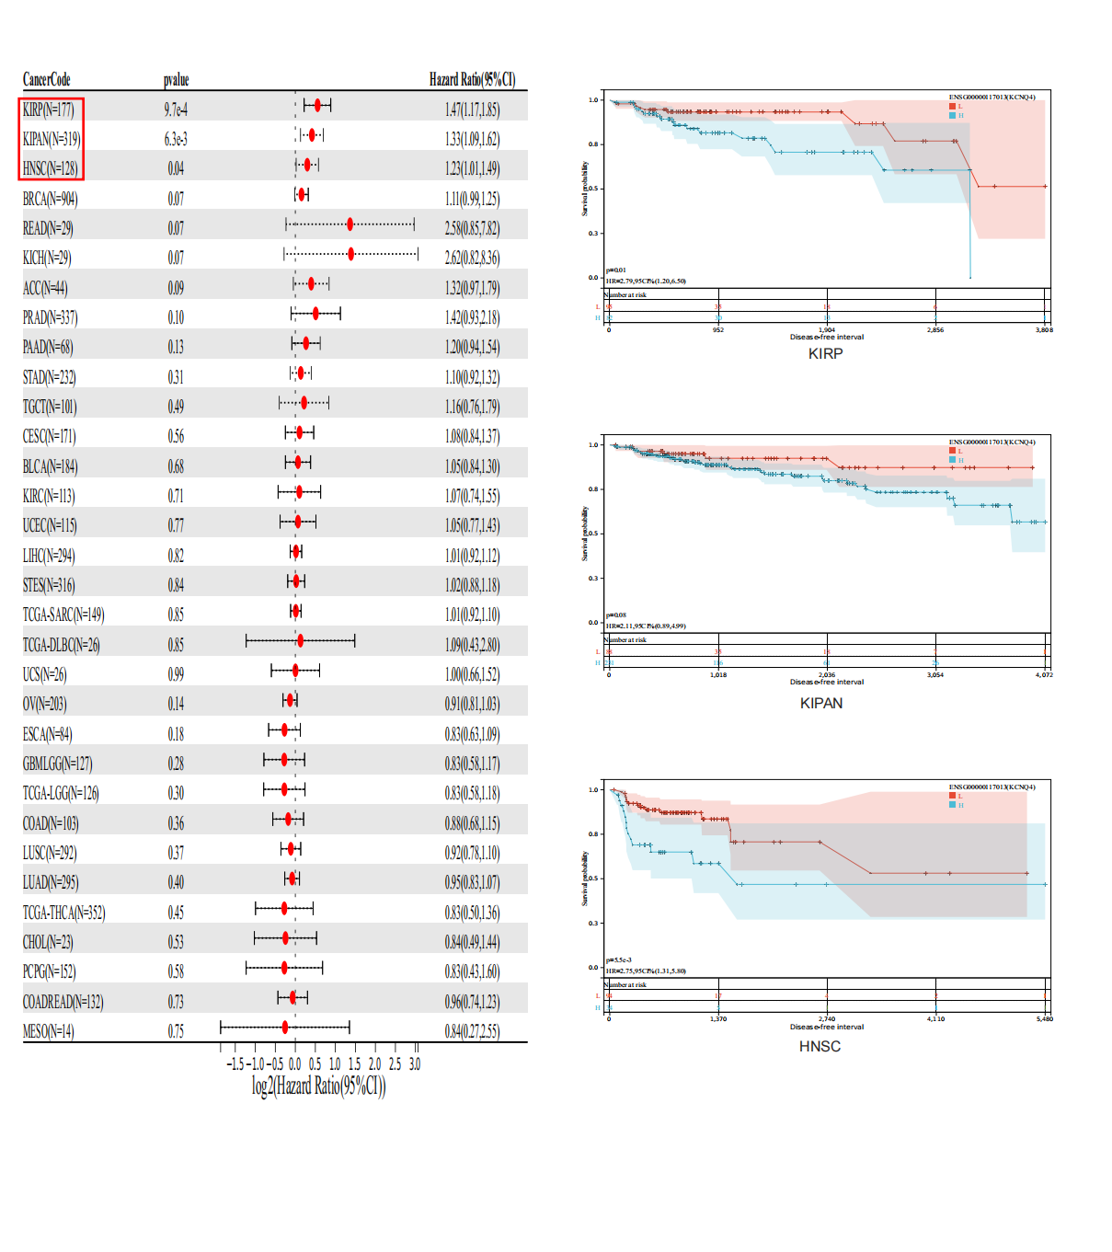Supplementary Figure 6 |DFS of prognostic analysis of KCNQ4 from UCSC.
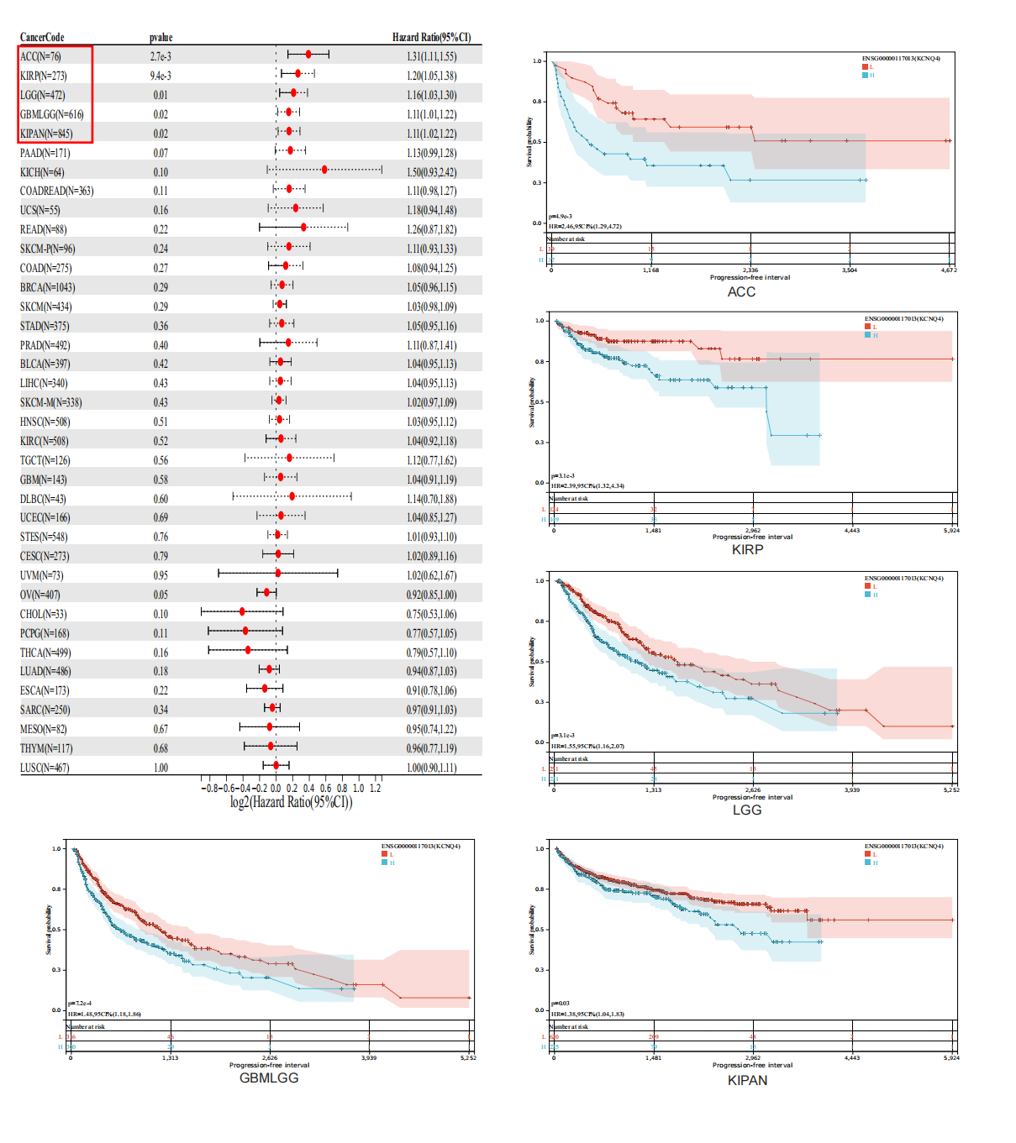
Supplementary Figure 7 |PFS of prognostic analysis of KCNQ4 from UCSC.

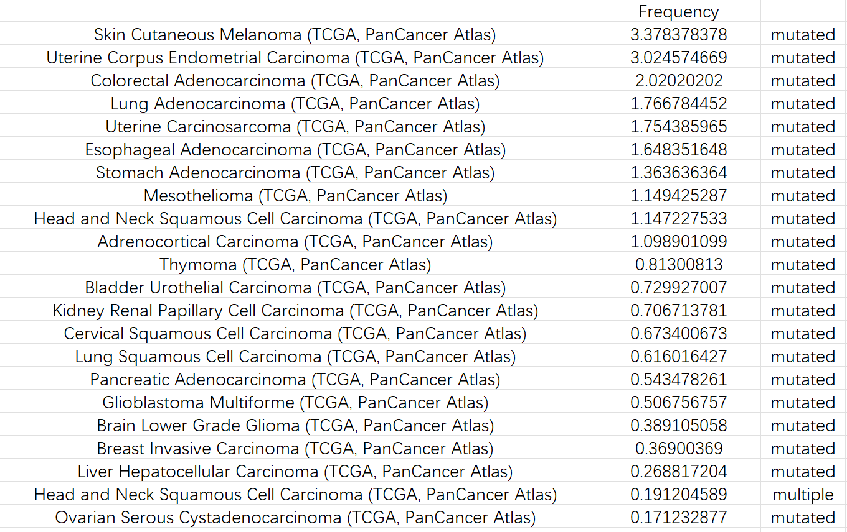Supplementary Figure 8|The mutation frequency of KCNQ4 via Bioportal

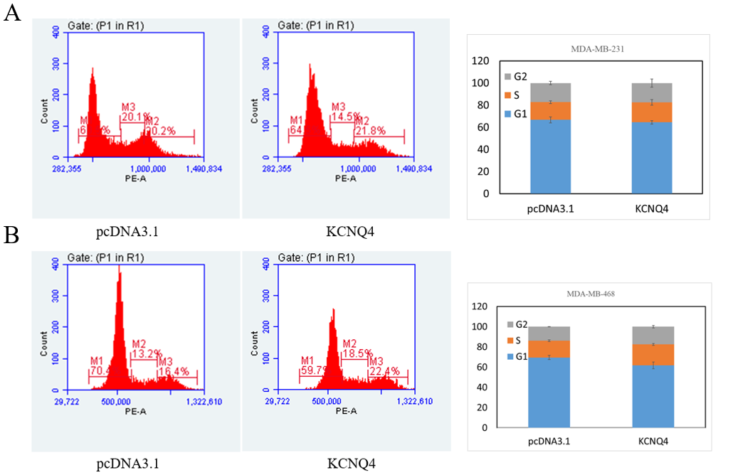
Supplementary Figure 9|Breast Cell cycle experiment of KCNQ4
The effect of KCNQ4 on breast cancer cell line MDA-MB-231 was detected by flow cytometry(Supplementary Figure 9A) and the impact of MDA-MB-468 (Supplementary Figure 9B) cycles

