Supplementary Information:
Hybrid hemp/glass fiber reinforced high-temperature shape memory photopolymer with mechanical and flame-retardant analysis
Sakil Mahmudª, John Konlanª, Jenny Deicaza^{b}, and Guoqiang Li^{a,b,*}
ª Department of Mechanical and Industrial Engineering, Louisiana State University, Baton Rouge, LA 70803, United States of America.
^{b} Department of Mechanical Engineering, Southern University and A&M College, Baton Rouge, LA 70813, United States of America.
*Corresponding author: G. Li (E-mail: lguoqi1@lsu.edu).

Table S1: Typical mechanical properties of hemp fiber and its chemical composition¹⁻⁴
Properties of fibers |  |  | Chemical composition
 | Glass fibers | Hemp fibers | Glass fibers | Hemp fibers
Density (g/cm³) | 2.62 | 1.4 | 52.4% SiO₂ | 77.5% Cellulose
Tensile strength (MPa) | 3400 | 550 – 900 | 14.4% Al₂O₃ | 10.0% Hemicellulose
Elastic modulus (GPa) | 73 | 70 | 10.6% B₂O₃ | 6.8% Lignin
Specific strength (MPa/(g/cm³)) | 1297 | 393 – 643 | 17.2% CaO | 2.9% Pectin
Specific modulus (MPa/(g/cm³)) | 28 | 50 | 4.5% MgO | 0.9% Fat & wax
Elongation at failure (%) | 4.8 | 1.6 | 0.8% Others | 1.8% Water soluble materials
Moisture absorption (%) | N/A | 6 – 12
Cost ($/kg) | 2.47 | 0.67

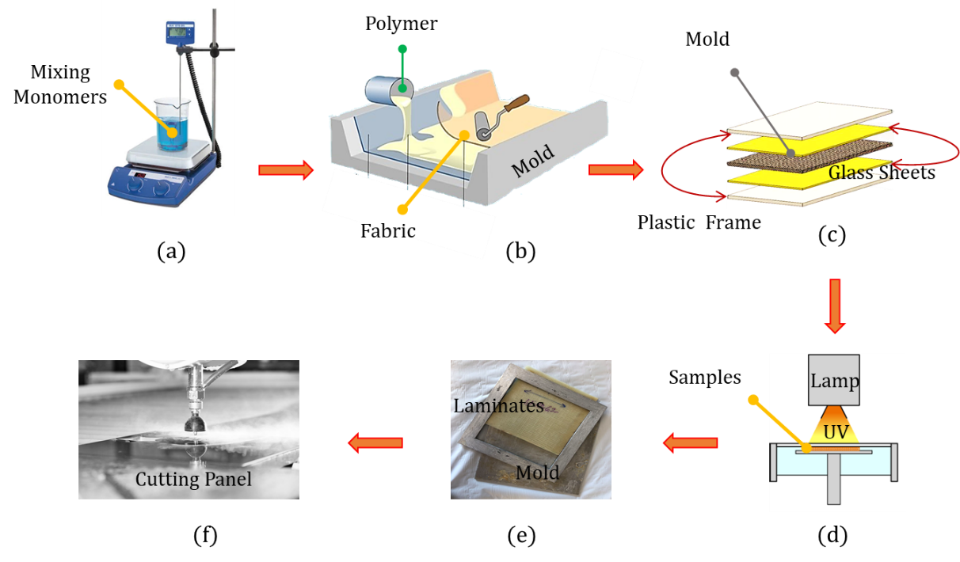
Figure S 1: (a) Mixing of TIA monomer and TPO photoinitiators, (b) lamination of fabrics using hand-layup, (c) laminate sandwiched in the mold with the glass sheet and open plastic frame, and the C-clamping to exert pressure, (d) UV-curing of composite laminates, (e) demolding the sandwiched laminate after UV-curing, and (f) cutting of boards into rectangular beams.

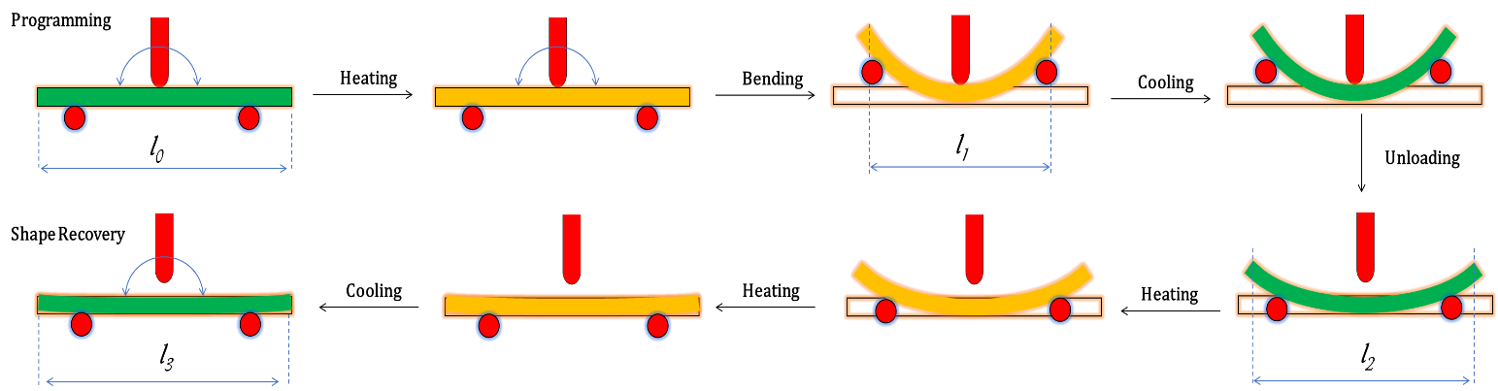

Figure S 2: A schematic diagram of bending programming and recovery cycle of composite laminates.

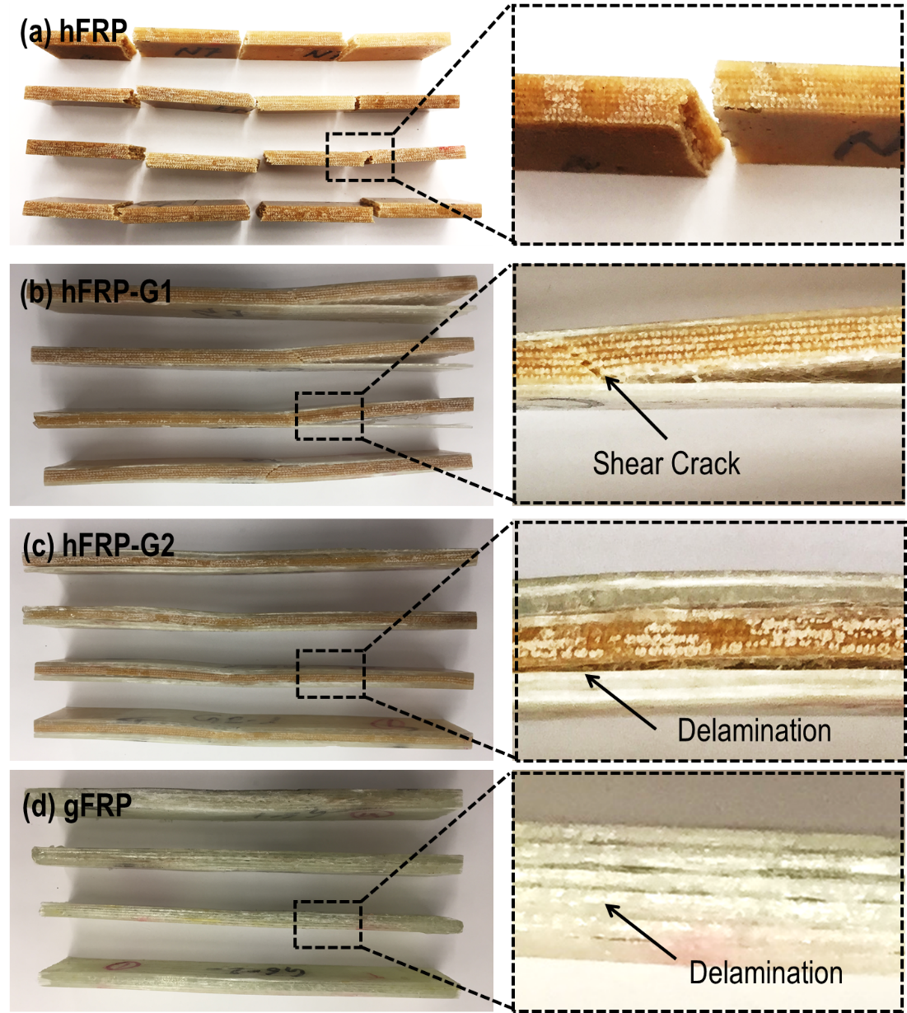
Figure S 3: Typical failure of laminates upon low-velocity impact: (a) hFRP, (b) hFRP-G1, (c) hFRP-G2, and (d) gFRP laminate composites.

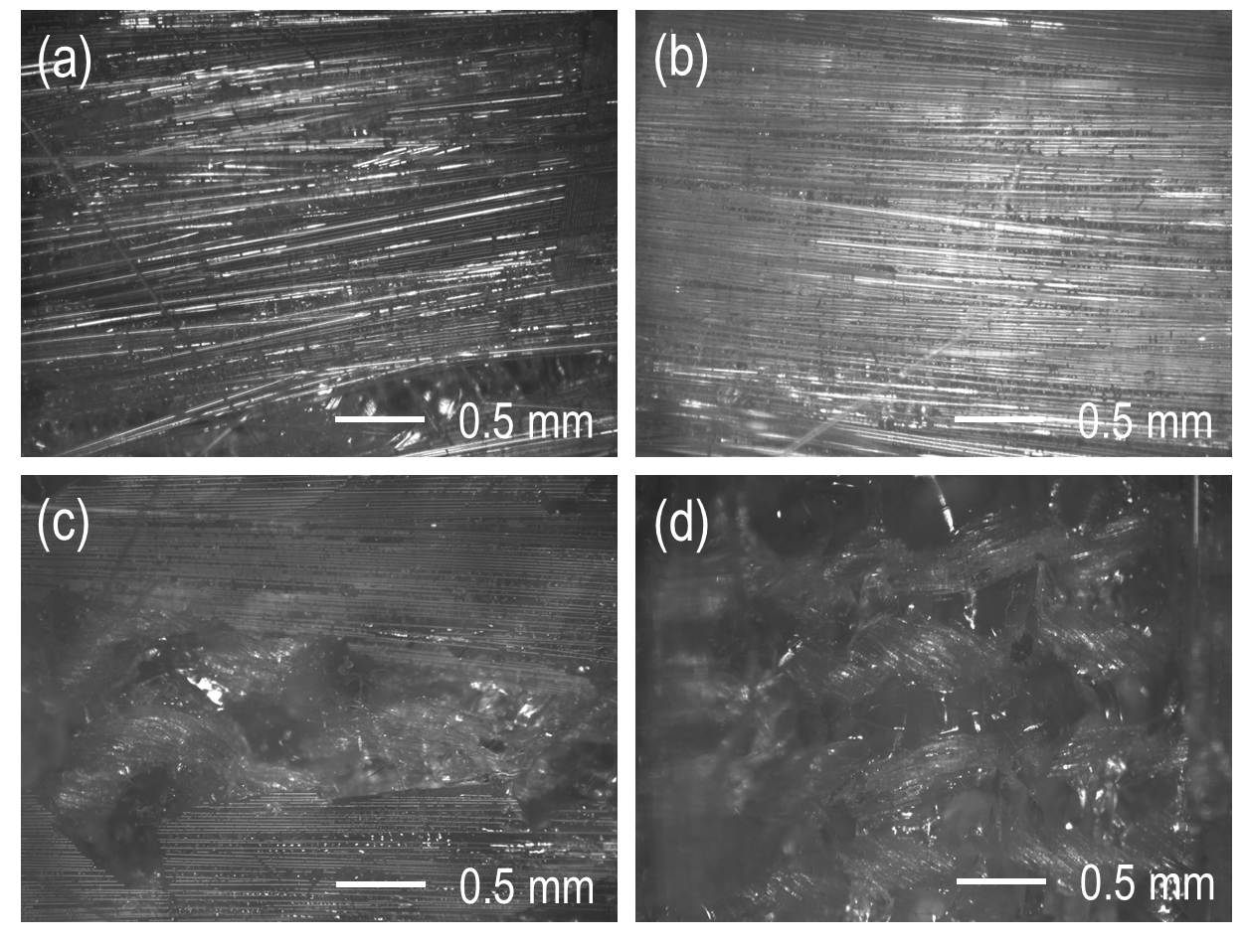
Figure S 4: Optical microscopic images of the delaminated surface after low-velocity impact. (a) gFRP composites laminate, (b) hybrid composites: fracture surface on the glass fiber side, (c) hybrid composites: fracture surface on the hemp fiber side, and (d) hybrid composites: cross-sectional image of the hemp fiber reinforced polymer core.

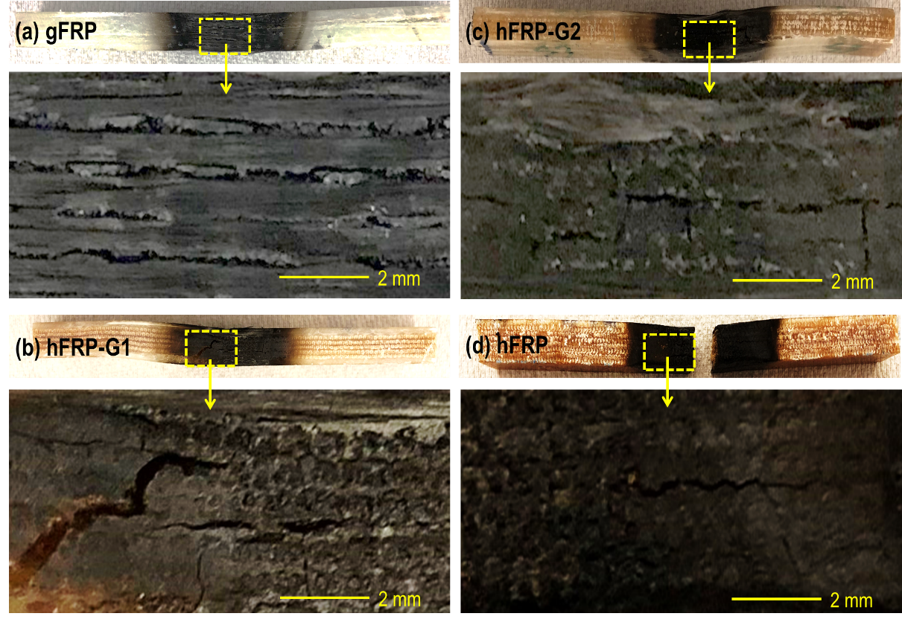
Figure S 5: Typical failure of laminates upon low-velocity impact after burning 40 s: (a) gFRP, (b) hFRP-G1, (c) hFRP-G2, and (d) hFRP laminate composites.

Figure S 6: XPS curves of gFRP laminate composites char.

Figure S 7: XPS curves of hFRP laminate composites char.

Figure S 8: XPS curves of hFRP-G1laminate composites char.
Figure S 9: XPS curves of hFRP-G1 laminate composites char.
References:
1 Shahria, S. Fabrication and property evaluation of hemp–flax fiber reinforced hybrid composite. Cellulose 7, 17-23 (2019).
2 Lu, N., Swan, R. H. & Ferguson, I. Composition, structure, and mechanical properties of hemp fiber reinforced composite with recycled high-density polyethylene matrix. Journal of Composite Materials 46, 1915-1924, doi:10.1177/0021998311427778 (2012).
3 Islam, M., Pickering, K. & Foreman, N. Influence of alkali treatment on the interfacial and physico-mechanical properties of industrial hemp fibre reinforced polylactic acid composites. Composites Part A: Applied Science and Manufacturing 41, 596-603 (2010).
4 Bodig, J. & Jayne, B. A. Mechanics of wood and wood composites. (1982).

