Supporting Information
Insight into the effects of different oxygen heteroatoms on nicotine adsorption from cigarette mainstream smoke
Phongphot Sakulaueª, Kulpavee Jitapunkulª, Parinya Inthasuwan^{b}, Hiromu Takano^{c}, Takafumi Ishii^{c}, Kanokwan Kongpatpanich^{d}, Kajornsak Faungnawakij^{e}, Metta Chareonpanich^{f}, Khanin Nueangnoraj*ª

ª School of Bio-Chemical Engineering and Technology, Sirindhorn International Institute of Technology, Thammasat University, Pathum Thani, 12120, Thailand
^{b} Sustainable Energy and Resources Engineering, Faculty of Engineering, Kasetsart University, Bangkok, 10900, Thailand
^{c} International Research and Education Center for Element Science, Faculty of Science and Technology, Gunma University, 1–5–1 Tenjincho, Kiryu, Gunma, 376–8515, Japan
^{d} Department of Materials Science and Engineering, School of Molecular Science and Engineering, Vidyasirimedhi Institute of Science and Technology, Rayong, 21210, Thailand
^{e} National Nanotechnology Center, National Science and Technology Development Agency, Pathum Thani 12120, Thailand
^{f} Department of Chemical Engineering, Faculty of Engineering, Kasetsart University, Bangkok, 10900, Thailand

*Corresponding author: K. Nueangnoraj (khanin@siit.tu.ac.th)
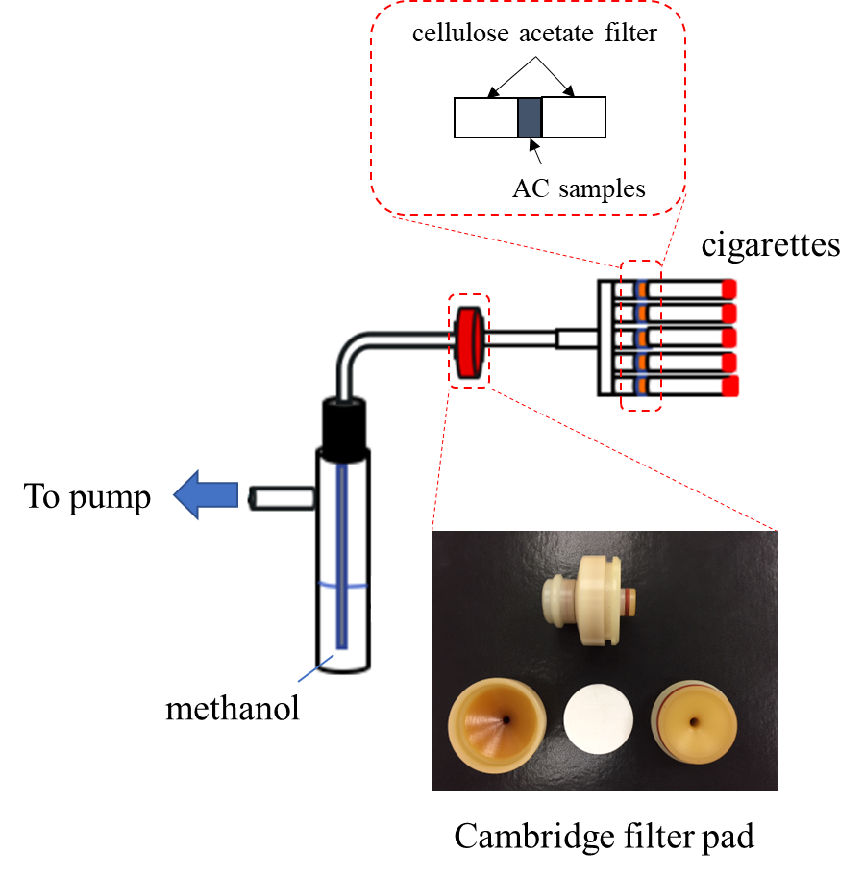
Figure S1. A schematic diagram of the laboratory-scale smoking apparatus.

Analysis of nicotine
The amount of nicotine that was trapped in methanol solution was analyzed by gas chromatography – flame ionization detector (GC-FID). The column was RTX-1 fused with silica gas chromatography capillary column (Restek, 30 m x 0.32 mm ID with the thickness of 0.5 µm) coated with 100% dimethyl polysiloxane. Helium was used as a carrier gas at a linear velocity of 2 ml min⁻¹. Air and hydrogen flow rates were 450 and 45 ml min⁻¹, respectively. The split ratio was 20:1. The injector was held isothermally at 250 °C. The column temperature program was set as follows: initial temperature 160 °C held for 3 min, then increased at 15 °C min⁻¹ up to 230 °C. The FID was maintained at 300 °C. All results were performed in triplicate. Calibration curves were constructed in a range of 0.2 – 1.0 mg ml⁻¹ from a standard nicotine solution (Figure S2).
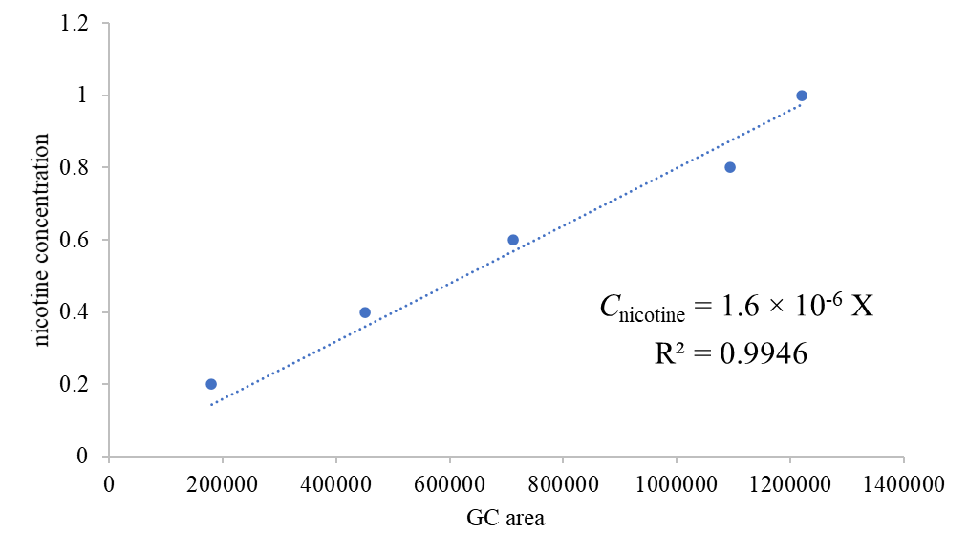
Figure S2. Calibration curve of nicotine in methanol solution.

Table S1. Time, area, concentration of nicotine, and amount of nicotine adsorbed from gas chromatography.
sample | average time  (min) | average area  (μV s⁻¹) | $$C_{nicotine, }$$  (mg cigarette⁻¹) | amount of nicotine adsorbed  (mg cigarette⁻¹)
SMS (red) | 4.32 | 1044564 | 1.67 | –
AC(350) | 4.32 | 334685 | 0.53 | 1.14
AC(400) | 4.32 | 275749 | 0.44 | 1.23
AC(450) | 4.32 | 176411 | 0.28 | 1.39
AC(500) | 4.32 | 212709 | 0.34 | 1.33
AC(550) | 4.32 | 128025 | 0.20 | 1.47

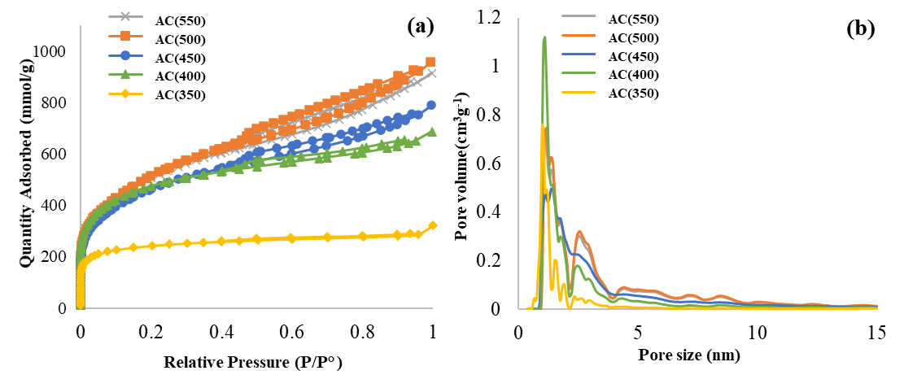
Figure S3. (a) N₂-sorption isotherms and (b) DFT pore size distributions of the obtained ACs.

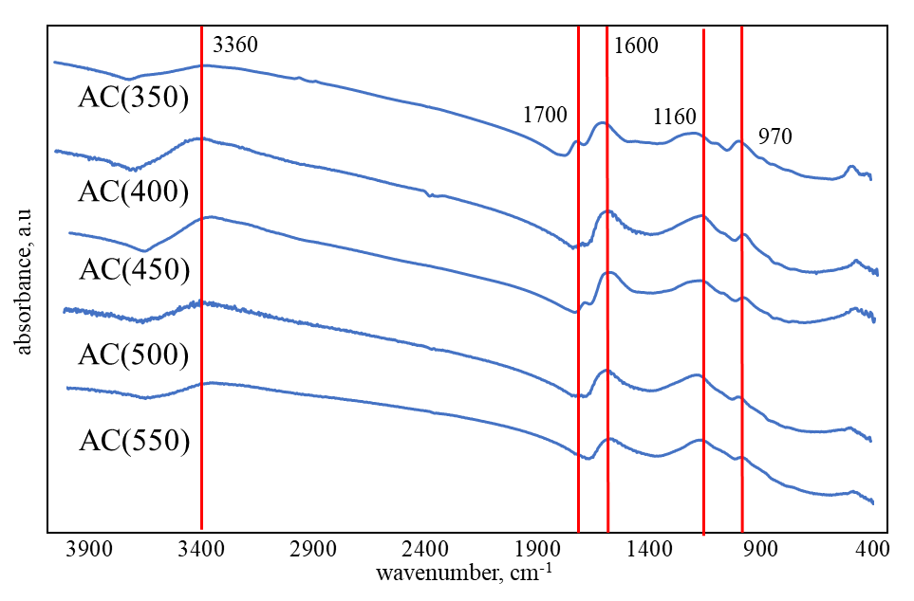
Figure S4. FTIR spectra of the obtained ACs.

Table S2. The atomic concentration of each element analyzed by XPS.
sample | %at |  |  |  | O/C | P/C
sample | C | O | N | P | O/C | P/C
AC(350) | 80.7 | 17.4 | 0.40 | 1.47 | 0.215 | 0.0182
AC(400) | 84.1 | 14.3 | 0.33 | 1.24 | 0.170 | 0.0147
AC(450) | 82.9 | 14.4 | 0.58 | 2.05 | 0.174 | 0.0247
AC(500) | 84.4 | 13.2 | 0.24 | 2.12 | 0.156 | 0.0251
AC(550) | 82.0 | 14.8 | 0.37 | 2.79 | 0.180 | 0.0340

Table S3. The amount of each functional group obtained from the peak deconvolution of CO and the CO₂ evolution.
sample | CO  (mmol/g) | anhydride  (mmol/g) | phenol  (mmol/g) | quinone  (mmol/g) | CO₂  (mmol/g) | carboxylic  (mmol/g) | anhydride  (mmol/g) | lactone  (mmol/g)
AC(350) | 4.82 | 0.68 | 1.57 | 2.58 | 0.80 | 0.42 | 0.34 | 0.05
AC(400) | 3.29 | 0.46 | 0.46 | 2.37 | 0.40 | 0.18 | 0.19 | 0.02
AC(450) | 2.64 | 0.27 | 0.20 | 2.17 | 0.19 | 0.08 | 0.07 | 0.04
AC(500) | 2.36 | 0.13 | 0.21 | 2.02 | 0.12 | 0.04 | 0.04 | 0.05
AC(550) | 3.62 | 0.12 | 0.19 | 3.31 | 0.18 | 0.04 | 0.03 | 0.12

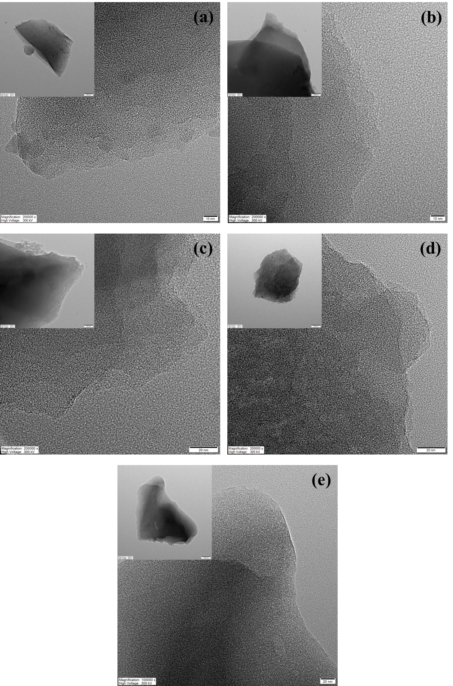
Figure S5. High resolution TEM images of the obtained ACs: (a) AC(350), (b) AC(400), (c) AC(450), (d) AC(500), and (e) AC(550). The inserts are those with low resolution.

