Supplementary Data

Characterization and in-vitro Alzheimer's Properties of Exopolysaccharide from Bacillus maritimus MSM1

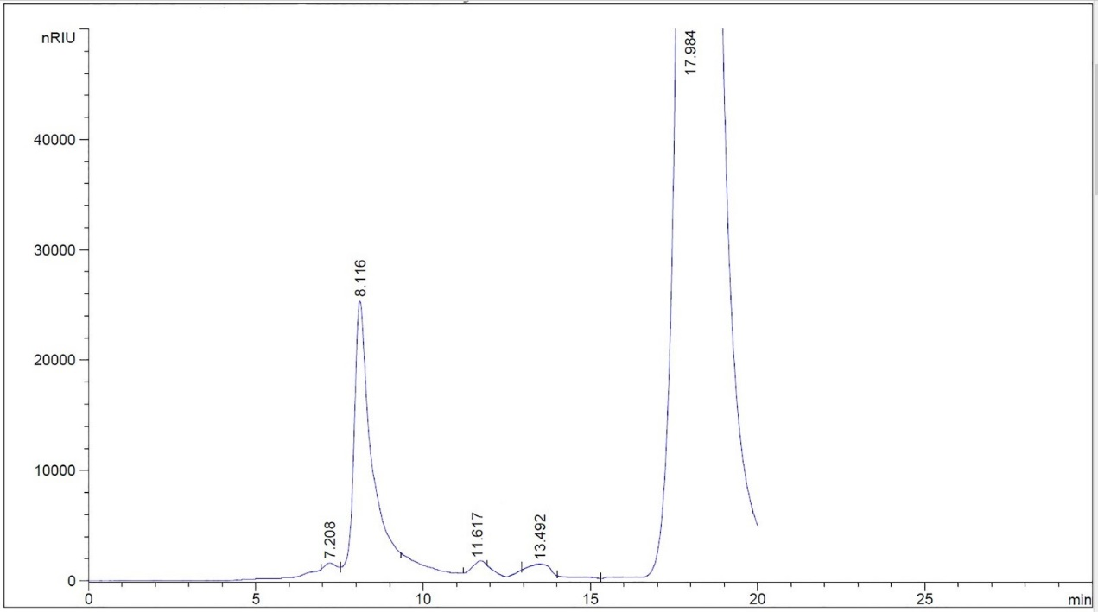

Fig. S1. HPLC analysis of the EPS from Bacillus maritimus MSM1

