Supplementary Materials for
A pan-cancer analysis of the role of USP5 in human cancers

Bokang Yan¹, Jiaxing Guo², Shuang Deng¹, Dongliang Chen¹*, Meiyuan Huang¹*

*Correspondence: Meiyuan Huang (meiyuanhuang2022@163.com) or Dongliang Chen (1156080708@qq.com)

This file includes:
Figures S1 to S5
Table S1

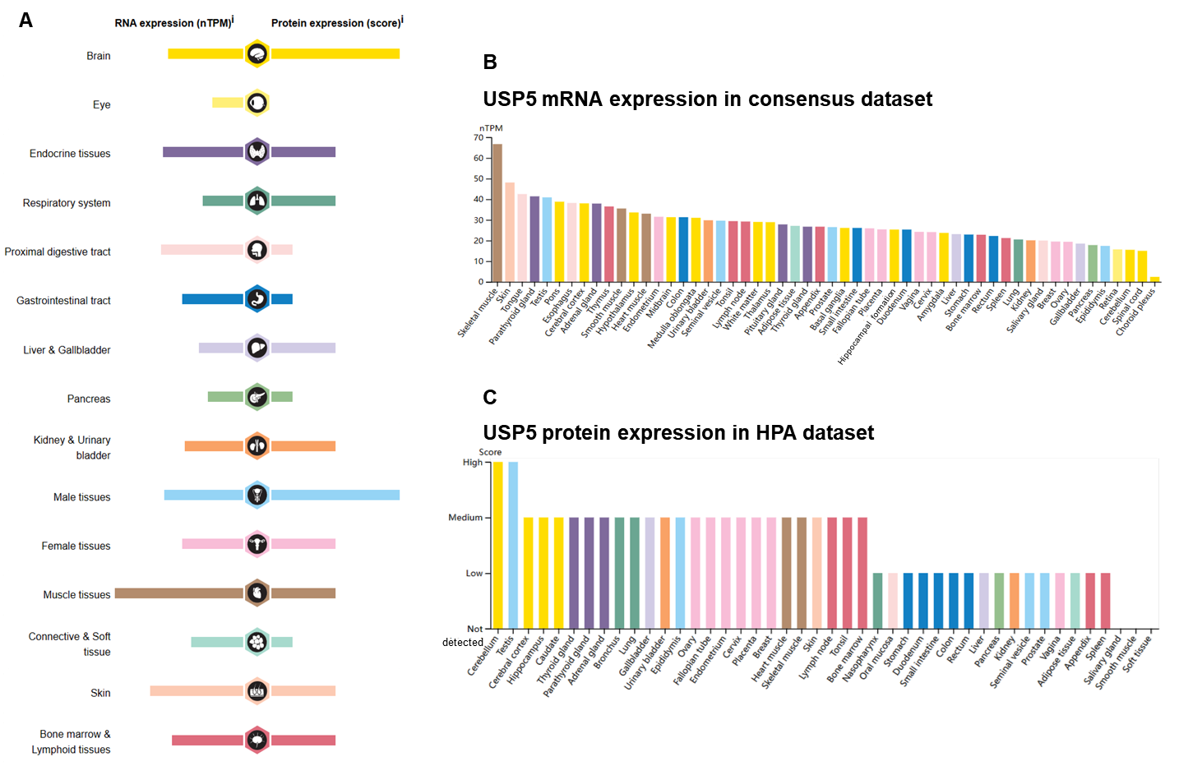
Figure S1. The mRNA and protein expression levels of USP5 in human organs/tissues analyzed via HPA. (A) The summary of USP5 mRNA and protein expression levels in human organs or tissues. (B) The expression summary of USP5 mRNA in various human organs or tissues. (C) The expression summary of USP5 protein in various human organs or tissues.

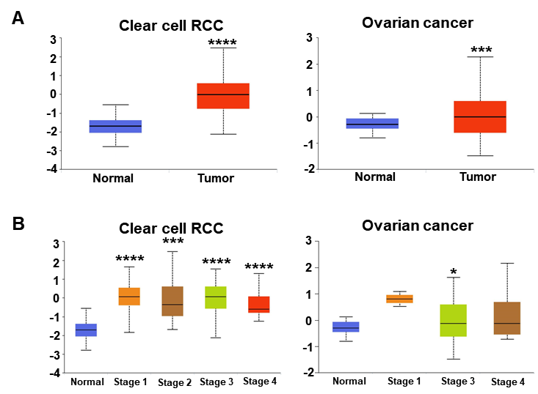
Figure S2. The protein expression level of USP5 in different cancers. (A) Using CPTAC web tool, the protein expression of USP5 was analyzed in clear cell RCC and ovarian cancer. (B) The protein expression of USP5 was analyzed by the main pathological stages of clear cell RCC and ovarian cancer.

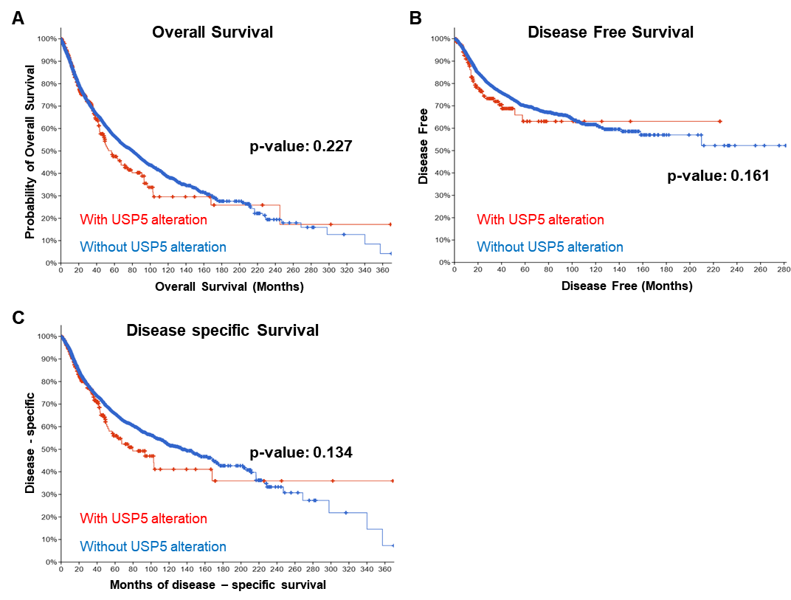Figure S3. Analysis of the correlation between USP5 mutation status and patients’ prognosis of pan-cancer. Correlations between USP5 mutation status and OS (A), DFS (B) and DSS (C) of cancer patients were analyzed on cBioPortal online platform based on TCGA data.

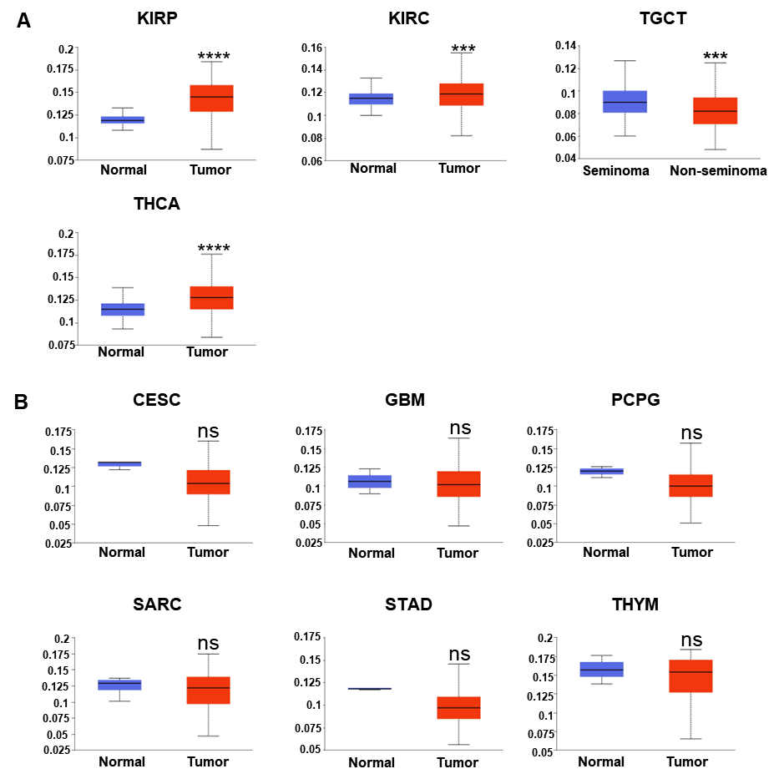Figure S4. DNA methylation features of USP5 in pan-cancer. (A) KIRP, KIRC, TGCT and THCA. (B) CESC, GBM, PCPG, SARC, STAD and THYM. The methylation level of USP5 obtained from UALCAN database.

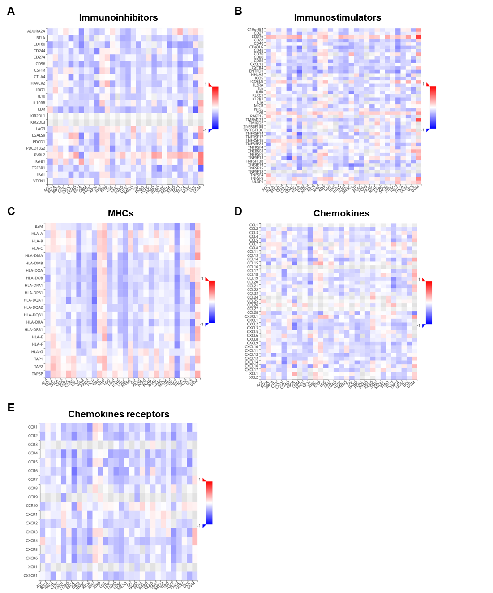Figure S5. Correlation between USP5 and immunoregulation-related genes in pan-cancer. Correlations between USP5 expression and immunostimulators (A), immunoinhibitors (B), MHC molecules (C), chemokines (D) and chemokine receptors (E) were obtained via the TISIDB database.
Table S1. The abbreviation of 37 cancer types analyzed in this study.
Abbreviation | Cancer types
ACC | Adrenocortical carcinoma
ALL | Acute Lymphoblastic Leukemia
BLCA | Bladder Urothelial Carcinoma
BRCA | Breast invasive carcinoma
CESC | Cervical squamous cell carcinoma and endocervical adenocarcinoma
CHOL | Cholangiocarcinoma
COAD | Colon adenocarcinoma
COADREAD/CRC | Colorectal cancer
DLBC | Lymphoid Neoplasm Diffuse Large B-cell Lymphoma
ESCA | Esophageal carcinoma
GBM | Glioblastoma multiforme
HNSC | Head and Neck squamous cell carcinoma
KICH | Kidney Chromophobe
KIRC | Kidney renal clear cell carcinoma
KIRP | Kidney renal papillary cell carcinoma
LAML | Acute Myeloid Leukemia
LGG | Brain Lower Grade Glioma
LIHC | Liver hepatocellular carcinoma
LUAD | Lung adenocarcinoma
LUSC | Lung squamous cell carcinoma
MESO | Mesothelioma
OV | Ovarian serous cystadenocarcinoma
PAAD | Pancreatic adenocarcinoma
PCPG | Pheochromocytoma and Paraganglioma
PRAD/PC | Prostate adenocarcinoma
RB | Retinoblestoma
RCC | Renal cell carcinoma
READ | Rectum adenocarcinoma
SARC | Sarcoma
SKCM | Skin Cutaneous Melanoma
STAD | Stomach adenocarcinoma
TGCT | Testicular Germ Cell Tumors
THCA | Thyroid carcinoma
THYM | Thymoma
UCEC | Uterine Corpus Endometrial Carcinoma
UCS | Uterine Carcinosarcoma
UVM/UM | Uveal Melanoma

