Supplementary Fig 1. Correlation between EYAs expression and methylation levels based on UALCAN (A-D). Spearman correlation between methylation and expression of EYAs based on GSCALite database (E). ns indicates not significant; * p < 0.05; *** p < 0.001.

Supplementary Table 1. univariate and multivariate analyses of factors contributing to the overall survival of ccRCC patients.
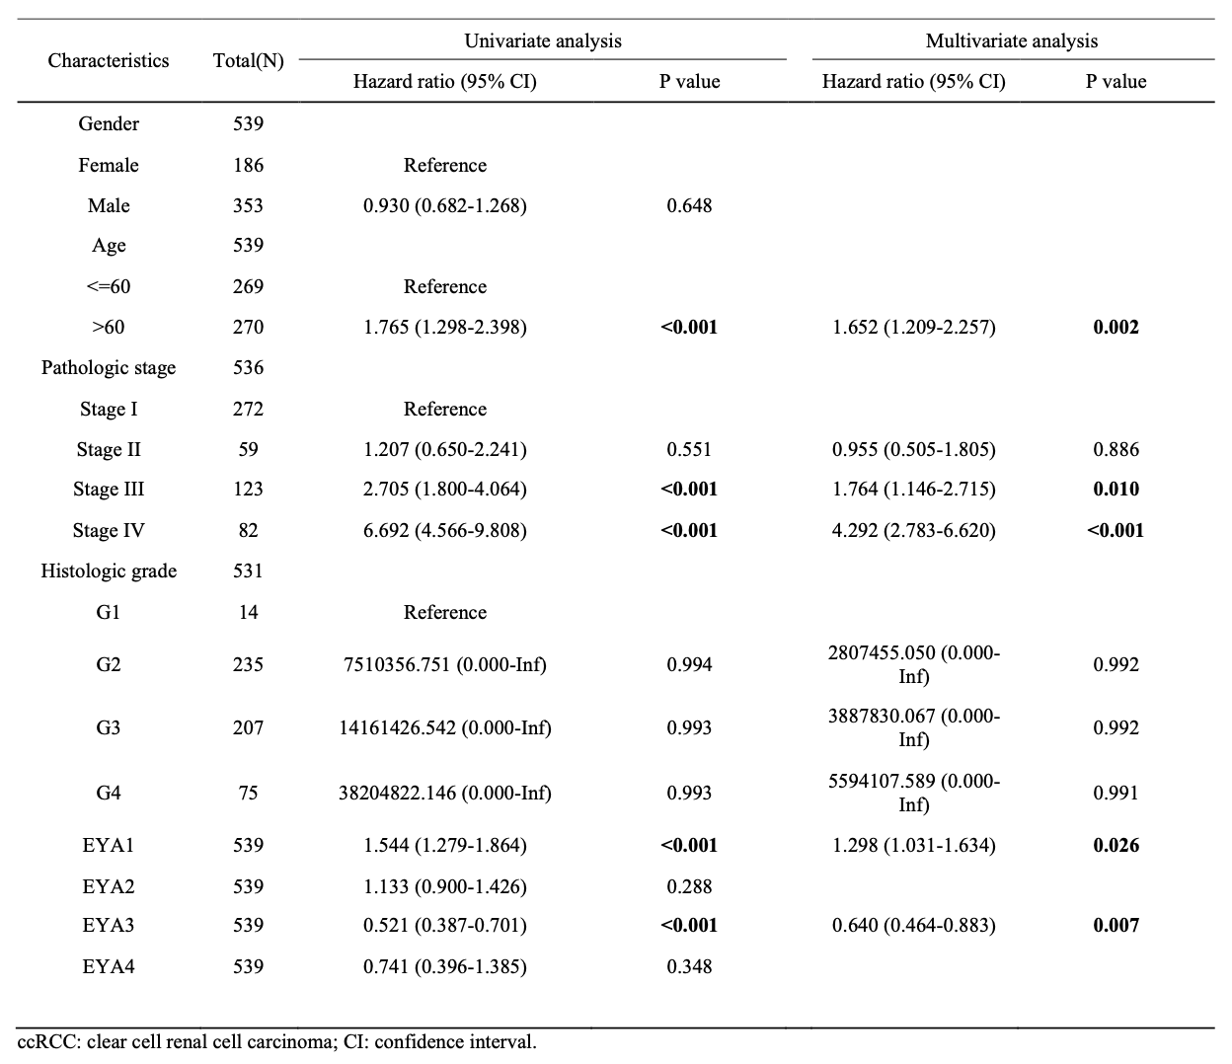

Supplementary Table 2. GO and KEGG functional enrichment analyses of EYAs and their 50 associated neighbor genes.
