Supplementary Material
Table 1. The Histologic Score System Used for Determining the Severity of Inflammation of the Stented Bile Duct
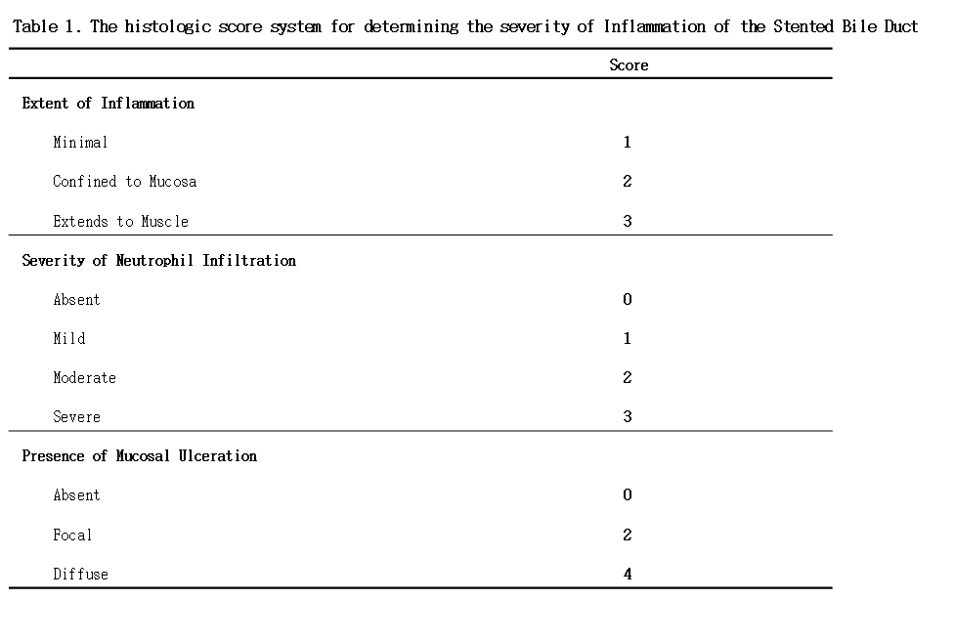

Figure 1. Preparation of Biliary Obstruction Animal Model Using Intraductal Radio Frequency Ablation (RFA).
A, Ampulla of Vater in Micro pig; B, Intraductal RFA electrode (ELRA electrode, STARmed Co. Ltd, Goyang, Gyeogi-do, Korea); C, Cholangiography of Micro pig before Intraductal RFA; D, Cholangiography of catheter with two radiologically marked electrodes

