Abbreviation | Full Name | Abbreviation | Full Name
ACC | Adrenocortical carcinoma | LUSC | Lung squamous cell carcinoma
BLCA | Bladder Urothelial Carcinoma | MESO | Mesothelioma
BRCA | Breast invasive carcinoma | OV | Ovarian serous cystadenocarcinoma
CESC | Cervical squamous cell carcinoma and endocervical adenocarcinoma | PAAD | Pancreatic adenocarcinoma
CHOL | Cholangiocarcinoma | PCPG | Pheochromocytoma and Paraganglioma
COAD | Colon adenocarcinoma | PRAD | Prostate adenocarcinoma
DLBC | Lymphoid Neoplasm Diffuse Large B-cell Lymphoma | READ | Rectum adenocarcinoma
ESCA | Esophageal carcinoma | SARC | Sarcoma
GBM | Glioblastoma multiforme | SKCM | Skin Cutaneous Melanoma
HNSC | Head and Neck squamous cell carcinoma | STAD | Stomach adenocarcinoma
KICH | Kidney Chromophobe | TGCT | Testicular Germ Cell Tumors
KIRC | Kidney renal clear cell carcinoma | THCA | Thyroid carcinoma
KIRP | Kidney renal papillary cell carcinoma | THYM | Thymoma
LAML | Acute Myeloid Leukemia | UCEC | Uterine Corpus Endometrial Carcinoma
LGG | Brain Lower Grade Glioma | UCS | Uterine Carcinosarcoma
LIHC | Liver hepatocellular carcinoma | UVM | Uveal Melanoma
LUAD | Lung adenocarcinoma

Additional file T1: Abbreviation and full name of 33 different types of human tumors.

Additional file P1-1
Additional file P1-2

Additional file P1: 65 genes with co-expression relationship to LPAR5. [Figures created by R, version 4.1.3.].
Additional file P2A
Additional file P2B

Additional file P2: Drug sensitivity analysis. (A) Lower IC50 values in the LPAR5 high expression group. (B) Lower IC50 values in the LPAR5 low expression group. [Figures created by R, version 4.1.3.].
Additional file P3

Additional file P3: GSEA enrichment analysis. (A) GO enrichment analysis of BRCA, LGG, OV, PRAD, SARC, SKCM, TGCT, and UVM. (B) KEGG enrichment analysis of ACC, BRCA, ESCA, KIRP, LGG, IHC, OV, PCPG, PRAD, SARC, SKCM, TGCT, THYM, UCEC, and UVM. [Figures created by R, version 4.1.3.].

Additional file P4

Additional file P4: Analysis of tumor microenvironment. (A) Stromal cells infiltration in 10 cancer species. (B) Immune cells infiltration in 13 cancer species. [Figures created by Sangerbox website (version 3.0; http://vip.sangerbox.com/home.html)].
Additional file P5-1

Additional file P5-2
Additional file P5-3

Additional file P5: Relationship between LPAR5 expression and immune cell infiltration in 20 types of cancer. [Figures created by R, version 4.1.3.].
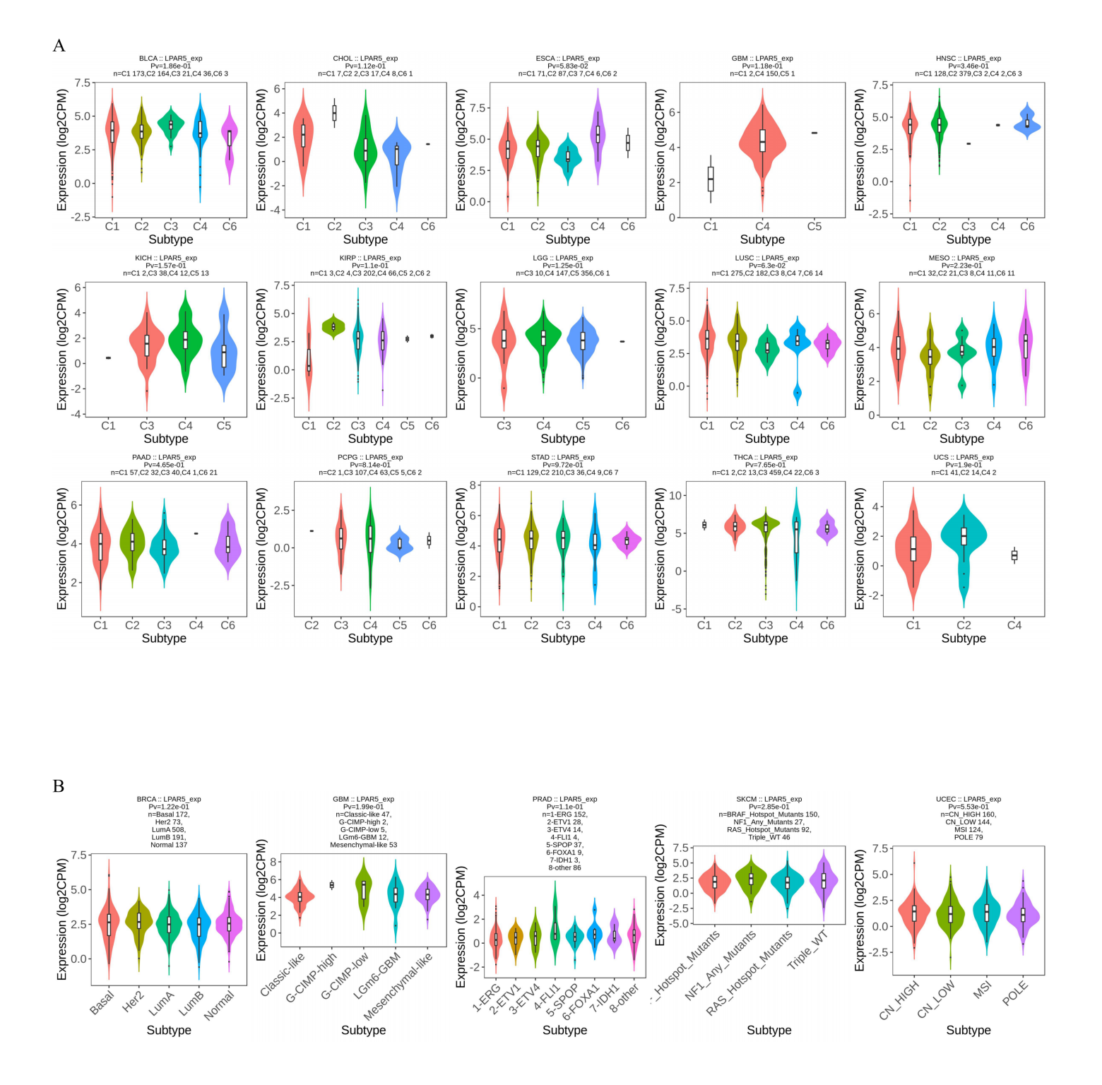

Additional file P6: The immune and molecular subtypes of the remaining cancers. (A) The immune subtype. (B) The molecular subtype. [Figures created by TISIDB database (http://cis.hku.hk/TISIDB/index.php)].

