High expression of RNF31 is associated with tumor immune cell infiltration and leads to poor prognosis in liver hepatocellular carcinoma

Guifu Xi^{1†}, Runfen Cheng^{2†}, Leiting Liang¹, Na Che¹, Yalei Wang², Nan Zhao¹, Xiaohui Liang¹, Bing Shao², Xiulan Zhao^{1*}, Danfang Zhang^{1*}

† These authors contributed equally to this work and share first authorship

1 Department of Pathology, Tianjin Medical University, Tianjin 300070, China

2 Tianjin Medical University Cancer Institute and Hospital, National Clinical Research Center for Cancer, Key Laboratory of Cancer Prevention and Therapy, Tianjin’s Clinical Research Center for Cancer, Tianjin 300060, China

*Correspondence:

Danfang Zhang, E-mail: zhangdf@tmu.edu.cn.

Xiulan Zhao, E-mail: zhaoxiulan@tmu.edu.cn.

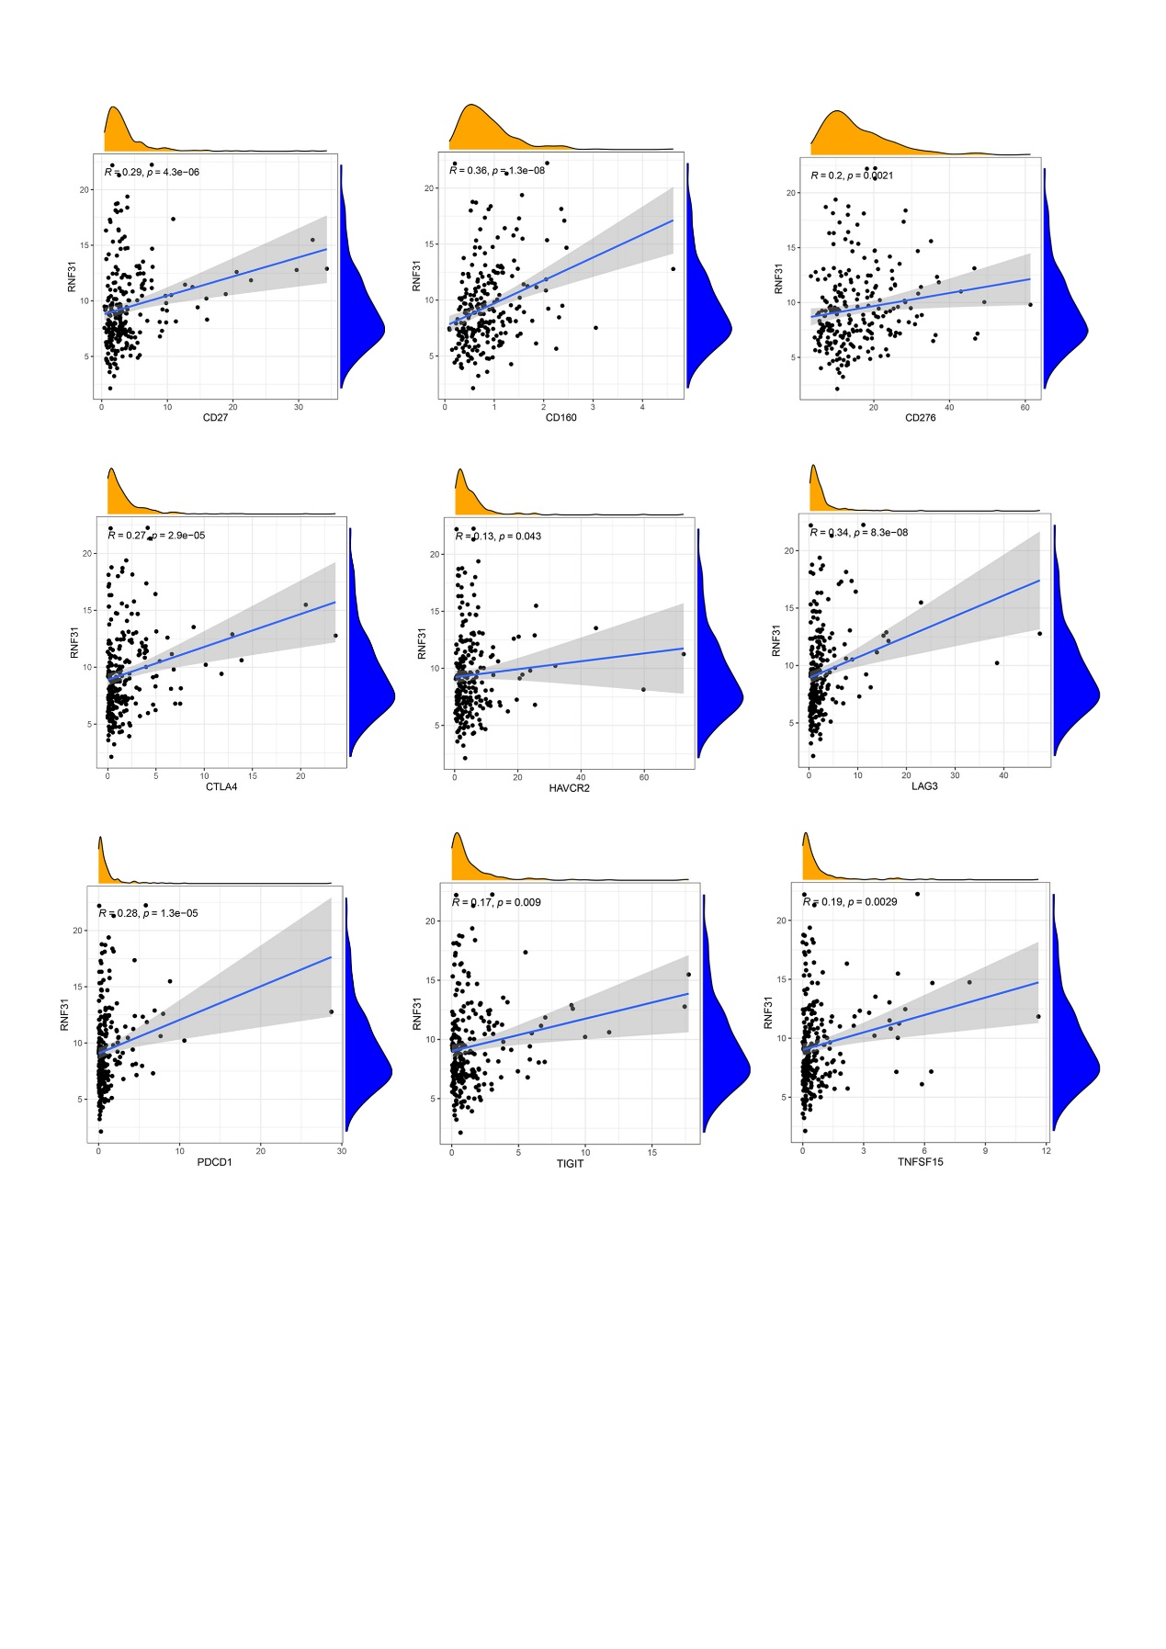
Supplementary Figure S1| A significant positive correlation between RNF31 and immune checkpoint genes.

