SUPPLEMENTARY MATERIAL
Whole Brain Analysis
A RM-ANCOVA controlling for TSPO genotype and age was conducted across 10 ROIs: amygdala, hippocampus, insula, temporal lobe, PFC, striatum, thalamus, ACC, occipital lobe, and cerebellum. Whole brain analysis revealed no main effect of group (F_{(1,35)}=1.007, p=0.323) and a marginal ROI*Group interaction (F_{(4.053, 141.868)}=1.535, p=0.194). PTSD participants had 14% higher TSPO binding compared to HC. Sensitivity analysis of the whole brain revealed similar results: no main effect of group (F_{(1,35)}=0.660, p=0.422) (PTSD participants had 9% higher TSPO binding compared to HC) and a marginal ROI*Group interaction (F_{(4.053, 141.868)}=2.140, p=0.091), where the largest group difference was observed in the amygdala (p=0.114).
Table S1: Whole Brain Analysis
ROI | Group | [¹⁸F]FEPPA V_{T} | % Difference | p value
Amygdala | PTSD | 9.84 | 30% | 0.107
Amygdala | HC | 7.52 | 30% | 0.107
Hippocampus | PTSD | 10.19 | 12% | 0.279
Hippocampus | HC | 8.87 | 12% | 0.279
Insula | PTSD | 10.75 | 6.5% | 0.596
Insula | HC | 10.08 | 6.5% | 0.596
Temporal Lobe | PTSD | 11.09 | 11.7% | 0.363
Temporal Lobe | HC | 9.93 | 11.7% | 0.363
Striatum | PTSD | 9.66 | 22% | 0.328
Striatum | HC | 8.5 | 22% | 0.328
Thalamus | PTSD | 12.84 | 13.2% | 0.322
Thalamus | HC | 11.34 | 13.2% | 0.322
ACC | PTSD | 10.47 | 15% | 0.356
ACC | HC | 9.22 | 15% | 0.356
Occipital Lobe | PTSD | 11.12 | 8.1% | 0.488
Occipital Lobe | HC | 10.29 | 8.1% | 0.488
PFC | PTSD | 11.13 | 16% | 0.406
PFC | HC | 10.03 | 16% | 0.406
Cerebellum | PTSD | 11.22 | 11.5% | 0.357
Cerebellum | HC | 10.06 | 11.5% | 0.357

Table S2: Participant Demographics: PTSD regular cannabis users vs. non-users
 | PTSD Non-users  n=12 | PTSD Cannabis Users  n=6 | p value
Age, years | 47±10.8 | 40±10.3 | 0.166
Sex, male n(%) | 3 (25) | 5 (83) | 0.027
NIH race, caucasian n (%) | 8 (66) | 6 (83) | 0.317
BMI | 27.4±3.3 | 24.77±3.5 | 0.203
TSPO genotype, HAB (%) | 6 (50) | 3 (50) | 0.858
Years of education | 15.9±2.9 | 15±1.7 | 0.543
Cigarette Smokers n (%) | 3 (25) | 0 (0) | 0.058
Positive THC on PET day n (%) | 7 (38) | 4(23) | 0.123
Alcohol drinks / week | 2.71±2.4 | 2.69±1.9 | 0.959
SSRI Users n(%) | 9 (75) | 1 (17) | 0.009
Co-morbid MDD n(%) | 3 (25) | 2 (33) | 0.793
History of TBI n(%) | 6 (50) | 2 (33) | 0.402
Questionnaires
BDI, mean ± SD | 24±13 | 20±10 | 0.580
GAD-7, mean ± SD | 10.45±6.4 | 7.75±3.6 | 0.450
PHQ-9, mean ±S D | 14.8±8.4 | 10±5.7 | 0.379
PCL, mean ± SD | 57.9±18.8 | 48.3±16.1 | 0.304
PSS, mean ± SD | 32.6±16.2 | 25.4±10.3 | 0.387
Values are mean +/- SD unless otherwise indicated
Body Mass Index (BMI); High Affinity Binder (HAB); Beck Depression Inventory (BDI); PTSD Symptom Scale (PSS); PTSD Checklist (PCL).

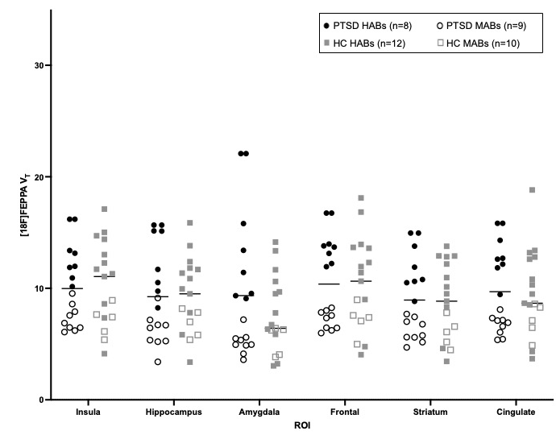
Figure S1: Sensitivity Analysis [18F]FEPPA V_{T} scatterplot. Capping the influential data point at the second highest value revealed no main effect of group (F_{(1,35)}=0.472, p=0.496) and a significant ROI*Group interaction (F_{(2.563, 89.704}=3.957, p=0.015). PTSD participants had a 29% higher TSPO binding compared to HC in the amygdala (p=0.114).

Figure S2: Scatter plot of cortisol concentrations between PTSD (n=18) and HC (n=20). Serum cortisol was marginally lower (p=0.077, % difference: -21%) in PTSD participants compared to HC participants.

