Supplementary figure 1. Imaging site for fluorescent pictures.
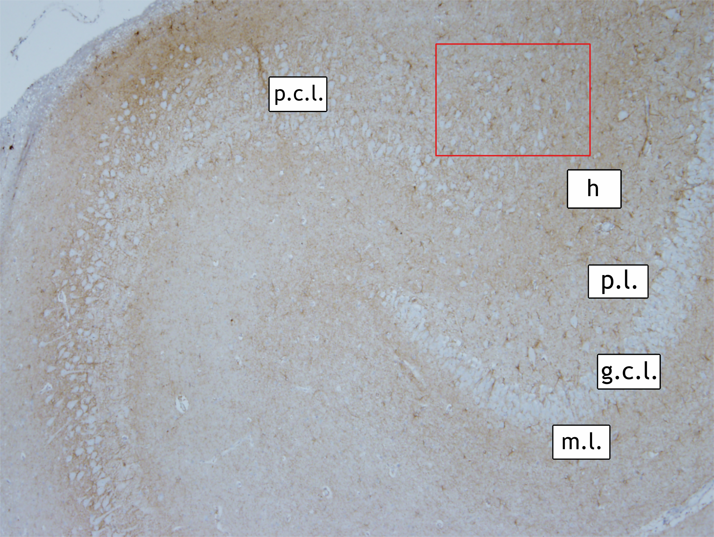
Red rectangle indicates where fluorescent pictures presented in the Figure 4 were captured. Depending on the slice, the pictures were taken either in the dorsal or in the ventral portion of the hippocampus. m.l. - molecular layer, g.c.l. – granular cell layer, p.l. – polymorphic layer, h – hilus, p.c.l. – pyramidal cell layer

Supplementary table 1. Patient information for control dogs included in the study.
Patient ID | Age (months) | Sex | Breed | Control type | General pathology | Days between death and tissue processing
21 | 2 | m/- | Pinscher | Patient | Right-sided aortic arch; ventricular septal defect | 1
22 | 5 | f/- | Labrador mixed breed | Patient | Multiple hematomas and hemorrhages; coagulation dysfunction, suspicion of intoxication | 1
23 | 18 | m/c | Mixed breed | Patient | Multiple hemorrhages; dermatitis, folliculitis, furunculosis, hyperkeratosis (Demodex canis); nephritis punctata | 3
24 | 23 | f/c | Mixed breed | Patient | Multifocal mineralization of dura mater (not clinically relevant); foreign bodies in stomach, gastritis; hyperplasia of lymph nodes and spleen | 1
25 | 32 | m/c | Great Dane | Patient | Right ventricle dilatation, myocardium fibrosis; lung hyperemia and alveolar edema | unknown
26 | 36 | m/- | Kangal | Patient | Lung hyperemia and alveolar edema | 1
27 | 36 | m/- | German Spaniel | Patient | Plasmocytoma (humerus) | unknown
28 | 38 | m/- | Mixed breed | Patient | unknown | unknown
29 | 48 | f/c | Bernese Mountain Dog mixed breed | Patient | Lung hyperemia and alveolar edema | 1
30 | 60 | m/- | German Shepherd | Patient | Acute dilatation of right atrium; multiple organ congestion; pulmonary alveolar edema and emphysema; multifocal hemorrhages in cutaneous and subcutaneous layers | 1
31 | 66 | f/- | German Shepherd | Patient | Multiple organ congestion, erythrophagocytosis | 1
32 | 96 | f/- | Pekingese | Patient | Pyelonephritis, sepsis | unknown
33 | 108 | f/c | Kuvasz | Patient | Gonarthritis purulenta, phlegmona in the wound area | 0
34 | 120 | f/- | American Cocker Spaniel | Patient | Moderate hepatonecrosis, purulent inflammation; adenocarcinoma (mammary gland), leiomyoma in myometrium and hyperplasia of endometrium | 1
35 | 132 | m/- | Collie | Patient | Carcinoma with angiosis carcinomatosa (thyroid gland), Leydig cell tumour (both testicles), nodular spleen hyperplasia, follicular gastritis | 2
36 | 132 | f/- | Mixed breed | Patient | Hemangiosarcoma (heart - right auricle, spleen), leiomyoma (uterus), cystadenoma (mammary gland), multiple metastases in lungs; high degree of pancreas atrophy | 2
37 | 140 | m/c | German Shepherd | Patient | Splenic and gastric torsion; pulmonary alveolar edema and emphysema | 3
38 | 180 | m/- | Standard Long-haired Dachshund | Patient | Peridontitis, rhinitis, hepatitis, hepatolipidosis, focal pneumonia, endocardiosis | 1
39 | 12 | m/- | Beagle | Experimental | Infection with Angiostrongylus vasorum | unknown
40 | 12 | w/- | Beagle | Experimental | Infection with Angiostrongylus vasorum | unknown
41 | 12 | w/- | Beagle | Experimental | Infection with Angiostrongylus vasorum | unknown
42 | 12 | w/- | Beagle | Experimental | Infection with Angiostrongylus vasorum | unknown
43 | 12 | m/- | Beagle | Experimental | Infection with Angiostrongylus vasorum | unknown
44 | 4 | m/- | Beagle | Experimental | Infection with Angiostrongylus vasorum | unknown
45 | 4 | w/- | Beagle | Experimental | Infection with Toxocara canis and Uncinaria stenocephala, intermittent diarrhea | unknown
46 | 4 | m/- | Beagle | Experimental | Infection with Toxocara canis and Uncinaria stenocephala, intermittent diarrhea | unknown
47 | 4 | w/- | Beagle | Experimental | Infection with Toxocara canis and Uncinaria stenocephala, intermittent diarrhea | unknown
48 | 4 | w/- | Beagle | Experimental | Infection with Toxocara canis and Uncinaria stenocephala, intermittent diarrhea | unknown
49 | 4 | m/- | Beagle | Experimental | Infection with Toxocara canis and Uncinaria stenocephala, intermittent diarrhea | unknown
50 | 4 | m/- | Beagle | Experimental | Infection with Toxocara canis and Uncinaria stenocephala, intermittent diarrhea | unknown

Clinically relevant information regarding canine patients without CNS disease and experimental controls.
m/- - male, not castrated; f/- - female, not castrated; m/c – male, castrated; f/c – female, castrated

