Online Supplement

Acute and Long-Term Effects of Cannabinoids on Hypertension and Kidney Injury

Daria Golosova^{1,*}, Vladislav Levchenko², Olha Kravtsova², Oleg Palygin^{1,3}, Alexander Staruschenko^{1,2,4,5*}

From the ¹Department of Physiology, Medical College of Wisconsin, Milwaukee, WI 53226, USA; ²Department of Molecular Pharmacology and Physiology, University of South Florida, Tampa, FL 33602, USA; ³Division of Nephrology, Department of Medicine, Medical University of South Carolina, Charleston, SC 29425, USA; ⁴Hypertension and Kidney Research Center, University of South Florida, Tampa, FL 33602, USA; ⁵Clement J. Zablocki VA Medical Center, Milwaukee, WI 53295, USA

*To whom correspondence should be addressed
Alexander Staruschenko, PhD; Department of Molecular Pharmacology and Physiology, University of South Florida, 560 Channelside Dr., Tampa, FL 33602, USA. E-mail: staruschenko@usf.edu
Daria Golosova, MD, PhD; Department of Physiology, Medical College of Wisconsin, 8701 Watertown Plank Road, Milwaukee, WI 53226, USA. Phone: (414) 955-7415; E-mail: dgolosova@mcw.edu

Supplementary Table S1. Urinary excretion of ions in SS rats with or without chronic treatment with the 0.05 mg/kg of AEA within 14 days on HS.
Urinary ion excretion, mmol per day | 7DHS+Vehicle | 7DHS+AEA (0.05 mg/kg)
Potassium | 1.02±0.03 | 1.21±0.09
Sodium | 25±1 | 25±2
Calcium | 0.16±0.04 | 0.15±0.02
Chloride | 25±1 | 25±2
14DHS | 14DHS+Vehicle | 14DHS+AEA (0.05 mg/kg)
Potassium | 1.20±0.05 | 1.09±0.11
Sodium | 23.1±0.4 | 18±2
Calcium | 0.15±0.01 | 0.11±0.01
Chloride | 23.0±0.3 | 18±2

7DHS, 14DHS – 7 days and 14 days on HS (8% NaCl). Data are presented as means ± SE. n ≥ 5 rats for each group; t-test *P < 0.05. Urine samples were collected for 24 hrs.

Supplementary Table S2. Urinary excretion of ions in SS rats with or without chronic treatment with the 3 mg/kg of AEA within 14 days on HS.

Urinary ion excretion, mmol per day | 7DHS+Vehicle | 7DHS+AEA (3 mg/kg)
Potassium | 1.10±0.03 | 0.98±0.05
Sodium | 21±1 | 20±1
Calcium | 0.13±0.01 | 0.15±0.02
Chloride | 20±1 | 20±2
14DHS | 14DHS+Vehicle | 14DHS+AEA (3 mg/kg)
Potassium | 1.23±0.04 | 1.05±0.08
Sodium | 22±1 | 20±2
Calcium | 0.16±0.01 | 0.14±0.02
Chloride | 22±1 | 19±2

7DHS, 14DHS – 7 days and 14 days on HS (8% NaCl). Data are presented as means ± SE. n ≥ 8 rats for each group; t-test *P < 0.05. Urine samples were collected for 24 hrs.

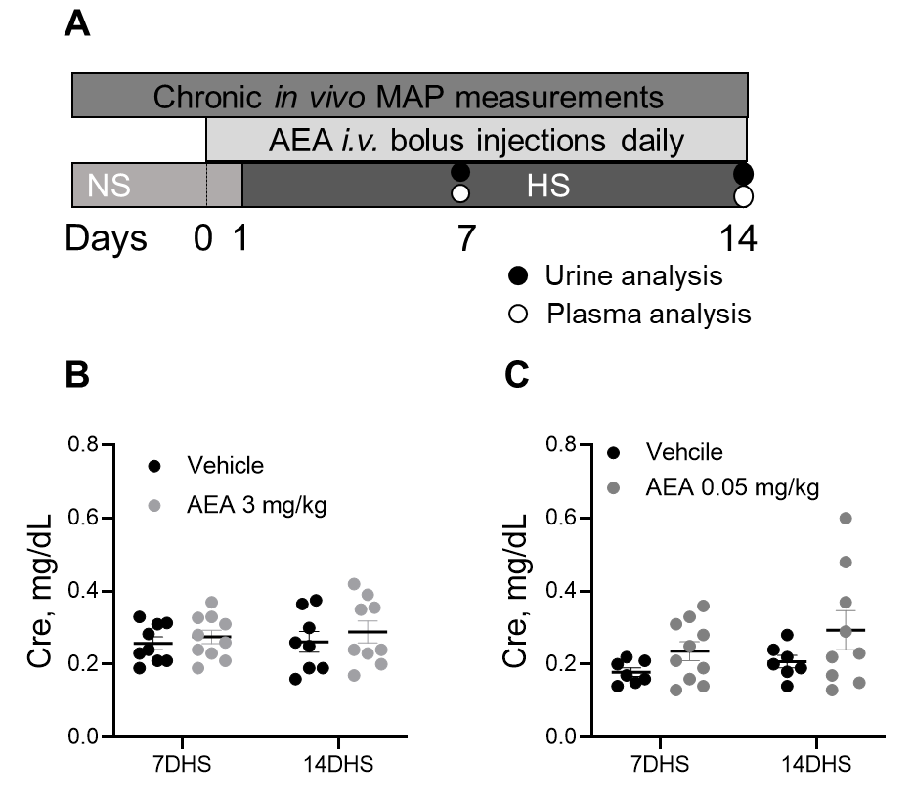
Supplementary Figure S1. Schematic representation of the experimental protocol. A. Chronic treatment with AEA in SS rats following a change in a diet from a normal salt (NS; 0.4 % NaCl) to a high salt (HS; 8% NaCl) and chronically treated with AEA or vehicle. The drug was injected starting day 0 (NS). B, C. Plasma creatinine levels in both groups treated with AEA.

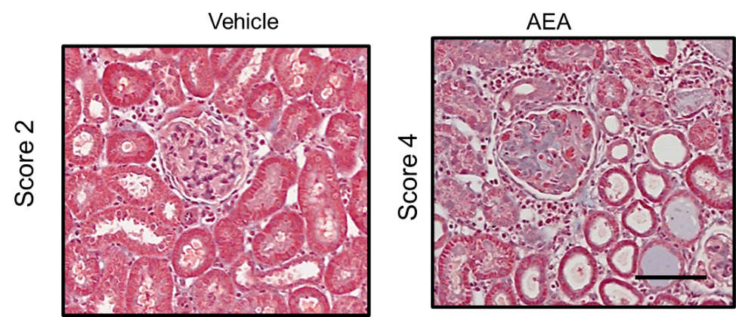

Supplementary Figure S2. Representative images of kidney tissue stained with Masson’s trichrome (×40 magnification). Glomeruli damage score in a group treated either with AEA 3mg/kg or a corresponding vehicle. Scale bar is 150 µm.
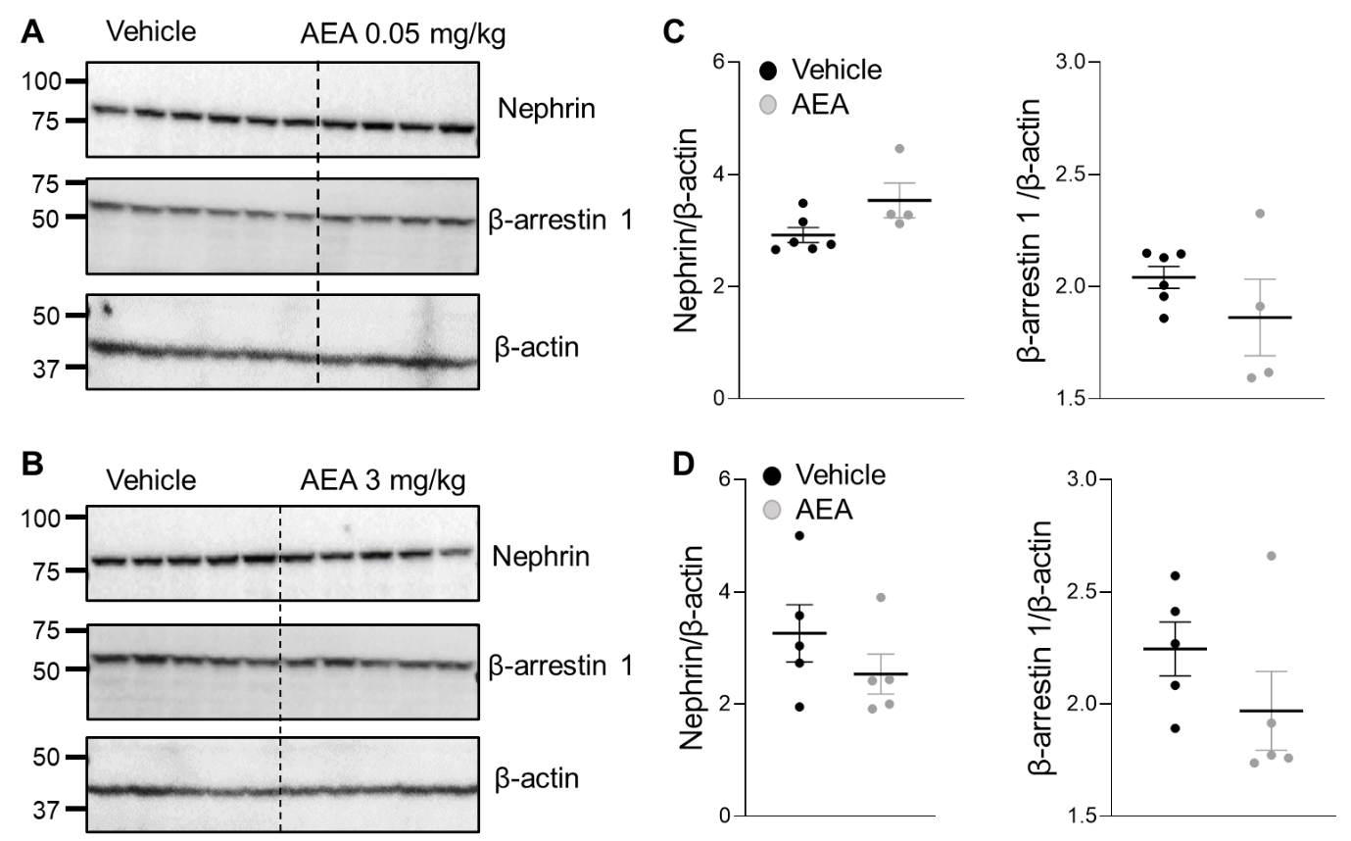

Supplementary Figure S3. The effect of anandamide on the expression of nephrin and β-arrestin 1 in the kidney. Representative Western blots showing renal expression of nephrin and β-arrestin 1 in the kidney cortex after chronic treatment with AEA at a dose 0.05 mg/kg (A) and 3 mg/kg (B). The summary quantitative data graphs show changes in nephrin and β-arrestin 1 normalized to β-actin after chronic treatment with AEA at a dose 0.05 mg/kg (C) and 3 mg/kg (D). Error bars are ± SEM. Full-length blots are available in Supplementary Figure S7.

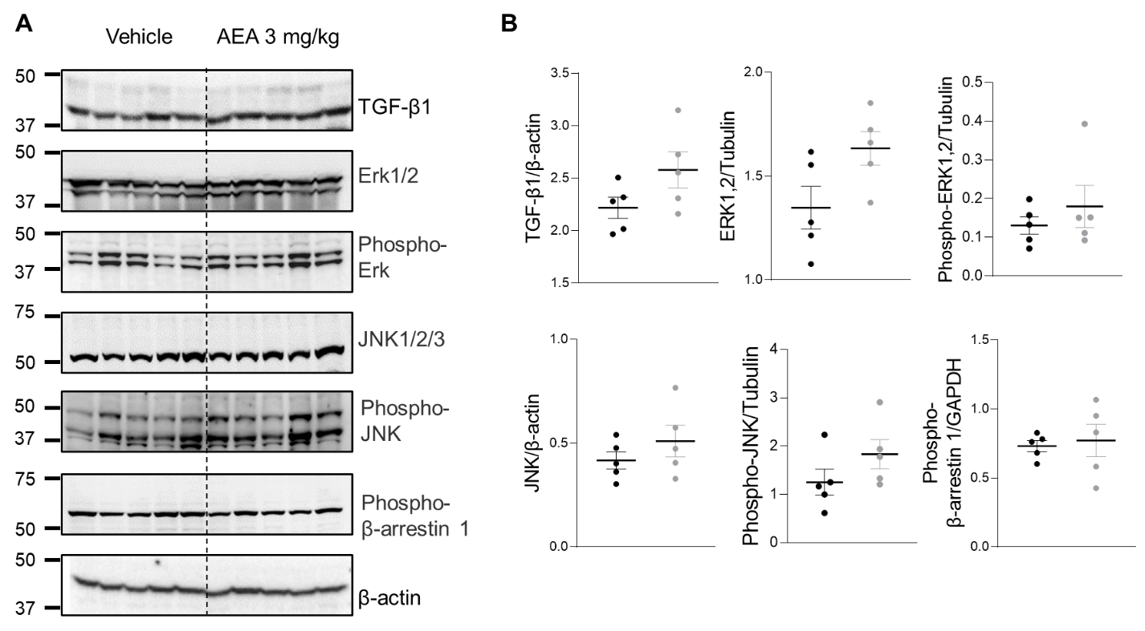

Supplementary Figure S4. Chronic treatment with AEA at a dose of 3 mg/kg does not lead to any changes in TGF-β1 expression in renal cortex. (A) Western blots showing renal expression of TGF-β1, Erk1/2, JNK1/2/3, phospho-JNK, phospho-β-arrestin 1 after chronic treatment with a high dose of AEA. (B) Quantitative data showing renal expression of TGF-β1, Erk1/2, phospho-Erk1/2, JNK1/2/3, phospho-JNK, phospho-β-arrestin 1 normalized to a corresponding loading control in the kidney cortex after chronic treatment with AEA at a dose 3 mg/kg. Uncropped blots are presented in Supplementary Figure S8.

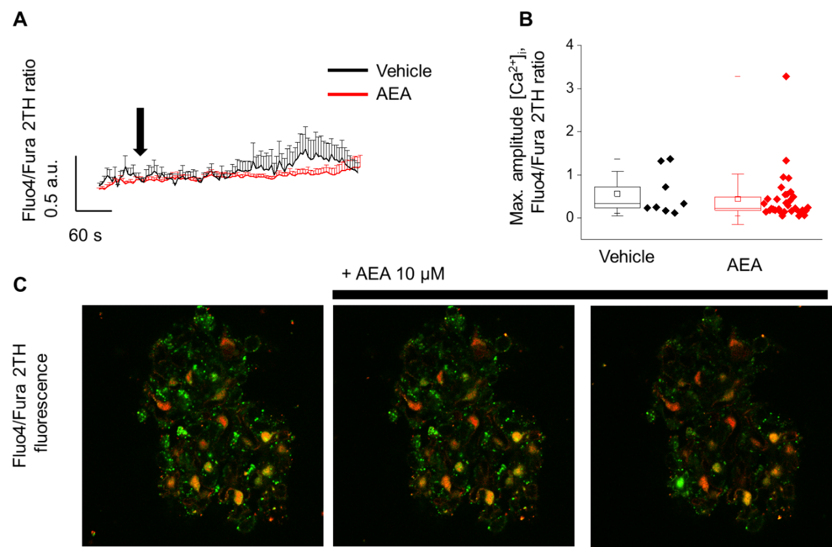

Supplementary Figure S5. Acute application of AEA does not change [Ca²⁺]_{i} levels in podocytes from freshly isolated rat glomeruli. A. The example of [Ca²⁺]_{i} levels after an application of 10 µM of AEA in podocytes from freshly isolated glomeruli from SS rats. B. Summary for the peak fluorescence intensity following an application of AEA. C. Representative image of a glomerulus loaded with ratiometric calcium dyes (Fluo4/Fura 2TH; merged) before and after the application of AEA. The ratiometric fluorescence intensity values (Fluo4/Fura 2TH) were calculated by selecting podocytes as regions of interest in Fiji, and baseline correction was performed in OriginPro 9.0.

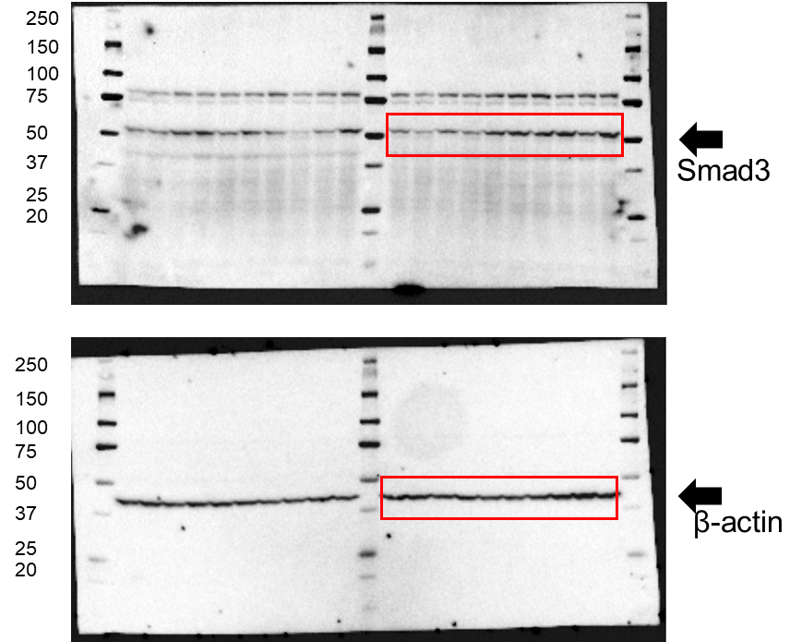
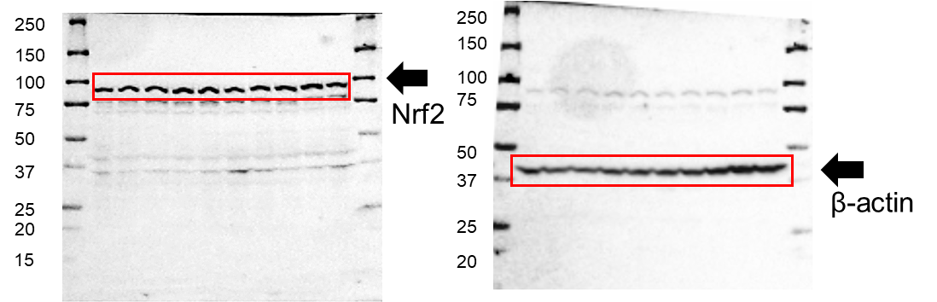

Supplementary Figure S6. Full-length uncropped blots showing Smad3 and Nrf2 protein expression demonstrated in Figure 6.

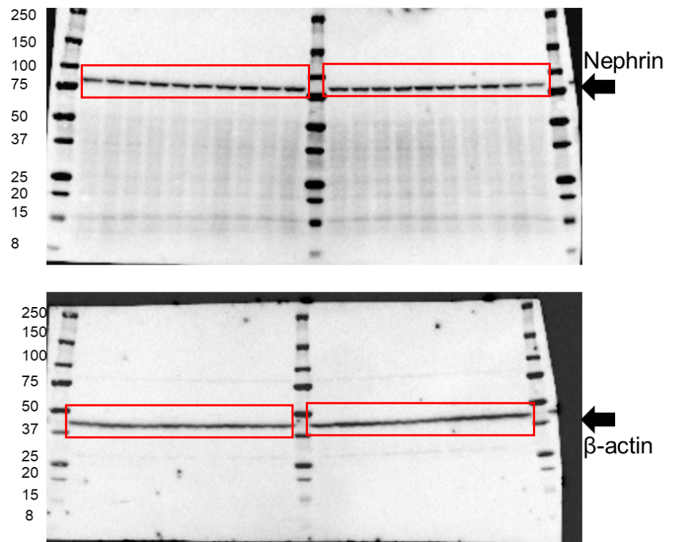
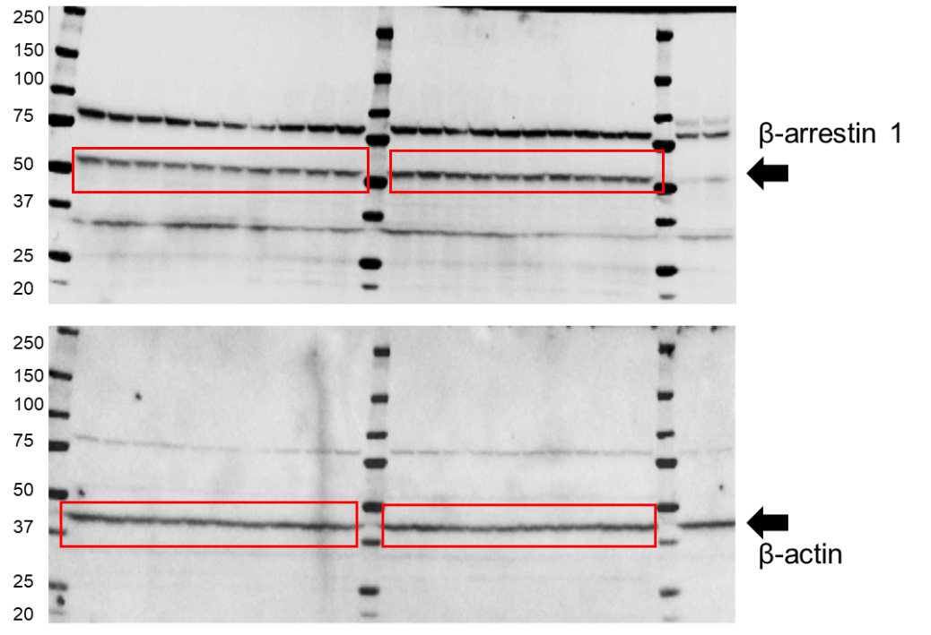

Supplementary Figure S7. Full-length uncropped blots showing expression of nephrin and β-arrestin 1 in Supplementary Figure S3.
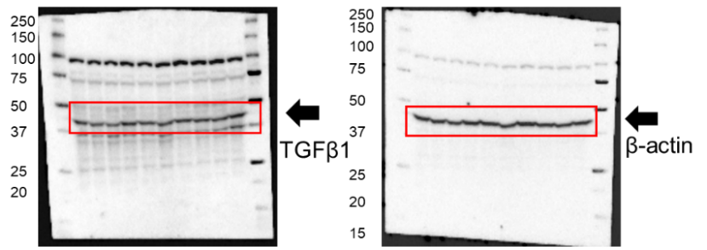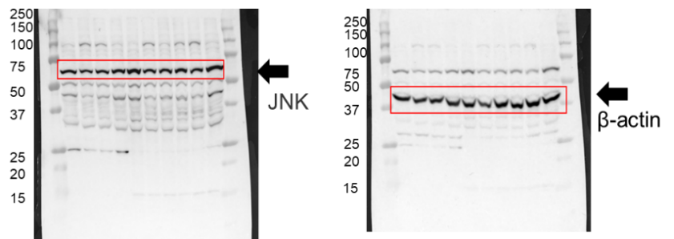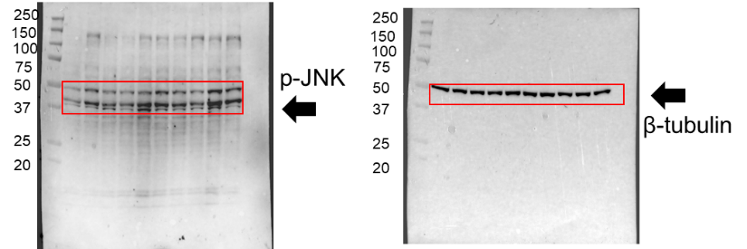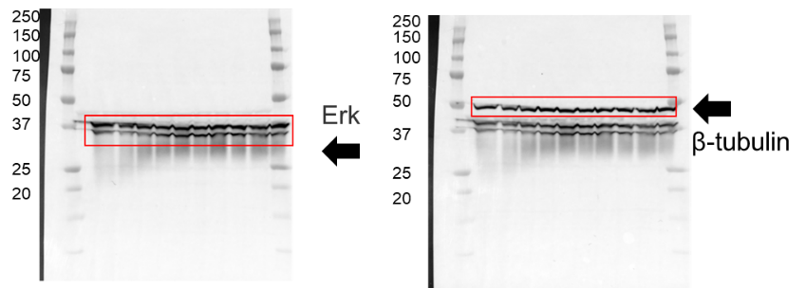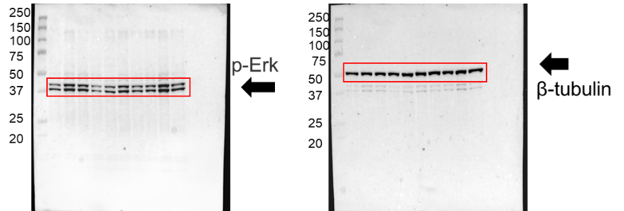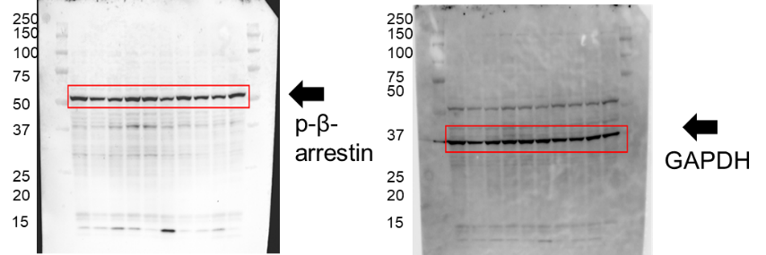
Supplementary Figure S8. Full-length uncropped blots showing expression of TGF-β1, TGF-β1, Erk1/2, phospho-Erk1/2, JNK1/2/3, phospho-JNK, phospho-β-arrestin 1 after chronic treatment with a high dose of AEA represented in Supplementary Figure S4

