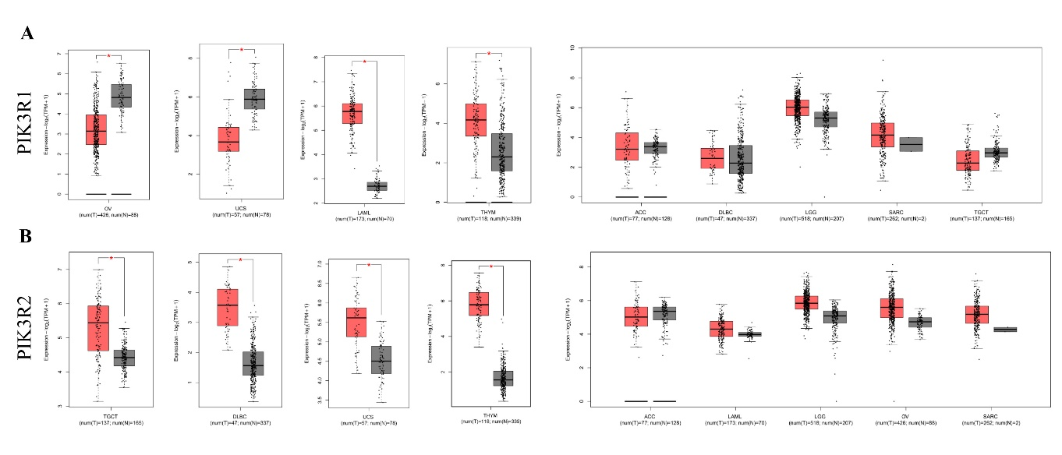
Figure S1| Expression level of PIK3R1 and PIK3R2 in different tumors. (A) Expression level of PIK3R1 in OV, UCS, LAML, THYM, ACC, DLBC, LGG, SARC, TGCT of TCGA was compared with the corresponding normal tissues in GTEX data via GEPIA database. *p < 0.05. (B) Expression level of PIK3R2 in TGCT, DLBC, UCS, THYM, ACC, LAML, LGG, SARC of TCGA was compared with the corresponding normal tissues in GTE data via GEPIA database, *p < 0.05.
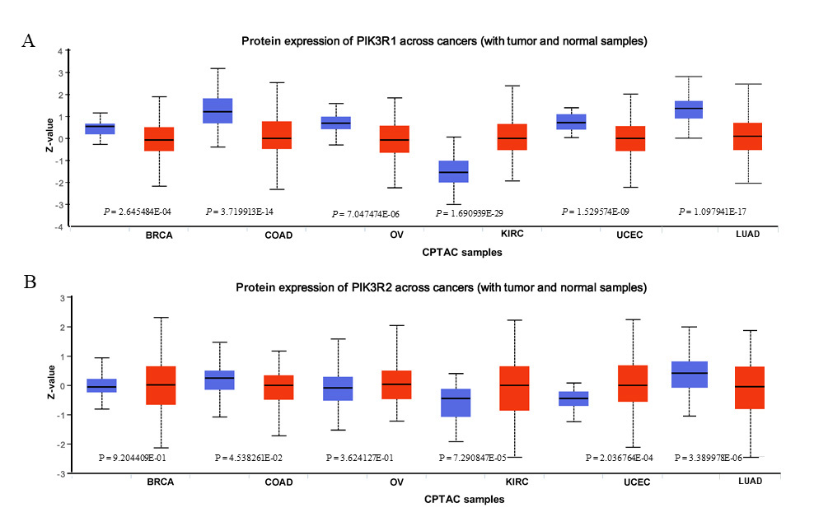
Figure S2 | Proteomic expression levels of PIK3R1 and PIK3R2 in different tumors. (A) Protein expression of PIK3R1 was compared with normal samples and BRCA, COAD, OV, KIRC, UCEC, LUAD by UALCAN database. (B) Protein expression of PIK3R2 was compared with normal samples and BRCA, COAD, OV, KIRC, UCEC, LUAD by UALCAN database.

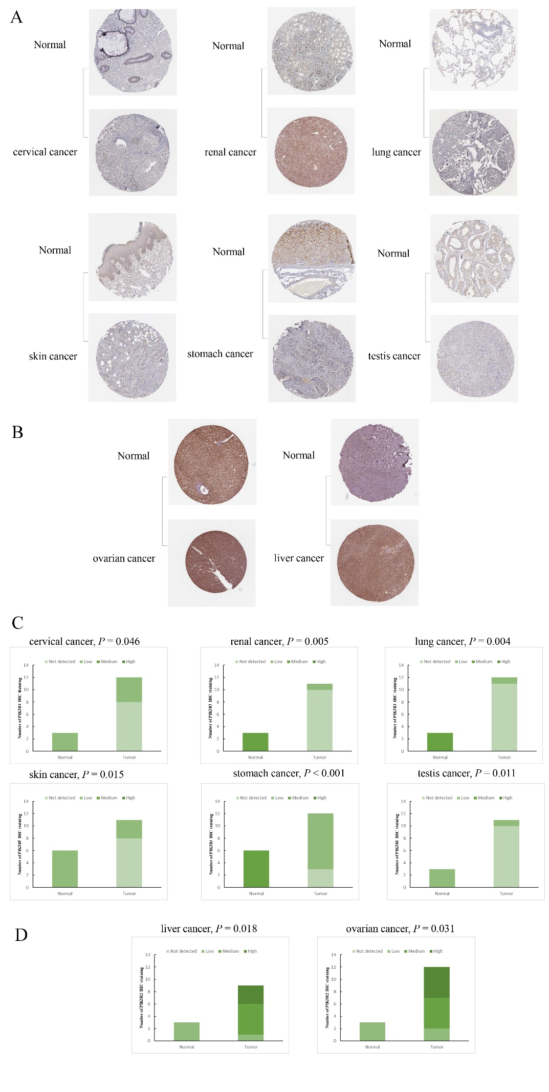
Figure S3 | The protein expression of PIK3R1 and PIK3R2 in normal and cancer tissues. (A) Immunohistochemistry images of PIK3R1 in cervical cancer, renal cancer, lung cancer, skin cancer, stomach cancer and testis cancer as well as normal tissues from the HPA database. (B) Immunohistochemistry images of PIK3R2 in liver cancer and ovarian cancer as well as normal tissues from the HPA database. (C) Statistical analysis of PIK3R1 immunohistochemical staining data in normal tissues and cervical cancer, renal cancer, lung cancer, skin cancer, stomach cancer, testis cancer tissues. (D) Statistical analysis of PIK3R2 immunohistochemical staining data in normal tissues and liver cancer, ovarian cancer tissues.
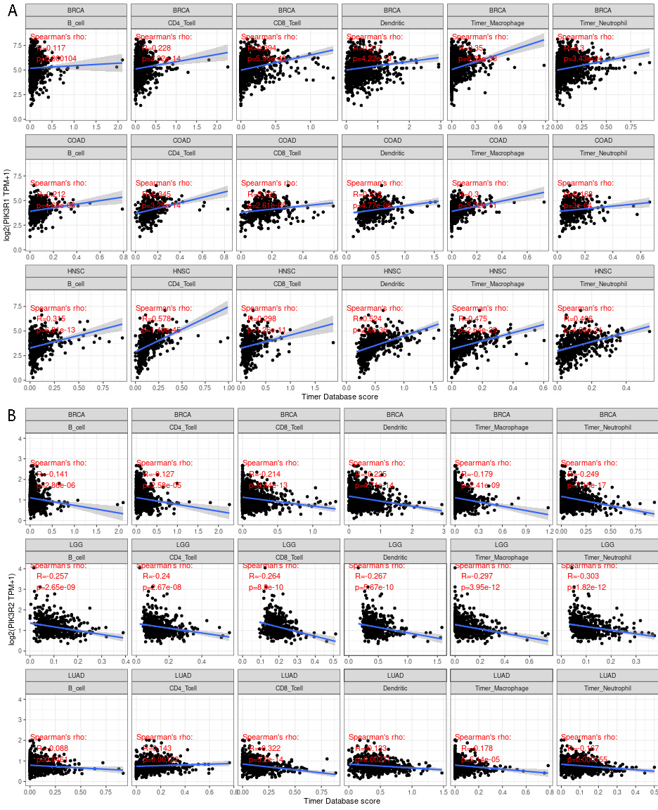
Figure S4 | The correlation between immune infiltration level and the expression of PIK3R1 and PIK3R2 in the top three tumors. (A) Correlation of PIK3R1 expression with immune infiltration level in BRCA, COAD, HNSC. (B) Correlation of PIK3R2 expression with immune infiltration level in BRCA, LGG, LUAD.

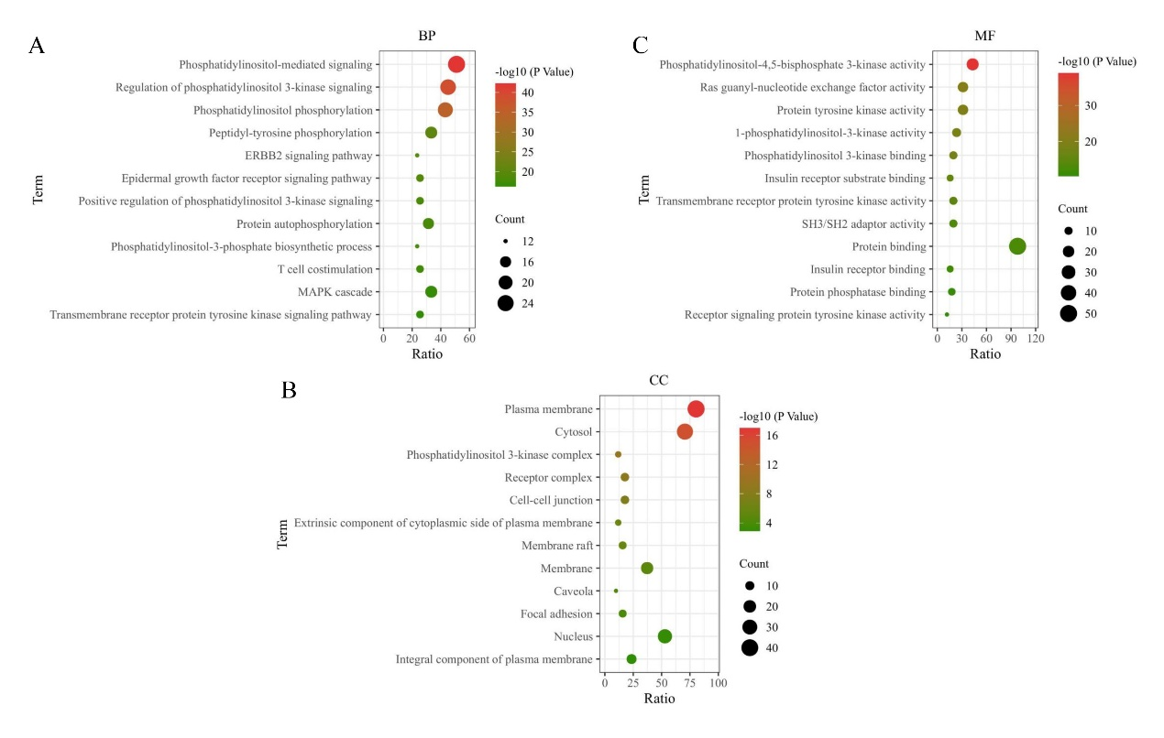
Figure S5 | GO analysis of the related genes of PIK3R1 and PIK3R2. We performed the GO enrichment analysis on 52 co-expressed genes via DAVID tool. The bubble chart showed the most highly enriched items of BP (A), CC (B), MF (C) in tumors, respectively.

