Supplementary Figure 1

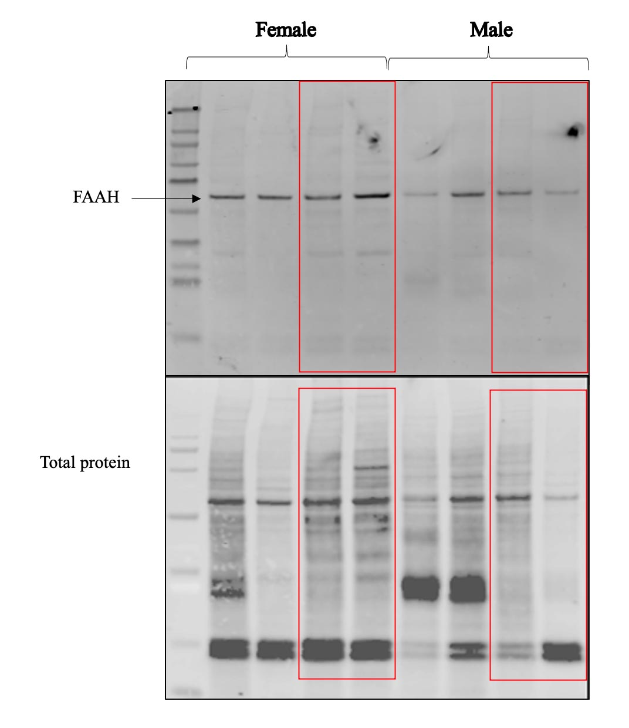
Supplementary Figure 1. FAAH protein in male vs. female submandibular gland. A protein band is detected at the expected molecular weight (~63kda). Bottom panel shows total protein.

