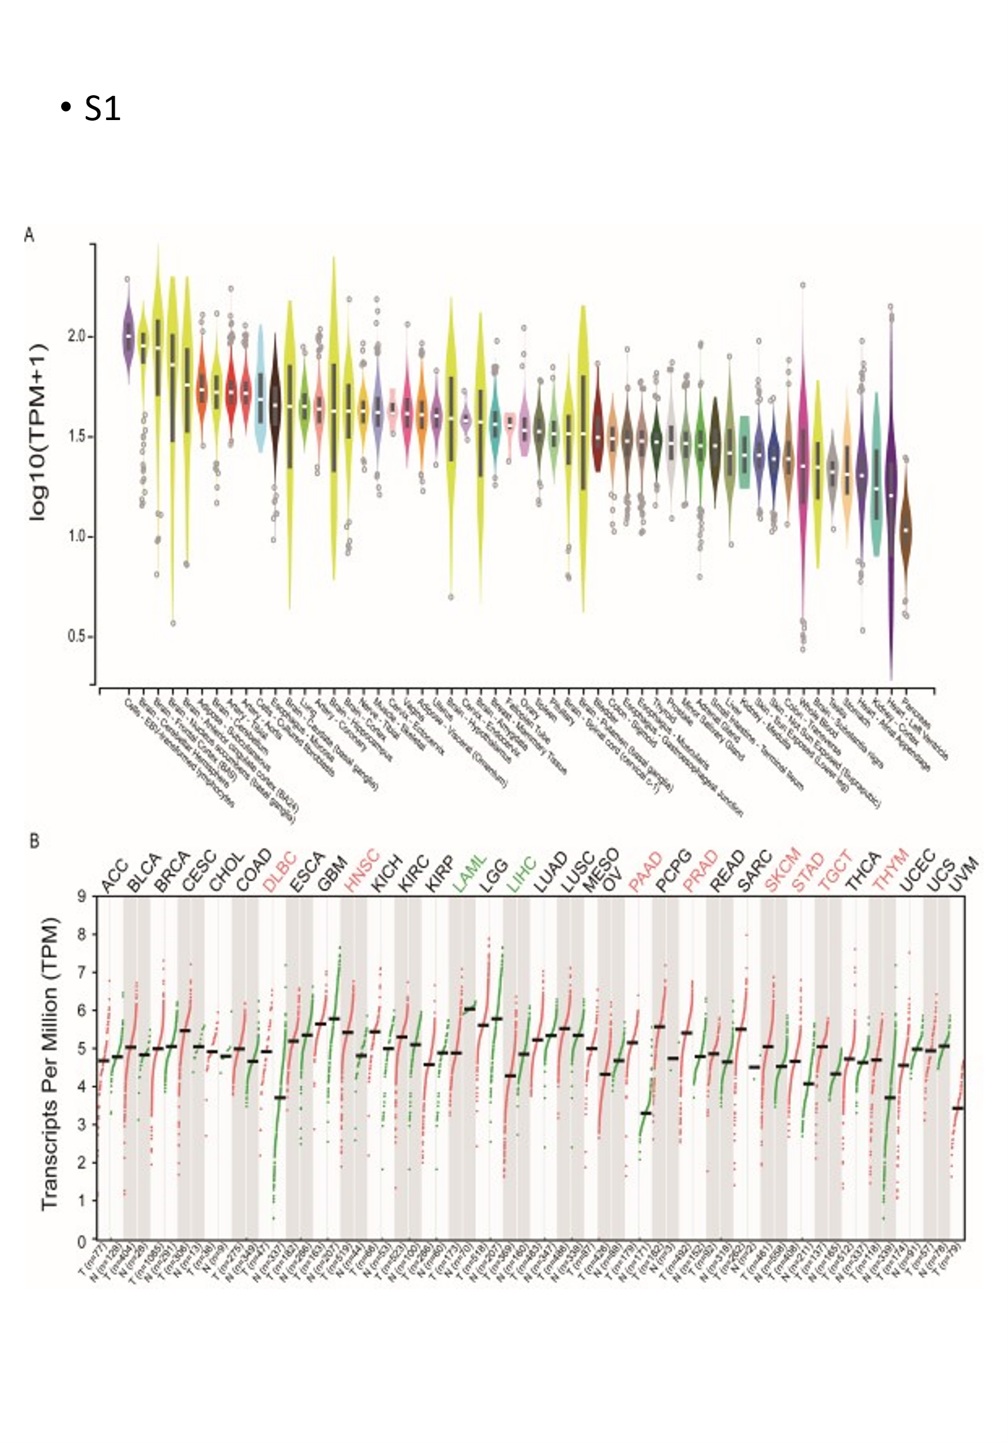
Supplementary Figure S1. MEK1 expression in different tissues. (A) MEK1 expression in normal tissues. (B) MEK1 expression between 32 types of tumor and paired normal tissues.

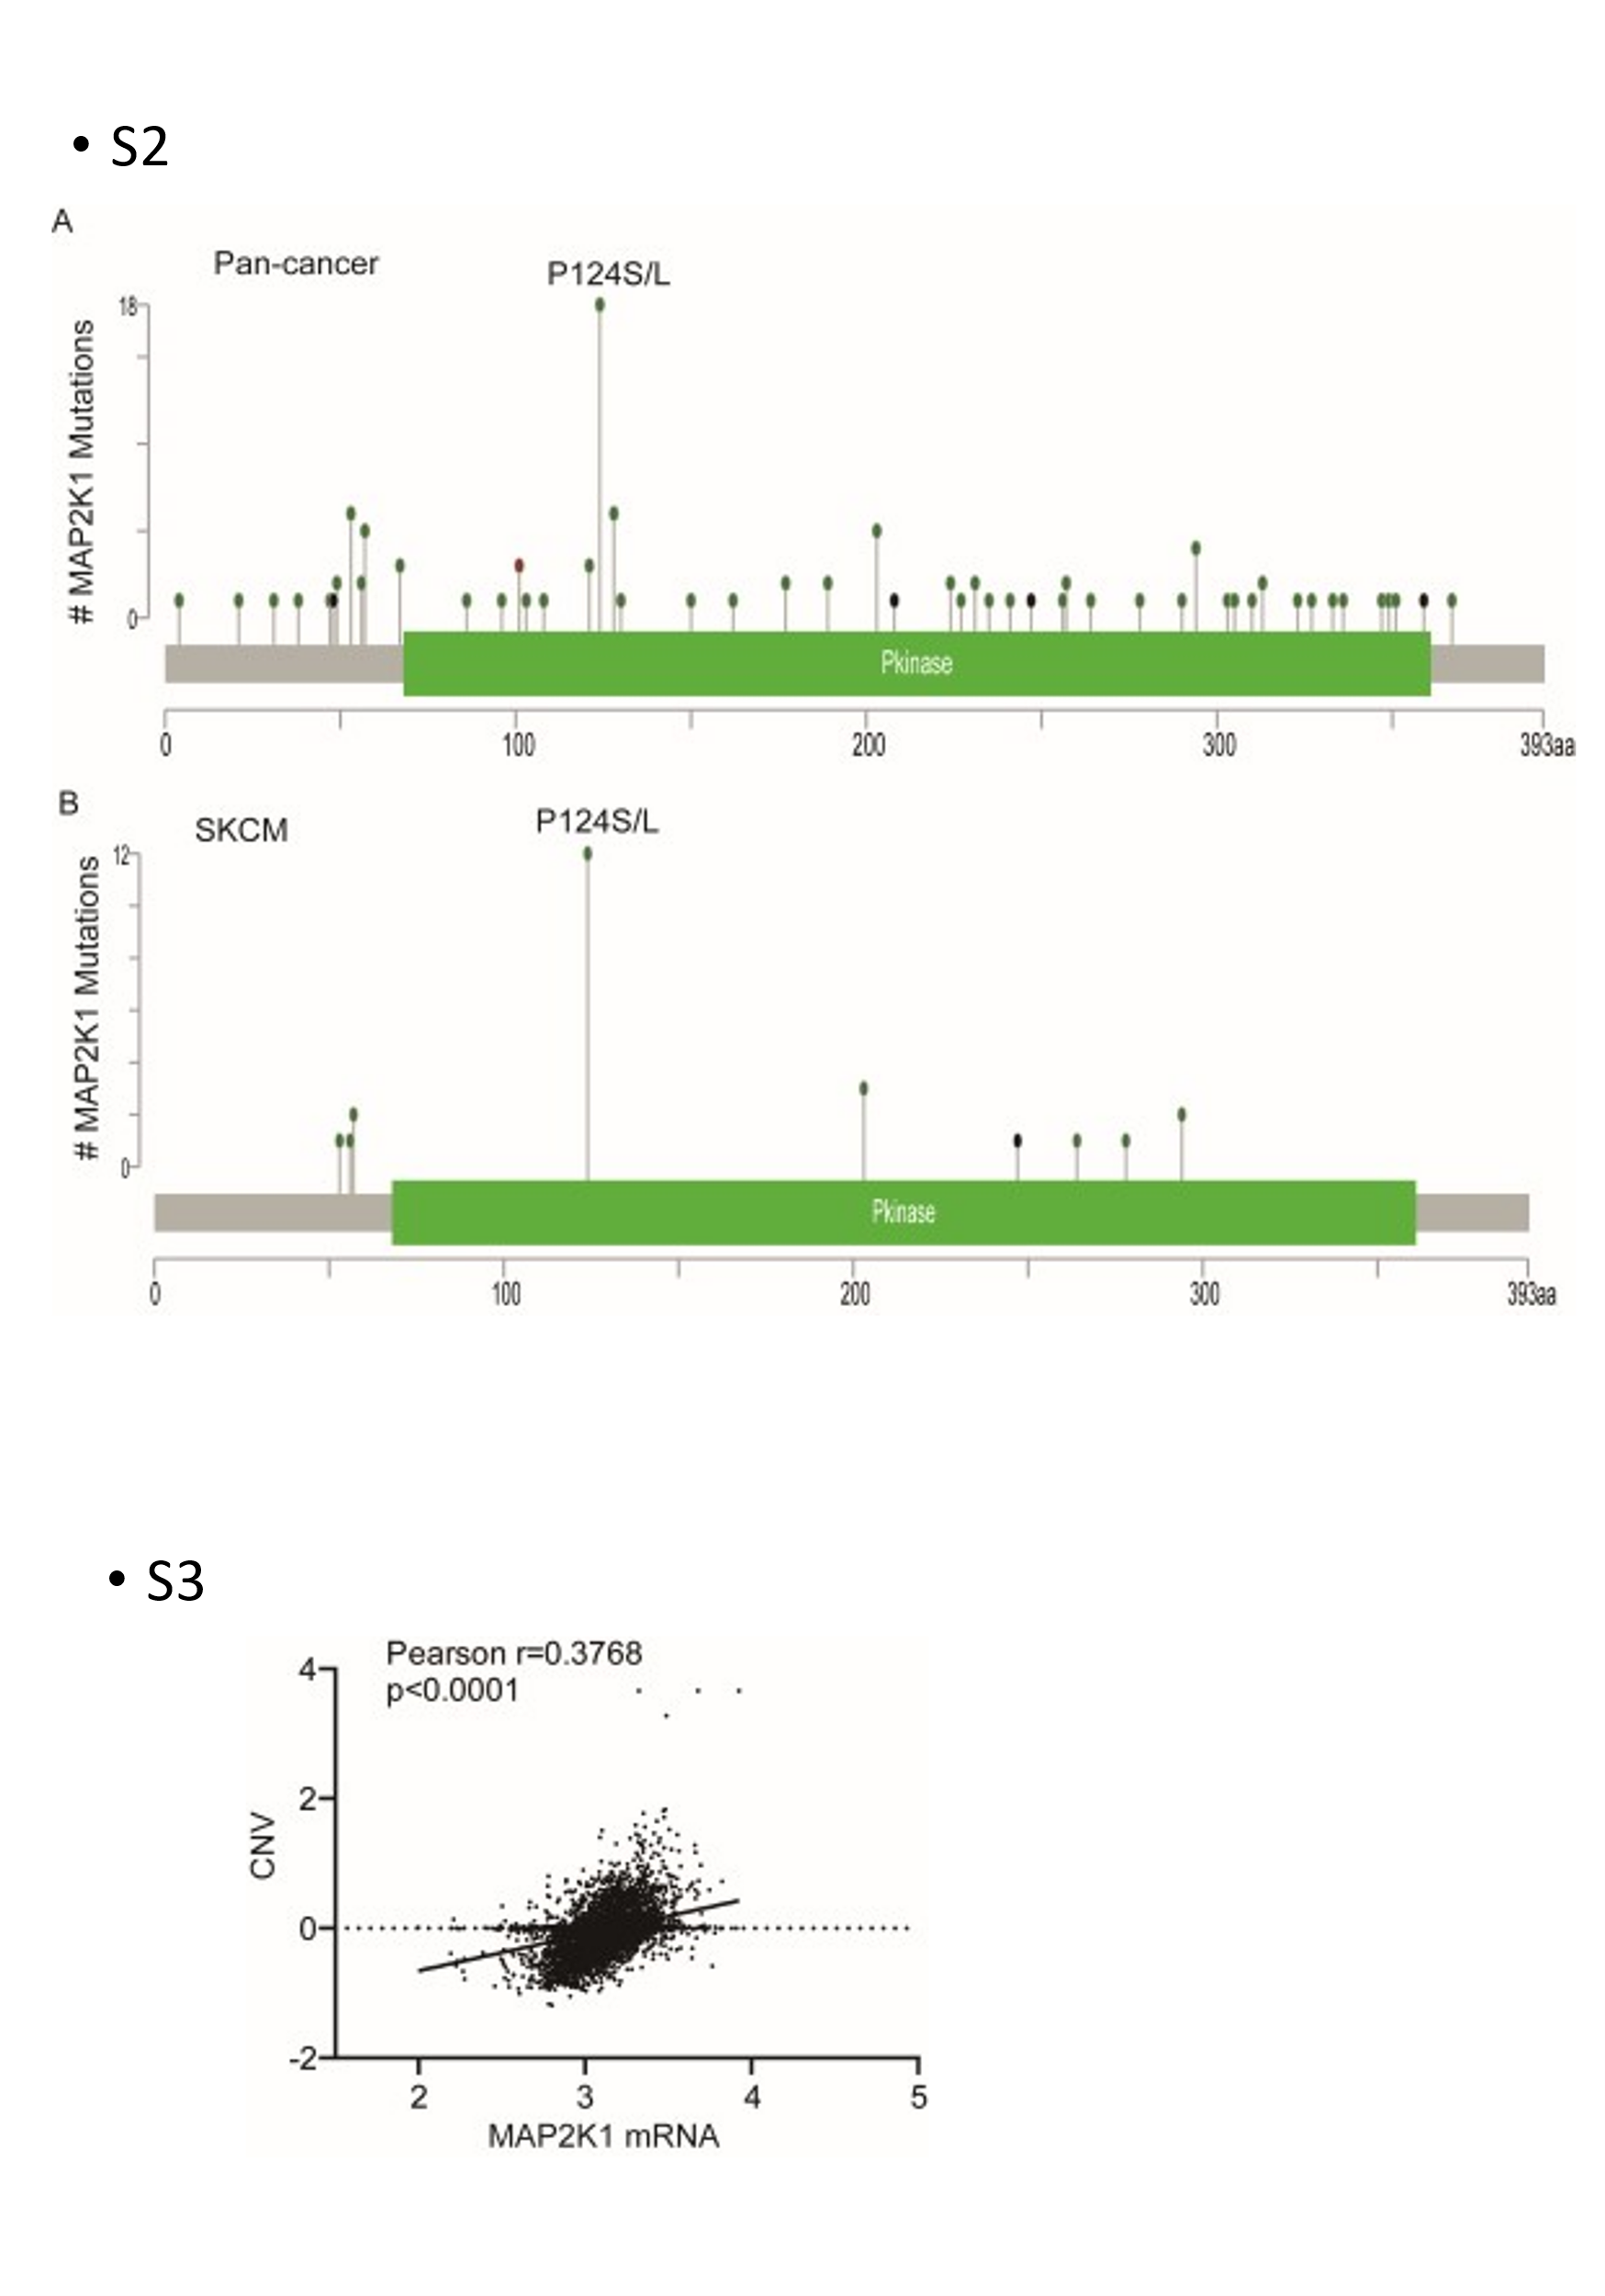
Supplementary Figure S2. MEK1 distribution of mutation sites. (A) MEK1 mutation site distribution in pancancer. (B) MEK1 mutation site distribution in skin cutaneous melanoma (SKCM).
Supplementary Figure S3. MEK1 mRNA expression was significantly correlated with MEK1 copy number variant (CNV).
Supplementary Table 1. Somatic mutation distribution in different functional domains
 | Pkinase: protein kinase domain (68－361) | other | total
Pan-cancer | 78 | 30 | 108
GBM
LGG
LUAD | 6 | 3 | 9
LUSC | 5 |  | 5
STAD | 7 |  | 7
HNSC | 4 | 1 | 5
SKCM | 25 | 5 | 30
COADRE | 6 | 7 | 13
THYM |  | 1 | 1
UCEC | 12 | 2 | 14
THCA | 1 |  | 1
ESCA | 2 | 1 | 3
PCPG |  | 1 | 1
CHOL | 1 |  | 1
LIHC | 1
CESC | 3 | 4 | 71
OV | 1 | 1 | 2
KIRC |  | 1 | 1
SARC
BLCA | 1 | 1 | 2
TGCG
PRAD
PAAD
BRCA | 3 | 2 | 5
KIRP

