Delta-9-tetrahydrocannabinol inhibits invasion of HTR8/SVneo human extravillous trophoblast cells and negatively impacts mitochondrial function

Supplementary Material

O’Llenecia S. Walker¹, Harmeet Gurm¹, Reeti Sharma², Navkiran Verma², Linda L May², Sandeep Raha^{1, *}

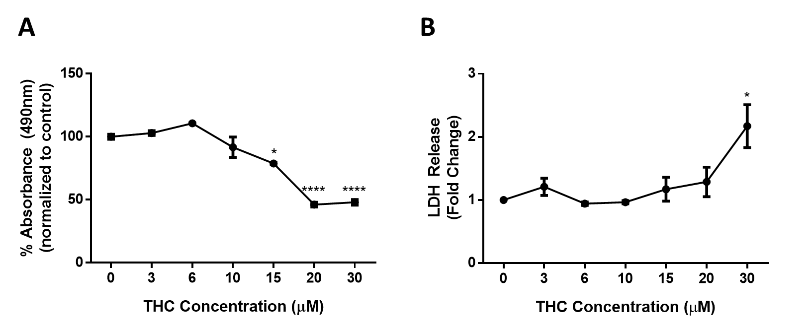

Figure S1. THC negatively impacts HTR8/SVneo cells viability and plasma membrane integrity. HTR8/SVneo cells were treated with THC as indicated for 48 hours and subjected to MTS (A) and LDH (B) assays. Each data point represents the mean ± SEM of 3 biological replicates measured at 490nm (MTS) or 490nm and 680nm (LDH). Significant differences were determined by a one-way ANOVA followed by a Bonferroni post hoc test. *P < 0.05; ****P < 0.0001, relative to control.

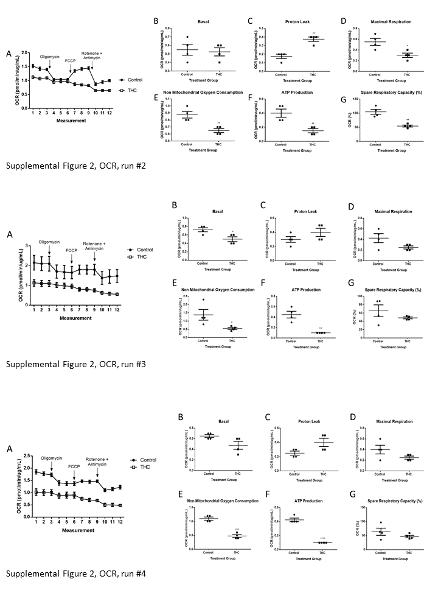

Figure S2. Mitochondrial respiration indices are impaired in HTR8/SVneo cells upon 48-hour exposure to 20 µM THC (experiments 2-4). (A) Representative mitochondrial profile. (B-G) Mitochondrial parameters as indicated. The detection of OCR was performed with 4 biological replicates per experiment, for each treatment condition, and repeated 3 more times. Individual data (B-G), group mean and SEM (A-G) are shown. Significance was assessed by Student’s t-test (*P < 0.05, **P < 0.01, ***P < 0.001).

A
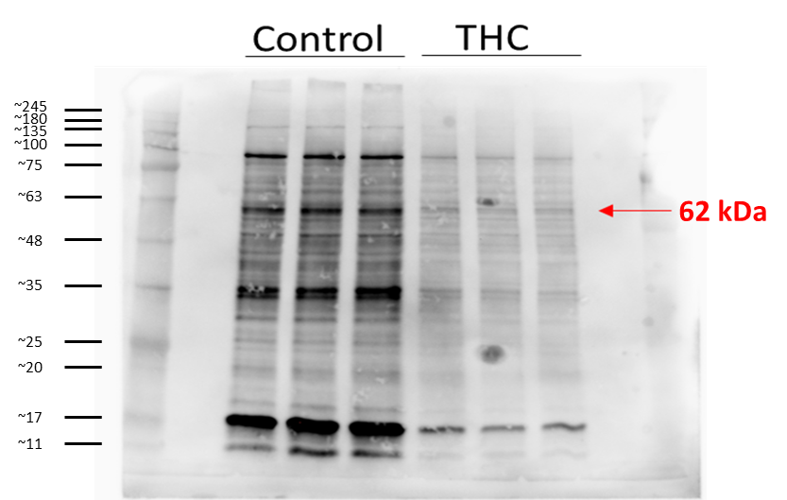

B
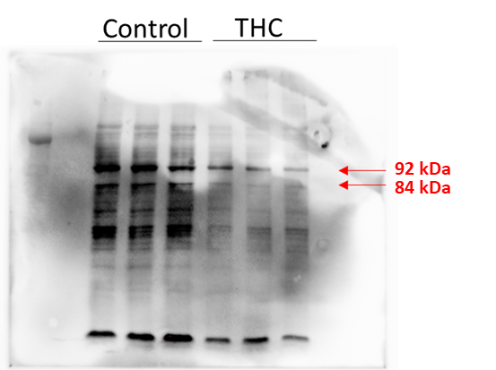

C
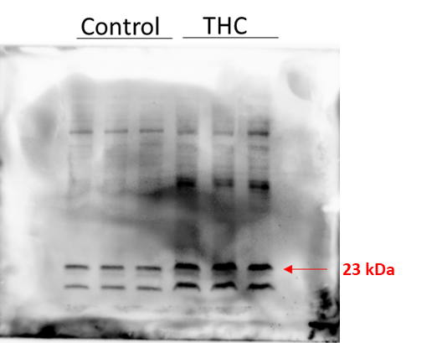

D
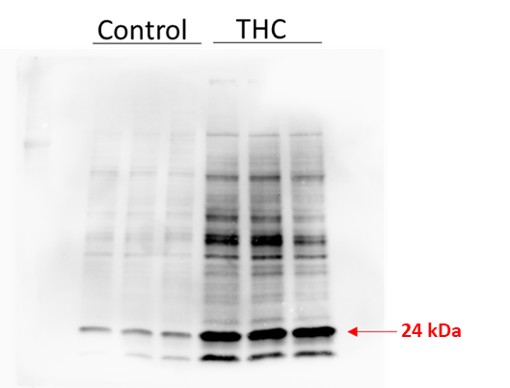

E
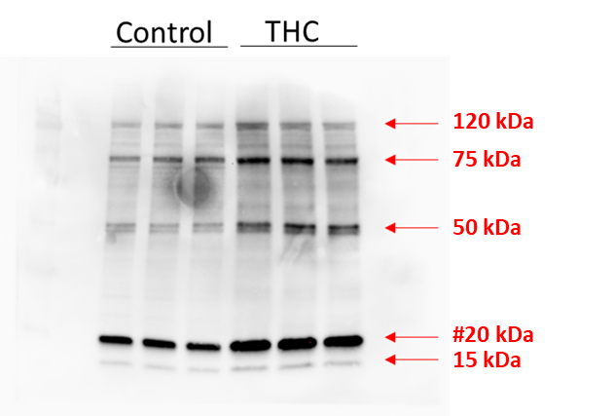

F
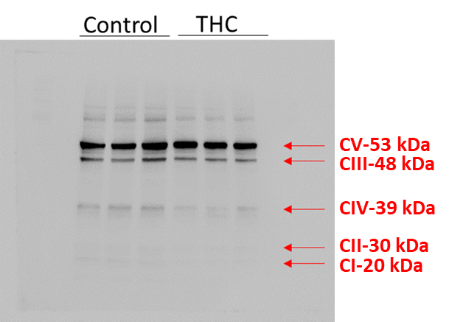

F
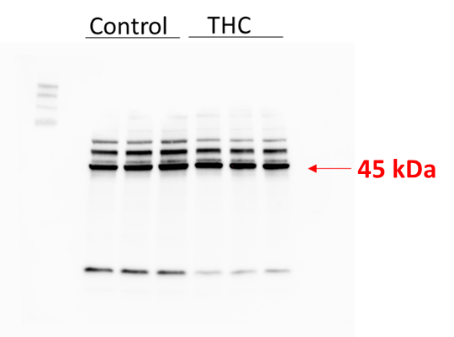

F G
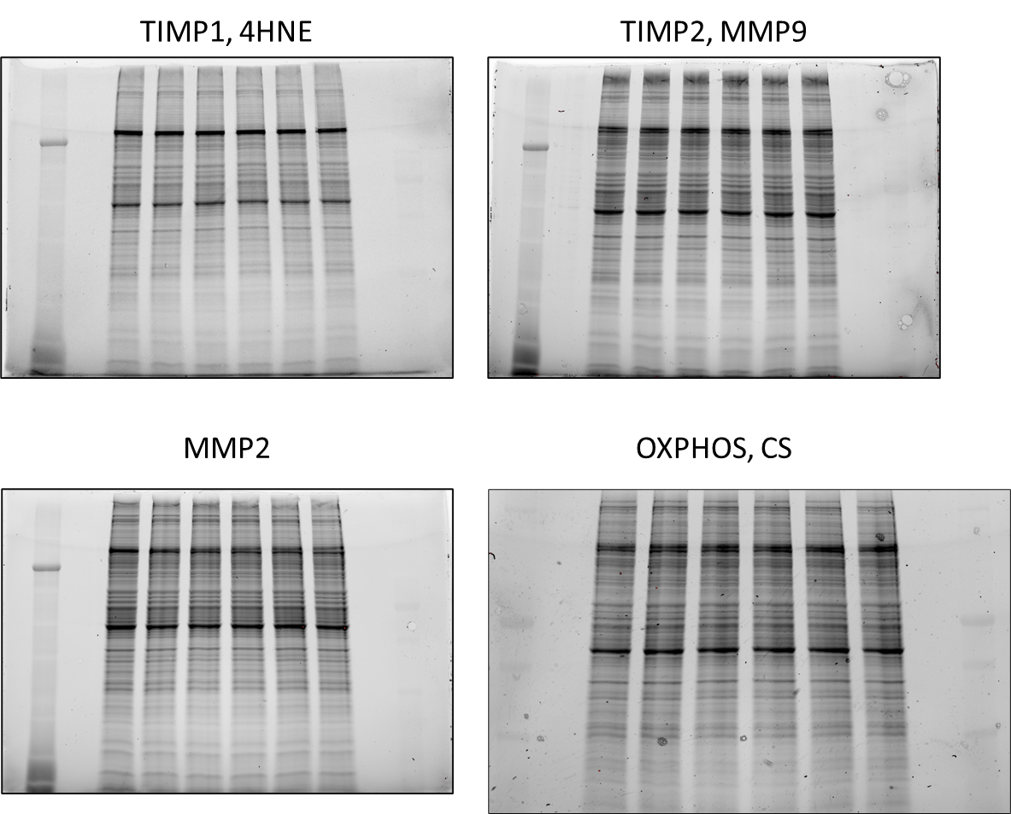

H I

Figure S3. Representation of full Western blot images and stain-free gel images. Uncropped Western blots images representative of the figures utilized in the primary manuscript are provided here. (A) MMP2; (B) MMP9; (C) TIMP1; (D) TIMP2; (E) 4-HNE; (F) Oxidative Phosphorylation enzymes; (E) Citrate Synthase (CS). Total protein visualized using Stain-Free gels (BioRad Laboratories) which were used for the Western blots in panels A-E. (F) Representation of the SDS PAGE used for the TIMP1 and 4-HNE Western blots. (G) Representation of the SDS PAGE used for the TIMP2 and MMP9 Western blots. (H) Representation of the SDS PAGE used for the MMP2 Western blot. (I) Representation of the SDS PAGE used for the Oxidative Phosphorylation enzymes and CS Western blots.

