Comparative assessment of antimicrobial, antiradical and cytotoxic activities of cannabidiol and its propyl analogue cannabidivarin
Chiara Russo, Margherita Lavorgna, Roberta Nugnes, Elena Orlo and Marina Isidori *

Department of Environmental, Biological and Pharmaceutical Sciences and Technologies, University of Campania “Luigi Vanvitelli”, Via Vivaldi 43, 81100 Caserta, Italy;
chiara.russo@unicampania.it;
margherita.lavorgna@unicampania.it;
roberta.nugnes@unicampania.it
elena.orlo@unicampania.it
*Correspondence: marina.isidori@unicampania.it

Table S1. IC50 (µM) values obtained with MTT assay. IC50 (µM) values obtained with MTT assay, after 24, 48, and 72 h of exposure of different cell lines: A549, Caco-2, Hep G-2, MDA-MB-231 and TelCOFS02MA to CBD and CBDV. Results are expressed means ± standard deviations from five independent experiments. Significant differences (p<0.05) among samples were calculated by One Way-ANOVA, Tukey's Multiple Comparison Test and expressed using different letters (a, b, c). Different numbers (from 1 to 5) define different cell lines.

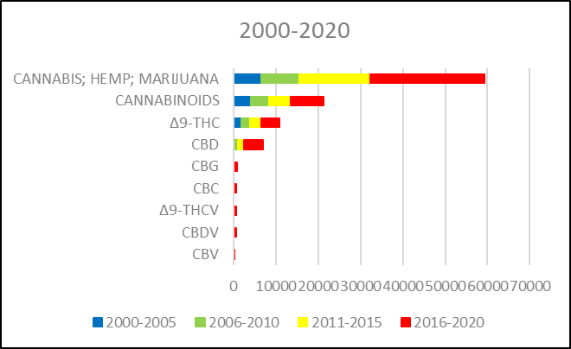
Figure S1. Number of scientific documents. Number of scientific documents (https://scifinder.cas.org/) containing “cannabinoids”, ”Δ9-tetrahydrocannabinol“, “cannabidiol”, “cannabigerol“, “cannabichromene“, “Δ9-tetrahydrocannabivarin“, “cannabidivarin”, “cannabivarin” as entered, and at least one of the concepts “cannabis, hemp, marijuana” refined for publication years.

Figure S2.
Percentages of E. coli growth. Percentages E. coli growth after 24-, 48- and 72h- exposure at different concentrations [µM] of CBD or CBDV. Results are expressed as means ± standard deviation from five independent experiments. Significant differences from negative controls are highlighted by asterisks (ANOVA, Dunnett’s test - *p < 0.05; **p < 0.001; ***p < 0.0001).
NC: negative control.

Figure S3.
Percentages of S. aureus growth. Percentages of S. aureus growth after 24-, 48- and 72h- exposure at different concentrations [µM] of CBD or CBDV. Results are expressed as means ± standard deviation from five independent experiments. Significant differences from negative controls are highlighted by asterisks (ANOVA, Dunnett’s test - *p < 0.05; **p < 0.001; ***p < 0.0001).
NC: negative control.

