Supplement documents for the Manuscript:

Comparing Microfluidics and Ultrasonication as formulations method for developing hempseed oil nanoemulsions for oral delivery applications

Farahnaz Fathordoobady¹, Natalia Sannikova², Yigong Guo¹, Anika Singh¹, David Kitts¹, Anubhav Pratap-Singh¹*

¹ Food Nutrition and Health Program, Faculty of Land and Food Systems, The University of British Columbia,
2205 East Mall, Vancouver, BC V6T 1Z4
² Ascension Sciences Inc., Vancouver, BC
*Correspondence: anubhav.singh@ubc.ca

Supplement Table 1. Experimental design and response variables for optimization of nanoemulsion

Run  Order | Pt  Type | HSO Cons (%) | Poloxamer  Cons  (%) | Lecithin Cons  (%) | Time  (min) | Particle size  (nm) | PDI | Zeta potential | EE  (%)
1 | 1 | 10 | 5 | 5 | 5 | 283.7 | 0.385 | 24 | 99.8
2 | 1 | 10 | 5 | 0 | 5 | 383.6 | 0.525 | 10.5 | 65.2
3 | 1 | 10 | 1 | 0 | 20 | 343.8 | 0.484 | 6.3 | 40.1
4 | 0 | 7.5 | 3 | 2.5 | 12.5 | 200.3 | 0.176 | 27.1 | 99.8
5 | 1 | 5 | 5 | 5 | 20 | 179.9 | 0.242 | 42.8 | 99.7
6 | 1 | 10 | 1 | 0 | 5 | 362.8 | 0.515 | 19.3 | 38.5
7 | 1 | 5 | 5 | 0 | 5 | 253.1 | 0.369 | 4.5 | 69.5
8 | 0 | 7.5 | 3 | 2.5 | 12.5 | 202.6 | 0.195 | 47.8 | 99.9
9 | 1 | 10 | 5 | 5 | 20 | 220.4 | 0.247 | 48.1 | 99.6
10 | 0 | 7.5 | 3 | 2.5 | 12.5 | 192.4 | 0.185 | 40 | 99.9
11 | 1 | 5 | 1 | 0 | 5 | 263.9 | 0.451 | 37 | 46.2
12 | 1 | 5 | 1 | 5 | 20 | 294.1 | 0.476 | 21.6 | 99.8
13 | 1 | 10 | 1 | 5 | 5 | 280 | 0.432 | 40.5 | 99.6
14 | 1 | 10 | 1 | 5 | 20 | 210.9 | 0.251 | 44.3 | 99.4
15 | 1 | 5 | 1 | 0 | 20 | 423.1 | 0.833 | 11.3 | 43.4
16 | 0 | 7.5 | 3 | 2.5 | 12.5 | 201.8 | 0.218 | 41.6 | 99.8
17 | 1 | 5 | 5 | 0 | 20 | 277.8 | 0.419 | 19.6 | 50.5
18 | 1 | 5 | 5 | 5 | 5 | 208.3 | 0.321 | 47.4 | 99.9
19 | 1 | 10 | 5 | 0 | 20 | 505.5 | 0.577 | 25.6 | 67.5
20 | 1 | 5 | 1 | 5 | 5 | 212.5 | 0.33 | 35.9 | 99.7
21 | 0 | 7.5 | 3 | 2.5 | 12.5 | 191.8 | 0.16 | 32.9 | 99.7
22 | -1 | 7.5 | 3 | 2.5 | 27.5 | 175.4 | 0.154 | 47.8 | 99.5
23 | 0 | 7.5 | 3 | 2.5 | 12.5 | 206.6 | 0.24 | 49.5 | 99.6
24 | -1 | 7.5 | -1 | 2.5 | 12.5 | 223.7 | 0.268 | 45.4 | 98.7
25 | -1 | 7.5 | 3 | -2.5 | 12.5 | 332.1 | 0.485 | 18.2 | 85.6
26 | -1 | 7.5 | 7 | 2.5 | 12.5 | 198.7 | 0.213 | 46.2 | 99.1
27 | -1 | 12.5 | 3 | 2.5 | 12.5 | 274.7 | 0.252 | 37.3 | 98.9
28 | -1 | 7.5 | 3 | 7.5 | 12.5 | 194 | 0.184 | 47.6 | 99.6
29 | -1 | 7.5 | 3 | 2.5 | -2.5 | 345.5 | 0.471 | 37.6 | 95.6
30 | -1 | 2.5 | 3 | 2.5 | 12.5 | 162.9 | 0.222 | 45.5 | 99.2

Supplement Table 2. Fatty acids identified by GC/MS in HSO¹
Fatty acid | Retention time (min) | *m/z[M+H] ⁺ | **Content (%)
Palmitic acid (C16:0) | 9.18 | 256.4 | 5.16± 0.08
Stearic acid (C18:0) | 10.40 | 284.48 | 2.53± 0.04
Oleic acid (C18:1, ꞷ₉) | 10.53 | 282.47 | 6.76± 0.20
Linoleic acid (C18:2, ꞷ₆) | 10.86 | 280.44 | 60.31± 0.86
γ -linolenic acid (C18:3, ꞷ₆) | 10.98 | 278.43 | 4.65± 0.08
α-linolenic acid (C18:3, ꞷ₃) | 11.24 | 278.43 | 18.94± 0.14
Stearidonic acid (C18:4, ꞷ₃) | 11.41 | 276.4 | 1.03± 0.03
Eicosenoic acid (C20:1, ꞷ₉) | 11.68 | 310.51 | 0.34± 0.04
Decosanoic acid (C22:0) | 11.81 | 340.58 | 0.28± 0.01
PUFA |  |  | 83.90
MUFA |  |  | 7.10
SFA/UFA |  |  | 0.09
ꞷ₆/ꞷ₃ |  |  | 3.25/1
* GC-MS results are based on employing the m/z corresponding to the molecular ions [M + H] ⁺
** Values are the mean and standard deviation for three experimental determinations

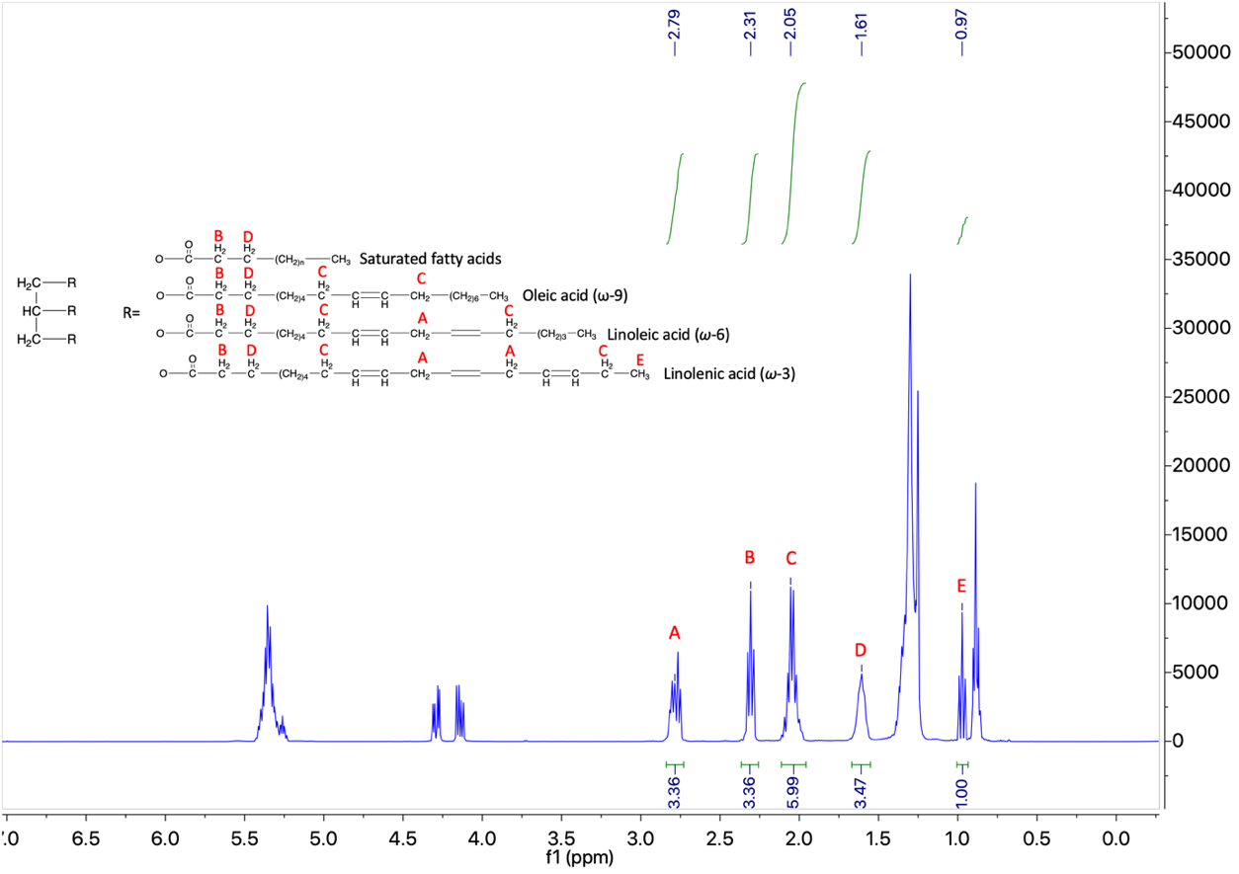
Supplement Fig 1. ¹H NMR spectrum of hempseed oil (HSO) in CDCl₃

Supplement Fig. 2. LC-MS results based on employing the m/z corresponding to the molecular ions [M + H] ⁺

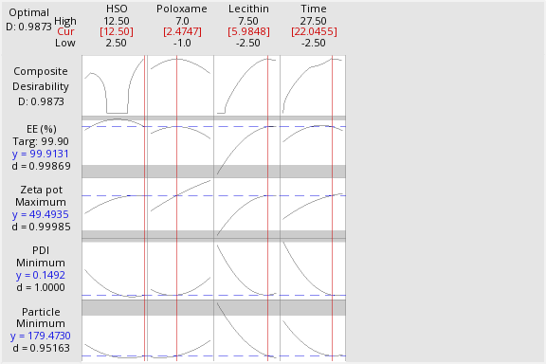

Supplement Fig. 3 Graphical optimization of ultrasound process condition

