Co-Expression based Cancer Staging and Application
Xiangchun Yu^{2,3,5}, Sha Cao⁴, Yi Zhou³, Zhezhou Yu^{2*}, and Ying Xu^{1, 3*}
¹Cancer Systems Biology Center, The China-Japan Union Hospital, and ²College of Computer Science and Technology, Jilin University, Changchun, China; ³Computational Systems Biology Lab, Department of Biochemistry and Molecular Biology and Institute of Bioinformatics, University of Georgia, Georgia, USA; ⁴Department of Biostatistics, Indiana University School of Medicine, Indianapolis, USA; and ⁵School of Information Engineering, Jiangxi University of Science and Technology, Ganzhou, China.
Correspondence authors: yuzz@jlu.edu.cn; xyn@uga.edu.

To understand what might be the reasons for “incorrect” predictions by our method compared to the annotated stages in TCGA by pathologists, we have examined the prediction results for BRCA, COAD, KIRC, KIRP, LUAD, and THCA. The following Figures S1(1-6) show the distributions of the numbers of DEGs in stage-specific samples for predicted (a) and annotated (b) stages of the six cancer types, respectively.
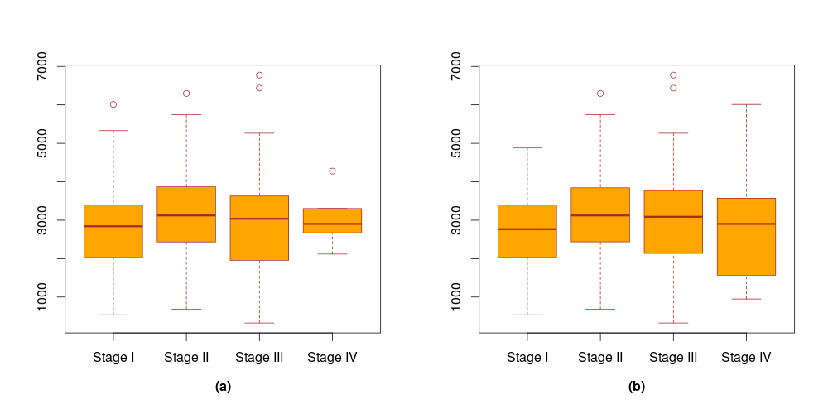
Figure S1(1): The numbers of DEGs in stage-specific samples for annotated (a) and predicted (b) stages of BRCA.
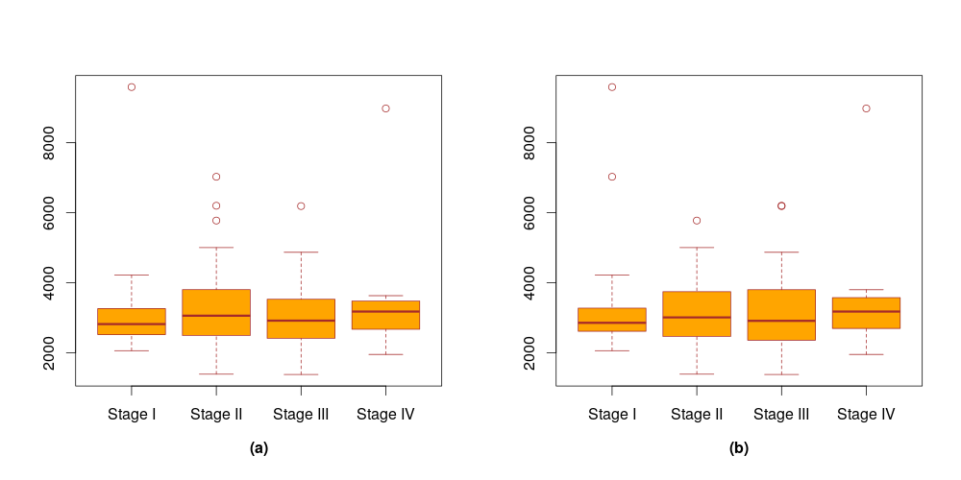
Figure S1(2): The numbers of DEGs in stage-specific samples for annotated (a) and predicted (b) stages of COAD.
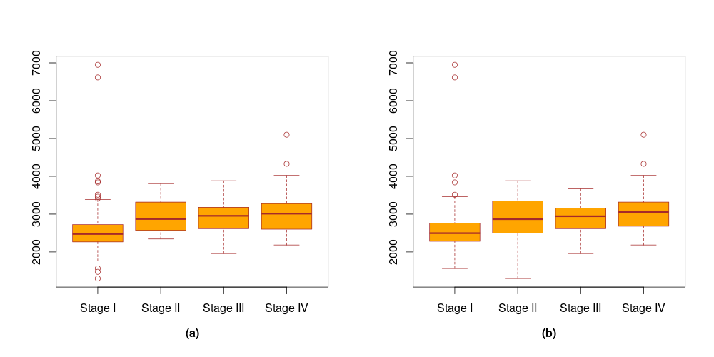
Figure S1(3): The numbers of DEGs in stage-specific samples for annotated (a) and predicted (b) stages of KIRC.
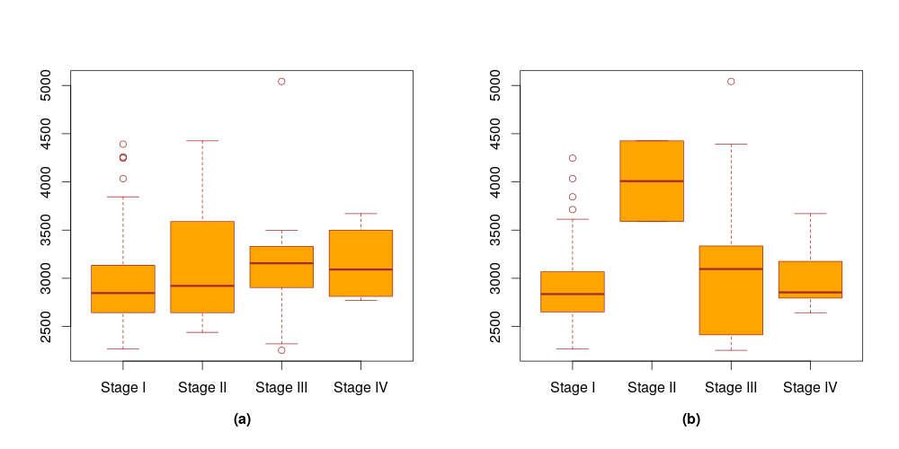
Figure S1(4): The numbers of DEGs in stage-specific samples for annotated (a) and predicted (b) stages of KIRP.
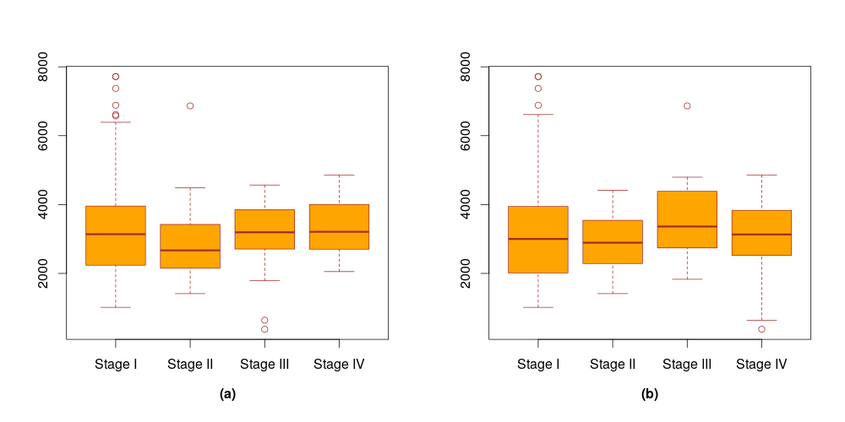
Figure S1(5): The numbers of DEGs in stage-specific samples for annotated (a) and predicted (b) stages of LUAD.
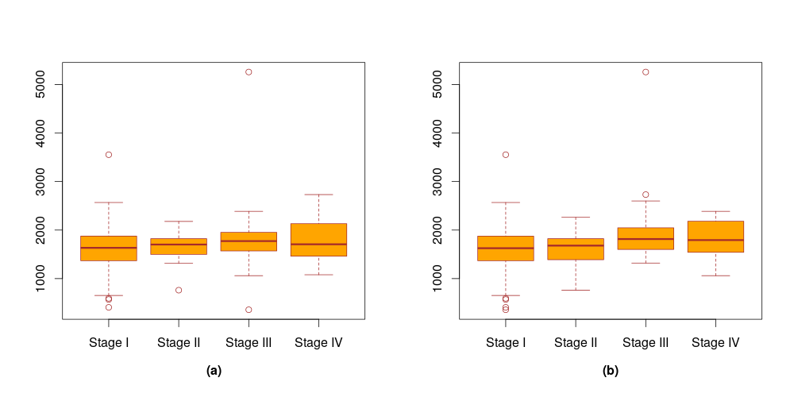
Figure S1(6): The numbers of DEGs in stage-specific samples for annotated (a) and predicted (b) stages of THCA.

