Supplemental documents

Supplemental Table 1: Color changes (ΔE*) calculated for HSO samples during 24 h storage at 40,55,70 and 85°C

Sample | Temperature (°C) | Color difference value (ΔE*)
Sample | Temperature (°C) | 2h | 4h | 8h | 12h | 24h
HSO | 40 | 1.29ª | 1.50ª | 2.23^{ab} | 3.69^{c} | 3.98^{c}
HSO | 55 | 1.35ª | 2.15^{ab} | 4.08^{c} | 4.15^{c} | 6.11^{d}
HSO | 70 | 2.09ª | 2.87^{ab} | 6.25^{c} | 6.99^{cd} | 8.54e
HSO | 85 | 3.12ª | 4.67^{b} | 6.41^{c} | 7.80^{d} | 10.41e
HSO+BHT | 40 | 0.63ª | 1.78^{bc} | 2.86^{c} | 3.96^{cd} | 4.95^{d}
HSO+BHT | 55 | 1.19ª | 1.57ª | 2.97^{ab} | 4.02^{bc} | 5.13^{c}
HSO+BHT | 70 | 1.28ª | 1.94^{ab} | 3.56^{b} | 5.08^{c} | 5.52^{c}
HSO+BHT | 85 | 1.24ª | 2.45^{ab} | 4.12^{bc} | 5.28^{c} | 5.86^{c}
HSO+T | 40 | 0.78ª | 1.50ª | 2.34^{ab} | 2.89^{b} | 4.42^{c}
HSO+T | 55 | 1.66ª | 2.95^{ab} | 3.86^{b} | 4.39^{bc} | 5.49^{c}
HSO+T | 70 | 2.76ª | 3.95^{ab} | 4.69^{bc} | 5.54^{c} | 6.21^{d}
HSO+T | 85 | 1.33ª | 2.79^{ab} | 4.58^{bc} | 5.73^{c} | 6.48^{d}
HSO+AP | 40 | 0.83ª | 1.76ª | 2.98^{ab} | 4.70^{bc} | 4.95^{c}
HSO+AP | 55 | 1.07ª | 1.88^{ab} | 3.06^{bc} | 4.53^{c} | 5.09^{c}
HSO+AP | 70 | 1.93ª | 3.55^{b} | 4.64^{bc} | 5.32^{c} | 5.54^{c}
HSO+AP | 85 | 2.15ª | 3.09^{ab} | 5.01^{c} | 5.47^{c} | 6.31^{d}
Values represents means (n=3)
^{a-e} In a row followed by the different small letters are significantly different by Turkey’s test (p < 0.05)

cd
bc
a
c
b
e
d
cd
g
f
f
i
i
ij
g
j
k
jk
h
l
lm
m
lm
d

Supplemental Fig. 1 Color changes (ΔE*) of HSO samples (without/with antioxidant) during 15 days storage
at 25°C
^{a-m} Bars depicited with different small letters are significantly different by Turkey’s test (p < 0.05)

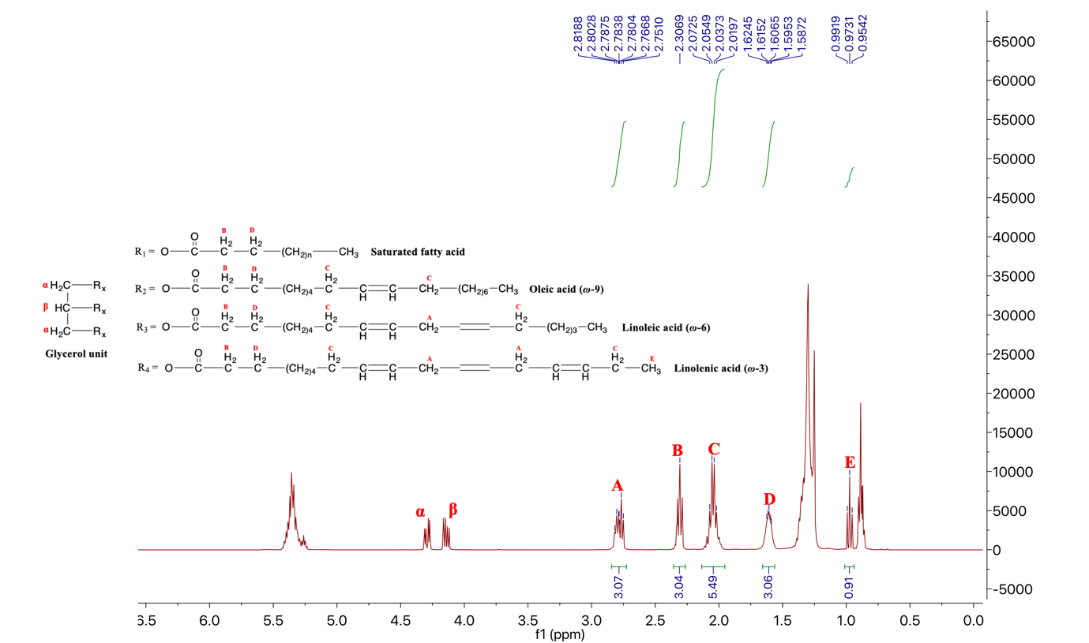
Supplemental Fig. 2 ¹H NMR spectrum of hemp seed oil (HSO) in CDCl₃

Supplemental Fig. 3 Decarboxylation of CBDA in HSO samples (without/with antioxidants) incubated at 85°C for 24h

List vof abbriviations:

ANOVA: Analysis of Variances
AOAC: Association of Official Analytical Chemists
AP: Ascorbyl palmitate
BHT: Butylated hydroxytoluene
CBD: Canabidiol
CBDA: Cannabidiolic acid
CBDV: Cannabidivarin
CBG: Cannabigerol
CDH: Conjugated diene hydroperoxides
CIE: International Commission on Illumination
E_{a}: Activation energies
ESI: Electrospray Ionization
GC-FID: Gas Chromatography with Flame Ionization Detector
GLA: Gamma linoleic acid
HPLC: High Performance Liquid Chromatography
HSO: Hempseed oil
LC-MS: Liquid chromatography–Mass Spectrometry
NMR: Nuclear Magnetic Resonance
p-AV: para-Anisidine value
PUFAs: Poly unsaturated fatty acids
TBARS: Thiobarbituric acid reactive substance
THC: tetrahydrocannabinol
THCA: tetrahydrocannabinolic acid
THCV: Tetrahydrocannabivarin
UV-Vis : Ultra Violet Visible
α-T: Alpha-tocopherol

