Low-Cost Active Thermography using Cellphone Infrared Cameras: from Early Detection of Dental Caries to Quantification of THC in Oral Fluid
Nakisa Samadi⁺, Damber Thapa⁺, Mohammadhossein Salimi, Artur Parkhimchyk, and Nima Tabatabaei*
Department of Mechanical Engineering, Lassonde School of Engineering, York University, 4700 Keele St., Toronto, ON, M3J 1P3, Canada *Nima.Tabatabaei@Lassonde.YorkU.ca
⁺these authors contributed equally to this work

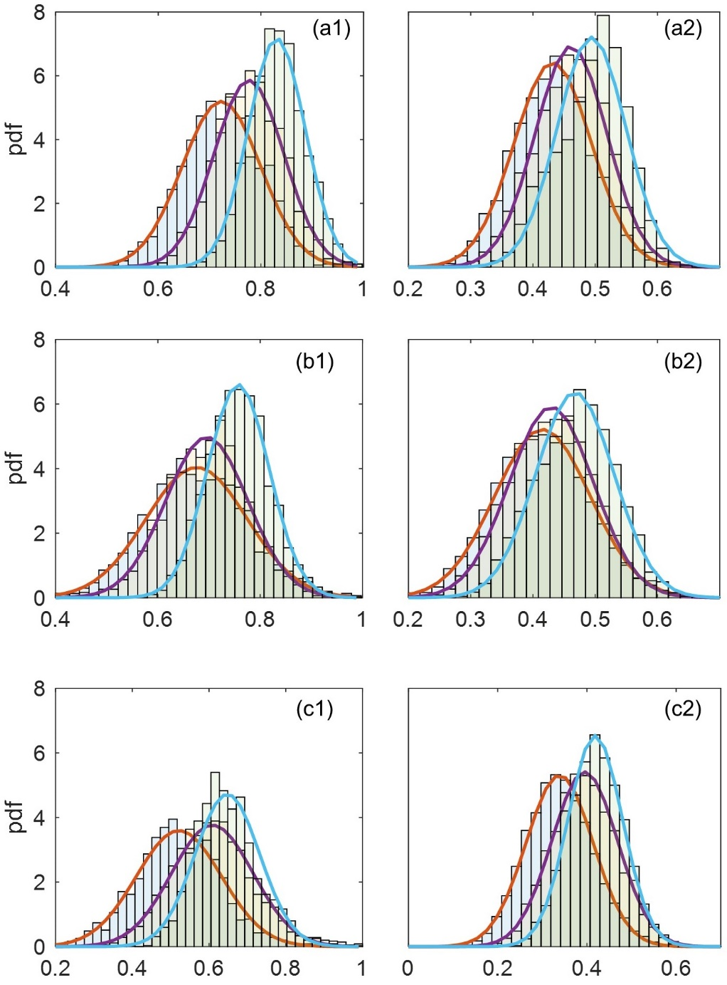
Figure 1. Histograms with probability density function (pdf) of the images at the foreground (left) and background region (right) at camera frame rates of 9, 15 and 33 fps for defects at different depths. The panel a, b and c are corresponding to defects 300µm, 500µm and 800µm below intact interrogation surface, respectively. Mean ± STD of the pdf are reported in supplementary table 1.

Depth | Foreground |  |  | Background
Depth | 9fps | 15 fps | 33 fps | 9fps | 15 fps | 33 fps
300µm | 0.7230±0.0767 | 0.7767±0.0680 | 0.8308±0.0556 | 0.4318±0.0621 | 0.4612±0.0575 | 0.4941±0.0553
500µm | 0.6758±0.0988 | 0.6956±0.0802 | 0.7572±0.0604 | 0.4153±0.0765 | 0.4295±0.0675 | 0.4674±0.0627
800µm | 0.5215±0.1109 | 0.6086±0.1060 | 0.6476±0.0845 | 0.3388±0.0751 | 0.3950±0.0737 | 0.4186±0.0610
Table 1. Means and STDs of the probability density functions calculated from the Supplementary Fig. 1.

