A Dual-modality Smartphone Microendoscope for Quantifying the Physiological and Morphological Properties of Epithelial Tissues

Xiangqian Hong, Tongtong Lu, Liam Fruzyna and Bing Yu *

The supplemental figure below helps to explain the differences between the SmartME design and the previously reported designs.

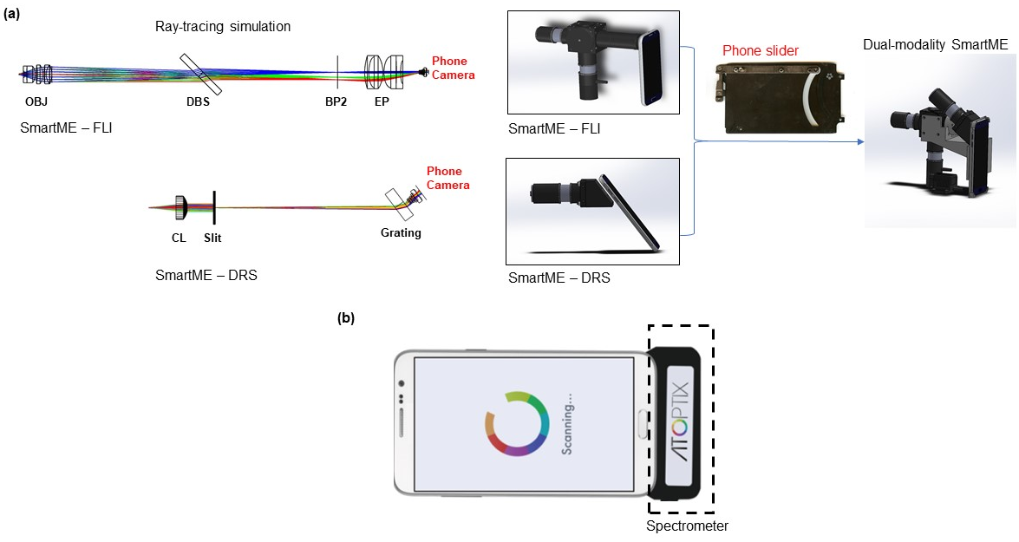
Supplemental figure: (a) Design process for SmartME. The SmartME uses the rear camera of a smartphone as the image sensor for both the DRS and FLI modules. Left: The distance between the phone camera and eyepiece (EP)/Grating was optimized to match the exit pupil of the FLI/DRS imaging system and the entrance pupil of the camera lens kit. Right: a phone slider was used to ensure easy switching between the two modules with minimum misalignments. (b) Design of the G-Fresnel spectrometer developed by Edwards et al. The spectrometer connects to the phone through the Micro USB port.

