Contrasting Roles of Cannabidiol as an Insecticide and Rescuing Agent for Ethanol–induced Death in the Tobacco Hornworm Manduca sexta

Supplementary information

Sang-Hyuck Park^{1,2}, S. Kyle Staples¹, Eric L. Gostin¹, Jeffrey P. Smith¹, Jose J. Vigil¹, Dustin Seifried³, Chad Kinney^{2,3}, Christopher S. Pauli², and Brian D. Vanden Heuvel^{1*}

¹Department of Biology, ²Institute of Cannabis Research, and ³Department of Chemistry, Colorado State University-Pueblo, Pueblo CO 81001, USA.

*Correspondence and requests for materials should be addressed to B.V.H. (email: brian.vandenheuvel@csupueblo.edu)

- Supplementary Table

Table 1. The total CBD and THC amounts of C. sativa L. hemp varieties (Colorado Gold and Green Thunder) used in this study.
 | C. sativa L. hemp  (Colorado Gold) | C. sativa L. hemp  (Green Thunder)
Total CBD | 0.81% | 3.2%
Total THC | 0.09% | 0.11%

A total THC and CBD were calculated by using the formula; % of CBD _{total} = % of CBD + (% of CBDA × *0.877) and % of THC _{total} = % of THC + (% of THCA × 0.877). *0.877 is a molecular weight ratio of CBDA/CBD and THCA/THC.

- Supplementary Figure

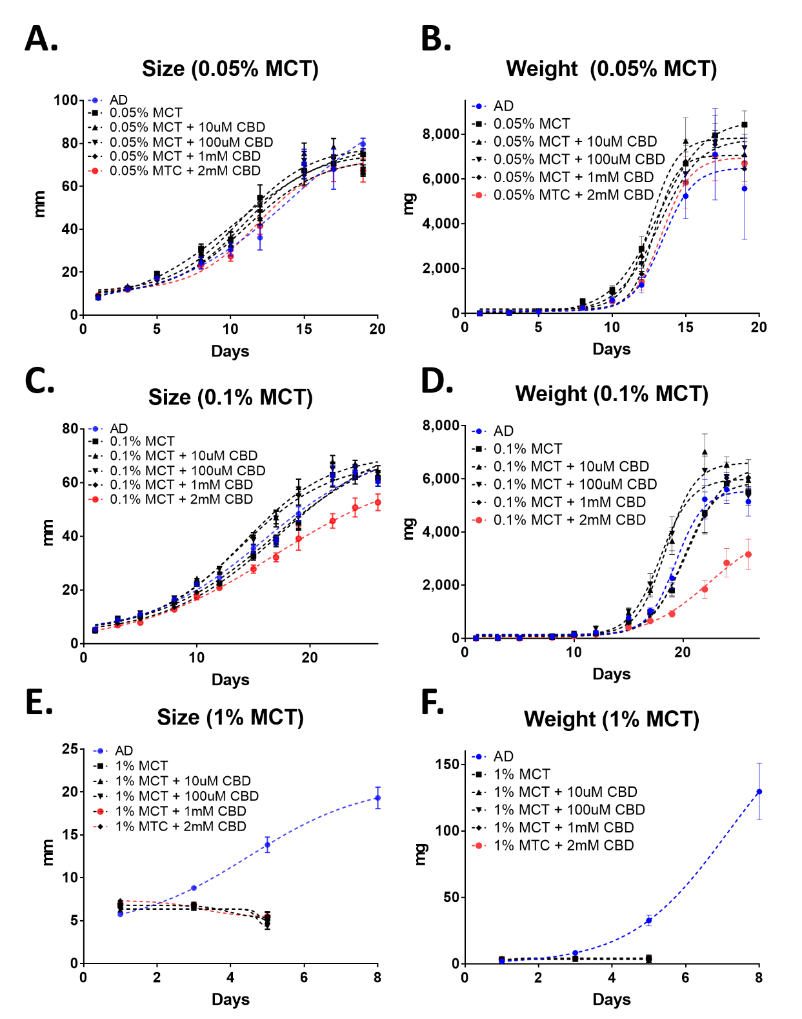

Figure 1. The effects of medium-chain triglyceride (MCT) on the growth of tobacco hornworm Manduca sexta (n=20-22). First instar larvae were grown on artificial diet (AD) containing various amounts of CBD dissolved in 0.05% (A, B), 0.1% (C, D), and 1% MCT oil (E, F).

