Supplementary Information

Motor neuron development in zebrafish is altered by brief (5-hr) exposures to THC (Δ⁹-tetrahydrocannabinol) or CBD (cannabidiol) during gastrulation

Kazi T. Ahmed^{1*}, Md Ruhul Amin^{1*}, Parv Shah
and Declan W. Ali^{1,2}

Institutional Affiliation: ¹Department of Biological Sciences and
Physiology, and the ²Neuroscience and Mental Health Institute
CW-405 Biological Sciences Building
University of Alberta
Edmonton, Alberta, Canada
T6G 2E9
*Contributed equally to the study

Running title: neurodevelopment in zebrafish is altered by THC and CBD

Corresponding Author: Declan W. Ali
Department of Biological Sciences
CW-405, Biological Sciences Building
University of Alberta
Edmonton, Alberta, Canada
T6G 2E9
Phone: 1.780.492.6094
Fax: 1.780.492.9234
Email: declan.ali@ualberta.ca

Key Words: cannabinoids, motor neurons, muscle, NMJ, CNS

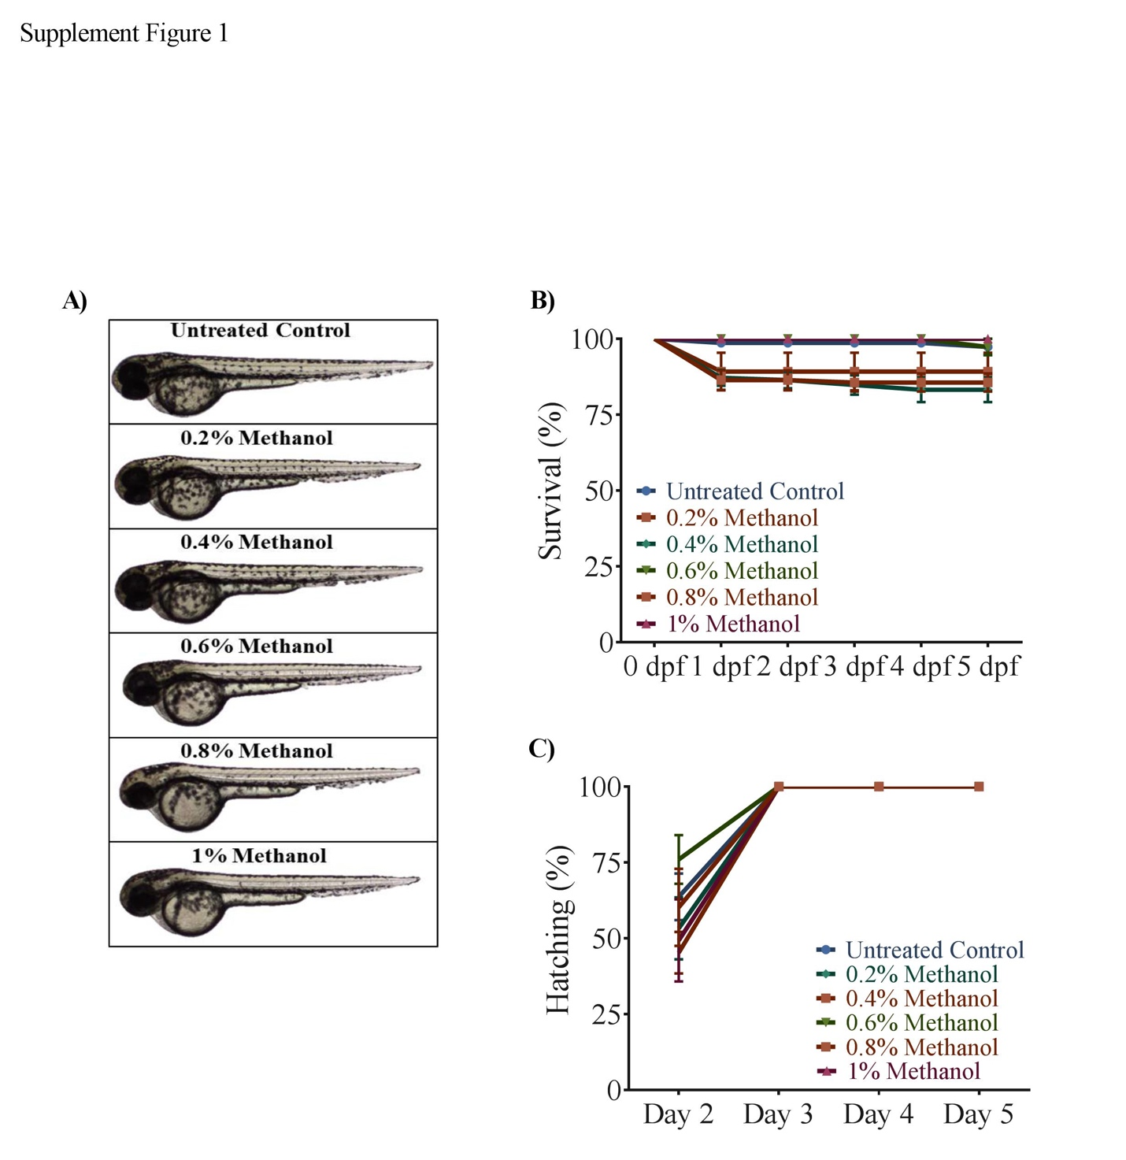
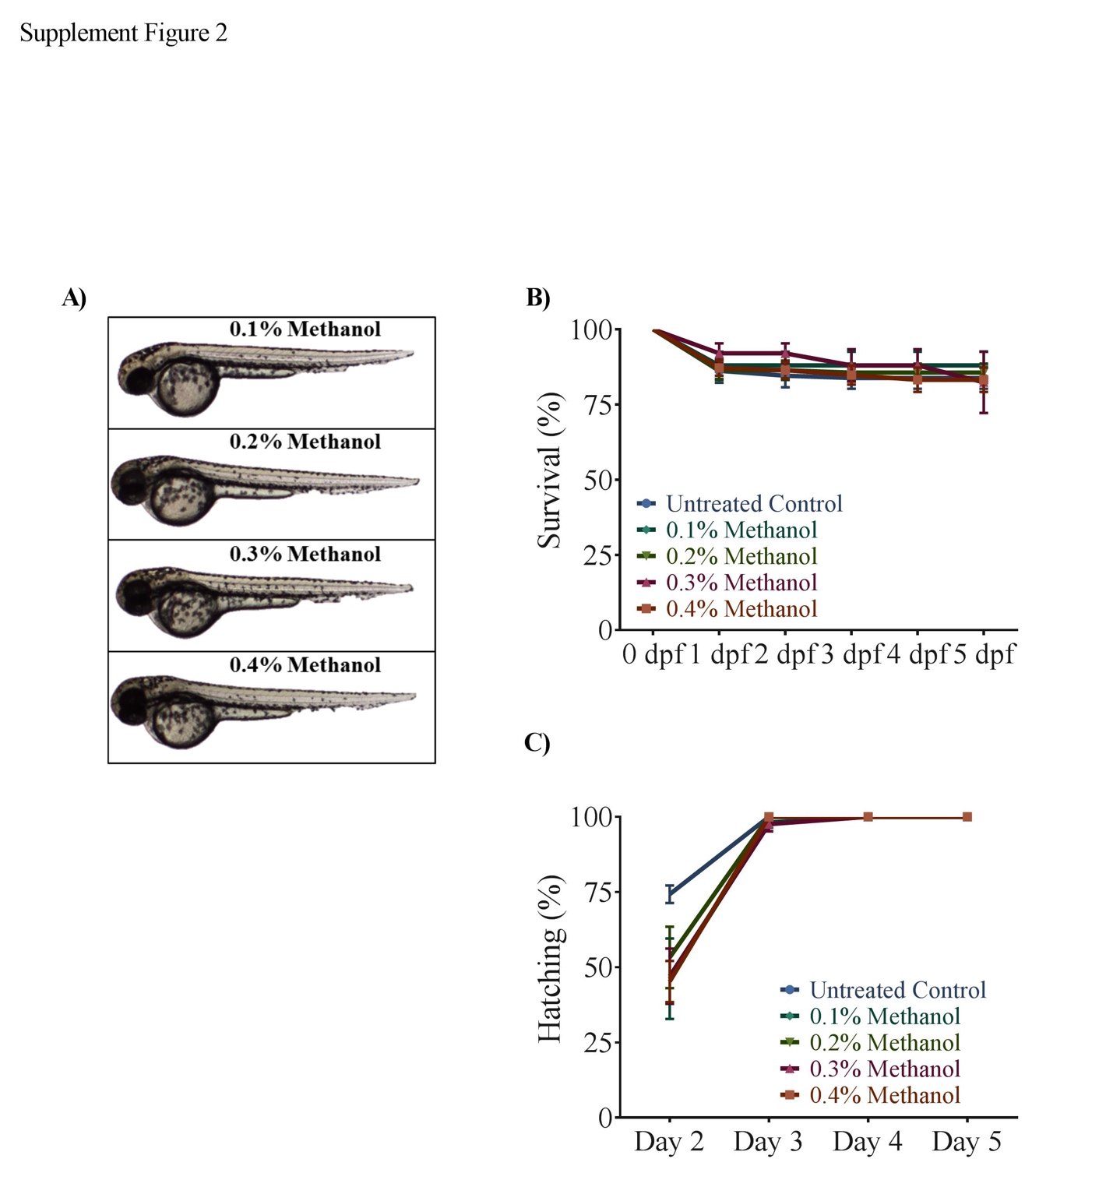

Supplement Figure 1. Effect of vehicle control of THC (methanol) on morphology, survival and hatching of zebrafish embryos. (A) Embryos were untreated (control), or exposed to 0.2%, 0.4%, 0.6%, 0.8% or 1% methanol (from 5.25 hpf to 10.75 hpf) and then allowed to develop in normal embryo media. Images were taken at 48-52 hpf. (B) Line graph showing the percentage of embryos that survived within the first 5 days of development following methanol exposure during gastrulation (N=5 experiments and n=125 embryos for each treatment). (C) Line graph showing the percentage of embryos that hatched within the first 5 days after egg fertilization following methanol exposure (N=3-5 experiment and n=75-125 embryos for each treatment).

Supplement Figure 2. Effect of vehicle control of CBD (methanol) on morphology, survival and hatching of zebrafish embryos. (A) Embryos were exposed to 0.1%, 0.2%, 0.3% or 0.4% methanol (from 5.25 hpf to 10.75 hpf) and then allowed to develop in normal embryo media. Images were taken at 48-52 hpf. (B) Line graph showing the percentage of embryos that survived within the first 5 days of development following methanol exposure during gastrulation (N=5 experiments and n=125 for each treatment). (C) Line graph showing the percentage of embryos that hatched within the first 5 days after egg fertilization following methanol exposure (N=5 experiments and n=125 embryos for each treatment).

