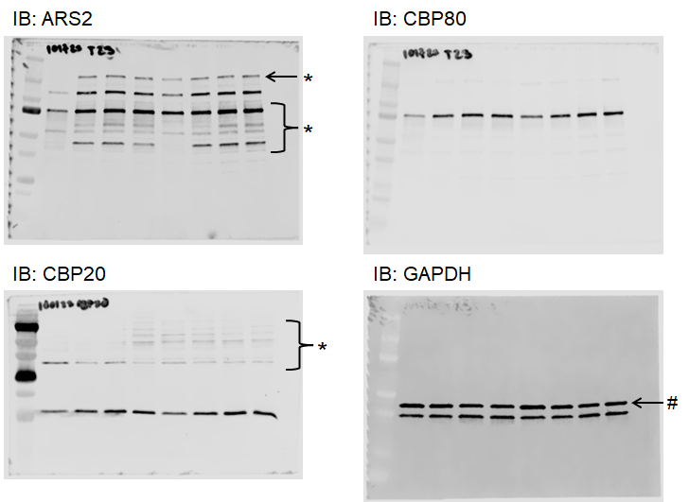

Uncropped Western blots from Figure 1B. Lane 1: protein ladder, Lane 2: resting (d0) human CD4⁺ T cells, Lane 3: d1 activated human CD4⁺ T cells, Lane4: d2 activated human CD4⁺ T cells, Lane 5: d3 activated human CD4⁺ T cells. Lane 6: resting (d0) human CD8⁺ T cells, Lane 7: d1 activated human CD8⁺ T cells, Lane8: d2 activated human CD8⁺ T cells, Lane 9: d3 activated human CD8⁺ T cells. *non-specific bands, # remaining signal from re-probe of β-Actin blot.

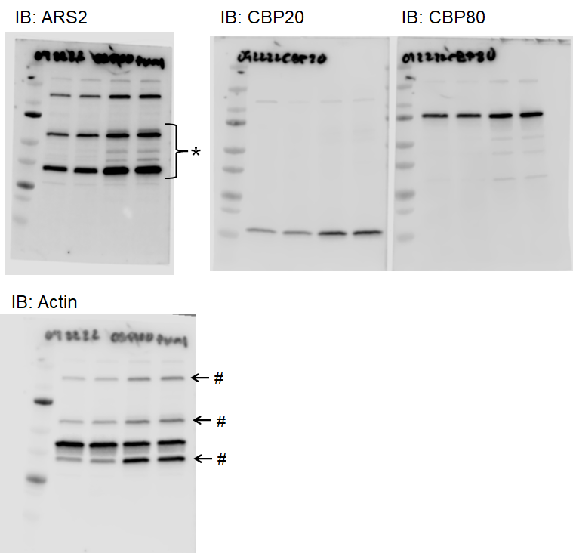

Uncropped Western blots from Supplemental Figure 1B. Lane 1: protein ladder, Lane 2: resting (d0) T cells, Lane 3: d1 activated T cells, Lane4: d2 activated T cells, Lane 5: d3 activated T cells. *non-specific bands, # remaining signal from re-probe of ARS2 blot.

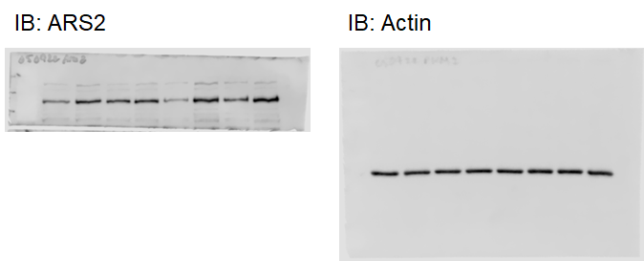

Uncropped Western blots from Figure 2E. Lane 1: protein ladder, Lane 2: d1 activated ARS2^{iKO} mouse T cells, Lane 3: d1 activated ARS2^{fl/fl} mouse T cells, Lane 4: d1 activated CD28^{AYAA} mouse T cells, Lane 5: d1 activated CD28^{Y170F} mouse T cells, Lane 6: d3 activated ARS2^{iKO} mouse T cells, Lane 7: d3 activated ARS2^{fl/fl} mouse T cells, Lane 8: d3 activated CD28^{AYAA} mouse T cells, Lane 9: d3 activated CD28^{Y170F} mouse T cells. **Membrane for ARS2 blot was cut at ~80 kDa to facilitate simultaneous probing of large (ARS2) and small proteins.

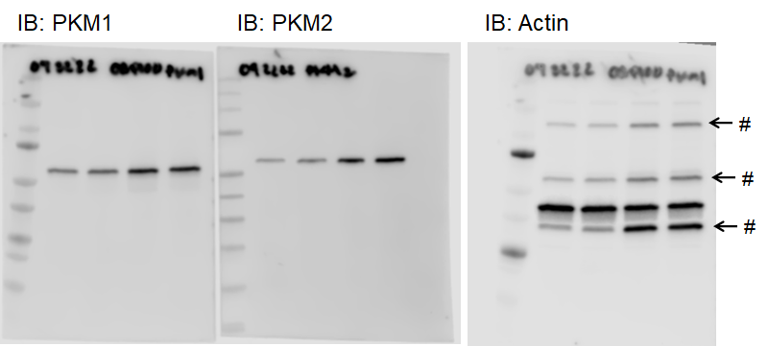

Uncropped Western blots from Figure 3C. Lane 1: protein ladder, Lane 2: resting (d0) human T cells, Lane 3: d1 activated human T cells, Lane4: d2 activated human T cells, Lane 5: d3 activated human T cells. # remaining signal from re-probe of ARS2 blot.

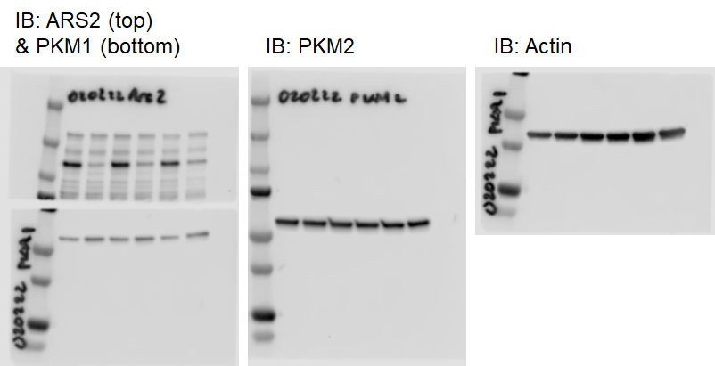

Uncropped Western blots from Figure 3G. Lane 1: protein ladder, Lane 2: d3 activated control siRNA transfected human T cells, Lane 3: d3 activated ARS2 siRNA transfected human T cells, Lane4: d4 activated control siRNA transfected human T cells, Lane 5: d4 activated ARS2 siRNA transfected human T cells, Lane 6: d5 activated control siRNA transfected human T cells, Lane 7: d5 activated ARS2 siRNA transfected human T cells.

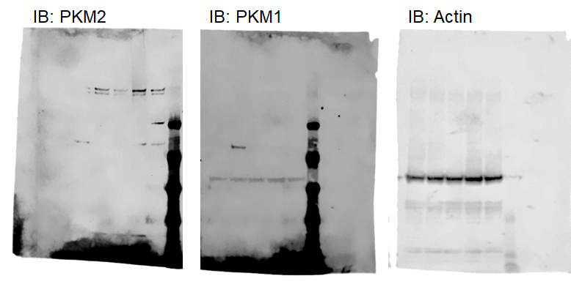

Uncropped Western blots from Supplemental Figure 5B. Lane 1: Pkm2^{fl/fl} T cells, Lane 2: Pkm2^{KO} T cells, Lanes 3 – 5: Unrelated samples, Lane 6: protein ladder.

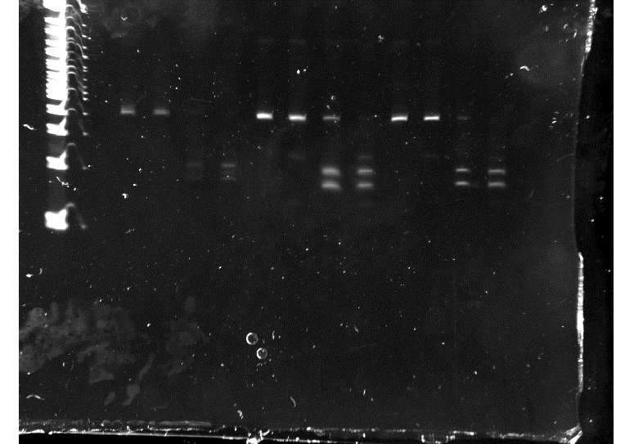

Uncropped EtBr-stained 2% agarose DNA gel photo from Supplemental Figure 3D. Lane 1: DNA ladder, Lane 2: no sample, Lane 3: undigested PKM cDNA from resting (d0) human T cells, Lane 4: NcoI digested PKM cDNA from resting (d0) human T cells, Lane 5: PstI digested PKM cDNA from resting (d0) human T cells, Lane 6: NcoI + PstI digested PKM cDNA from resting (d0) human T cells, Lane 7: undigested PKM cDNA from d1 activated human T cells, Lane 8: NcoI digested PKM cDNA from d1 activated human T cells, Lane 9: PstI digested PKM cDNA from d1 activated human T cells, Lane 10: NcoI + PstI digested PKM cDNA from d1 activated human T cells, Lane 11: undigested PKM cDNA from d3 activated human T cells, Lane 12: NcoI digested PKM cDNA from d3 activated human T cells, Lane 13: PstI digested PKM cDNA from d3 activated human T cells, Lane 14: NcoI + PstI digested PKM cDNA from d3 activated human T cells.

