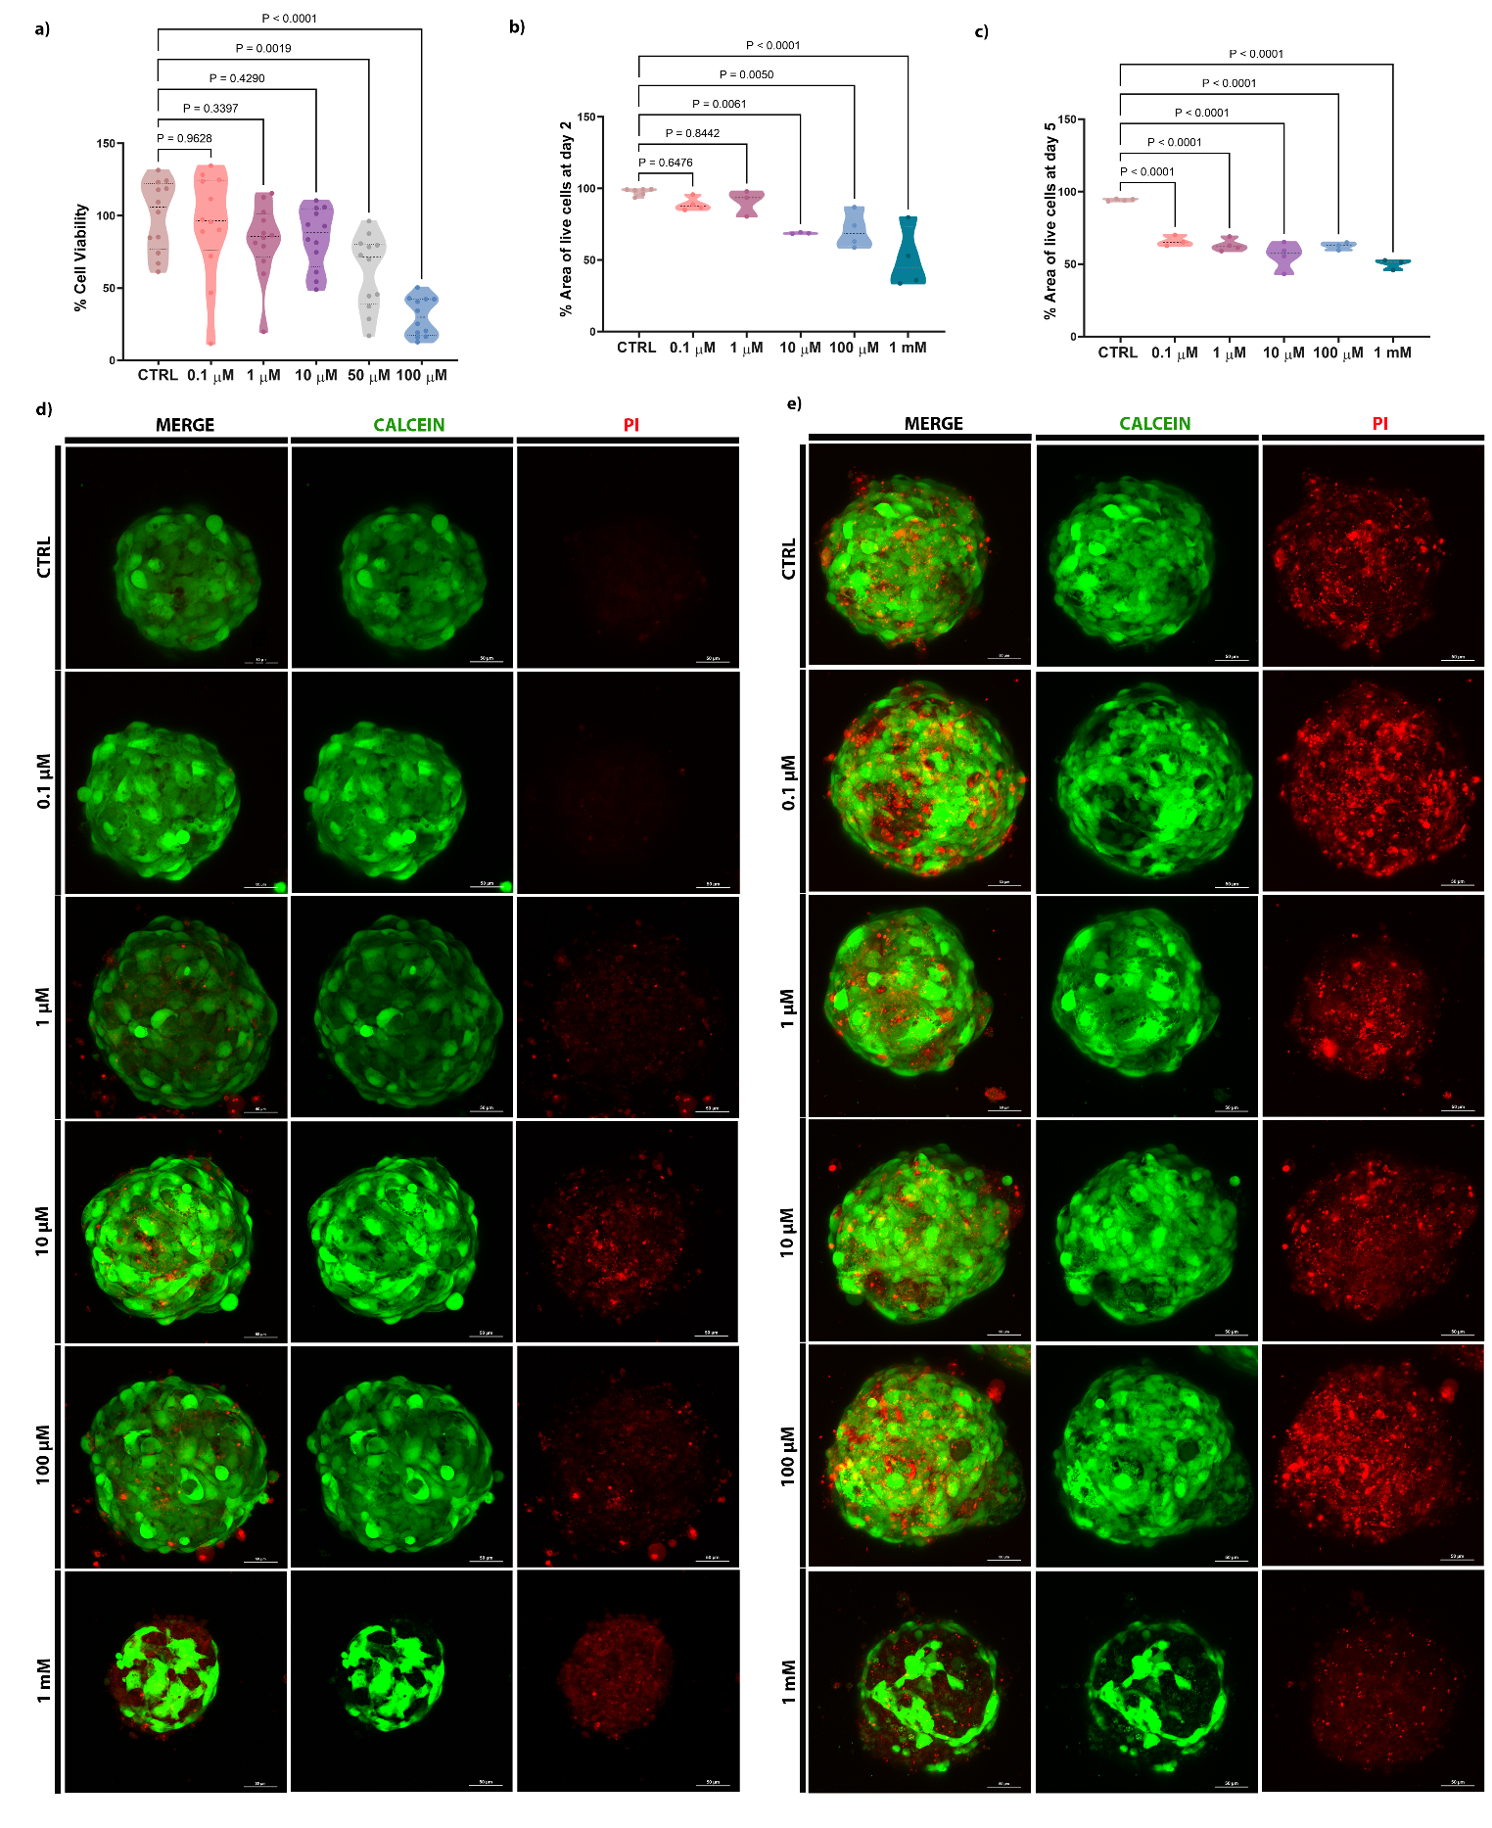
Supplementary Figure 1. Cell viability of 2D and 3D hFOB1.19 cultures exposed to PFOA during proliferative and differentiation phases.
a) Analysis of cell viability of hFOB1.19 2D culture after exposure to different concentrations of PFOA (n=12 independent biological replicates) by MTT assay. P-values indicate the results of comparisons between each PFOA-treated group and the control group. Values of p < 0.05 are considered statistically significant. b-c) Analysis of cell viability of hFOB1.19 spheroids after exposure to different concentrations of PFOA (n = 3-4 independent biological replicates) in two different time points by LIVE/DEAD staining. Quantification was performed by measuring the stained area in each channel using ImageJ and the percentage of live cells was then calculated as %live cells = (area positive for calcein-AM (live cells)/area positive for calcein-AM (live cells) + area positive for PI (dead cells)) x 100. P-values indicate the results of comparisons between each PFOA-treated group and the control group. Values of p < 0.05 are considered statistically significant. d-e) Maximum Intensity Projection (MIP) of representative confocal images showing of the LIVE/DEAD staining after 2 days (d) and 5 days (e) of PFOA treatment. Live cells were stained with calcein (green), while dead cells were stained with propidium iodide (PI) (red). Scale bar=50 μm.
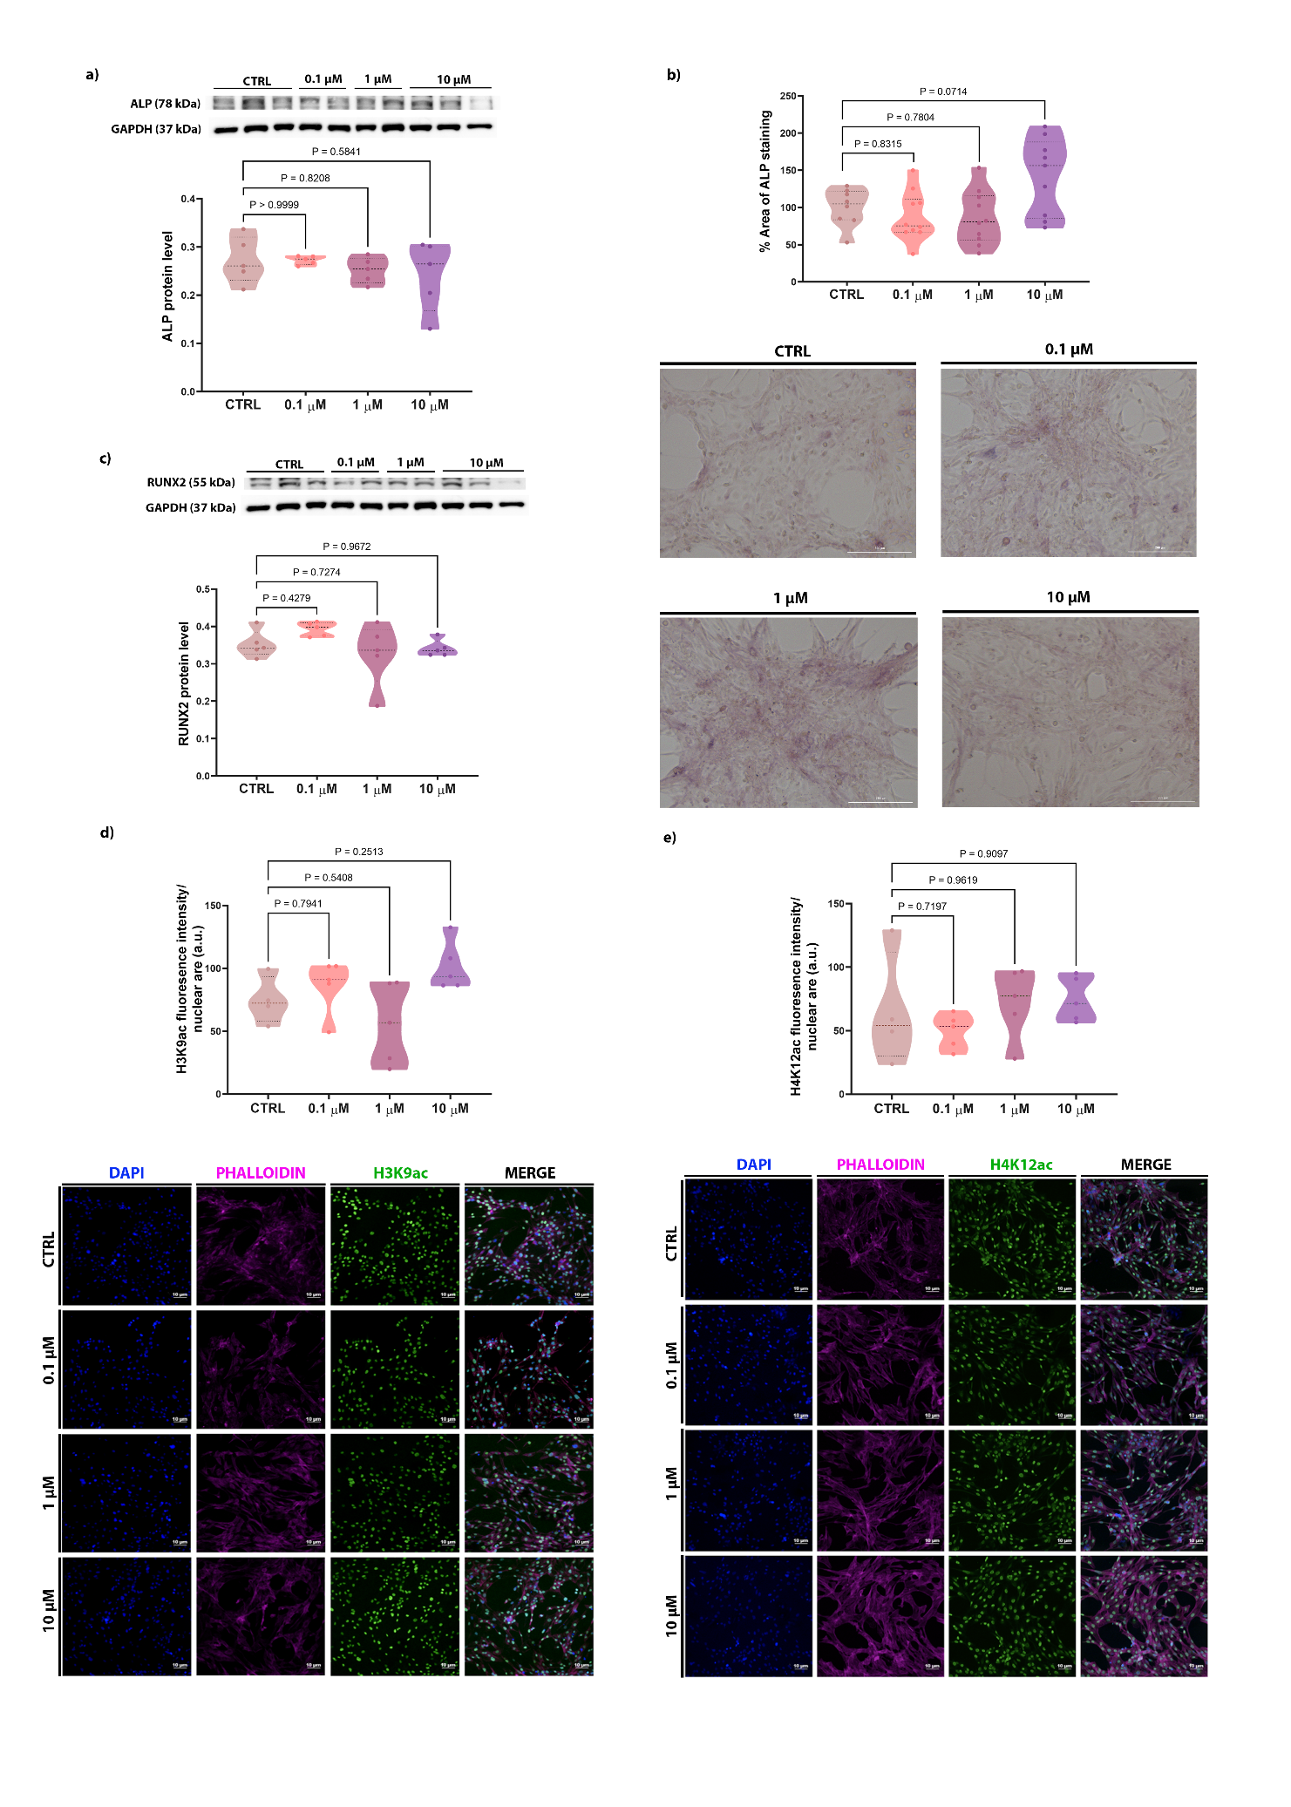
Supplementary Figure S2. Osteogenic markers correlate with PFOA responsiveness in 2D osteoblast after 5 days of exposure.
Analysis of osteogenic marker protein levels by western blot a) ALP 78 kDa b) ALP % positive area intensity measured using ImageJ and converted to % values over control. One-way ANOVA was used to analyze the difference between the groups and Tukey’s post hoc test was used for multiple comparisons among groups c) RUNX2 in hFOB1.19 cells exposed to different PFOA concentrations. P-values indicate the results of comparisons between each PFOA-treated group and the control group. Values of p < 0.05 are considered statistically significant. d and e) The violin blots represent the mean fluorescence intensity (MFI) profiles of H3K9ac and H4K12ac levels, respectively, in hFOB1.19 cells exposed to different PFOA concentrations (n = 5 individual biological replicates). Representative confocal images of hFOB1.19 cells immunostained for histone acetylation (green) and F-actin (purple); nuclei were counterstained with DAPI (blue). Scale bar: 10 µm.
Table 1. List of primary and secondary antibodies used in Western blotting (WB) and Immunofluorescence (IF) analysis.
Primary Antibody | Diluition of primary antibody | Diluition of secondary  antibody | Origin | Experimental  Analysis | Manufacturer primary antibodies | Catalogue number
anti-RUNX2 | 1:1000 | 1:10000 | Anti-rabbit | WB | Sigma-Aldrich | HPA022040-100UL
anti-ALP | 1:1000 | 1:30000 | Anti-mouse | WB | Abcam | ab126820
anti-COL1A2 | 1:1000 | 1:10000 | Anti-rabbit | WB | Proteintech | 14695-1-AP
anti-NRF2 | 1:500 | 1:1000 | Anti-rabbit | WB | Cell Signaling  Technology | 12721
Stress defense cocktail (anti-CAT, anti-SOD-1, anti-TRX) | 1:1000  1:500 | 1:10000 (2D)  1:2500 (3D) | Anti-rabbit | WB | Abcam | ab179843
anti-CB1 | 1:1000  1:1000  1:100 | 1:30000 (2D)  1:2500 (3D) | Anti-rabbit | WB  IF | Abcam | ab259323
anti-GAPDH | 1:10000 | 1:30000 (2D) | Anti-mouse | WB | Proteintech | 60004-1-Ig
anti-GAPDH | 1:1000 | 1:2500 (3D) | Anti-rabbit | WB | Cell Signaling  Technology | 2118
Anti-H3K9ac | 1:200 | 1:500 | Anti-rabbit | IF | Abcam | ab10812
Anti-H4K12ac | 1:200 | 1:500 | Anti-rabbit | IF | Abcam | ab46983
Secondary Antibody | Diluition of primary antibody | Diluition of secondary  antibody | Origin | Experimental  Analysis | Manufacturer primary antibodies | Catalogue number
Goat Anti-Rabbit IgG H&L (Alexa Fluor® 488) |  | 1:400 | Anti-rabbit | IF | Abcam | ab150077
Goat Anti-Mouse IgG H&L (Alexa Fluor® 647)  Phalloidin |  | 1:400 | Anti-mouse | IF | Abcam | ab150115
Anti-mouse |  | 1:30000 |  | WB 2D | Bethyl Laboratories | A90-116P
Anti-rabbit |  | 1:10000 |  | WB 2D | Invitrogen | 65-6120
Anti-rabbit |  | 1:2500 |  | WB 3D | Sigma-Aldrich | A0545

