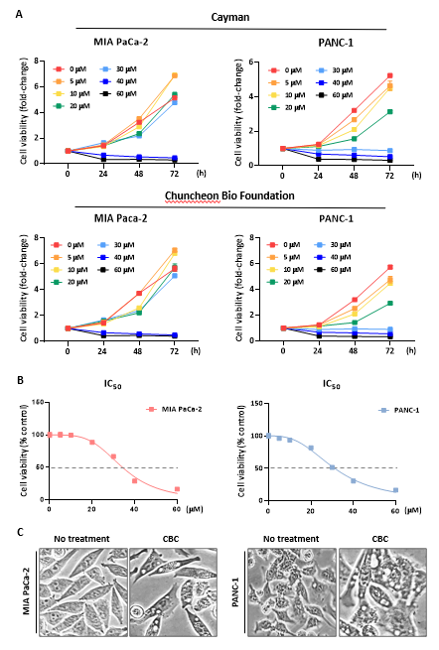

Supplementary Fig S1. Growth inhibitory effect and morphological changes induced by cannabichromene (CBC) treatment. (A) An MTT assay was performed to evaluate the growth-inhibitory effects of CBC on MIA PaCa-2 and PANC-1 pancreatic cancer cells. The cell proliferation inhibitory effects of CBC obtained from Cayman Inc. and Chuncheon Bio Foundation were compared (Upper: CBC from Cayman Inc.; Lower: CBC from Chuncheon Bio Foundation). (B) The IC₅₀ values were determined using GraphPad Prism (MIA PaCa-2 = 34.33 μM, PANC-1 = 31.65 μM). (C) Morphological changes and intracellular vesicle formation induced by CBC treatment were also observed.

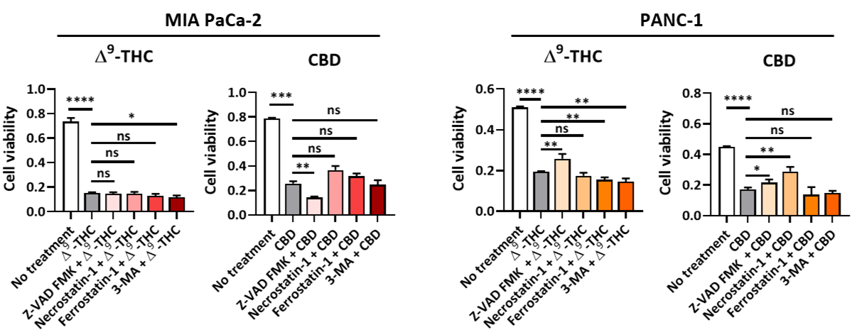
Supplementary Fig S2. Cell viability changes after combination treatment with several inhibitors and Δ⁹-tetrahydrocannabinol (Δ⁹-THC) or cannabidiol (CBD). Δ⁹-THC treatment reduced cell viability, but combination treatment with several inhibitors did not result in any significant changes. CBD treatment resulted in a significant decrease in cell viability, which was recovered only after combination treatment with Z-VAD-FMK and necrostatin-1. Statistical significance was determined using Student’s t-tests, with p-values ≤ 0.05 indicating statistical significance.

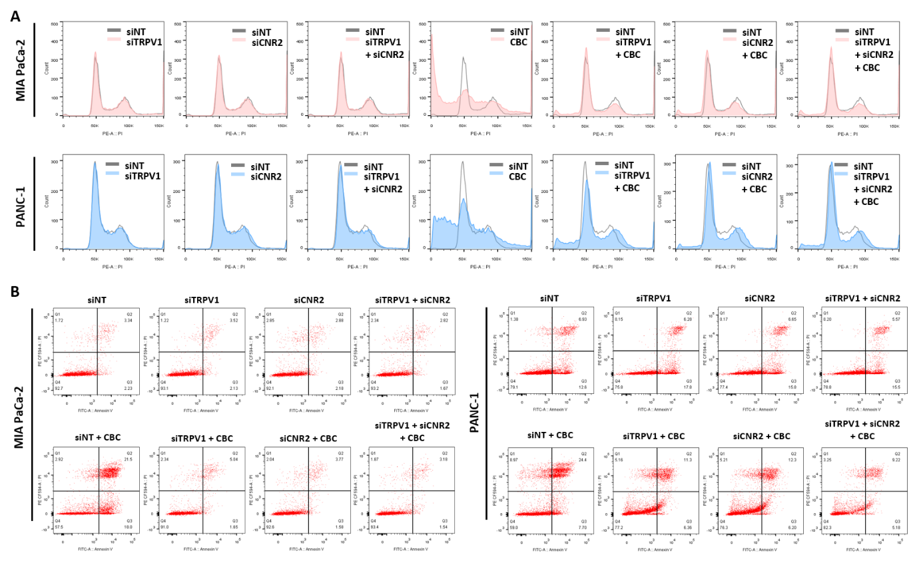
Supplementary Fig S3. Original data for FACS and AnnexinV/propidium iodide (PI) staining experiment corresponding to the graphs in Figure 6B and C.

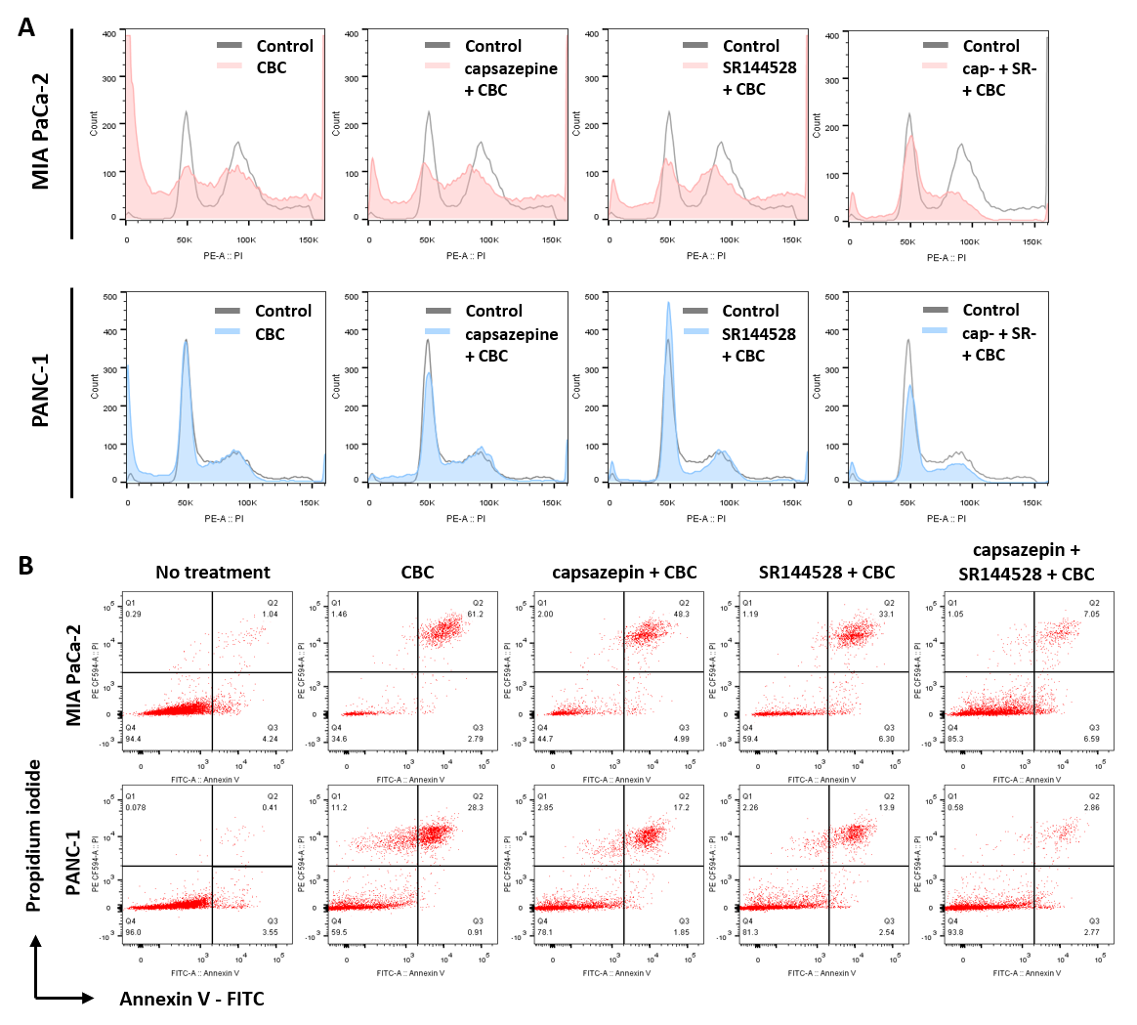
Supplementary Fig S4. Original data for FACS and AnnexinV/propidium iodide (PI) staining experiment corresponding to the graphs in Figure 6D and E.

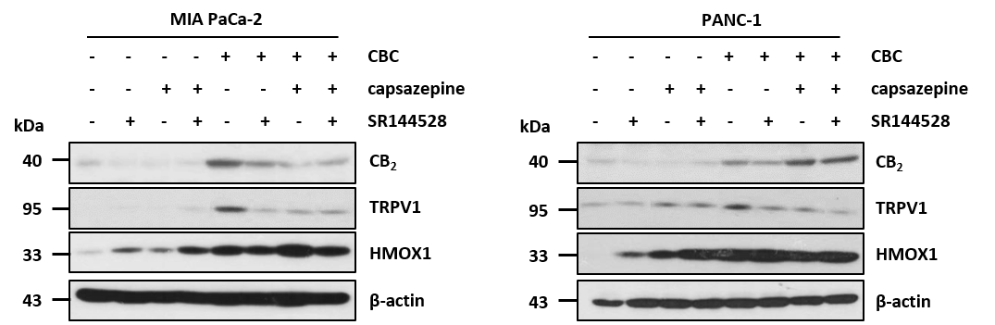
Supplementary Fig S5. Western blot analysis of HMOX-1 after combination treatment comprising inhibitors of cannabinoid receptors and cannabichromene (CBC). Western blot analysis showed that HMOX1 protein expression did not change after combination treatment with capsazepine or SR144528 and CBC.

