A novel c-Met/TRK inhibitor 1D228 efficiently inhibits tumor growth by targeting angiogenesis and tumor cell proliferation.
Baijiao An^{1,3}, Wenyan Nie¹ , Jinhui Hu⁴, Yangyang Fan¹, Haoran Nie¹, Mengxuan Wang¹, Yaxuan Zhao¹, Han Yao², Yuanyuan Ren², Chuanchuan Zhang¹, Mengna Wei², Wei Li², Jiadai Liu², Chunhua Yang ¹, Yin Zhang ^{1,3*}, Xingshu Li^{2*}, and Geng Tian^{1,3*}.

1 School of Pharmacy, Binzhou Medical University, Yantai, Shandong, 264003, PR China

2 School of Pharmaceutical Sciences, Sun Yat-Sen University, Guangzhou 510006, PR China

3 Shandong Technology Innovation Center of Molecular Targeting and Intelligent Diagnosis and Treatment, Yantai, Shandong, 264003, PR China

4 School of Biotechnology and Health Sciences, Wuyi University, Jiangmen, 529020, PR China

Supplementary Contents
Content
- Supplemental Figures and legends
- Supplemental Tables
- Original Western blot

Fig.S1 Upset maps show the simultaneous and significantly abnormal intersection of MET, NTRK1, NTRK2, and NTRK3 expression in multiple cancers; (A) 8 cancer species in the TCGA database showed significant abnormal expression of both NTRK and c-Met；(B) 21 cancer species in TCGA and GTEx database showed significant aberrant expression of both of them.

Fig.S2 Effects of 1D228 on the signaling pathway and anti-proliferative activity of MKN45, ASPC1 and HS746T cells. (A) Expression of AXL, p-AXL, ALK, p-ALK, MER and p-MER proteins in MKN45 cells；(B) Effect of 1D228 on the expression of c-Met, AKT and their corresponding phosphorylated proteins in ASPC1 cells；(C) Activity of 1D228 on HS746T; (D) CCK8 assay for anti-proliferative activity of 1D228, Tepotinib, Larotrectinib and combinations against MKN45 (Data are represented as mean ± SD, n=3. Unpaired t-test was used. ***: P≤0.001, **: P≤0.01).

Fig.S3 1D228 inhibited the migration of MHCC97H and ASPC1 cells. (A) 1D228 inhibited the migration of MHCC97H cells at concentrations of 1, 5 and 10 nM; (B) 1D228 inhibited the migration of ASPC1 cells at concentrations of 10, 100 and 100 nM.

Fig.S4 (A)Antiproliferative activity of the compound 1D228 against C166 cells and HUVEC cells; (B) Protein level of CyclinD1 and NF-KB in MKN45 tumor tissues.

Fig.S5 ¹H NMR (A) and ¹³C NMR (B) of 1D228.

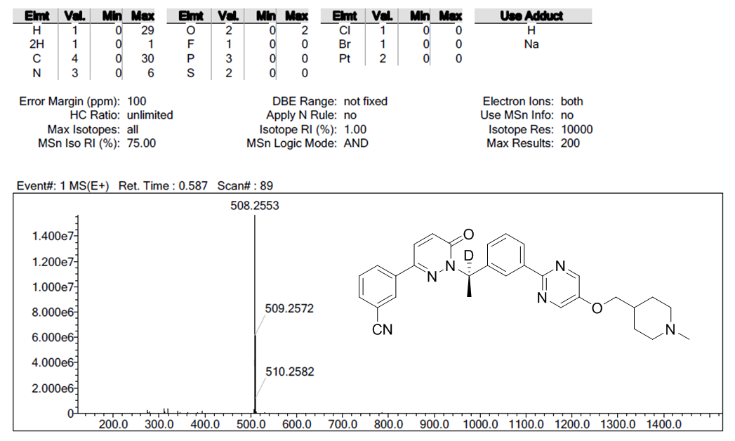
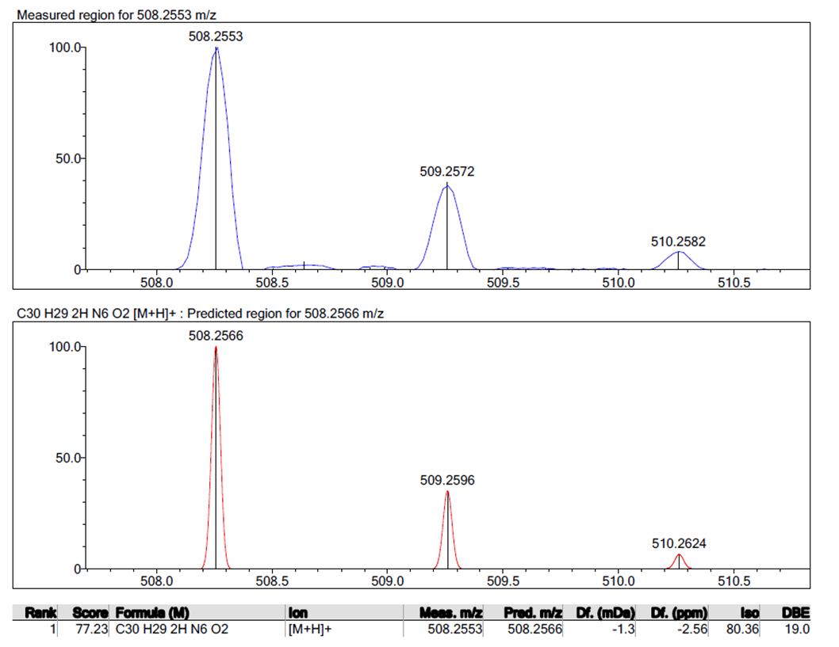
Fig.S6 HRMS (ESI) Spectrum of 1D228.

Supplemental tables
Table S1 The TCGA database reveals abnormal expression of MET, and NTRKs simultaneously in 8 cancer species
MET | NTRK1 | NTRK2 | NTRK3 | ..count.. | values
TRUE | TRUE | TRUE | TRUE | 8 | BLCA、GBM、KICH、KIRC、KIRP、LUAD、PRAD、THCA
FALSE | TRUE | TRUE | TRUE | 3 | LUSC、UCEC、
TRUE | FALSE | TRUE | TRUE | 4 | BRCA、COAD、LIHC、READ
FALSE | FALSE | TRUE | TRUE | 0
TRUE | TRUE | FALSE | TRUE | 1 | HNSC
FALSE | TRUE | FALSE | TRUE | 0
TRUE | FALSE | FALSE | TRUE | 3 | CESC、ESCA、STAD
FALSE | FALSE | FALSE | TRUE | 0
TRUE | TRUE | TRUE | FALSE | 0
FALSE | TRUE | TRUE | FALSE | 0
TRUE | FALSE | TRUE | FALSE | 0
FALSE | FALSE | TRUE | FALSE | 1 | THYM
TRUE | TRUE | FALSE | FALSE | 2 | CHOL、PCPG
FALSE | TRUE | FALSE | FALSE | 0
TRUE | FALSE | FALSE | FALSE | 1 | PAAD

Table S2 Significant aberrant expression of METs, and NTRKs simultaneously in 21 cancer species in the TCGA and GTEx database
MET | NTRK1 | NTRK2 | NTRK3 | ..count.. | values
TRUE | TRUE | TRUE | TRUE | 21 | ACC、BLCA、BRCA、CESC、COAD、GBM、KICH、KIRC、KIRP、LGG、LIHC、LUAD、LUSC、OV、PAAD、PRAD、READ、SKCM、TGCT、THCA、UCEC
FALSE | TRUE | TRUE | TRUE | 1
TRUE | FALSE | TRUE | TRUE | 1 | DLBC
FALSE | FALSE | TRUE | TRUE | 0
TRUE | TRUE | FALSE | TRUE | 4 | ESCA、HNSC、STAD、UCS
FALSE | TRUE | FALSE | TRUE | 0
TRUE | FALSE | FALSE | TRUE | 0
FALSE | FALSE | FALSE | TRUE | 0
TRUE | TRUE | TRUE | FALSE | 0
FALSE | TRUE | TRUE | FALSE | 0
TRUE | FALSE | TRUE | FALSE | 0
FALSE | FALSE | TRUE | FALSE | 1 | THYM
TRUE | TRUE | FALSE | FALSE | 2 | CHOL、PCPG
FALSE | TRUE | FALSE | FALSE | 0
TRUE | FALSE | FALSE | FALSE | 0

Table S3 Active compound 1D228 selectivity profile against 77 kinases
No. | Kinase | 1D228(%inhibition)@500nM | SD
1 | TRKC | 98.97490899 | 0.516729044
2 | MET | 98.41023795 | 0.123434959
3 | TRKB | 97.14737997 | 0.242132851
4 | TRKA | 93.58061047 | 0.333267742
5 | ALK | 89.49144648 | 2.570688057
6 | AXL | 89.15455865 | 0.586372084
7 | MER | 84.12182119 | 2.583330992
8 | LYNa | 27.34466781 | 11.56474128
9 | INSR | 18.55089981 | 0.862983345
10 | FLT3 | 17.85846483 | 1.58932497
11 | RET | 12.2397088 | 3.465533248
12 | FRK | 11.30581833 | 7.741350166
13 | YES | 11.30093532 | 1.954908286
14 | EGFR T790M L858R | 11.10777471 | 0.474070641
15 | FYN [b] | 10.89557436 | 3.792222137
16 | MUSK | 9.134475789 | 3.315180022
17 | HER2 | 8.776664097 | 1.986036229
18 | EPHA8 | 8.524810723 | 0.384258597
19 | TEC | 8.286494281 | 0.318370202
20 | PDGFRα | 8.205647675 | 6.968805766
21 | JAK1 | 7.194830582 | 0.714171706
22 | ROS1 | 7.047430651 | 1.950648344
23 | ABL1 | 6.373033883 | 18.31837362
24 | FLT1 | 6.00455485 | 8.897028373
25 | EPHB3 | 5.67500008 | 0.926656354
26 | KDR | 5.618924349 | 1.265862957
27 | LYNb | 5.264063305 | 0.70167176
28 | IGF1R | 5.259258184 | 0.37436658
29 | LCK | 5.206929863 | 7.789832508
30 | BMX | 5.121428705 | 0.896501642
31 | EPHB4 | 5.077790615 | 0.572159301
32 | TYK2 | 4.509326659 | 4.568177769
33 | ABL2 | 4.452347197 | 8.340013503
34 | TYRO3 | 4.202290908 | 1.590761847
35 | IRR | 3.882700344 | 0.984574313
36 | EPHA5 | 3.739816649 | 1.555792545
37 | CSF1R | 3.21373716 | 1.038892456
38 | BRK | 3.18869635 | 1.47802798
39 | FGFR3 | 3.051062478 | 0.15681926
40 | SRC | 2.90585978 | 2.585173437
41 | SRM | 2.655628234 | 1.204384972
42 | SYK | 2.468116698 | 2.438437437
43 | Her4 | 2.211068735 | 0.594009271
44 | ACK | 1.959804148 | 1.022349265
45 | JAK2 | 1.822938633 | 2.400345295
46 | FGFR1 | 1.720749484 | 4.351100522
47 | ITK | 1.600503327 | 8.697459449
48 | RON | 1.3838053 | 1.444041213
49 | TXK | 1.291750327 | 4.877836911
50 | EGFR | 1.173340299 | 0.419443343
51 | PYK2 | 1.141612741 | 0.28602106
52 | FES | 1.046088687 | 0.892904376
53 | FGFR2 | 1.036313628 | 1.947712304
54 | JAK3 | 0.193346546 | 0.781065561
55 | FGFR4 | -0.369902136 | 3.19016627
56 | ZAP70 | -0.65998976 | 2.292060251
57 | EPHA2 | -0.797754207 | 4.338051332
58 | EPHA7 | -1.356870217 | 0.204220471
59 | EPHA1 | -1.533013103 | 1.271117261
60 | EPHA6 | -1.78052958 | 2.853206283
61 | TIE2 | -2.642591574 | 2.662917088
62 | FLT4 | -3.030927591 | 4.024762545
63 | CSK | -3.072334066 | 4.867674947
64 | EPHB2 | -3.544633411 | 1.722118302
65 | BTK | -3.812926293 | 0.465931217
66 | PDGFRβ | -3.951967635 | 4.942501836
67 | DDR2 | -3.977464913 | 5.064065849
68 | HCK | -4.058094123 | 9.038667158
69 | KIT | -4.496350796 | 4.960618953
70 | EPHB1 | -6.478447133 | 7.523719008
71 | FYN [a] | -7.775129935 | 1.531977428
72 | FAK | -9.578633085 | 7.56830502
73 | EPHA3 | -11.81050837 | 6.590522602
74 | DDR1 | -11.81297028 | 7.985033977
75 | FER | -13.29509443 | 3.82347252
76 | EPHA4 | -14.66809515 | 2.775240101
77 | FGR | -20.70240676 | 5.279764343

Table S4 The 80 pairs samples in tissue microarrays for immunohistochemistry analysis
NO. | Gender | Age | Tissue type | Pathological classification | Grade | Expression gene
1 | Male | 40 | Tumor | gastric adenocarcinoma | Ⅲ | TRKlow | METhigh
2 | Male | 45 | Tumor | gastric adenocarcinoma | Ⅱ-Ⅲ | TRKlow | METhigh
3 | Male | 76 | Tumor | gastric adenocarcinoma | Ⅱ | TRKhigh | METhigh
4 | Female | 56 | Tumor | gastric adenocarcinoma | Ⅲ | TRKlow | METhigh
5 | Male | 75 | Tumor | gastric adenocarcinoma | Ⅲ | TR Klow | METhigh
6 | Male | 69 | Tumor | gastric adenocarcinoma | Ⅲ | TRKhigh | METhigh
7 | Male | 68 | Tumor | gastric adenocarcinoma | Ⅱ-Ⅲ | TRKlow | METhigh
8 | Male | 46 | Tumor | gastric adenocarcinoma | Ⅱ | TRKlow | METhigh
9 | Male | 68 | Tumor | gastric adenocarcinoma | Ⅲ | TRKlow | METhigh
10 | Male | 56 | Tumor | gastric adenocarcinoma | Ⅱ-Ⅲ | TRKlow | METlow
11 | Female | 72 | Tumor | gastric adenocarcinoma | Ⅱ-Ⅲ | TRKhigh | METhigh
12 | Male | 71 | Tumor | gastric adenocarcinoma | Ⅱ | TRKlow | METlow
13 | Male | 63 | Tumor | gastric adenocarcinoma | Ⅱ-Ⅲ | TRKlow | METhigh
14 | Male | 63 | Tumor | gastric adenocarcinoma | Ⅲ | TRKlow | METlow
15 | Female | 65 | Tumor | gastric adenocarcinoma | Ⅱ-Ⅲ | TRKlow | METhigh
16 | Male | 55 | Tumor | gastric adenocarcinoma | Ⅱ | TRKlow | METhigh
17 | Male | 79 | Tumor | gastric adenocarcinoma | Ⅲ | TRKlow | METhigh
18 | Male | 77 | Tumor | gastric adenocarcinoma | Ⅱ | TRKlow | METhigh
19 | Male | 52 | Tumor | gastric adenocarcinoma | Ⅱ-Ⅲ | TRKlow | METlow
20 | Male | 65 | Tumor | gastric adenocarcinoma | Ⅲ | TRKlow | METlow
21 | Female | 71 | Tumor | gastric adenocarcinoma | Ⅱ | TRKlow | METhigh
22 | Male | 70 | Tumor | gastric adenocarcinoma | Ⅱ | TRKlow | METhigh
23 | Male | 62 | Tumor | gastric adenocarcinoma | Ⅲ | TRKlow | METhigh
24 | Female | 54 | Tumor | gastric adenocarcinoma | Ⅲ | TRKlow | METhigh
25 | Male | 65 | Tumor | gastric adenocarcinoma | Ⅱ | TRKhigh | METhigh
26 | Male | 61 | Tumor | gastric adenocarcinoma | Ⅲ | TRKlow | METlow
27 | Male | 77 | Tumor | gastric adenocarcinoma | Ⅲ | TRKlow | METlow
28 | Male | 75 | Tumor | gastric adenocarcinoma | Ⅱ-Ⅲ | TRKlow | METlow
29 | Male | 66 | Tumor | gastric adenocarcinoma | Ⅱ | TRKlow | METhigh
30 | Male | 60 | Tumor | gastric adenocarcinoma | Ⅲ | TRKlow | METhigh
31 | Male | 72 | Tumor | gastric adenocarcinoma | Ⅱ | TRKlow | METhigh
32 | Female | 83 | Tumor | gastric adenocarcinoma | Ⅱ | TRKlow | METhigh
33 | Male | 69 | Tumor | gastric adenocarcinoma | Ⅱ | TRKlow | METlow
34 | Male | 60 | Tumor | gastric adenocarcinoma | Ⅲ | TRKlow | METlow
35 | Female | 80 | Tumor | gastric adenocarcinoma | Ⅲ | TRKhigh | METlow
36 | Male | 53 | Tumor | gastric adenocarcinoma | Ⅱ | TRKlow | METlow
37 | Male | 53 | Tumor | gastric adenocarcinoma | Ⅱ-Ⅲ | TRKlow | METlow
38 | Male | 52 | Tumor | gastric adenocarcinoma | Ⅲ | TRKlow | METlow
39 | Male | 58 | Tumor | gastric adenocarcinoma | Ⅱ | TRKlow | METhigh
40 | Male | 65 | Tumor | gastric adenocarcinoma | Ⅱ | TRKlow | METhigh
41 | Female | 73 | Tumor | gastric adenocarcinoma | Ⅱ | TRKlow | METhigh
42 | Male | 67 | Tumor | gastric adenocarcinoma | Ⅱ | TRKhigh | METhigh
43 | Male | 77 | Tumor | gastric adenocarcinoma | Ⅱ-Ⅲ | TRKlow | METhigh
44 | Male | 48 | Tumor | gastric adenocarcinoma | Ⅱ-Ⅲ | TRKlow | METhigh
45 | Female | 62 | Tumor | gastric adenocarcinoma | Ⅲ | TRKlow | METlow
46 | Female | 34 | Tumor | gastric adenocarcinoma | Ⅲ | TRKlow | METlow
47 | Male | 85 | Tumor | gastric adenocarcinoma | Ⅱ-Ⅲ | TRKlow | METhigh
48 | Male | 59 | Tumor | gastric adenocarcinoma | Ⅲ | TRKlow | METlow
49 | Male | 68 | Tumor | gastric adenocarcinoma | Ⅱ-Ⅲ | TRKlow | METhigh
50 | Male | 50 | Tumor | gastric adenocarcinoma | Ⅱ-Ⅲ | TRKlow | METlow
51 | Male | 51 | Tumor | gastric adenocarcinoma | Ⅱ | TRKlow | METhigh
52 | Male | 72 | Tumor | gastric adenocarcinoma | Ⅲ | TRKlow | METlow
53 | Male | 73 | Tumor | gastric adenocarcinoma | Ⅱ | TRKlow | METhigh
54 | Male | 70 | Tumor | gastric adenocarcinoma | Ⅱ | TRKlow | METhigh
55 | Female | 53 | Tumor | gastric adenocarcinoma | Ⅱ-Ⅲ | TRKlow | METlow
56 | Male | 69 | Tumor | gastric adenocarcinoma | Ⅱ-Ⅲ | TRKlow | METlow
57 | Male | 67 | Tumor | gastric adenocarcinoma | Ⅱ | TRKlow | METhigh
58 | Male | 65 | Tumor | gastric adenocarcinoma | Ⅲ | TRKlow | METlow
59 | Male | 55 | Tumor | gastric adenocarcinoma | Ⅲ | TRKlow | METlow
60 | Female | 85 | Tumor | gastric adenocarcinoma | Ⅱ | TRKlow | METhigh
61 | Male | 30 | Tumor | gastric adenocarcinoma | Ⅲ | TRKlow | METhigh
62 | Male | 73 | Tumor | gastric adenocarcinoma | Ⅱ-Ⅲ | TRKlow | METhigh
63 | Female | 64 | Tumor | gastric adenocarcinoma | Ⅱ-Ⅲ | TRKlow | METlow
64 | Female | 67 | Tumor | gastric adenocarcinoma | Ⅱ-Ⅲ | TRKlow | METlow
65 | Male | 64 | Tumor | gastric adenocarcinoma | Ⅲ | TRKlow | METlow
66 | Male | 56 | Tumor | gastric adenocarcinoma | Ⅱ-Ⅲ | TRKhigh | METhigh
67 | Male | 63 | Tumor | gastric adenocarcinoma | Ⅱ-Ⅲ | TRKlow | METhigh
68 | Female | 54 | Tumor | gastric adenocarcinoma | Ⅱ-Ⅲ | TRKlow | METlow
69 | Male | 60 | Tumor | gastric adenocarcinoma | Ⅲ | TRKlow | METlow
70 | Male | 60 | Tumor | gastric adenocarcinoma | Ⅱ-Ⅲ | TRKlow | METhigh
71 | Male | 60 | Tumor | gastric adenocarcinoma | Ⅱ | TRKhigh | METhigh
72 | Male | 86 | Tumor | gastric adenocarcinoma | Ⅱ | TRKlow | METhigh
73 | Male | 53 | Tumor | gastric adenocarcinoma | Ⅲ | TRKlow | METhigh
74 | Male | 64 | Tumor | gastric adenocarcinoma | Ⅱ-Ⅲ | TRKlow | METlow
75 | Male | 53 | Tumor | gastric adenocarcinoma | Ⅱ | TRKlow | METhigh
76 | Male | 72 | Tumor | gastric adenocarcinoma | Ⅲ | TRKlow | METhigh
77 | Male | 51 | Tumor | gastric adenocarcinoma | Ⅱ | TRKlow | METlow
78 | Female | 43 | Tumor | gastric adenocarcinoma | Ⅲ | TRKlow | METlow
79 | Female | 75 | Tumor | gastric adenocarcinoma | Ⅲ | TRKlow | METlow
80 | Male | 56 | Tumor | gastric adenocarcinoma | Ⅱ-Ⅲ | TRKlow | METlow

