SUPPLEMENTARY FIGURES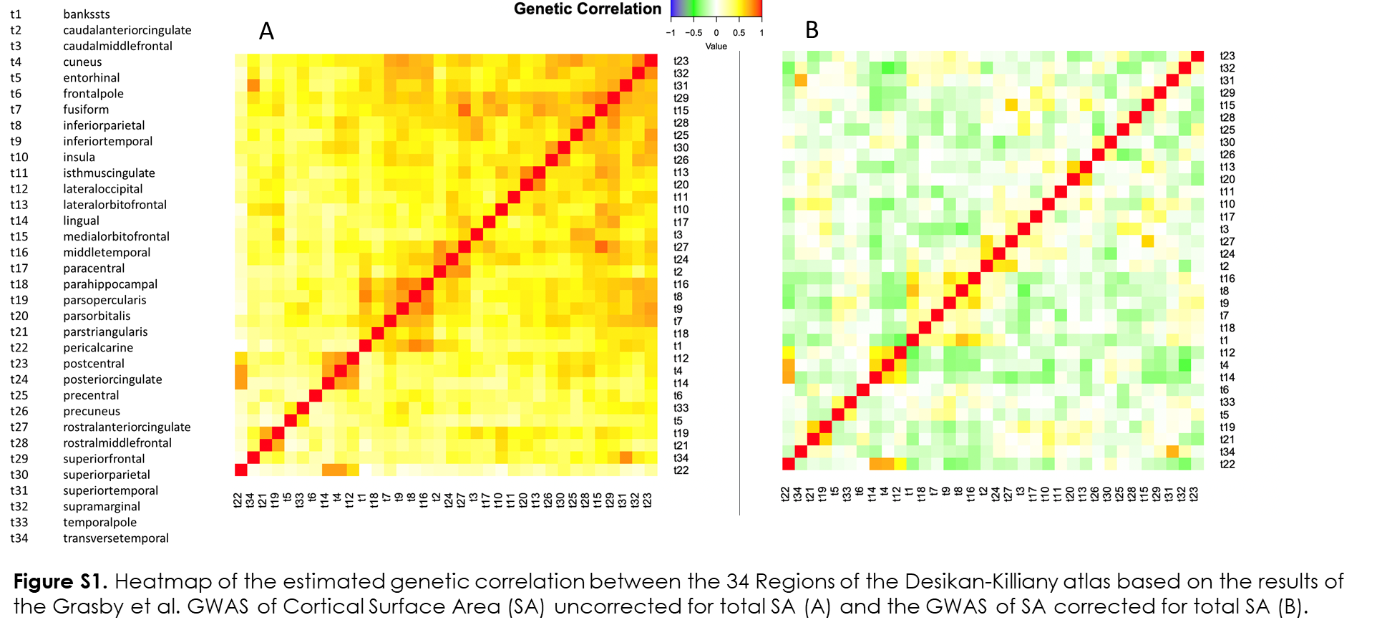

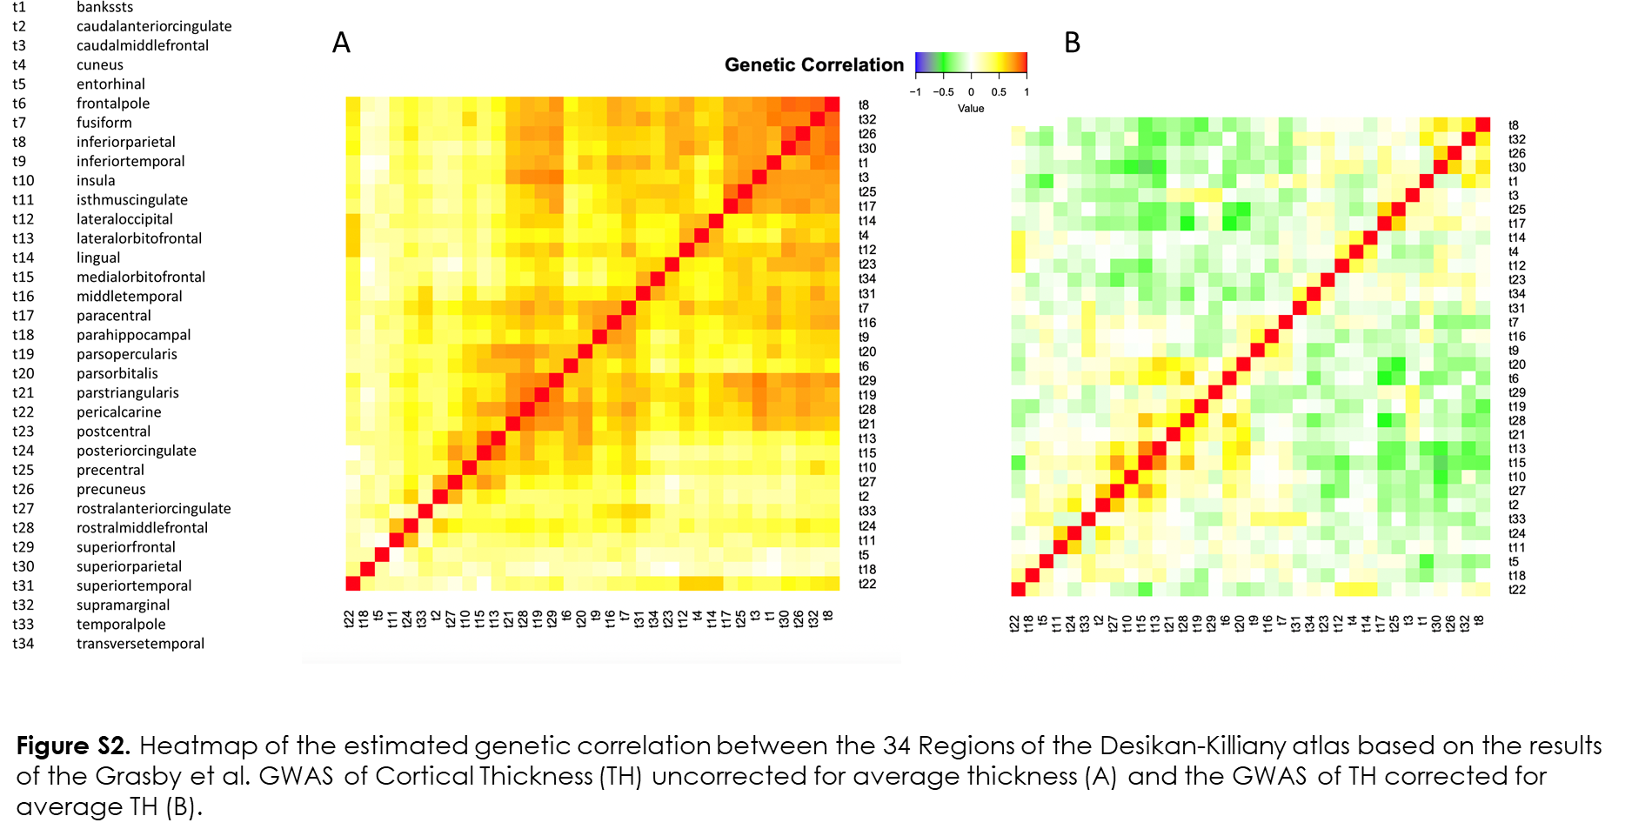
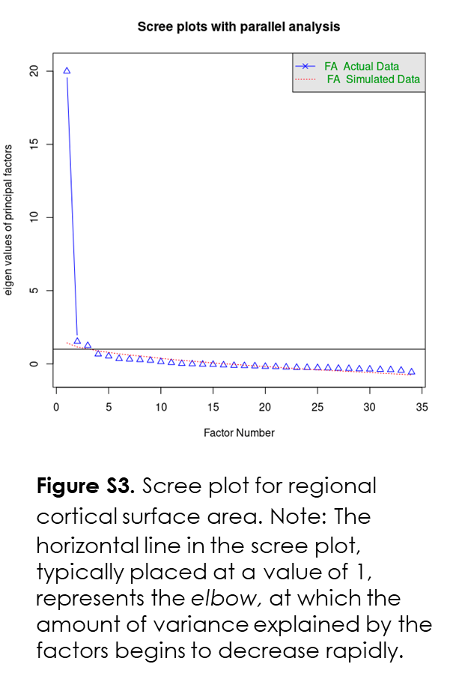

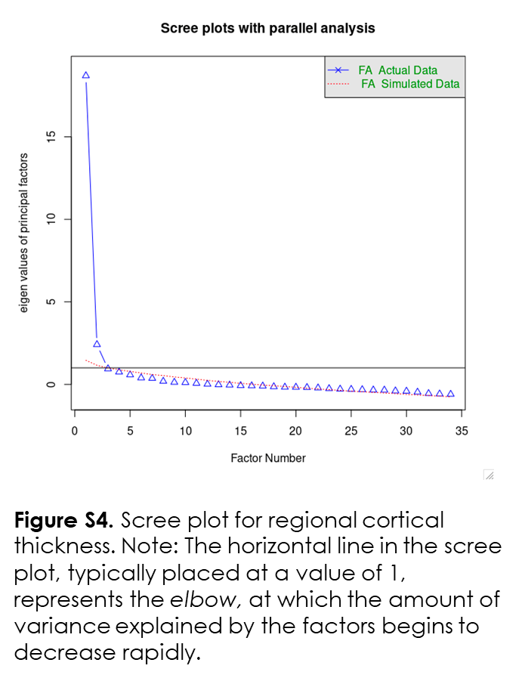
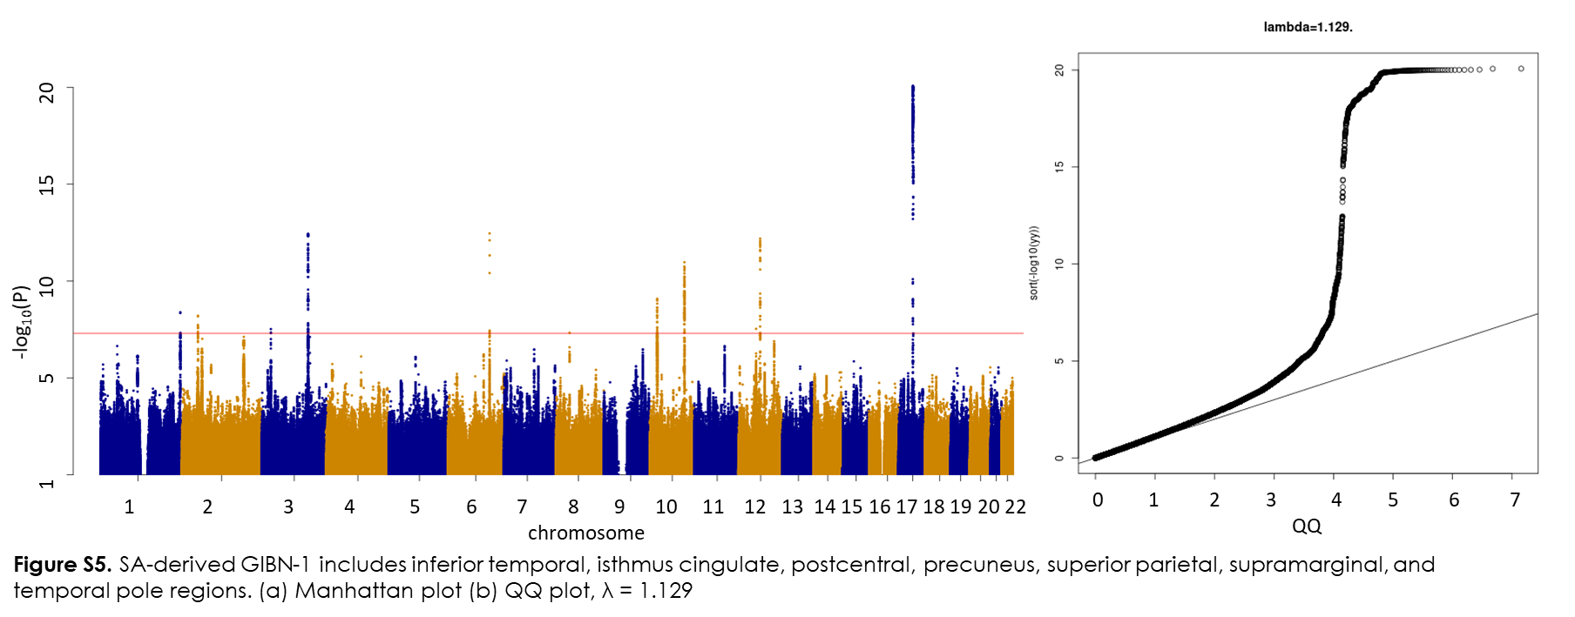

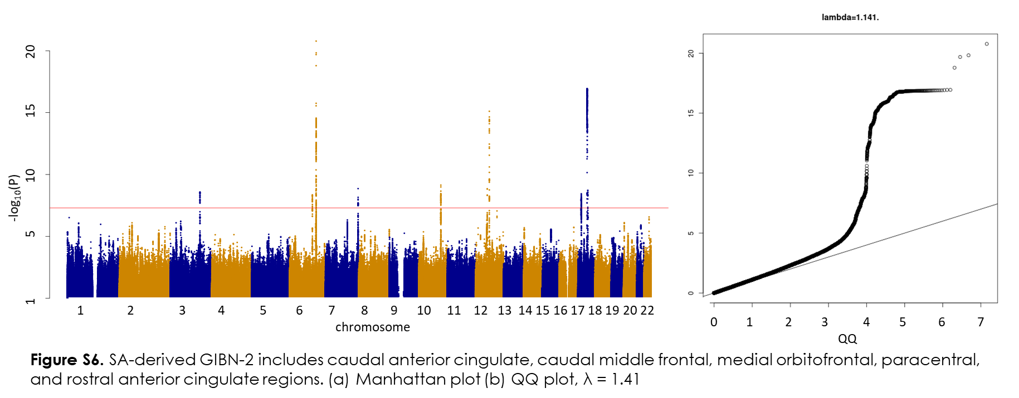

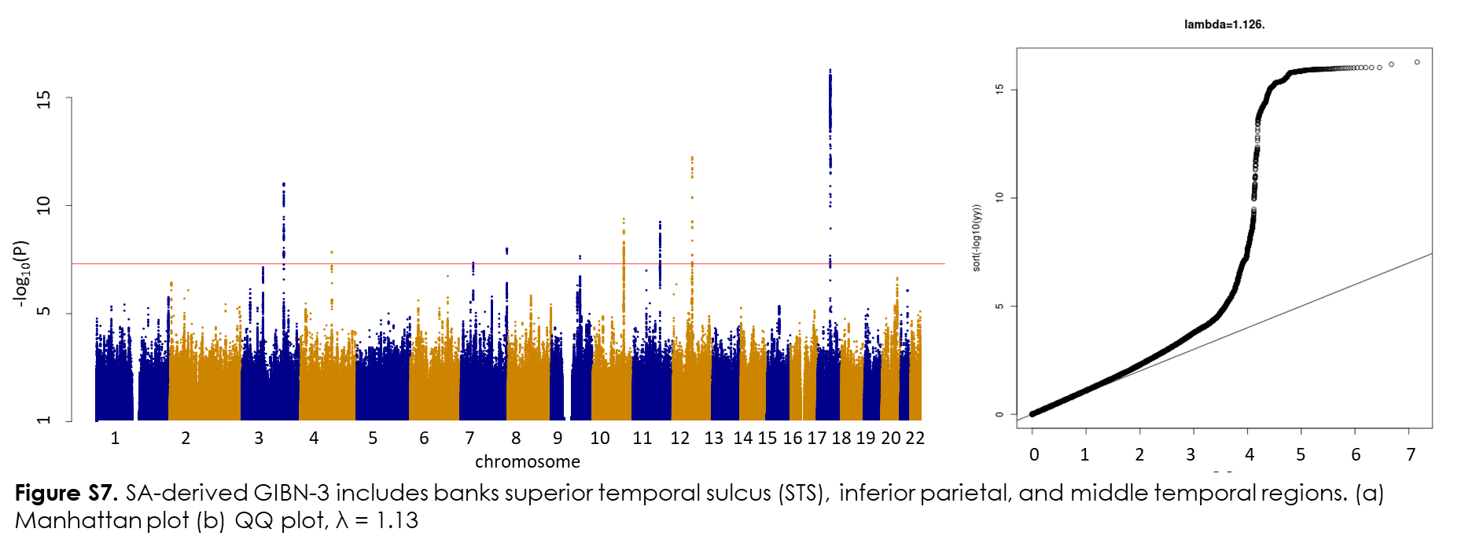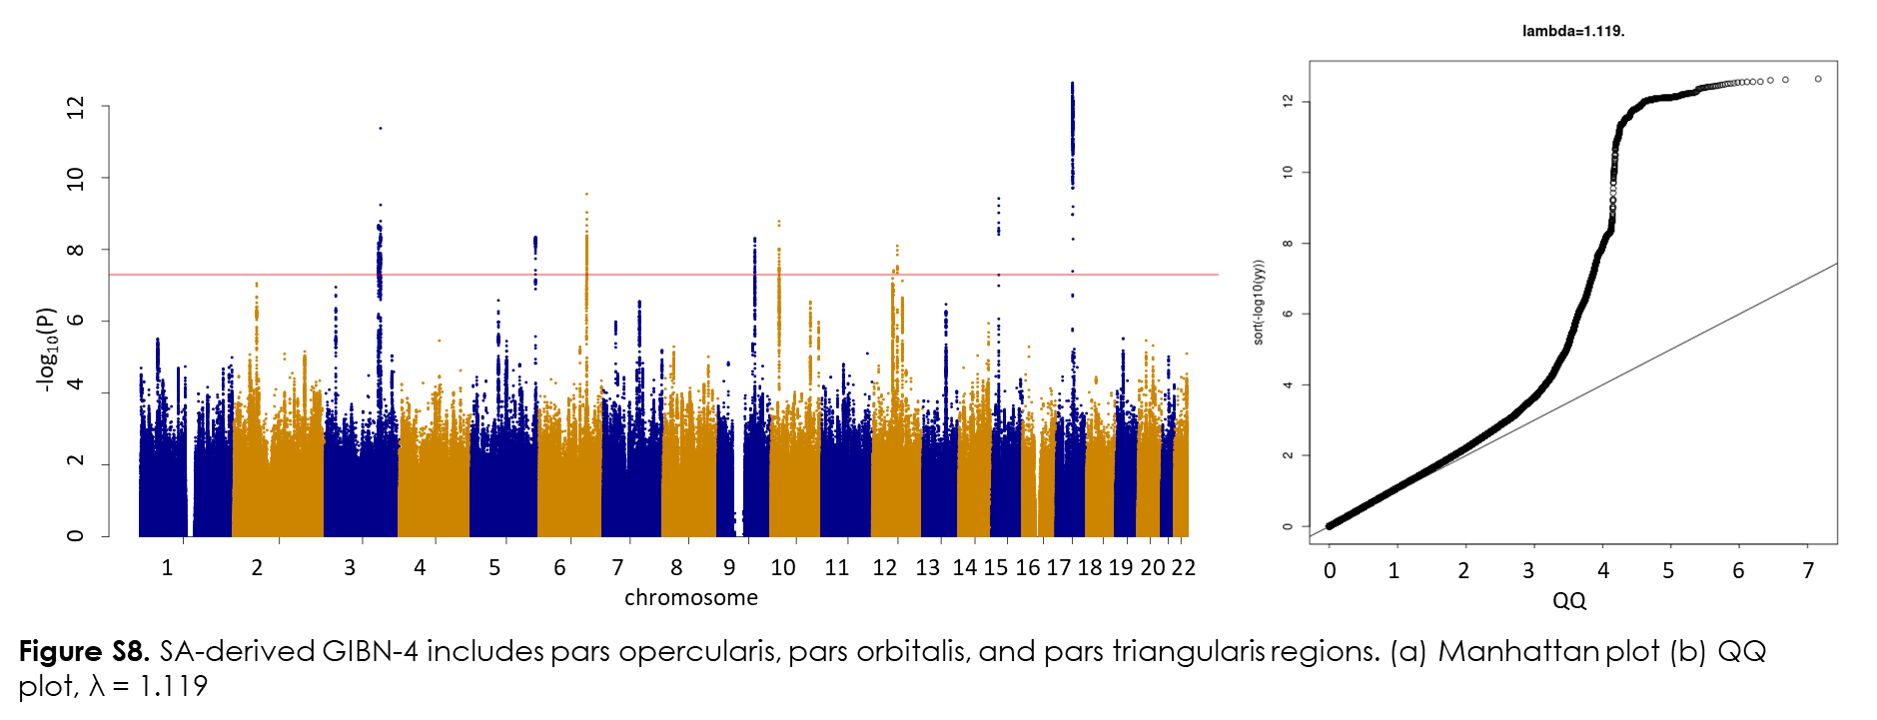

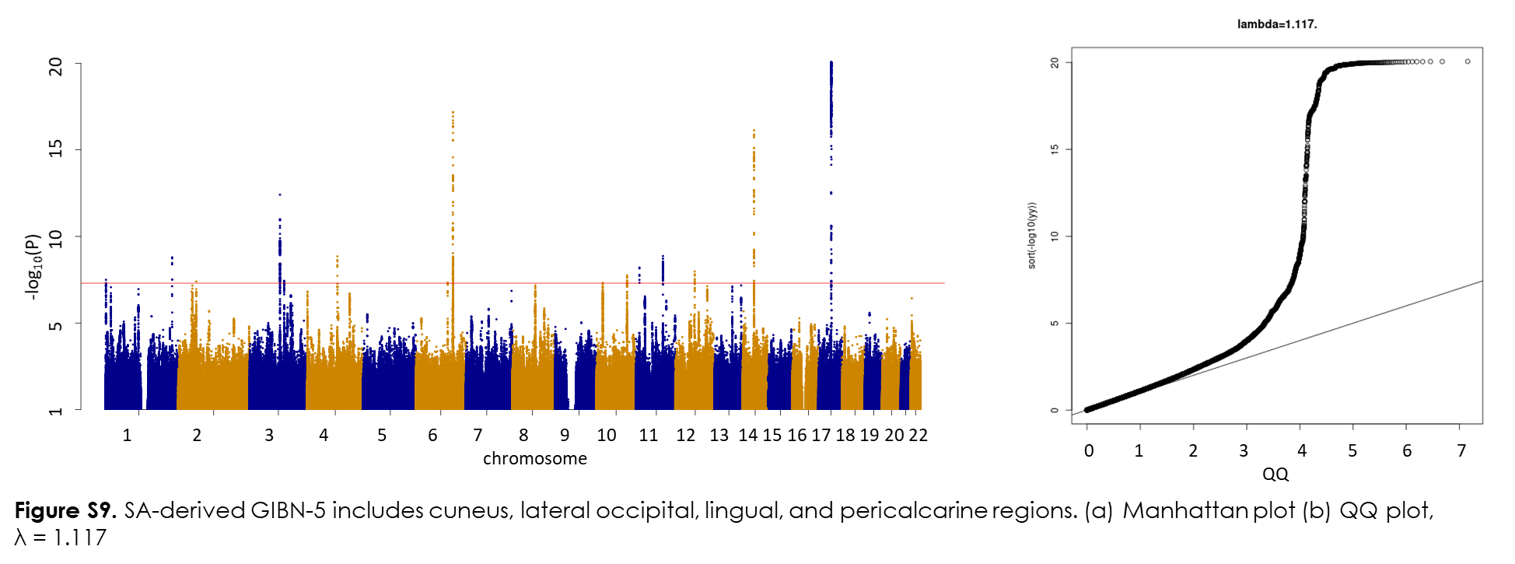

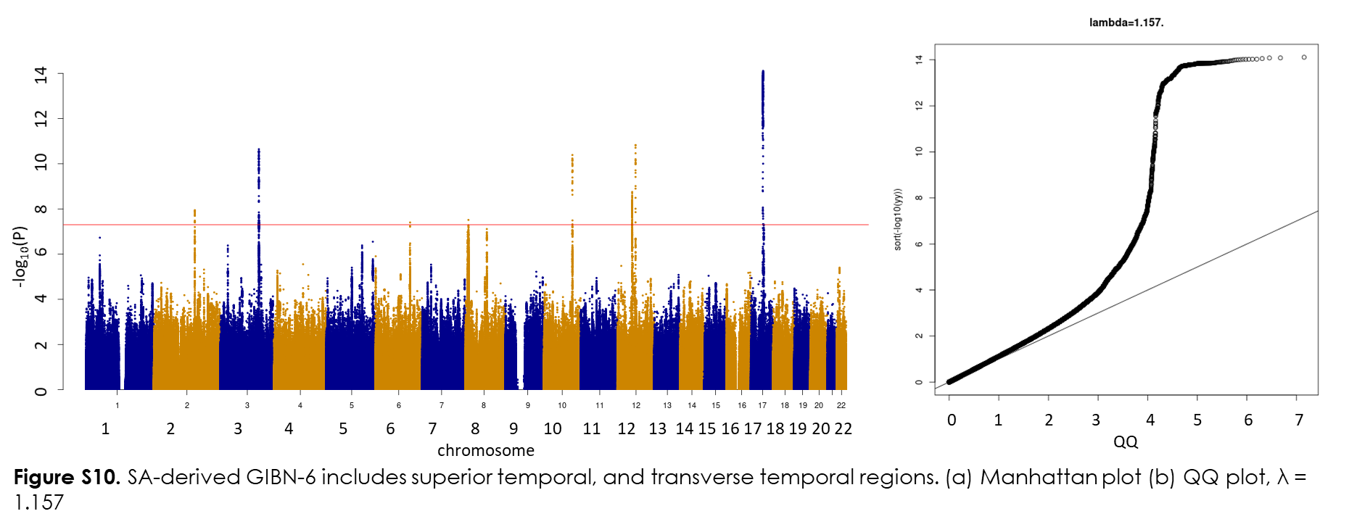
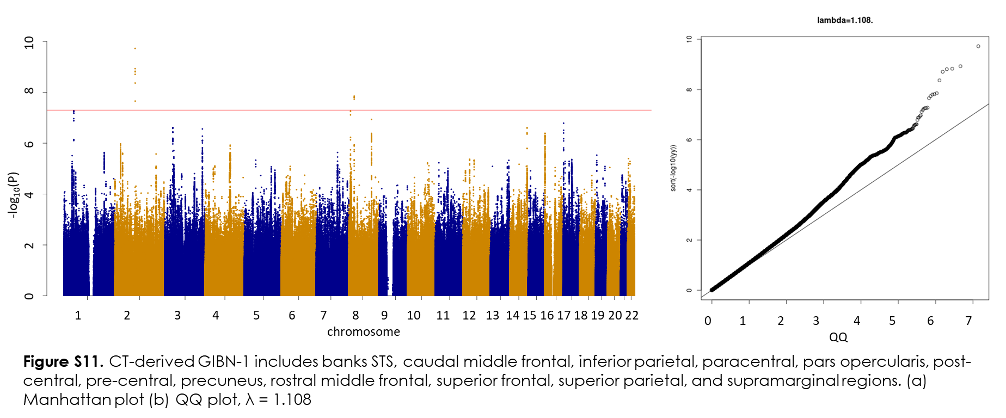
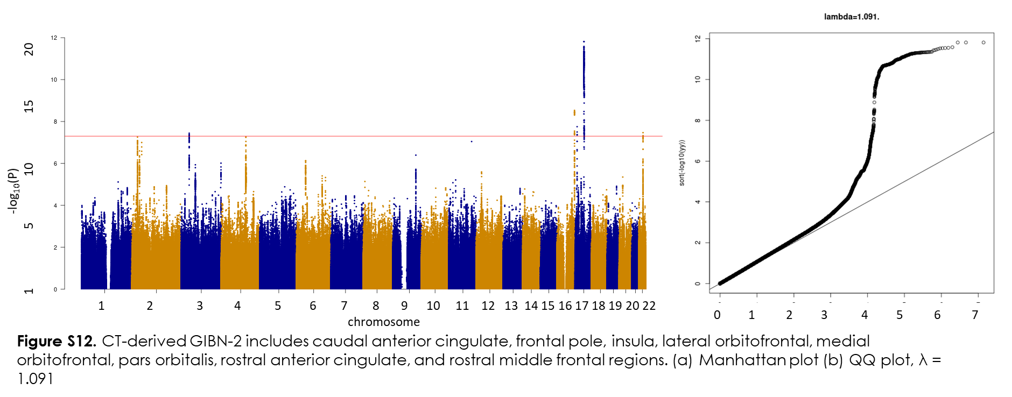

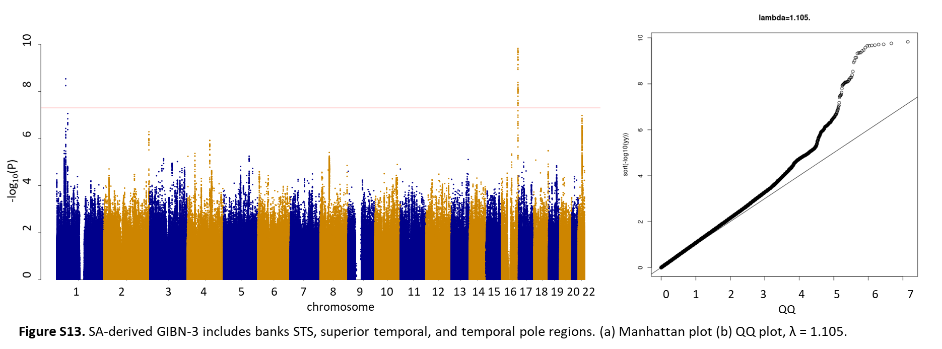
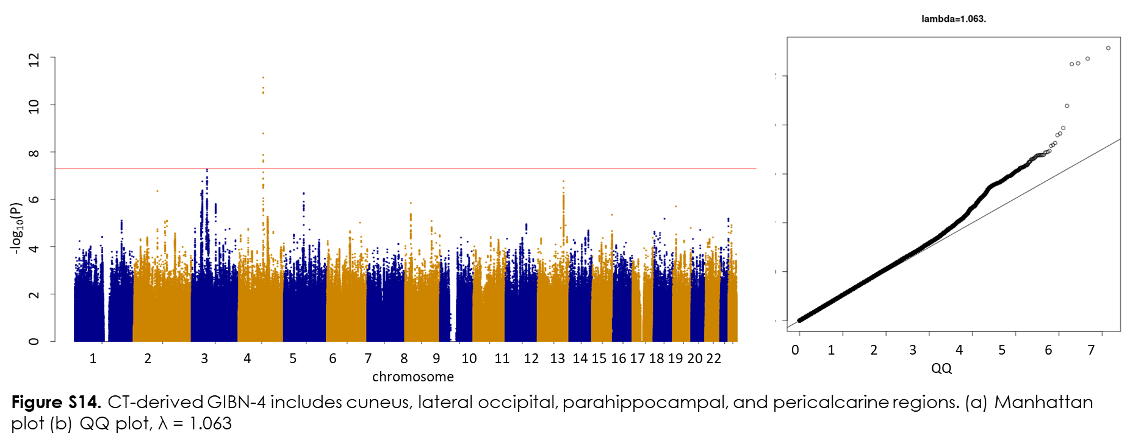

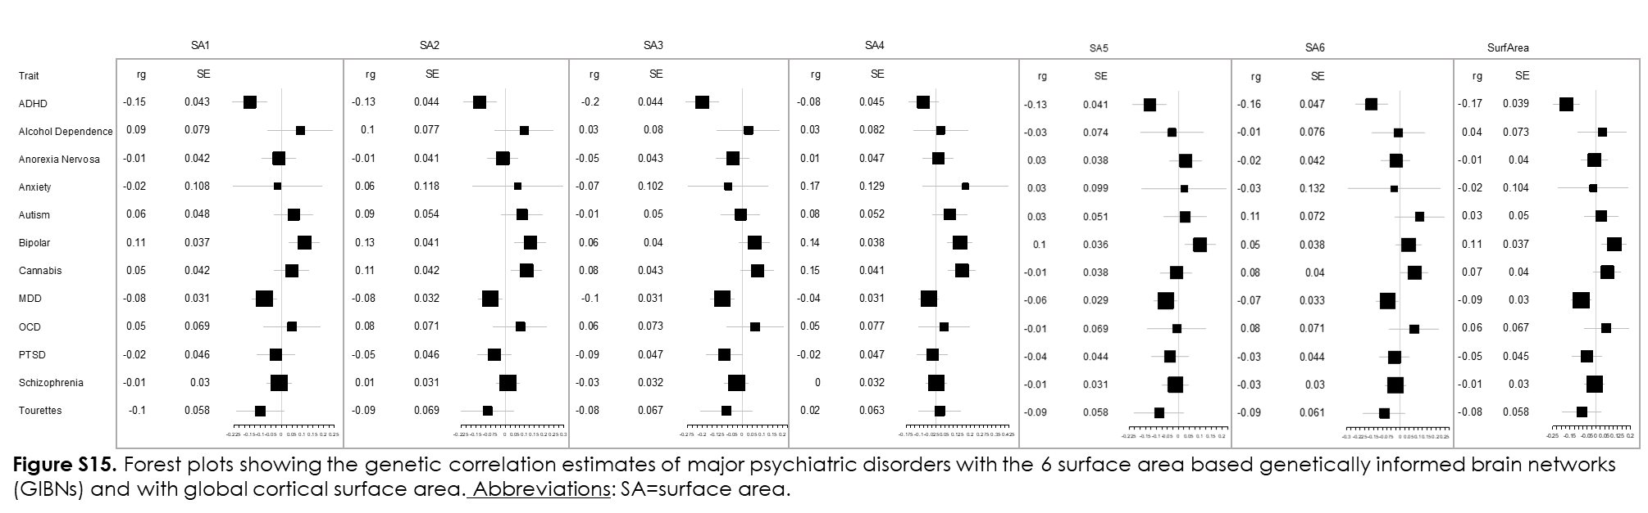

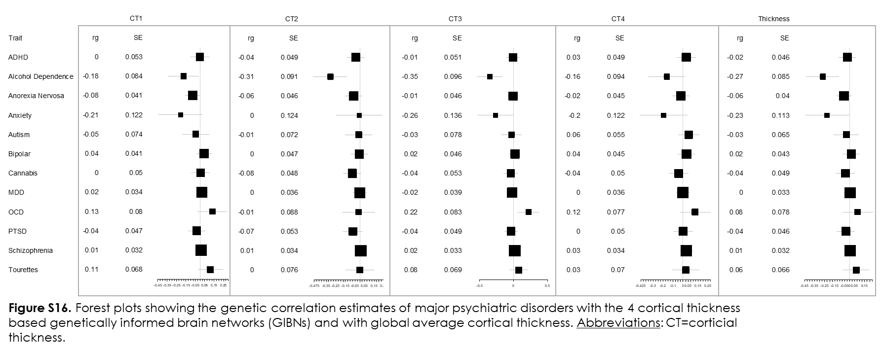
SUPPLEMENTARY TABLES
Table S1. Model Fit Statistics for the genetically informed brain networks (GIBNS) of surface area. The 6 Factor surface area model fit the data the best (lower AIC, lower SRMR, or higher CFI indicate better fit).
Number of Factors | Cutoff in EFA | AIC | model Ꭓ² | DF | CFI | SRMR
6 | 0.5 | 22,712,604.05 | 22,712,478.1 | 237 | 0.92 | 0.062
5 | 0.5 | 30,128,114.56 | 30,127,992.6 | 264 | 0.91 | 0.064
3 | 0.5 | 37,107,176.74 | 37,107,062.7 | 321 | 0.89 | 0.064
6 | 0.3 | 38,521,514.25 | 38,521,322.3 | 465 | 0.91 | 0.056
9 | 0.3 | 39,497,504.82 | 39,497,276.8 | 481 | 0.91 | 0.055
4 | 0.3 | 42,768,842.21 | 42,768,674.2 | 511 | 0.90 | 0.058
7 | 0.3 | 43,175,172.83 | 43,174,968.8 | 493 | 0.90 | 0.060
5 | 0.3 | 44,590,135.39 | 44,589,955.4 | 471 | 0.90 | 0.059
3 | 0.3 | 47,348,969.86 | 47,348,817.9 | 519 | 0.89 | 0.061
2 | 0.5 | 51,228,607.05 | 51,228,473.1 | 494 | 0.88 | 0.071
1 | 0.5 | 53,156,095.52 | 53,155,963.5 | 495 | 0.87 | 0.073
2 | 0.3 | 53,561,525.01 | 53,561,385.0 | 525 | 0.88 | 0.071
1 | 0.3 | 60,204,948.95 | 60,204,812.9 | 527 | 0.86 | 0.077

Abbreviations: GIBN=genetically informed brain network; AIC=Akaike Information Criteria; DF = degrees of freedom; CFI=Comparative Fit Index; SRMR=Standardized Root Mean Square Residuals.

Table S2. Estimated Loadings for the best fitting 6-GIBN model for surface area (standardized estimates).
GIBN | Region | Standardized Estimates | p
SA1 | inferiortemporal | 0.79 | 6.25E-35
SA1 | isthmuscingulate | 0.79 | 5.91E-25
SA1 | postcentral | 0.90 | 8.90E-62
SA1 | precuneus | 0.81 | 4.24E-44
SA1 | superiorparietal | 0.82 | 8.00E-35
SA1 | supramarginal | 0.90 | 5.45E-38
SA1 | temporalpole | 0.70 | 6.73E-21
SA2 | caudalanteriorcingulate | 0.76 | 7.75E-30
SA2 | caudalmiddlefrontal | 0.76 | 4.78E-32
SA2 | medialorbitofrontal | 0.93 | 1.36E-38
SA2 | paracentral | 0.79 | 3.91E-31
SA2 | rostralanteriorcingulate | 0.89 | 5.61E-48
SA3 | bankssts | 0.87 | 4.12E-35
SA3 | inferiorparietal | 0.91 | 1.04E-46
SA3 | middletemporal | 0.96 | 3.97E-41
SA4 | parsopercularis | 0.80 | 5.59E-25
SA4 | parsorbitalis | 0.89 | 9.99E-32
SA4 | parstriangularis | 0.68 | 1.69E-17
SA5 | cuneus | 0.94 | 3.67E-51
SA5 | lateraloccipital | 1.00 | 5.41E-56
SA5 | lingual | 0.89 | 6.58E-39
SA5 | pericalcarine | 0.66 | 1.86E-18
SA6 | superiortemporal | 1.00 | 9.85E-35
SA6 | transversetemporal | 0.83 | 3.96E-30

Abbreviations: GIBN=genetically informed brain network; SA=surface area.

Table S3. Estimated genetic correlation between GIBNS for the 6-GIBN model for surface area (standardized estimates).
GIBN1 | GIBN2 | Correlation | p
SA1 | SA2 | 0.90 | < 5e-300
SA1 | SA3 | 0.90 | 2.51E-213
SA1 | SA4 | 0.84 | 1.16E-113
SA1 | SA5 | 0.76 | 1.21E-94
SA1 | SA6 | 0.78 | 1.70E-74
SA2 | SA3 | 0.76 | 4.11E-79
SA2 | SA4 | 0.91 | 3.77E-151
SA2 | SA5 | 0.72 | 2.78E-74
SA2 | SA6 | 0.80 | 1.67E-122
SA3 | SA4 | 0.69 | 3.58E-39
SA3 | SA5 | 0.61 | 1.29E-33
SA3 | SA6 | 0.66 | 1.81E-27
SA4 | SA5 | 0.73 | 1.32E-51
SA4 | SA6 | 0.85 | 4.71E-49
SA5 | SA6 | 0.64 | 1.62E-47

Abbreviations: GIBN=genetically informed brain network; SA=surface area.

Table S4. Model Fit Statistics for genetically informed brain networks associated with cortical thickness. The 4-factor cortical thickness model fit the data the best (lower AIC and SRMR, higher CFI indicate better fit).
Number of Factors | Cutoff in EFA | AIC | model Ꭓ² | DF | CFI | SRMR
4 | 0.5 | 17,761,928 | 17,761,812.5 | 267 | 0.93 | 0.077
5 | 0.5 | 19,714,869 | 19,714,736.7 | 312 | 0.93 | 0.073
3 | 0.5 | 23,231,378 | 23,231,260.5 | 319 | 0.91 | 0.077
2 | 0.5 | 24,940,105 | 24,939,991.3 | 349 | 0.91 | 0.081
1 | 0.5 | 27,175,213 | 27,175,097.1 | 377 | 0.90 | 0.089
4 | 0.3 | 32,553,940 | 32,553,773.5 | 445 | 0.90 | 0.067
3 | 0.3 | 35,492,466 | 35,492,316.2 | 453 | 0.89 | 0.078
5 | 0.3 | 39,453,793 | 39,453,615.0 | 472 | 0.88 | 0.073
1 | 0.3 | 44,089,256 | 44,089,123.7 | 495 | 0.87 | 0.094

Abbreviations: AIC=Akaike Information Criteria; DF=degrees of freedom; CFI=Comparative Fit Index; SRMR=Standardized Root Mean Square Residuals.

Table S5. Estimated loadings for the 4-GIBN model for cortical thickness (standardized estimates).
GIBN | Region | standardized estimates | p
CT1 | bankssts | 0.83 | 1.74E-19
CT1 | caudalmiddlefrontal | 0.87 | 8.69E-32
CT1 | inferiorparietal | 0.92 | 3.80E-36
CT1 | paracentral | 0.89 | 4.33E-44
CT1 | parsopercularis | 0.90 | 8.81E-27
CT1 | postcentral | 0.75 | 1.14E-15
CT1 | precentral | 0.84 | 2.75E-24
CT1 | precuneus | 0.95 | 1.67E-55
CT1 | rostralmiddlefrontal | 0.54 | 1.37E-08
CT1 | superiorfrontal | 0.93 | 9.93E-39
CT1 | superiorparietal | 0.89 | 4.56E-39
CT1 | supramarginal | 0.92 | 1.38E-30
CT2 | caudalanteriorcingulate | 0.65 | 4.17E-12
CT2 | frontalpole | 0.86 | 1.39E-13
CT2 | insula | 0.81 | 8.09E-20
CT2 | lateralorbitofrontal | 0.87 | 1.52E-20
CT2 | medialorbitofrontal | 0.74 | 1.62E-17
CT2 | parsorbitalis | 0.92 | 2.98E-21
CT2 | rostralanteriorcingulate | 0.67 | 2.42E-10
CT2 | rostralmiddlefrontal | 0.43 | 2.37E-05
CT3 | superiortemporal | 0.98 | 2.10E-32
CT3 | temporalpole | 0.71 | 1.58E-09
CT4 | cuneus | 0.76 | 2.52E-18
CT4 | lateraloccipital | 0.92 | 1.27E-31
CT4 | parahippocampal | 0.40 | 2.55E-06
CT4 | pericalcarine | 0.66 | 2.86E-09
Abbreviations: GIBN=genetically informed brain network; ; CT=cortical thickness

Table S6. Estimated genetic correlation between GIBNs for the 4-GIBN model for cortical thickness (CT) as standardized estimates (ρ).
GIBN1 | GIBN2 | ρ | p
CT1 | CT2 | 0.71 | 2.57E-47
CT1 | CT3 | 0.77 | 4.42E-31
CT1 | CT4 | 0.87 | 2.13E-53
CT2 | CT3 | 0.76 | 8.02E-28
CT2 | CT4 | 0.67 | 1.10E-19
CT3 | CT4 | 0.68 | 3.68E-17
Abbreviations: GIBN=genetically informed brain network; CT=cortical thickness

Table S7. Model Fit Statistics from the sensitivity analysis of the genetically informed brain networks (GIBNS) of surface area reversing the chromosome set order (exploratory factor analysis in even, confirmatory factor analysis in odd). The 7 Factor surface area model fit the data the best (lower AIC, lower SRMR, or higher CFI indicate better fit).
Number of Factors | Cutoff in EFA | AIC | model Ꭓ² | DF | CFI | SRMR
7 | 0.5 | 35,990,423.2 | 35,990,279.2 | 253 | 0.89 | 0.064
5 | 0.5 | 42,852,807.3 | 42,852,669.4 | 366 | 0.89 | 0.065
3 | 0.5 | 44,551,289.0 | 44,551,167.0 | 374 | 0.88 | 0.067
4 | 0.5 | 46,756,432.4 | 46,756,304.5 | 371 | 0.88 | 0.068
8 | 0.3 | 53,395,900.2 | 53,395,694.3 | 458 | 0.87 | 0.066
7 | 0.3 | 53,458,691.3 | 53,458,505.4 | 468 | 0.87 | 0.067
6 | 0.3 | 54,550,270.2 | 54,550,096.2 | 508 | 0.87 | 0.069
5 | 0.3 | 55,026,670.5 | 55,026,504.6 | 512 | 0.87 | 0.069
4 | 0.3 | 56,792,714.5 | 56,792,556,5 | 516 | 0.87 | 0.070
3 | 0.3 | 57,245,633.6 | 57,245,481,6 | 519 | 0.84 | 0.071
2 | 0.5 | 65,917,784.2 | 65,917,654.2 | 463 | 0.84 | 0.080
2 | 0.3 | 67,651,989.8 | 67,651,841.9 | 521 | 0.82 | 0.078
1 | 0.3 | 75,240,141.9 | 75,240,005.9 | 527 | 0.82 | 0.083

Abbreviations: GIBN=genetically informed brain network; AIC=Akaike Information Criteria; DF = degrees of freedom; CFI=Comparative Fit Index; SRMR=Standardized Root Mean Square Residuals.

Table S8. Estimated Loadings (standardized estimates) for the best fitting 7-GIBN model for surface area from the sensitivity analyses reversing the chromosome set order (exploratory factor analysis in even, confirmatory factor analysis in odd).
GIBN | Region | Standardized Estimates | p
SA1 | bankssts | 0.74 | 3.51E-21
SA1 | fusiform | 0.86 | 2.86E-45
SA1 | inferiorparietal | 0.92 | 1.22E-54
SA1 | inferiortemporal | 0.89 | 1.04E-56
SA1 | middletemporal | 0.90 | 2.46E-50
SA1 | parahippocampal | 0.77 | 3.18E-28
SA1 | supramarginal | 0.64 | 9.31E-05
SA2 | cuneus | 1.00 | 2.41E-41
SA2 | lateraloccipital | 0.99 | 3.24E-44
SA2 | lingual | 0.79 | 1.69E-28
SA2 | pericalcarine | 0.66 | 2.74E-23
SA3 | insula | 0.82 | 8.57E-28
SA3 | parsopercularis | 0.76 | 5.60E-19
SA3 | parstriangularis | 0.69 | 1.62E-20
SA3 | superiortemporal | 0.89 | 3.74E-34
SA3 | transversetemporal | 0.71 | 1.81E-23
SA4 | medialorbitofrontal | 0.95 | 2.59E-46
SA4 | paracentral | 0.80 | 3.36E-24
SA4 | rostralanteriorcingulate | 0.89 | 1.85E-42
SA5 | lateralorbitofrontal | 0.93 | 2.97E-47
SA5 | parsorbitalis | 0.88 | 2.75E-36
SA6 | postcentral | 0.95 | 4.36E-46
SA6 | precentral | 0.88 | 8.38E-38
SA6 | rostralanteriorcingulate | 0.20 | 2.23E-01
SA7 | caudalanteriorcingulate | 0.83 | 6.55E-21
SA7 | posteriorcingulate | 0.89 | 4.31E-24

Abbreviations: GIBN=genetically informed brain network; SA=surface area.

Table S9. Estimated genetic correlation (standardized estimates) between GIBNS for the 7-GIBN model for surface area from the sensitivity analyses reversing the chromosome set order (exploratory factor analysis in even, confirmatory factor analysis in odd).
GIBN1 | GIBN2 | Correlation | p
SA1 | SA2 | 0.55 | 5.12E-30
SA1 | SA3 | 0.82 | 9.73E-101
SA1 | SA4 | 0.80 | 4.26E-121
SA1 | SA5 | 0.75 | 2.66E-85
SA1 | SA6 | 0.86 | 3.64E-139
SA1 | SA7 | 0.85 | 5.14E-98
SA2 | SA3 | 0.53 | 3.95E-22
SA2 | SA4 | 0.58 | 2.79E-35
SA2 | SA5 | 0.56 | 1.66E-23
SA2 | SA6 | 0.70 | 2.57E-59
SA2 | SA7 | 0.56 | 2.29E-21
SA3 | SA4 | 0.85 | 5.51E-111
SA3 | SA5 | 0.87 | 9.73E-153
SA3 | SA6 | 0.82 | 1.75E-97
SA3 | SA7 | 0.78 | 1.64E-52
SA4 | SA5 | 0.79 | 3.56E-88
SA4 | SA6 | 0.85 | 9.10E-119
SA4 | SA7 | 0.88 | 2.71E-129
SA5 | SA6 | 0.76 | 7.52E-73
SA5 | SA7 | 0.73 | 9.66E-41
SA6 | SA7 | 0.77 | 3.21E-49

Abbreviations: GIBN=genetically informed brain network; SA=surface area.

Table S10. Model Fit Statistics for the sensitivity analyses of genetically informed brain networks associated with cortical thickness reversing the chromosome set order (exploratory factor analysis in even, confirmatory factor analysis in odd). The 4 Factor surface area model fit the data the best (lower AIC, lower SRMR, or higher CFI indicate better fit).
Number of Factors | Cutoff in EFA | AIC | model Ꭓ² | DF | CFI | SRMR
4 | 0.3 | 58,699,212.8 | 58,699,046.8 | 512 | 0.86 | 0.077
2 | 0.3 | 63,055,094.7 | 63,054,940.7 | 518 | 0.85 | 0.082
3 | 0.3 | 64,190,549.8 | 64,190,383.8 | 512 | 0.85 | 0.080
1 | 0.5 | 65,300,561.0 | 65,300,433.0 | 464 | 0.83 | 0.105
2 | 0.5 | 69,957,082.7 | 69,956,952.7 | 463 | 0.83 | 0.092
1 | 0.3 | 78,215,831.1 | 78,215,695.1 | 527 | 0.82 | 0.104

Abbreviations: AIC=Akaike Information Criteria; DF=degrees of freedom; CFI=Comparative Fit Index; SRMR=Standardized Root Mean Square Residuals.

Table S11. Estimated loadings (standardized estimates) for the 4-GIBN model for cortical thickness from the sensitivityanalyses reversing the chromosome set order (exploratory factor analysis in even, confirmatory factor analysis in odd.

GIBN | Region | standardized estimates | P
CT1 | bankssts | 0.87 | 2.352E-28
CT1 | caudalmiddlefrontal | 0.84 | 1.58E-22
CT1 | cuneus | 0.62 | 1.48E-09
CT1 | fusiform | 0.92 | 1.77E-41
CT1 | lateraloccipital | 0.81 | 9.33E-37
CT1 | lingual | 0.74 | 9.34E-24
CT1 | middletemporal | -0.09 | 7.14E-01
CT1 | paracentral | 0.76 | 2.76E-26
CT1 | parsopercularis | 0.60 | 1.37E-08
CT1 | parstriangularis | 0.44 | 4.45E-07
CT1 | pericalcarine | 0.57 | 8.38E-10
CT1 | postcentral | 0.75 | 1.78E-25
CT1 | precentral | 0.84 | 1.55E-30
CT1 | precuneus | 0.88 | 1.22E-42
CT1 | rostralmiddlefrontal | 0.36 | 3.44E-05
CT1 | superiorfrontal | 0.61 | 6.62E-14
CT1 | superiorparietal | 0.88 | 2.83E-47
CT1 | superiortemporal | 0.77 | 5.02E-32
CT1 | supramarginal | 0.94 | 2.18E-51
CT1 | transversetemporal | 0.74 | 3.65E-24
CT2 | caudalanteriorcingulate | 0.53 | 5.72E-09
CT2 | frontalpole | 0.80 | 4.09E-10
CT2 | fusiform | -0.06 | 7.51E-01
CT2 | insula | 0.77 | 1.53E-17
CT2 | isthmuscingulate | 0.56 | 5.86E-17
CT2 | lateralorbitofrontal | 1.03 | 6.07E-07
CT2 | medialorbitofrontal | 0.73 | 4.20E-12
CT2 | parsopercularis | 0.34 | 9.70E-04
CT2 | parsorbitalis | 0.57 | 6.03E-04
CT2 | parstriangularis | 0.51 | 5.13E-07
CT2 | posteriorcingulate | 0.75 | 7.43E-24
CT2 | precuneus | 0.65 | 6.07E-08
CT2 | rostralanteriorcingulate | 0.61 | 2.10E-09
CT2 | rostralmiddlefrontal | 0.34 | 2.86E-04
CT3 | fusiform | 0.94 | 6.23E-06
CT3 | inferiortemporal | 0.78 | 1.06E-16
CT3 | lateralorbitofrontal | -0.21 | 2.69E-01
CT3 | middletemporal | 0.97 | 1.12E-04
CT3 | parsorbitalis | 0.29 | 7.17E-02
CT3 | supramarginal | 0.54 | 8.28E-06
CT4 | cuneus | 0.23 | 9.60E-02
CT4 | entorhinal | 0.72 | 6.02E-06
CT4 | parahippocampal | 0.47 | 1.26E-04

Abbreviations: GIBN=genetically informed brain network; ; CT=cortical thickness

Table S12. Estimated genetic correlation (standardized estimates) between GIBNS for the 4-GIBN model for cortical Thickness from the sensitivity analyses reversing the chromosome set order (exploratory factor analysis in even, confirmatory factor analysis in odd.
GIBN1 | GIBN2 | Correlation | p
CT1 | CT2 | 0.69 | 9.26E-40
CT1 | CT3 | 0.85 | 1.27E-58
CT1 | CT4 | 0.47 | 2.39E-04
CT2 | CT3 | 0.80 | 1.04E-27
CT2 | CT4 | 0.51 | 1.19E-05
CT3 | CT4 | 0.66 | 4.77E-07

Abbreviations: GIBN=genetically informed brain network; CT=cortical thickness
Table S13. Independent GWS loci associated with GIBNs as identified by FUMA.
GIBN | rsID | Chr | Pos | Beta | p
SA2 | rs4273712 | 6 | 126964510 | -0.29 | 1.66E-21
SA1 | rs62057153 | 17 | 43904528 | 0.28 | 8.45E-21
SA5 | rs55638417 | 17 | 43900434 | 0.28 | 8.60E-21
SA5 | rs74580701 | 6 | 127000881 | 0.66 | 6.64E-18
SA2 | rs79600142 | 17 | 43897722 | 0.26 | 1.13E-17
SA3 | rs56319902 | 17 | 43871982 | 0.26 | 5.22E-17
SA5 | rs73313052 | 14 | 59625997 | 0.28 | 7.48E-17
SA2 | rs7312464 | 12 | 66374247 | 0.20 | 7.78E-16
SA6 | rs9896243 | 17 | 44826056 | 0.23 | 7.75E-15
SA4 | rs55663797 | 17 | 43544379 | 0.27 | 2.27E-13
SA1 | rs11759026 | 6 | 126792095 | -0.19 | 3.48E-13
SA1 | rs34464850 | 3 | 141721762 | -0.21 | 3.60E-13
SA5 | rs6788676 | 3 | 104674040 | -0.17 | 3.89E-13
SA3 | rs8756 | 12 | 66359752 | 0.18 | 5.84E-13
SA1 | rs7312464 | 12 | 66374247 | 0.16 | 6.47E-13
CT2 | rs2316766 | 17 | 43919068 | -0.28 | 1.54E-12
SA4 | rs2279829 | 3 | 147106319 | -0.24 | 4.21E-12
CT4 | rs13107325 | 4 | 103188709 | 0.44 | 7.19E-12
SA3 | rs34464850 | 3 | 141721762 | -0.21 | 9.61E-12
SA1 | rs1628768 | 10 | 105012994 | -0.17 | 1.07E-11
SA6 | rs10878349 | 12 | 66327632 | 0.16 | 1.49E-11
SA6 | rs34464850 | 3 | 141721762 | -0.20 | 2.27E-11
SA6 | rs1163249 | 10 | 104909890 | 0.18 | 4.10E-11
CT3 | rs12711473 | 16 | 87224293 | 0.19 | 1.48E-10
CT1 | rs11692435 | 2 | 98275354 | 0.30 | 1.90E-10
SA4 | rs11759026 | 6 | 126792095 | -0.19 | 2.84E-10
SA4 | rs4924345 | 15 | 39639898 | 0.32 | 3.78E-10
SA3 | rs4917384 | 10 | 104995788 | 0.15 | 4.13E-10
SA3 | rs3847535 | 11 | 92558024 | 0.15 | 5.62E-10
SA2 | rs1628768 | 10 | 105012994 | -0.16 | 7.21E-10
SA1 | rs7082934 | 10 | 21881379 | 0.13 | 8.26E-10
SA5 | rs3858368 | 11 | 92553286 | 0.14 | 1.35E-09
SA2 | rs7778997 | 7 | 156183533 | -0.36 | 1.38E-09
SA5 | rs13135092 | 4 | 103198082 | -0.23 | 1.41E-09
SA2 | rs7297175 | 12 | 56473808 | 0.14 | 1.43E-09
SA5 | rs3754356 | 1 | 228270964 | 0.16 | 1.61E-09
SA4 | rs11012732 | 10 | 21830104 | 0.17 | 1.63E-09
SA6 | rs11170566 | 12 | 53907067 | -0.19 | 1.78E-09
SA2 | rs11079849 | 17 | 47090785 | -0.15 | 1.91E-09
SA4 | rs2271386 | 3 | 141712708 | -0.20 | 2.12E-09
SA2 | rs3817176 | 3 | 141712780 | -0.17 | 2.64E-09
CT3 | rs61784835 | 1 | 47974123 | 0.17 | 2.92E-09
CT2 | rs12711473 | 16 | 87224293 | 0.17 | 2.94E-09
SA2 | rs4792721 | 17 | 16006827 | 0.13 | 3.60E-09
SA1 | rs3006933 | 1 | 243659727 | -0.13 | 4.08E-09
SA2 | rs2490272 | 6 | 108895386 | -0.13 | 4.41E-09
SA4 | rs7711765 | 5 | 170832637 | -0.16 | 4.52E-09
SA4 | rs113343136 | 9 | 98314306 | -0.26 | 4.88E-09
SA1 | rs7563432 | 2 | 48281138 | 0.13 | 6.18E-09
SA5 | rs10765918 | 11 | 12071855 | 0.15 | 6.24E-09
SA4 | rs7312464 | 12 | 66374247 | 0.15 | 7.94E-09
SA3 | rs78200999 | 7 | 155996837 | -0.14 | 9.78E-09
SA5 | rs10878349 | 12 | 66327632 | 0.12 | 1.06E-08
SA6 | rs13035861 | 2 | 150040224 | -0.12 | 1.13E-08
SA3 | rs2301718 | 4 | 106009763 | -0.16 | 1.39E-08
CT1 | rs3200031 | 8 | 26227484 | -0.24 | 1.41E-08
CT2 | rs12602519 | 17 | 10027480 | -0.16 | 1.77E-08
SA5 | rs1628768 | 10 | 105012994 | -0.13 | 1.77E-08
SA3 | rs28457693 | 9 | 98217348 | -0.20 | 2.18E-08
SA1 | rs7975351 | 12 | 53902190 | -0.12 | 2.93E-08
SA1 | rs12630663 | 3 | 28007315 | -0.12 | 3.02E-08
SA6 | rs9969436 | 8 | 10842659 | -0.12 | 3.07E-08
SA5 | rs6701689 | 1 | 2020343 | -0.13 | 3.19E-08
CT2 | rs1004763 | 22 | 38474952 | -0.15 | 3.41E-08
SA5 | rs56007616 | 3 | 118994959 | 0.18 | 3.61E-08
CT2 | rs533577 | 3 | 39489651 | 0.15 | 3.61E-08
SA4 | rs7297175 | 12 | 56473808 | 0.14 | 3.83E-08
SA6 | rs4273712 | 6 | 126964510 | -0.13 | 3.98E-08
SA5 | rs7570830 | 2 | 61745528 | -0.11 | 4.01E-08
SA3 | rs2299148 | 7 | 42023400 | -0.14 | 4.43E-08
SA5 | rs2802292 | 6 | 108908518 | -0.11 | 4.63E-08
SA1 | rs10109434 | 8 | 41169496 | 0.12 | 4.72E-08
SA5 | rs12357321 | 10 | 21790476 | 0.12 | 4.74E-08
SA6 | rs9909861 | 17 | 47079416 | -0.12 | 4.89E-08
Table S14 Correlation between CT and SA GIBNS

GIBN1 | GIBN2 | ρ | p
CT1 | SA1 | -0.2842 | 3.88E-09
CT1 | SA2 | -0.2031 | 0.0002
CT1 | SA3 | -0.1472 | 0.0042
CT1 | SA4 | -0.1872 | 0.0001
CT1 | SA5 | -0.2263 | 3.82E-07
CT1 | SA6 | -0.2233 | 0.0003
CT2 | SA1 | -0.3923 | 3.02E-17
CT2 | SA2 | -0.4289 | 1.77E-19
CT2 | SA3 | -0.2958 | 3.11E-08
CT2 | SA4 | -0.3541 | 1.73E-12
CT2 | SA5 | -0.3128 | 5.84E-13
CT2 | SA6 | -0.3048 | 8.81E-09
CT3 | SA1 | -0.1999 | 8.70E-05
CT3 | SA2 | -0.1633 | 0.0027
CT3 | SA3 | -0.095 | 0.0736
CT3 | SA4 | -0.0904 | 0.0992
CT3 | SA5 | -0.1475 | 0.0039
CT3 | SA6 | -0.1758 | 0.0076
CT4 | SA1 | -0.2311 | 5.29E-06
CT4 | SA2 | -0.1957 | 0.0002
CT4 | SA3 | -0.1653 | 0.0016
CT4 | SA4 | -0.1618 | 0.0011
CT4 | SA5 | -0.0763 | 0.1318
CT4 | SA6 | -0.2117 | 3.14E-05
Abbreviations: GIBN=genetically informed brain network; CT=cortical thickness derived GIBNS; SA=surface area derived GIBNS;

Table S15. LDSC estimates of the pairwise genetic correlation between SA-derived GIBNs and psychiatric disorders. Nominally significant associations are indicated in bold. Genetic correlation between global SA and psychiatric disorders included for comparison.
p1 | p2 | rg | p | FDR | p1 | p2 | rg | p | FDR
SA1 | ADHD | -0.15 | 6.00E-04 | 0.014 | SA5 | ADHD | -0.13 | 0.0013 | 0.017
SA1 | Alcohol Dependence | 0.090 | 0.25 | 0.58 | SA5 | Alcohol Dependence | -0.029 | 0.69 | 0.91
SA1 | Anorexia Nervosa | -0.011 | 0.79 | 0.95 | SA5 | Anorexia Nervosa | 0.034 | 0.38 | 0.71
SA1 | Anxiety | -0.017 | 0.88 | 0.96 | SA5 | Anxiety | 0.028 | 0.78 | 0.95
SA1 | Autism | 0.058 | 0.23 | 0.57 | SA5 | Autism | 0.031 | 0.55 | 0.85
SA1 | Bipolar | 0.11 | 0.0047 | 0.043 | SA5 | Bipolar | 0.10 | 0.0039 | 0.039
SA1 | Cannabis | 0.049 | 0.24 | 0.57 | SA5 | Cannabis | -0.0089 | 0.81 | 0.95
SA1 | MDD | -0.080 | 0.0098 | 0.078 | SA5 | MDD | -0.057 | 0.046 | 0.26
SA1 | OCD | 0.051 | 0.46 | 0.77 | SA5 | OCD | -0.0073 | 0.92 | 0.99
SA1 | PTSD | -0.025 | 0.59 | 0.88 | SA5 | PTSD | -0.038 | 0.39 | 0.71
SA1 | Schizophrenia | -0.011 | 0.73 | 0.93 | SA5 | Schizophrenia | -0.013 | 0.67 | 0.91
SA1 | Tourette’s | -0.099 | 0.087 | 0.37 | SA5 | Tourette’s | -0.086 | 0.142 | 0.44
SA2 | ADHD | -0.13 | 0.0038 | 0.039 | SA6 | ADHD | -0.16 | 8.00E-04 | 0.014
SA2 | Alcohol Dependence | 0.097 | 0.21 | 0.54 | SA6 | Alcohol Dependence | -0.010 | 0.89 | 0.97
SA2 | Anorexia Nervosa | -0.012 | 0.78 | 0.95 | SA6 | Anorexia Nervosa | -0.023 | 0.59 | 0.88
SA2 | Anxiety | 0.065 | 0.58 | 0.88 | SA6 | Anxiety | -0.034 | 0.80 | 0.95
SA2 | Autism | 0.086 | 0.114 | 0.40 | SA6 | Autism | 0.11 | 0.124 | 0.41
SA2 | Bipolar | 0.13 | 0.0018 | 0.022 | SA6 | Bipolar | 0.047 | 0.21 | 0.54
SA2 | Cannabis | 0.11 | 0.011 | 0.080 | SA6 | Cannabis | 0.082 | 0.039 | 0.23
SA2 | MDD | -0.075 | 0.020 | 0.14 | SA6 | MDD | -0.071 | 0.030 | 0.20
SA2 | OCD | 0.078 | 0.27 | 0.58 | SA6 | OCD | 0.079 | 0.27 | 0.58
SA2 | PTSD | -0.054 | 0.23 | 0.57 | SA6 | PTSD | -0.033 | 0.45 | 0.77
SA2 | Schizophrenia | 0.014 | 0.66 | 0.91 | SA6 | Schizophrenia | -0.026 | 0.39 | 0.71
SA2 | Tourette’s | -0.090 | 0.19 | 0.51 | SA6 | Tourette’s | -0.088 | 0.153 | 0.45
SA3 | ADHD | -0.20 | 3.29E-06 | 0.00040 | Global Surface Area | ADHD | -0.1702 | 1.30E-05
SA3 | Alcohol Dependence | 0.031 | 0.70 | 0.91 | Global Surface Area | Alcohol Dependence | 0.0394 | 0.5875
SA3 | Anorexia Nervosa | -0.047 | 0.27 | 0.58 | Global Surface Area | Anorexia Nervosa | -0.0079 | 0.8421
SA3 | Anxiety | -0.070 | 0.50 | 0.82 | Global Surface Area | Anxiety | -0.0151 | 0.8847
SA3 | Autism | -0.0084 | 0.87 | 0.96 | Global Surface Area | Autism | 0.0313 | 0.5289
SA3 | Bipolar | 0.061 | 0.131 | 0.41 | Global Surface Area | Bipolar | 0.1061 | 0.0037
SA3 | Cannabis | 0.075 | 0.085 | 0.37 | Global Surface Area | Cannabis | 0.066 | 0.1008
SA3 | MDD | -0.10 | 0.0011 | 0.017 | Global Surface Area | MDD | -0.0854 | 0.0044
SA3 | OCD | 0.064 | 0.38 | 0.71 | Global Surface Area | OCD | 0.0604 | 0.3642
SA3 | PTSD | -0.089 | 0.056 | 0.29 | Global Surface Area | PTSD | -0.0518 | 0.2449
SA3 | Schizophrenia | -0.029 | 0.35 | 0.71 | Global Surface Area | Schizophrenia | -0.008 | 0.7923
SA3 | Tourette’s | -0.079 | 0.24 | 0.57 | Global Surface Area | Tourette’s | -0.0807 | 0.1605
SA4 | ADHD | -0.076 | 0.093 | 0.39
SA4 | Alcohol Dependence | 0.026 | 0.75 | 0.94
SA4 | Anorexia Nervosa | 0.012 | 0.81 | 0.95
SA4 | Anxiety | 0.17 | 0.18 | 0.49
SA4 | Autism | 0.080 | 0.125 | 0.41
SA4 | Bipolar | 0.14 | 3.00E-04 | 0.012
SA4 | Cannabis | 0.15 | 4.00E-04 | 0.012
SA4 | MDD | -0.044 | 0.152 | 0.45
SA4 | OCD | 0.046 | 0.55 | 0.85
SA4 | PTSD | -0.022 | 0.64 | 0.91
SA4 | Schizophrenia | 0.0015 | 0.96 | 0.99
SA4 | Tourette’s | 0.021 | 0.74 | 0.94

Abbreviations: LDSC=LD score regression; GIBN=genetically informed brain network; SA- =surface area derived GIBNS; r_{g}=genetic correlation; ADHD=Attention Deficit Hyperactivity Disorder; MDD=Major Depressive Disorder; P_{FDR} False Discovery Rate corrected significance value.

Table S16. LDSC estimates of the pairwise genetic correlation between CT-derived GIBNs and psychiatric disorders. Nominally significant associations are indicated in bold. Genetic correlation between global mean CT and psychiatric disorders included for comparison.

p1 | p2 | rg | p | FDR | p1 | p2 | rg | p | FDR
CT1 | ADHD | -0.0032 | 0.95 | 0.99 | CT4 | ADHD | 0.032 | 0.51 | 0.83
CT1 | Alcohol Dependence | -0.177 | 0.035 | 0.22 | CT4 | Alcohol Dependence | -0.163 | 0.084 | 0.37
CT1 | Anorexia Nervosa | -0.078 | 0.060 | 0.30 | CT4 | Anorexia Nervosa | -0.022 | 0.63 | 0.90
CT1 | Anxiety | -0.208 | 0.087 | 0.37 | CT4 | Anxiety | -0.196 | 0.11 | 0.40
CT1 | Autism | -0.047 | 0.53 | 0.84 | CT4 | Autism | 0.056 | 0.31 | 0.64
CT1 | Bipolar | 0.042 | 0.31 | 0.64 | CT4 | Bipolar | 0.035 | 0.44 | 0.77
CT1 | Cannabis | 0.004 | 0.94 | 0.99 | CT4 | Cannabis | -0.044 | 0.37 | 0.71
CT1 | MDD | 0.018 | 0.61 | 0.89 | CT4 | MDD | -0.00060 | 0.99 | 0.99
CT1 | OCD | 0.13 | 0.11 | 0.40 | CT4 | OCD | 0.12 | 0.13 | 0.41
CT1 | PTSD | -0.037 | 0.43 | 0.77 | CT4 | PTSD | 0.0012 | 0.98 | 0.99
CT1 | Schizophrenia | 0.012 | 0.71 | 0.91 | CT4 | Schizophrenia | 0.033 | 0.34 | 0.69
CT1 | Tourette’s | 0.11 | 0.11 | 0.40 | CT4 | Tourette’s | 0.027 | 0.70 | 0.91
CT2 | ADHD | -0.043 | 0.38 | 0.71 | Average Thickness | ADHD | -0.0235 | 0.6125
CT2 | Alcohol Dependence | -0.307 | 7.00E-04 | 0.014 | Average Thickness | Alcohol Dependence | -0.2684 | 0.0015
CT2 | Anorexia Nervosa | -0.063 | 0.17 | 0.49 | Average Thickness | Anorexia | -0.0562 | 0.1639
CT2 | Anxiety | -0.0050 | 0.97 | 0.99 | Average Thickness | anxiety | -0.2271 | 0.0451
CT2 | Autism | -0.013 | 0.86 | 0.96 | Average Thickness | Autism | -0.0332 | 0.6095
CT2 | Bipolar | -0.0044 | 0.93 | 0.99 | Average Thickness | Bipolar | 0.017 | 0.6938
CT2 | Cannabis | -0.079 | 0.10 | 0.40 | Average Thickness | Cannabis | -0.0424 | 0.3831
CT2 | MDD | 0.00030 | 0.99 | 0.99 | Average Thickness | MDD | 0.0034 | 0.9175
CT2 | OCD | -0.014 | 0.87 | 0.96 | Average Thickness | OCD | 0.0791 | 0.3104
CT2 | PTSD | -0.072 | 0.17 | 0.49 | Average Thickness | PTSD | -0.038 | 0.4088
CT2 | Schizophrenia | 0.011 | 0.76 | 0.94 | Average Thickness | Schizophrenia | 0.0054 | 0.8642
CT2 | Tourette’s | -0.0010 | 0.99 | 0.99 | Average Thickness | Tourette’s | 0.0649 | 0.3227
CT3 | ADHD | -0.0086 | 0.87 | 0.96
CT3 | Alcohol Dependence | -0.350 | 3.00E-04 | 0.012
CT3 | Anorexia Nervosa | -0.0072 | 0.88 | 0.96
CT3 | Anxiety | -0.265 | 0.051 | 0.28
CT3 | Autism | -0.032 | 0.69 | 0.91
CT3 | Bipolar | 0.020 | 0.66 | 0.91
CT3 | Cannabis | -0.040 | 0.46 | 0.77
CT3 | MDD | -0.021 | 0.59 | 0.88
CT3 | OCD | 0.22 | 0.0091 | 0.078
CT3 | PTSD | -0.037 | 0.45 | 0.77
CT3 | Schizophrenia | 0.017 | 0.61 | 0.89
CT3 | Tourette’s | 0.077 | 0.26 | 0.58

Abbreviations: GIBN=genetically informed brain network; CT=cortical thickness derived GIBNS; r_{g}=genetic correlation; ADHD=Attention Deficit Hyperactivity Disorder; MDD=Major Depressive Disorder; P_{FDR} False Discovery Rate corrected significance value.

