A Regulatory Variant of CHRM3 is Associated with Cannabis-Induced Hallucinations in European Americans
Supplementary Information
Contents
Supplementary Figures S1-S7
Supplementary Tables S1-S5
CHRM3 Co-Expression Analysis
The Association of CHRM3 Variants with Other Diseases
The Collaborative Study of the Genetics of Alcoholism (COGA)
Supplementary References

Supplementary Figures

Supplementary Figure S1

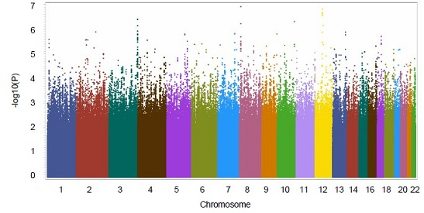
Supplementary Figure S1. Manhattan plots for meta-analysis of cannabis-induced hallucination GWAS in Yale-Penn 1 and 2 African Americans by including 3 PCs as well as other covariates, including sex, age, BMI and sample relatedness.

Supplementary Figure S2

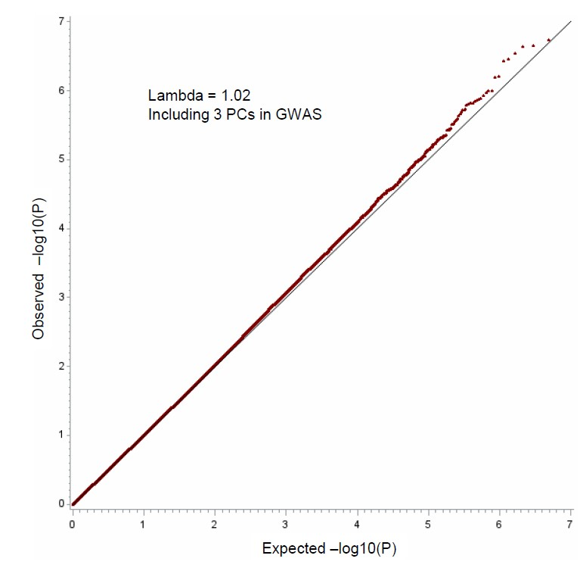
Supplementary Figure S2. QQ plot for meta-analysis of cannabis-induced hallucination GWAS in Yale-Penn 1 and 2 African Americans by including 3 PCs, as well as other covariates, including sex, age, BMI and sample relatedness.

Supplementary Figure S3
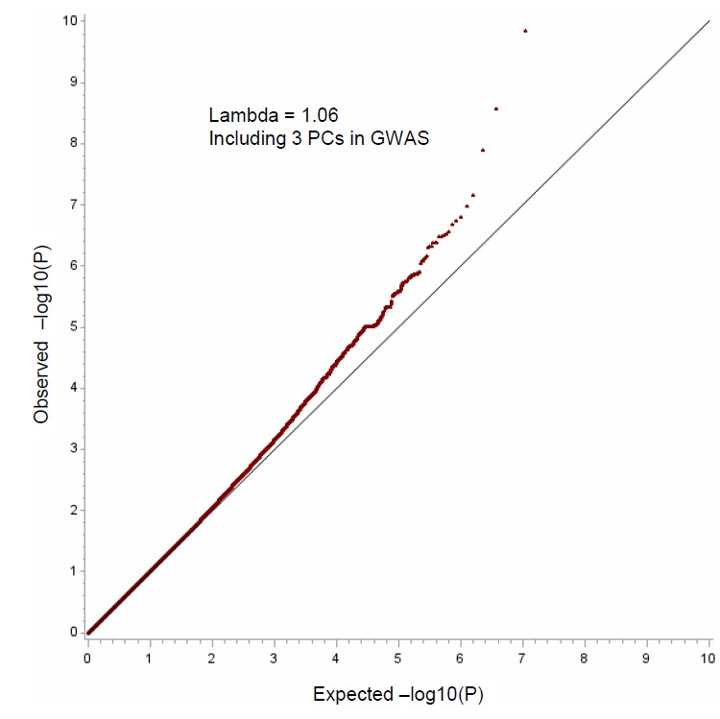
Supplementary Figure S3 QQ plot for meta-analysis of cannabis-induced hallucination GWAS in Yale-Penn 1 and 2 European Americans by including 3 PCs, as well as other covariates, including sex, age, BMI and sample relatedness.

Supplementary Figure S4
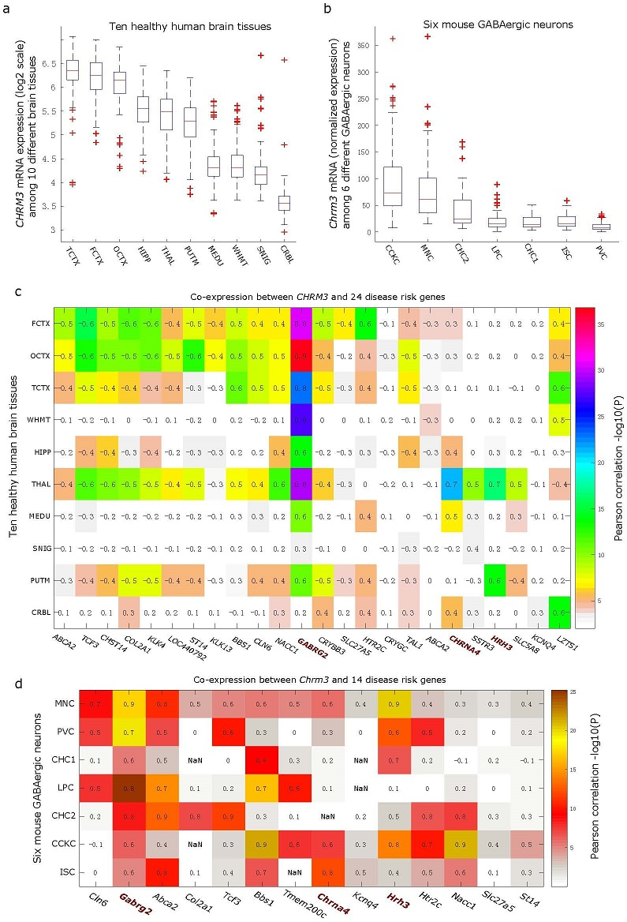

Supplementary Figure S4. The mRNA expression of CHRM3 and its mouse homologous Chrm3 were associated with 24 genes across 10 human brain tissues and with 14 mouse genes among 6 GABAergic neurons, respectively.
CHRM3 and the homologous mouse gene Chrm3 are variably expressed among 10 human brain tissues [1] (a) and 6 types of GABAergic neurons [2] (b), respectively. Pairwise Pearson correlation coefficients (r) for CHRM3 and 24 genes are depicted in the heatmap (c), while, the same correlation analysis between mouse gene Chrm3 and 14 mouse homologous genes out of these 24 human genes across 6 types of GABAergic neurons are displayed in (d). The -log10(P) correlation P values are indicated by different colors, with its corresponding Pearson correlation coefficient labeled in each square of the heatmaps; the NaN represents the gene is not expressed in specific cell type and cannot be correlated with Chrm3.
Note: line within each boxplot represents median, and box region indicates the range from first quantile to third quantile. Up and down whiskers, as well as pluses outside box region, represent maximum value, minimum value, and outliers, respectively. The abbreviations for 10 brain tissues are CRBL (cerebellar cortex), FCTX (frontal cortex), HIPP (hippocampus), MEDU (medulla specifically inferior olivary nucleus), OCTX (occipital cortex), PUTM (putamen), SNIG (substantia nigra), TCTX (temporal cortex), THAL (thalamus) and WHMT (intralobular white matter). The six types of neurons are martinotti cells (MNC), interneuron selective cells (ISC), CCK-basket cells (CCKC), PV basket cells (PVC), chandelier cells upper layer (CHC1) and deep layer (CHC2) of mouse brain, and long projecting cells (LPC), all of which were isolated from mouse frontal cortex.

Supplemental Figure S5
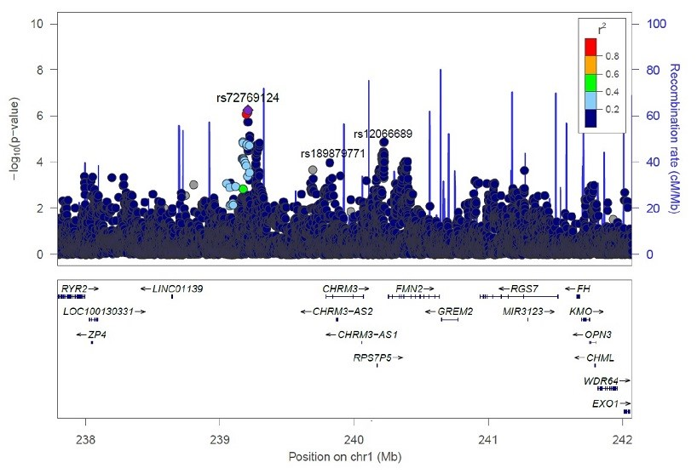
Supplementary Figure S5. Local Manhattan plot showing SNPs near gene CHRM3 and their association with schizophrenia. According to a published schizophrenia genome-wide association study [3], three SNPs, including rs72769124, rs12066689 and rs189879771, were not highly correlated with each other (all r² <0.2 in EAs) and were nominally associated with schizophrenia (P values 5.5×10⁻⁷, 1.3×10⁻⁶, and 1.1×10⁻⁴, respectively). Rs72769124 and rs12066689 were not associated with cannabis-induced hallucinations (Ca-HL) in European Americans (EAs) (all P values >0.5). Other SNPs near the association peak of rs72769124 were nominally associated with schizophrenia (all P values<1×10⁻⁵) but not associated with Ca-HL (all P values >0.87). Meanwhile, rs189879771, residing in the intronic region of CHRM3, was also not significantly associated with Ca-HL in EAs (P= 0.09). The light blue line and right Y-axis show the observed recombination rate in the 1000 Genomes Project European samples (EUR, hg19). The SNPs are colored in accordance to r² with rs72769124.

Supplementary Figure S6
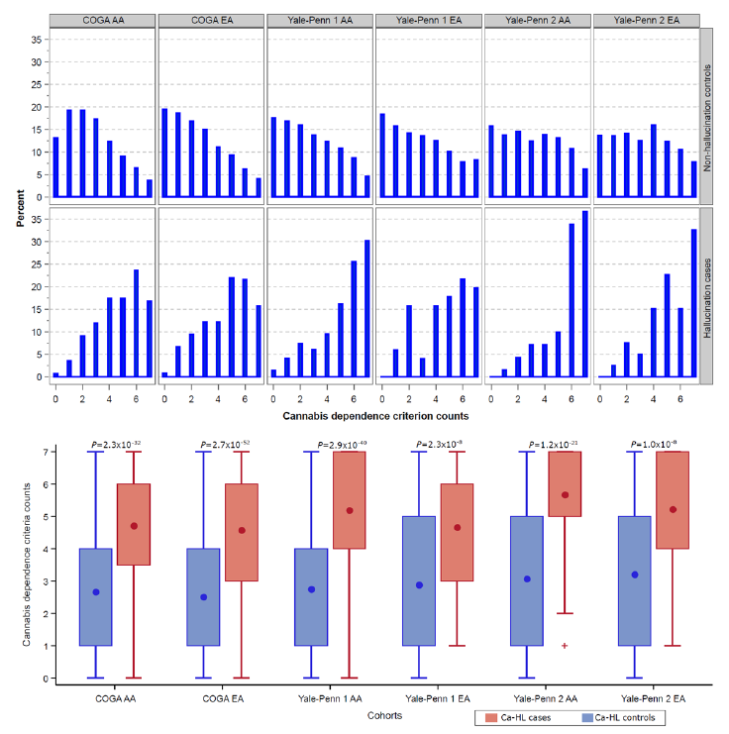
Supplementary Figure S6. Cannabis dependence (CAD) criterion counts were differentially distributed between cases and controls of cannabis-induced hallucinations.
In the upper panel, the percentages of CAD criterion counts ranging from 0 to 7 for cannabis-induced hallucination (Ca-HL) cases and controls across different subsamples are summarized in histograms. Meanwhile, in the lower panel, the significant difference of CAD criterion counts in Ca-HL cases and controls is demonstrated for each cohort. Dot within each boxplot represents mean, and box region indicates the range from first quantile to third quantile. Up and down whiskers represent maximum value and minimum value, respectively.
Supplementary Figure S7
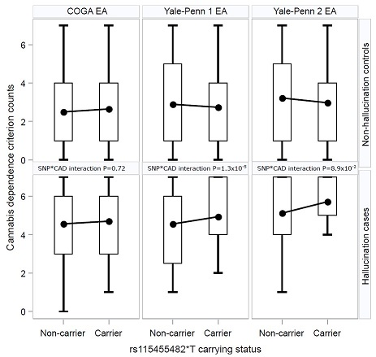
Supplementary Figure S7. The interaction between rs115455482*T allele and cannabis dependence criterion counts affects cannabis-induced hallucinations. Boxplots illustrate the interaction between rs115455482*T allele and cannabis dependence (CAD) criterion counts in Yale-Penn and COGA European Americans (EAs). To determine the interaction between CHRM3 SNP rs115455482 and CAD criterion counts, GEMMA [4] command ‘-gxe’ was used to fit a linear mixed model to control both the SNP main effect and the effect of CAD criterion counts, adjust sex, age, the first three PCs of ancestry, and the degree of relatedness among subjects, and test the interaction effect between rs115455482*T and CAD criterion counts. The association of the interaction between rs115455482*T and CAD criterion counts with Ca-HL was significant in Yale-Penn 1 EAs (P=1.3×10⁻⁵), marginally significant in Yale-Penn 2 EAs (P=8.9×10⁻²), and not significant in COGA EAs (P=0.72).
Dot within each boxplot represents mean, and box region indicates the range from first quantile to third quantile. Up and down whiskers represent maximum value and minimum value, respectively.
Supplementary Table S1. Linkage disequilibrium (LD) for rs115455482 and rs74722579 among European and African populations.

Query SNP | chr | pos (hg38) | LD | LD | variant | Ref | Alt | AFR | AMR | ASN | EUR | Motifs
Query SNP | chr | pos (hg38) | (r²) | (D') | variant | Ref | Alt | freq | freq | freq | freq | changed
rs115455482 (r2>=0.8) in EUR | 1 | 239386955 | 0.93 | 1 | rs117549427 | G | A | 0.01 | 0.01 | 0.05 | 0.06 | 9 altered motifs
rs115455482 (r2>=0.8) in EUR | 1 | 239393278 | 0.95 | 1 | rs60093138 | A | G | 0.27 | 0.07 | 0.15 | 0.06 | 6 altered motifs
rs115455482 (r2>=0.8) in EUR | 1 | 239397249 | 0.95 | -1 | rs1938228 | T | C | 0.70 | 0.96 | 0.95 | 0.94
rs115455482 (r2>=0.8) in EUR | 1 | 239399460 | 1 | 1 | rs115455482 | C | T | 0.01 | 0.02 | 0.05 | 0.06 | 4 altered motifs
rs115455482 (r2>=0.8) in EUR | 1 | 239401207 | 0.95 | 1 | rs74722579 | G | C | 0.10 | 0.02 | 0.05 | 0.06 | Irf,ZEB1
rs74722579 (r2>=0.2) in AFR | 1 | 239393278 | 0.29 | 1 | rs60093138 | A | G | 0.27 | 0.07 | 0.15 | 0.06 | 6 altered motifs
rs74722579 (r2>=0.2) in AFR | 1 | 239396048 | 0.24 | 1 | rs4130463 | C | T | 0.32 | 0.11 | 0.38 | 0.09 | 6 altered motifs
rs74722579 (r2>=0.2) in AFR | 1 | 239396169 | 0.24 | 1 | rs7552265 | A | G | 0.32 | 0.11 | 0.38 | 0.09 | PPAR,RXRA
rs74722579 (r2>=0.2) in AFR | 1 | 239397249 | 0.3 | -1 | rs1938228 | T | C | 0.70 | 0.96 | 0.95 | 0.94
rs74722579 (r2>=0.2) in AFR | 1 | 239400093 | 0.32 | 1 | rs114292606 | T | A | 0.03 | 0 | 0 | 0 | 4 altered motifs
rs74722579 (r2>=0.2) in AFR | 1 | 239401207 | 1 | 1 | rs74722579 | G | C | 0.10 | 0.02 | 0.05 | 0.06 | Irf,ZEB1

Note: By querying rs115455482 and rs74722579 in the Haploreg4 database [5], it was demonstrated that these two SNPs are two common variants highly linked (r²>0.9) in European but not African populations. Rs74722579 but not rs115455482 is a common variant in African population.

Supplementary Table S2. Top 100 co-expressed genes of CHRM3 identified by COXPRESdb [6] and ranked by its correlation value with CHRM3.
Gene | Function | Chr* | Entrez Gene ID
CHRM3 | cholinergic receptor, muscarinic 3 | Chr1 | 1131
SLC27A5 | solute carrier family 27 (fatty acid transporter), member 5 | Chr19 | 10998
SPATA3 | spermatogenesis associated 3 | Chr2 | 130560
CBX2 | chromobox homolog 2 | Chr17 | 84733
MAPT-AS1 | MAPT antisense RNA 1 | Chr17 | 100128977
LOC255654 | uncharacterized LOC255654 | Chr1 | 255654
HTR2C | 5-hydroxytryptamine (serotonin) receptor 2C, G protein-coupled | ChrX | 3358
NUTM2F | NUT family member 2F | Chr9 | 54754
OXGR1 | oxoglutarate (alpha-ketoglutarate) receptor 1 | Chr13 | 27199
SHC4 | SHC (Src homology 2 domain containing) family, member 4 | Chr15 | 399694
LZTS1 | leucine zipper, putative tumor suppressor 1 | Chr8 | 11178
MGAT3 | mannosyl (beta-1,4-)-glycoprotein beta-1,4-N-acetylglucosaminyltransferase | Chr22 | 4248
LINC01139 | long intergenic non-protein coding RNA 1139 | Chr1 | 339535
BBS1 | Bardet-Biedl syndrome 1 | Chr11 | 582
RNF207 | ring finger protein 207 | Chr1 | 388591
MYO7B | myosin VIIB | Chr2 | 4648
PPP1R12C | protein phosphatase 1, regulatory subunit 12C | Chr19 | 54776
ZSCAN5A | zinc finger and SCAN domain containing 5A | Chr19 | 79149
ZNF707 | zinc finger protein 707 | Chr8 | 286075
KLK4 | kallikrein-related peptidase 4 | Chr19 | 9622
ARHGAP33 | Rho GTPase activating protein 33 | Chr19 | 115703
ST14 | suppression of tumorigenicity 14 (colon carcinoma) | Chr11 | 6768
KIAA1683 | KIAA1683 | Chr19 | 80726
LOC100131347 | RAD52 motif containing 1 pseudogene | Chr17 | 100131347
KLHDC4 | kelch domain containing 4 | Chr16 | 54758
LTBP3 | latent transforming growth factor beta binding protein 3 | Chr11 | 4054
SUSD3 | sushi domain containing 3 | Chr9 | 203328
BCL6B | B-cell CLL/lymphoma 6, member B | Chr17 | 255877
HRASLS2 | HRAS-like suppressor 2 | Chr11 | 54979
MAPK8IP3 | mitogen-activated protein kinase 8 interacting protein 3 | Chr16 | 23162
ZDHHC1 | zinc finger, DHHC-type containing 1 | Chr16 | 29800
ABCA2 | ATP-binding cassette, sub-family A (ABC1), member 2 | Chr9 | 20
TRAF7 | TNF receptor-associated factor 7, E3 ubiquitin protein ligase | Chr16 | 84231
KLK13 | kallikrein-related peptidase 13 | Chr19 | 26085
ODAM | odontogenic, ameloblast asssociated | Chr4 | 54959
KREMEN1 | kringle containing transmembrane protein 1 | Chr22 | 83999
PRR4 | proline rich 4 (lacrimal) | Chr12 | 11272
CYTH3 | cytohesin 3 | Chr7 | 9265
ADAD2 | adenosine deaminase domain containing 2 | Chr16 | 161931
KLHDC10 | kelch domain containing 10 | Chr7 | 23008
ART3 | ADP-ribosyltransferase 3 | Chr4 | 419
PDE4A | phosphodiesterase 4A, cAMP-specific | Chr19 | 5141
GABRG2 | gamma-aminobutyric acid (GABA) A receptor, gamma 2 | Chr5 | 2566
DKFZP434A062 | uncharacterized LOC26102 | Chr9 | 26102
OBSL1 | obscurin-like 1 | Chr2 | 23363
EMX1 | empty spiracles homeobox 1 | Chr2 | 2016
SNTB2 | syntrophin, beta 2 (dystrophin-associated protein A1, 59kDa, basic component 2) | Chr16 | 6645
SSTR3 | somatostatin receptor 3 | Chr22 | 6753
NPAS4 | neuronal PAS domain protein 4 | Chr11 | 266743
ADAMTSL5 | ADAMTS-like 5 | Chr19 | 339366
BOK | BCL2-related ovarian killer | Chr2 | 666
LOC399884 | uncharacterized LOC399884 | Chr11 | 399884
TSSK6 | testis-specific serine kinase 6 | Chr19 | 83983
RGS6 | regulator of G-protein signaling 6 | Chr14 | 9628
ROPN1 | rhophilin associated tail protein 1 | Chr3 | 54763
TMEM132A | transmembrane protein 132A | Chr11 | 54972
OSBPL10 | oxysterol binding protein-like 10 | Chr3 | 114884
TMEM200C | transmembrane protein 200C | Chr18 | 645369
SOX8 | SRY (sex determining region Y)-box 8 | Chr16 | 30812
RNF151 | ring finger protein 151 | Chr16 | 146310
ADRA2B | adrenoceptor alpha 2B | Chr2 | 151
LTBR | lymphotoxin beta receptor (TNFR superfamily, member 3) | Chr12 | 4055
ADAMTS7 | ADAM metallopeptidase with thrombospondin type 1 motif, 7 | Chr15 | 11173
CRYBB3 | crystallin, beta B3 | Chr22 | 1417
SOSTDC1 | sclerostin domain containing 1 | Chr7 | 25928
CHRNA4 | cholinergic receptor, nicotinic, alpha 4 (neuronal) | Chr20 | 1137
NEU2 | sialidase 2 (cytosolic sialidase) | Chr2 | 4759
ENDOV | endonuclease V | Chr17 | 284131
LOC100131283 | uncharacterized LOC100131283 | Chr6 | 100131283
KCNQ4 | potassium voltage-gated channel, KQT-like subfamily, member 4 | Chr1 | 9132
ZNF696 | zinc finger protein 696 | Chr8 | 79943
ADCY1 | adenylate cyclase 1 (brain) | Chr7 | 107
TCF3 | transcription factor 3 | Chr19 | 6929
EXOG | endo/exonuclease (5'-3'), endonuclease G-like | Chr3 | 9941
H1FNT | H1 histone family, member N, testis-specific | Chr12 | 341567
NACC1 | nucleus accumbens associated 1, BEN and BTB (POZ) domain containing | Chr19 | 112939
SLC5A8 | solute carrier family 5 (sodium/monocarboxylate cotransporter), member 8 | Chr12 | 160728
LOC339539 | uncharacterized LOC339539 | Chr1 | 339539
TAL1 | T-cell acute lymphocytic leukemia 1 | Chr1 | 6886
CBLC | Cbl proto-oncogene C, E3 ubiquitin protein ligase | Chr19 | 23624
NANOS3 | nanos homolog 3 (Drosophila) | Chr19 | 342977
CRYGC | crystallin, gamma C | Chr2 | 1420
WNT8B | wingless-type MMTV integration site family, member 8B | Chr10 | 7479
ZNF777 | zinc finger protein 777 | Chr7 | 27153
LINGO2 | leucine rich repeat and Ig domain containing 2 | Chr9 | 158038
CLN6 | ceroid-lipofuscinosis, neuronal 6, late infantile, variant | Chr15 | 54982
DNM1P33 | DNM1 pseudogene 33 | Chr15 | 554175
FOXK1 | forkhead box K1 | Chr7 | 221937
SIK1 | salt-inducible kinase 1 | Chr21 | 150094
HRH3 | histamine receptor H3 | Chr20 | 11255
LOC440792 | proline dehydrogenase (oxidase) 1 pseudogene | Chr22 | 440792
HGC6.3 | uncharacterized LOC100128124 | Chr6 | 100128124
TTC23 | tetratricopeptide repeat domain 23 | Chr15 | 64927
FLJ31713 | uncharacterized protein FLJ31713 | Chr9 | 158263
TRIM2 | tripartite motif containing 2 | Chr4 | 23321
RBM17 | RNA binding motif protein 17 | Chr10 | 84991
LOC653602 | uncharacterized LOC653602 | Chr2 | 653602
FREM2 | FRAS1 related extracellular matrix protein 2 | Chr13 | 341640
SP8 | Sp8 transcription factor | Chr7 | 221833
COL2A1 | collagen, type II, alpha 1 | Chr12 | 1280

* Chr represents chromosome.

Supplementary Table S3. Disease enrichment among top 100 co-expressed genes of CHRM3.
Disease | Reference genes (n) | Observed genes (n) | Expected genes (n) | Ratio of enrichment | P¹ | AdjP² | Genes in the disease
Psychotic Disorders | 129 | 4 | 0.3 | 13.51 | 2.00E-04 | 3.80E-03 | CHRM3 GABRG2 TMEM200C HTR2C
Prostatic Neoplasms | 262 | 5 | 0.6 | 8.31 | 4.00E-04 | 3.80E-03 | KLK4  ST14  SLC5A8  LZTS1  SSTR3
Blindness | 172 | 4 | 0.39 | 10.13 | 7.00E-04 | 4.30E-03 | CRYGC  BBS1  CLN6  COL2A1
Nervous System Diseases | 694 | 7 | 1.59 | 4.39 | 1.10E-03 | 4.30E-03 | GABRG2 KCNQ4 CHRNA4  BBS1  HTR2C  CLN6  ABCA2
Epilepsy | 201 | 4 | 0.46 | 8.67 | 1.20E-03 | 4.30E-03 | GABRG2 CHRNA4 HTR2C  CLN6
Schizophrenia | 360 | 5 | 0.83 | 6.05 | 1.50E-03 | 4.30E-03 | GABRG2 CHRNA4 HRH3  HTR2C LOC440792
Eye Diseases | 368 | 5 | 0.84 | 5.92 | 1.60E-03 | 4.30E-03 | CHRM3 CRYGC CRYBB3  BBS1  COL2A1
Translocation, Genetic | 431 | 5 | 0.99 | 5.05 | 3.20E-03 | 6.20E-03 | SLC27A5 HTR2C SLC5A8  TCF3  TAL1
Urogenital Neoplasms | 432 | 5 | 0.99 | 5.04 | 3.30E-03 | 6.20E-03 | KLK4  KLK13  NACC1  ST14  LZTS1
Neoplasms | 854 | 7 | 1.96 | 3.57 | 3.60E-03 | 6.20E-03 | KLK4  KLK13  NACC1  ST14  SLC5AB  LZTS1  TAL1

1. Hypergeometric test P value. 2. Hypergeometric test after multiple test adjustment P value.

Supplementary Table S4. The association signals of CHRM3 SNPs reported in other GWAS and their corresponding association signals in the cannabis-induced hallucination GWAS in European Americans (EAs).

Cannabis-induced hallucination GWAS (EAs) |  |  | CHRM3 signals reported in other GWAS
dbSNP | P | Beta | Pvalue | PMID | Phenotype | GWAS
rs12059546 | 0.09 | 0.14 | 4.10E-08 | 22949513 | Genetic generalized epilepsis | European
rs1110615 | 0.06 | 0.24 | 6.60E-08 | 22949513 | Genetic generalized epilepsis | European
rs1591887 | 0.04 | 0.14 | 2.60E-07 | 22949513 | Genetic generalized epilepsis | European
rs12063454 | 0.06 | 0.12 | 2.80E-07 | 22949513 | Genetic generalized epilepsis | European
rs12077627 | 0.06 | 0.12 | 2.90E-07 | 22949513 | Genetic generalized epilepsis | European
rs10925980 | 0.03 | 0.07 | 1.90E-06 | 22949513 | Genetic generalized epilepsis | European
rs2355230 | 0.10 | 0.38 | 9.20E-10 | 21694509 | Postoperative nausea and vomiting | European
rs2165870 | 0.10 | 0.38 | 5.50E-05 | 21694509 | Postoperative nausea and vomiting | European
rs12034521 | 0.76 | 0.76 | 5.10E-06 | 20663923 | Autism | Mixed
rs6678395 | 0.47 | 0.87 | 8.60E-05 | 19181680 | Bone mineral content | European
rs6671410 | 0.71 | 0.78 | 2.30E-06 | 21826061 | Crystallized intelligence (combination of multiple tests) | European
rs2820037 | 0.27 | 0.27 | 7.70E-07 | 17554300 | Hypertension | European
rs2820037 | 0.27 | 0.27 | 8.00E-07 | 21347282 | Hypertension | African
rs2820038 | 0.27 | 0.27 | 9.10E-07 | 17554300 | Hypertension | European
rs2790622 | 0.27 | 0.27 | 9.40E-07 | 17554300 | Hypertension | European
rs2820046 | 0.29 | 0.29 | 1.10E-06 | 17554300 | Hypertension | European
rs9428826 | 0.29 | 0.29 | 2.30E-06 | 17554300 | Hypertension | European
rs2820026 | 0.52 | 0.52 | 3.40E-06 | 17554300 | Hypertension | European
rs1578180 | 0.12 | 0.33 | 3.80E-05 | 21130836 | Information processing speed (Digit symbol) | European
rs1072319 | 0.12 | 0.33 | 3.80E-05 | 21130836 | Information processing speed (Digit symbol) | European
rs946355 | 0.88 | 0.88 | 2.60E-05 | 19902172 | Insulin disposition index | Hispanic
rs10754677 | 0.92 | 0.96 | 3.40E-05 | 21658281 | Myocardial infarction (MI), sudden cardiac arrest in patients with coronary artery disease (CAD) | European
rs10925917 | 0.33 | 0.81 | 7.30E-05 | 21658281 | Myocardial infarction (MI), sudden cardiac arrest in patients with coronary artery disease (CAD) | European

Note: GRASP Search - v2.0.0.0 (https://grasp.nhlbi.nih.gov/Search.aspx) was used to search for genome-wide association studies (GWASs) having CHRM3 variants that passed the association threshold of P<1E-04. These variants were then queried in our cannabis-induced hallucination GWAS of European Americans only, as most of these GWAS variants are from European population.

Supplementary Table S5. Other top nominally significant SNPs in the cannabis-induced hallucination GWAS of European Americans (EAs) and African Americans (AAs).
Genomic position | Related Gene | Chr | P | BETA | dbSNP | GWAS
intronic | APBA2 | 15 | 1.77E-07 | 0.0565 | rs1123423 | EA
intronic | APBA2 | 15 | 2.10E-07 | 0.0575 | rs80318641 | EA
intronic | APBA2 | 15 | 4.08E-07 | 0.0542 | rs4779774 | EA
intronic | APBA2 | 15 | 4.16E-07 | 0.0563 | rs77925279 | EA
intronic | APBA2 | 15 | 4.78E-07 | 0.051 | rs59831373 | EA
intergenic | EFCAB3 | 4 | 2.75E-07 | 0.0794 | rs12953094 | EA
intergenic | EFCAB3 | 4 | 3.18E-07 | 0.083 | rs13216364 | EA
intergenic | LOC151121(dist=358659),LOC389033(dist=290312) | 2 | 4.66E-07 | 0.0816 | rs62353062 | EA
intergenic | MTRR(dist=30046),LOC729506(dist=402315) | 5 | 1.54E-07 | 0.0879 | rs76820885 | EA
intergenic | MTRR(dist=31009),LOC729506(dist=401352) | 5 | 4.16E-07 | 0.0861 | rs76433132 | EA
intronic | PTPRN2 | 7 | 4.87E-07 | 0.0642 | rs142876798 | EA
intronic | SPATA6 | 1 | 7.05E-08 | 0.0923 | rs62353096 | EA
intronic | SPATA6 | 1 | 1.03E-07 | 0.0908 | rs62353098 | EA
intronic | SPATA6 | 1 | 2.96E-07 | 0.0914 | rs184760481 | EA
intronic | SPATA6 | 1 | 3.26E-07 | 0.0854 | rs76005938 | EA
ncRNA_intronic | FLJ12825 | 12 | 2.85E-07 | 0.0976 | rs116099720 | AA
ncRNA_intronic | FLJ12825 | 12 | 2.20E-07 | 0.1002 | rs114771592 | AA
ncRNA_intronic | FLJ12825 | 12 | 2.25E-07 | 0.1014 | rs79417529 | AA
intergenic | SLC16A7(dist=1159672),FAM19A2(dist=758722) | 12 | 3.73E-07 | 0.0855 | rs74096290 | AA
intergenic | ACAP2(dist=4778),MIR5692C1(dist=40050) | 3 | 3.50E-07 | 0.1038 | rs112142845 | AA
intergenic | CSMD1(dist=682919),LOC100287015(dist=725830) | 8 | 1.38E-07 | 0.0675 | rs61686001 | AA

Note: SNPs with association signals passed the threshold of P<5E-07 are displayed.
CHRM3 Co-Expression Analysis
Disease enrichment analysis by using WEB-based WebGestalt (the 2013 version) [7] for the top 100 CHRM3 co-expressed genes (Supplementary Table S2) demonstrated that 24 CHRM3 co-expressed genes as well as CHRM3 itself (Supplementary Table S3) are significantly enriched within 10 diseases (all raw P values<1×10⁻² and adjusted P values<1×10⁻²). These enriched diseases include psychotic disorders, schizophrenia, epilepsy, nervous system diseases, eye diseases, prostatic neoplasms, blindness, genetic translocation and urogenital neoplasms and neoplasms. Four genes, including CHRM3, GABRG2, TMEM200C and HTR2C, are enriched for psychotic disorders with the most significant disease enrichment P value (raw P=2.0×10⁻⁴ and adjusted P value=3.8×10⁻³). Interestingly, another two enriched diseases are epilepsy (CHRM3 co-expressed genes: GABRG2, CHRNA4, HTR2C and CLN6) and schizophrenia (CHRM3 co-expressed genes: GABRG2, CHRNA4, HRH3, HTR2C and LOC440792), suggesting the potential role of CHRM3 in these diseases.

We further correlated the expression of these 24 disease risk genes with that of CHRM3 or its mouse homologous Chrm3 across 10 brain tissues described in the brain eQTL analysis (total samples=1,340) [1] or 6 GABAergic neurons isolated from mouse frontal cortex (total samples=584) [2], respectively. The expression data were specifically downloaded from Braineac database and the NCBI gene expression omnibus (GEO; accession No. GSE92522). These 6 GABAergic neurons are martinotti cells (MNC), interneuron selective cells (ISC), CCK-basket cells (CCKC), PV basket cells (PVC), chandelier cells upper layer (CHC1) and deep layer (CHC2) of mouse brain, and long projecting cells (LPC). CHRM3 or its mouse homologous Chrm3 was variably expressed either in 10 brain tissues (Supplementary Figure 4a) or among 6 mouse GABAergic neurons (Supplementary Figure 4b). We validated these co-expressed genes of CHRM3 or its mouse homologue Chrm3 at tissue level and single cell level, respectively. In Pearson correlation analysis, all these 24 CHRM3 co-expressed genes were nominally significantly (all P values<1×10⁻²) correlated with CHRM3 at least in one of 10 brain tissues (Supplementary Figure 4c), and the same is true for 14 Chrm3 co-expressed genes that expresses in GABAergic neurons. Notably, these 14 mouse genes were significantly co-expressed with Chrm3 in the MNC neuron cells. In CCKC neuron cells, 12 out of these 14 genes were strongly co-expressed with Chrm3 (Supplementary Figure 4d). The most significant correlation was observed between CHRM3 and the GABRG2 among 8 brain tissues (all P values<1×10⁻¹⁰ and r²>= 0.6), while the correlation was still significant but with lower correlation signals in other 2 brain tissues, including SNIG (P<1×10⁻⁵ and r²=0.3) and CRBL (P<1×10⁻² and r²=0.2), where CHRM3 expression were relatively lower than that of other 8 brain tissues (Supplementary Figure 4a). For mouse homologous Chrm3 and Gabrg2, the same ubiquitous co-expression was also observed at cellular level among 6 GABAergic neurons, including CCKC, MNC, PVC, CHC, LPC and ISC (all P values<1×10⁻⁵ and r²>0.6; only 14 mouse homologous genes out of these 24 co-expressed gene of CHRM3 were expressed at least in 3 out of 6 GABAergic neurons; Supplementary Figure 4d). This widespread co-expression between CHRM3 and GABRG2 is noteworthy considering in the context of the fact that GABRG2 is a risk gene for multiple diseases, including psychotic disorders, schizophrenia, epilepsy, and nervous system diseases (Supplementary Table S3). We also observed that in THAL CHRM3 was highly co-expressed with CHRNA4 and HRH3 (both P values<1×10⁻¹⁰ and r²=0.7), both of which are schizophrenia risk genes, further supporting the potential involvement of CHRM3 in schizophrenia. At a cellular level, mouse homologous Hrh3 was significantly co-expressed with Chrm3 among 5 out of 6 GABAergic neurons, including CCKC, MNC, PVC, CHC and ISC (all P values<1×10⁻⁵ and r²> 0.4; Supplementary Figure 4d). For mouse homologous Chrna4, it was also highly co-expressed with Chrm3 among 3 GABAergic neurons, which are CCKC, MNC and ISC. In addition, both in THAL and PUTM, HRH3 was significantly co-expressed with CHRM3 (both P values<1×10⁻¹⁰ and r²>= 0.5). As our top SNP rs115455482 was an eQTL in THAL (weak association signal in PUTM), the unique co-expression between CHRM3 and HRH3 in the two brain tissues suggests that expression variation of CHRM3 in THAL and PUTM may be also a risk factor for schizophrenia. Taken together, we show that CHRM3 is strongly co-expressed with GABRG2, HRH3, and CHRNA4, which are risk genes involved in psychotic disorders, such as epilepsy and schizophrenia, indicating that the association between the genotype of CHRM3 regulatory variant rs115455482 and cannabis-induced hallucinations is biologically meaningful.

The Association of CHRM3 Variants with Other Diseases
To examine whether CHRM3 has been reported in association with other diseases in previous GWASs, we searched in GRASP [8], a database containing summary statistics for published GWASs, and found that other CHRM3 variants, but not our top SNPs (rs115455482 and rs74722579) which were not included in GRASP, have been reported to be associated or possibly associated with epilepsy, postoperative nausea and vomiting, autism, bone mineral content, crystallized intelligence, hypertension, information process speed (digit symbol), insulin disposition index, and myocardial infarction, sudden cardiac arrest in patients with coronary artery disease (among these previously published GWAS, all these variants’ P values<1×10⁻⁴, see Supplementary Table S4). Except for association observed with insulin disposition index and autism which were specifically reported to be associated with CHRM3 variants in Hispanic and Admixed American populations, all CHRM3 association variations were reported in European population.

In our GWAS of Ca-HL, two epilepsy associated variants, including rs1591887 and rs10925980, were nominally significant in our data, and the effect betas were all positive. We did not consider a correction for multiple testing for these 23 variants in Supplementary Table S4, as only 9 unique signals emerged when considering linkage disequilibrium structures among these variants, which can be observed based on their similar association P values. Therefore, these results should be considered exploratory. Furthermore, CHRM3 variants were also marginally associated with postoperative nausea and vomiting (rs2355230 and rs12034521) and information processing speed (digit symbol) (rs1578180 and rs1072319).

The Collaborative Study of the Genetics of Alcoholism (COGA)
COGA recruited high risk families through alcohol dependent probands from inpatient and outpatient treatment facilities across 7 sites in the United States [9, 10]. The Institutional Review Boards at all sites approved this study and written consent was obtained from all participants. Comparison families were ascertained from a variety of sources (e.g., driver’s license records, dental clinics). All participants were interviewed using versions of the Semi-Structured Assessment for the Genetics of Alcoholism (SSAGA) which is reliable and valid [11, 12]. Genome-wide genotypic data and relevant phenotypic data were available for 7,595 individuals of European ancestry (EA) and 3,381 individuals of African ancestry (AA). The prevalence of lifetime cannabis use was 66% (EA) and 75.4% (AA) respectively.

Genotyping was performed using a variety of platforms, including the Illumina Human 1M array [13], Illumina OmniExpress 12V1 array [14] and the Illumina 2.5M array [15] ( Illumina, San Diego, CA), as well as on the Smokescreen (BioRelm, Walnut, CA) array. Multiple samples were genotyped on at least two different arrays with concordance >99%. Nonetheless, array type was included as a covariate in all analyses. A pruned set of 47,000 variants that were genotyped on all platforms and had minor allele frequencies (MAF) >10% in the combined samples, Hardy-Weinberg Equilibrium (HWE) p-values >0.001, missing rates<2%, and were not in linkage disequilibrium (LD, defined as R2<0.5) were used to assess reported pedigree structure using identity-by-descent calculations in PLINK [16]. Mendelian inconsistencies were detected in PEDCHECK [17] and relationship structures were corrected while genotype inconsistencies were set to missing. The same set of SNPs was used to calculate ancestral principal components in Eigenstrat [18]. Family ancestry was assigned based on the individual ancestry of the greatest proportion of family members. Imputation was performed using SHAPEIT2 [19] and then Minimac3 [20] with the 1000 Genomes (EUR and AFR, Phase 3, October 2014; build hg19) as the reference. Samples of differing genotype arrays were imputed separately to account for variability in content. Post-imputation quality control included exclusion of SNPs with R2<0.30 and inclusion of variants with genotype probabilities ≥0.90. Mendelian inconsistencies were further verified in Pedcheck [17] using hard-called imputed genotypes. Variants with missing rates less than 5%, MAF >=1% and HWE p values >0.000001 were used in analyses. All variants were mapped to NCBI GRCh37.

Supplementary References

1. Trabzuni, D., et al., Widespread sex differences in gene expression and splicing in the adult human brain. Nat Commun, 2013. 4: p. 2771.
2. Paul, A., et al., Transcriptional architecture of synaptic communication delineates gABAergic neuron identity. Cell, 2017. 171(3): p. 522-539 e20.
3. Schizophrenia Working Group of the Psychiatric Genomics, C., Biological insights from 108 schizophrenia-associated genetic loci. Nature, 2014. 511(7510): p. 421-7.
4. Zhou, X. and M. Stephens, Genome-wide efficient mixed-model analysis for association studies. Nat Genet, 2012. 44(7): p. 821-4.
5. Ward, L.D. and M. Kellis, HaploReg v4: systematic mining of putative causal variants, cell types, regulators and target genes for human complex traits and disease. Nucleic Acids Res, 2016. 44(D1): p. D877-81.
6. Okamura, Y., et al., COXPRESdb in 2015: coexpression database for animal species by DNA-microarray and RNAseq-based expression data with multiple quality assessment systems. Nucleic Acids Res, 2015. 43(D1): p. D82-D86.
7. Wang, J., et al., WEB-based GEne SeT AnaLysis Toolkit (WebGestalt): update 2013. Nucleic Acids Res, 2013. 41(W1): p. W77-W83.
8. Eicher, J.D., et al., GRASP v2.0: an update on the Genome-Wide Repository of Associations between SNPs and phenotypes. Nucleic Acids Res, 2015. 43(Database issue): p. D799-804.
9. Edenberg, H.J., The collaborative study on the genetics of alcoholism: an update. Alcohol Res Health, 2002. 26(3): p. 214-8.
10. Reich, T., et al., Genome-wide search for genes affecting the risk for alcohol dependence. Am J Med Genet, 1998. 81(3): p. 207-215.
11. Bucholz, K.K., et al., A New, Semistructured Psychiatric Interview for Use in Genetic-Linkage Studies - a Report on the Reliability of the Ssaga. J Stud Alcohol, 1994. 55(2): p. 149-158.
12. Hesselbrock, M., et al., A validity study of the SSAGA - a comparison with the SCAN. Addiction, 1999. 94(9): p. 1361-1370.
13. Edenberg, H.J., et al., Genome-Wide Association Study of Alcohol Dependence Implicates a Region on Chromosome 11. Alcohol Clin Exp Res, 2010. 34(5): p. 840-852.
14. Wang, J.C., et al., A genome-wide association study of alcohol-dependence symptom counts in extended pedigrees identifies C15orf53. Mol Psychiatry, 2013. 18(11): p. 1218-24.
15. Meyers, J.L., et al., An endophenotype approach to the genetics of alcohol dependence: a genome wide association study of fast beta EEG in families of African ancestry. Molecular Psychiatry, 2017. 22(12): p. 1767-1775.
16. Purcell, S., et al., PLINK: A tool set for whole-genome association and population-based linkage analyses. Am J Hum Genet, 2007. 81(3): p. 559-575.
17. O'Connell, J.R. and D.E. Weeks, PedCheck: A program for identification of genotype incompatibilities in linkage analysis. Am J Hum Genet, 1998. 63(1): p. 259-266.
18. Price, A.L., et al., Principal components analysis corrects for stratification in genome-wide association studies. Nat Genet, 2006. 38(8): p. 904-909.
19. Delaneau, O., J.F. Zagury, and J. Marchini, Improved whole-chromosome phasing for disease and population genetic studies. Nature Methods, 2013. 10(1): p. 5-6.
20. Das, S., et al., Next-generation genotype imputation service and methods. Nat Genet, 2016. 48(10): p. 1284-1287.

