Supplementary Materials for

Cannabis Suppresses Antitumor Immunity by Inhibiting JAK/STAT Signaling in T Cells through CNR2

Xinxin Xiong^{1,2}, Siyu Chen³, Jianfei Shen⁴, Hua You⁵, Han Yang⁶, Chao Yan⁷, Ziqian Fang¹, Jianeng Zhang¹, Xiuyu Cai¹, Xingjun Dong¹, Tiebang Kang¹, Wende Li^{3,*}, and Penghui Zhou^{1,*}

Correspondence to: Penghui Zhou, zhouph@sysucc.org.cn; Wende Li lwd@gdlami.com

This PDF file includes:

Figures. S1 to S6

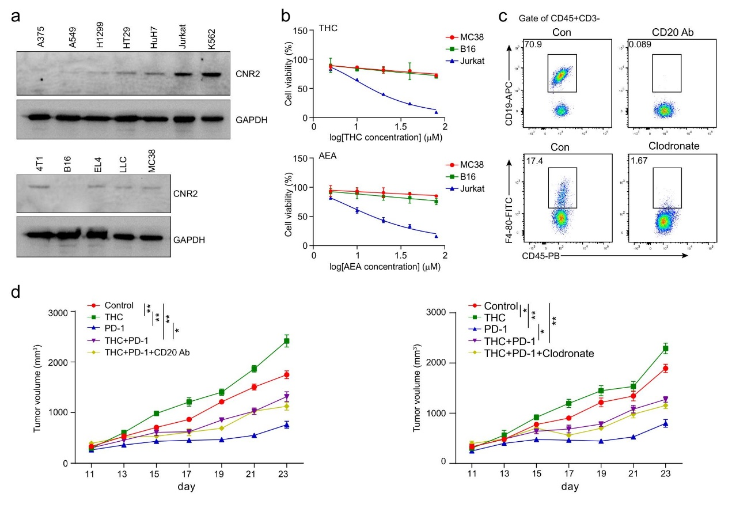
Supplementary Fig. S1. THC-mediated suppression of antitumor immunity is not through tumor cells, B cells and macrophages.
a CNR2 protein expression in tumor cell lines. Lysates (50 μg protein/lane) from tumor cells were analyzed by immunoblot using antibodies to either CNR2 or GAPDH. b Cell viability of B16, MC38 and Jurkat cells treated with various concentrations of THC and AEA, assessed by CCK8 assay. c In vivo administration of mAb SA271G2 and clodronate liposome depleted B cells and macrophages. d Mice bearing B16 tumors were treated with DMSO, THC, PD-1 Ab, THC+PD-1 Ab or THC+PD-1 Ab+ B cells depletion (left) or THC+PD-1 Ab+macrophage depletion (right) on day 10 after tumor inoculation. Tumor volumes were measured every other day (two-way ANOVA, mean ± SEM, *P<0.05, and **P<0.01).

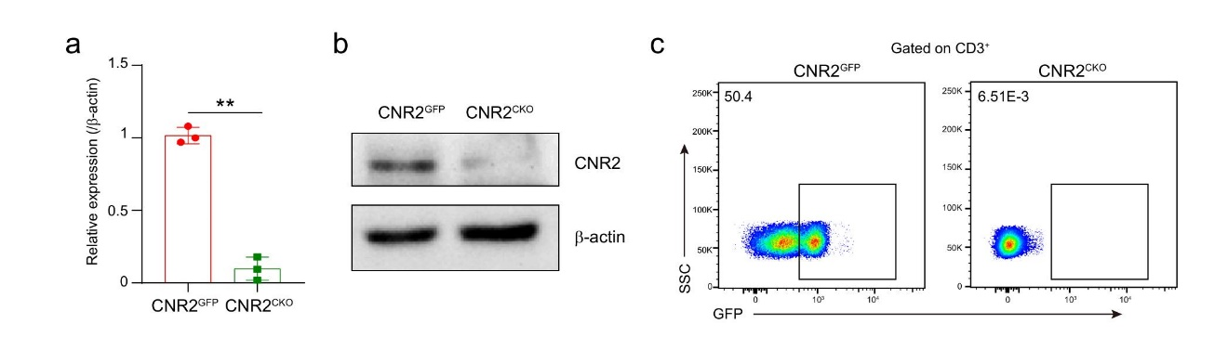
Supplementary Fig. S2. Characterization of Cnr2^{CKO} mice
a,b qPCR analysis of Cnr2 cDNA, and CNR2 immunoblot using CD8⁺ T cells from Cnr2^{GFP} and Cnr2^{CKO} mice (mean ± SD, **P < 0.01). c Flow cytometric analysis of the frequency of GFP⁺ populations in CD3⁺ T cells from Cnr2^{GFP} or Cnr2^{CKO} mice. Data are representative of three independent experiments.

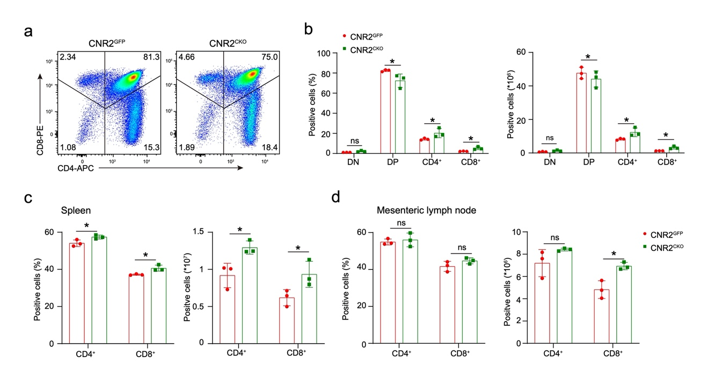
Supplementary Fig. S3. Subsets of T cells in the thymus and periphery of Cnr2^{CKO} mice
a Gating strategy used to define single-positive CD4⁺ and CD8⁺, double-positive (DP), and DN thymocyte populations of Cnr2^{CKO} and Cnr2^{GFP} mice. b Quantification of thymocyte populations from a. c,d Percents and numbers of CD4⁺ and CD8⁺ T cells from spleen or mesenteric lymph node of Cnr2^{CKO} and Cnr2^{GFP} mice. Statistical significance was assessed by two-way ANOVA, mean ± SD, *P < 0.05 and **P < 0.01. ns, no significance, P> 0.05.

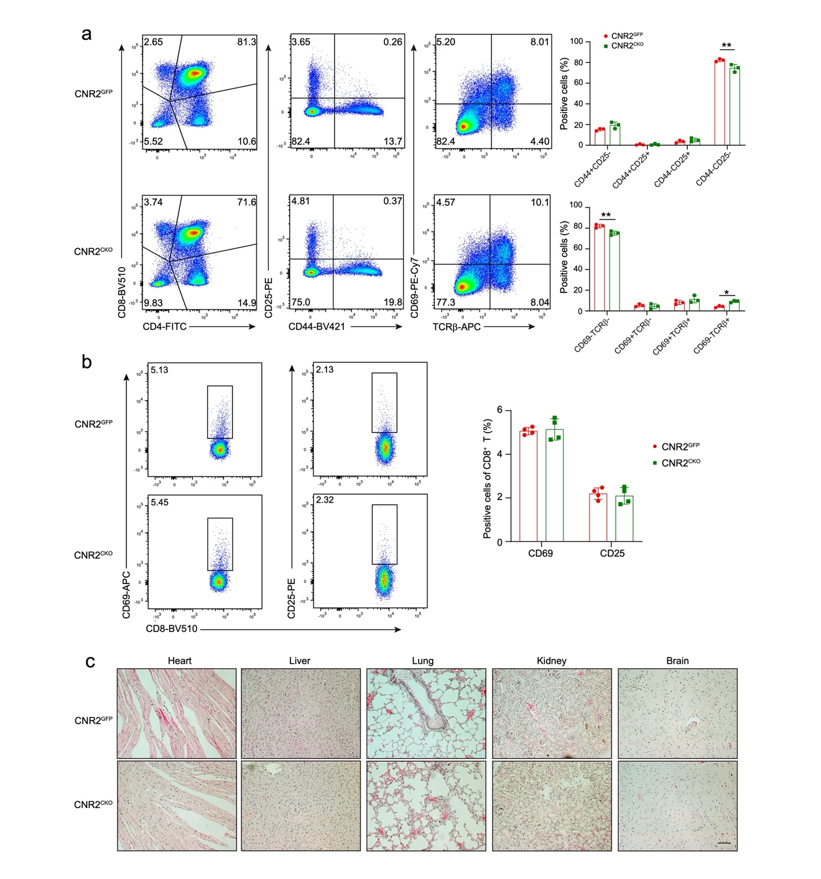
Supplementary Fig. S4. Development of T cells in Cnr2^{CKO} mice
a Flow cytometry analysis of the surface expression of CD4, CD8, CD25, CD44, CD69 and TCRβ on Cnr2^{GFP} and Cnr2^{CKO} thymocytes; quantification of each subsets was shown at right. b Flow cytometry analysis of the surface expression of CD25 and CD69 on T cells from spleens of aged Cnr2^{GFP} and Cnr2^{CKO} (left); quantification of each subsets was shown at right. c H&E staining of the heart, liver, lung, kidney and brain from aged Cnr2^{GFP} and Cnr2^{CKO} mice. Statistical significance was assessed by two-way ANOVA, mean ± SD, *P < 0.05.

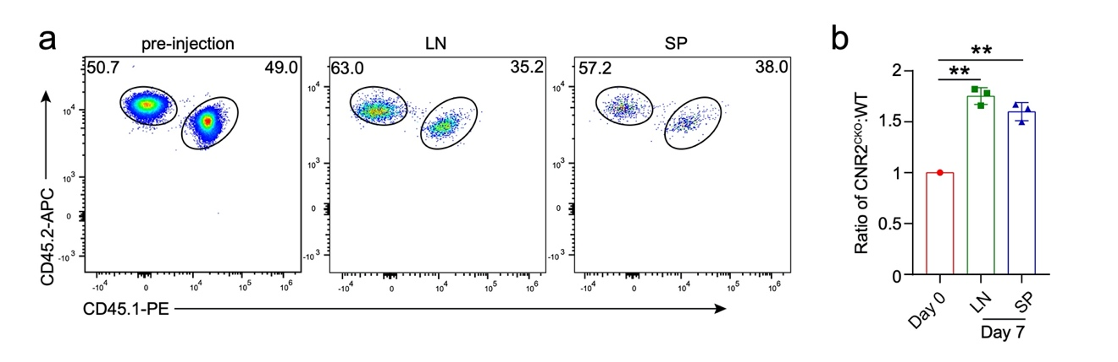
Supplementary Fig. S5. Increased homeostasis of Cnr2 deficient T cells
a Cnr2^{GFP} (CD45.1⁺CD45.2⁺) and Cnr2^{CKO} (CD45.2⁺) CD8⁺ T cells were 1:1 mixed and intravenously injected into Rag2^{-/-} mice (CD45.1⁺). Flow cytometric analysis shows the frequencies of Cnr2^{CKO} and Cnr2^{GFP} CD8⁺ T cells from lymph node and spleen. b Representative ratios of Cnr2^{CKO} to Cnr2^{GFP} CD8⁺ T cells in the lymph node and spleen evaluated on day 7. Statistical significance was assessed by two-way ANOVA, mean ± SD, **P < 0.01.

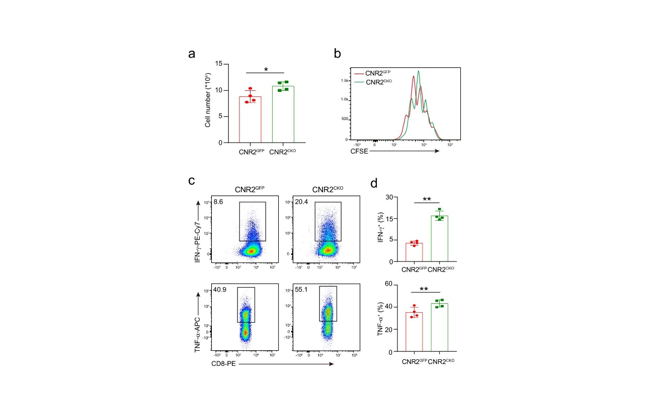
Supplementary Fig. S6. Cnr2 deficiency enhances T cell function and proliferation
CD8⁺ T cells from Cnr2^{GFP} or Cnr2^{CKO} mice were treated with anti-CD3 plus anti-CD28 for 48 hr. a Number of Cnr2^{GFP} or Cnr2^{CKO} CD8⁺ T cells after stimulation (mean ± SD, *P < 0.05). b Proliferation of Cnr2^{GFP} and Cnr2^{CKO} CD8⁺ T cells measured by CFSE dilution assay (mean ± SD). c,d IFN-γ and TNF-α production in Cnr2^{GFP} or Cnr2^{CKO} CD8⁺ T cells measured by flow cytometry analysis (mean ± SD, **P < 0.01). Statistical significance was assessed by two-tailed unpaired Student’s t test (a, d). Data are representative of three independent experiments.

