Supplementary Materials
Figure S1. Study Design
Figure S2. Trial procedures and study timeline
Figure S3. Consort flow diagram
Table S1. Demographic and clinical characteristics of the intention-to-treat, per-protocol and higher THC dose populations
Table S2. Cognitive outcome measures: intention-to-treat sensitivity analysis
Table S3. Cognitive outcome measures: standard dose sensitivity analyses
Table S4. PANSS: intention-to-treat sensitivity analysis
Table S5. PANSS: standard dose sensitivity analyses
Table S6. Visual analogue scales
Table S7. Physiological outcome measures
Table S8. Pharmacokinetic parameters of THC, CBD and metabolites
Table S9. Correlation between plasma exposure of CBD, THC and 11-OH-THC and change in PANSS-P and Hopkins Verbal Learning Task – Delayed Recall.
Figure S4. Correlation between plasma exposure of CBD, THC and 11-OH-THC and change in PANSS-P and Hopkins Verbal Learning Task – Delayed Recall.

Figure S1. Study design

Figure S2. Trial procedures and study timeline. PANSS: Positive and Negative Syndrome Scale; STAI: State-Trait Anxiety Inventory; PSI: Psychotomimetic States Inventory; SSPS: State Social Paranoia Scale; HVLT: Hopkins Verbal Learning Task; VAS: Visual Analogue Scales.

Figure S3. CONSORT flow diagram

Table S1. Demographic and clinical characteristics of the intention-to-treat, per-protocol and higher THC dose populations
 |  | Intention-to-treat (n=34) | Per-protocol (n=30) | Higher THC dose (n=6)
 | Age (years) | 40.2 (11.2) | 39.7 (11.1) | 40.8 (8.4)
Sex | Male | 32 (94.1%) | 28 (93.3%) | 5 (83.3%)
 | Female | 2 (5.9%) | 2 (6.7%) | 1 (16.7%)
Ethnicity | Black | 18 (52.9%) | 17 (56.7%) | 3 (50.0%)
 | Mixed/Other | 7 (20.5%) | 7 (23.3%) | 1 (16.7%)
 | White | 9 (26.4%) | 6 (20.0%) | 2 (33.3%)
Employed | Yes | 3 (8.8%) | 3 (10.0%) | 0 (0%)
 | No | 31 (91.2%) | 27 (90.0%) | 6 (100%)
Primary diagnosis (ICD-10 criteria) | Schizophrenia | 31 (91.2%) | 27 (90.0%) | 4 (66.7%)
 | Schizoaffective disorder | 3 (8.8%) | 3 (10.0%) | 2 (33.3%)
Illness duration and severity | Years of illness | 17.2 (11.0) | 17.1 (11.5) | 18.0 (10.3)
 | Relapses in past 10 years | 2.8 (3.0) | 2.6 (2.5) | 4.2 (2.2)
Treatment and management | Olanzapine equivalents | 13.9 (7.8) | 14.4 (7.7) | 8.9 (3.0)
 | Long-acting injectable (current) | 27 (79.4%) | 25 (83.3%) | 6 (100%)
 | Clozapine (current) | 4 (11.7%) | 4 (13.3%) | 0 (0.0%)
 | Community Treatment Order (ever) | 8 (23.5%) | 7 (23.3%) | 3 (50.0%)
Baseline Symptom severity | Positive subscale | 14.0 (5.7) | 13.9 (5.5) | 12.7 (5.1)
 | Negative subscale | 13.5 (6.6) | 13.3 (6.0) | 15.2 (9.0)
 | AUDIT score | 4.2 (5.1) | 4.3 (4.2) | 4.5 (4.0)
 | CUDIT score | 15.6 (4.9) | 15.9 (4.9) | 14.7 (6.7)
Cannabis Use Disorder (DSM-5) | Mild | 1 (2.9%) | 1 (3.3%) | 0 (0.0%)
 | Moderate | 2 (5.9%) | 2 (6.7%) | 0 (0.0%)
 | Severe | 31 (91.2%) | 27 (90.0%) | 6 (100%)
Cannabis use | Days per week | 5.4 (1.9) | 5.4 (1.9) | 5.8 (1.8)
 | Joints per day | 5.4 (4.3) | 5.3 (4.2) | 7.0 (6.6)
 | Grams per day | 1.0 (0.7) | 1.1 (0.7) | 1.6 (1.1)
 | High potency | 28 (82.3%) | 24 (80.0%) | 6 (100%)
 | Low potency | 6 (17.6%) | 6 (20.0%) | 0 (0%)
 | Tobacco in joints | 34 (100%) | 30 (100%) | 6 (100%)
Tobacco use* | Yes | 29 (85.3%) | 25 (83.3%) | 6 (100%)
 | No | 5 (14.7%) | 5 (17.6%) | 0 (0%)
Data are n (%) or mean (SD)

DSM-5: Diagnostic and Statistical Manual of Mental Disorders, Fifth Edition; AUDIT: Alcohol use disorders identification test; CUDIT: Cannabis use disorder identification test.

*Independent of cannabis use

Table S2. Cognitive outcome measures: intention-to-treat sensitivity analysis (n=34)
 |  |  | CBD | Placebo | Comparison
 |  | Screening visit | Post-cannabis | Post-cannabis | Mean difference | P value | Corrected P value
HVLT - Revised | Immediate recall | 19.0 (17.0-21.0) | 15.0 (13.0-17.0) | 16.6 (14.6-18.6) | -1.6 (-3.2-0.0) | 0.065 | 0.28
 | Immediate intrusions | 0.9 (0.6-1.2) | 2.3 (1.2-3.4) | 2.1 (1.0-3.2) | 0.2 (-0.7-1.1) | 0.71 | 0.71
 | Immediate repetitions | 1.4 (0.8-2.0) | 1.2 (0.4-1.9) | 1.7 (1.0-2.4) | -0.5 (-1.3-0.3) | 0.26 | 0.42
 | Delayed recall | 5.2 (4.4-6.1) | 3.3 (2.3-4.2) | 4.6 (3.6-5.5) | -1.3 (-2.0--0.6) | 0.001 | NA
 | Delayed intrusions | 0.5 (0.2-0.8) | 0.7 (0.1-1.4) | 1.1 (0.4-1.7) | -0.3 (-0.9-0.3) | 0.30 | 0.42
 | Delayed repetitions | 0.2 (0.0-0.3) | 0.1 (-0.2-0.4) | 0.4 (0.1-0.6) | -0.2 (-0.5-0.0) | 0.081 | 0.28
Digit Span | Forward | 5.9 (5.5-6.3) | 6.0 (5.6-6.5) | 6.3 (5.9-6.8) | -0.3 (-0.6-0.1) | 0.12 | 0.29
 | Reverse | 4.0 (3.6-4.3) | 3.8 (3.4-4.3) | 3.7 (3.3-4.2) | 0.1 (-0.4-0.6) | 0.69 | 0.71
Data are mean (95% CI)

Table S3. Cognitive outcome measures: standard dose sensitivity analyses (20 mg sessions only; per-protocol; n=30)
 |  |  | CBD | Placebo | Comparison
 |  | Screening visit | Post-cannabis | Post-cannabis | Mean difference | P value | Corrected P value
HVLT - Revised | Immediate recall | 19.3 (17.2-21.4) | 15.2 (13.0-17.4) | 17.0 (14.7-19.2) | -1.8 (-3.3--0.2) | 0.04 | 0.25
 | Immediate intrusions | 0.9 (0.6-1.2) | 2.1 (0.9-3.2) | 2.1 (0.9-3.2) | 0.0 (-1.0-1.0) | 1.00 | 1.00
 | Immediate repetitions | 1.3 (0.7-2.0) | 1.6 (0.7-2.5) | 1.6 (0.6-2.5) | 0.0 (-1.0-1.0) | 0.95 | 1.00
 | Delayed recall | 5.2 (4.4-6.1) | 3.5 (2.5-4.5) | 4.7 (3.7-5.7) | -1.3 (-2.0--0.6) | 0.002 | NA
 | Delayed intrusions | 0.5 (0.2-0.8) | 1.1 (0.3-1.9) | 1.0 (0.2-1.8) | 0.2 (-0.6-1.0) | 0.69 | 1.00
 | Delayed repetitions | 0.2 (0.0-0.3) | 0.3 (0.0-0.5) | 0.3 (0.0-0.5) | 0.0 (-0.3-0.3) | 1.00 | 1.00
Digit Span | Forward | 5.9 (5.6-6.3) | 5.9 (5.4-6.4) | 6.1 (5.6-6.6) | -0.2 (-0.6-0.2) | 0.28 | 0.65
 | Reverse | 3.9 (3.6-4.3) | 3.6 (3.0-4.3) | 4.1 (3.5-4.7) | -0.5 (-1.3-0.3) | 0.26 | 0.65
Data are mean (95% CI)

Table S4. Positive psychotic symptoms: intention-to-treat sensitivity analysis (n=34)
 | CBD |  |  | Placebo |  |  | Comparison
PANSS - Positive Scale | Baseline | Post-cannabis | Change | Baseline | Post-cannabis | Change | Estimated Marginal Mean difference | P value | Corrected P value
Total Score | 13.3 (11.4-15.1) | 18.8 (16.5-21.1) | 5.6 (4.1-7.2) | 13.7 (11.8-15.5) | 17.0 (14.8-19.2) | 3.2 (1.7-4.7) | 2.4 (0.8-4.0) | 0.0059 | NA
Delusions | 2.8 (2.2-3.4) | 3.3 (2.7-4.0) | 0.6 (0.3-1.0) | 2.8 (2.2-3.4) | 3.1 (2.5-3.8) | 0.2 (-0.1-0.6) | 0.4 (-0.1-0.8) | 0.14 | 0.23
Conceptual disorganization | 1.4 (1.1-1.6) | 3.5 (3.1-4.0) | 2.2 (1.8-2.6) | 1.3 (1.1-1.5) | 2.8 (2.3-3.2) | 1.5 (1.1-1.9) | 0.7 (0.3-1.2) | 0.0050 | 0.03
Hallucinatory behaviour | 2.3 (1.8-2.8) | 2.7 (2.1-3.3) | 0.3 (-0.2-0.9) | 2.2 (1.7-2.7) | 2.6 (2.0-3.1) | 0.4 (-0.2-0.9) | -0.1 (-0.6-0.4) | 0.82 | 0.82
Excitement | 1.2 (1.0-1.3) | 2.2 (1.7-2.6) | 1.0 (0.6-1.4) | 1.2 (1.0-1.4) | 1.7 (1.3-2.2) | 0.5 (0.1-0.9) | 0.5 (0.1-1.0) | 0.078 | 0.18
Grandiosity | 2.2 (1.6-2.7) | 2.4 (1.8-3.0) | 0.3 (0.0-0.5) | 2.2 (1.7-2.7) | 2.3 (1.7-2.8) | 0.1 (-0.2-0.3) | 0.2 (-0.1-0.5) | 0.16 | 0.23
Suspiciousness/persecution | 2.4 (1.8-2.9) | 3.3 (2.8-3.9) | 1.0 (0.6-1.4) | 2.6 (2.0-3.1) | 3.0 (2.4-3.6) | 0.4 (0.0-0.8) | 0.6 (0.2-1.0) | 0.010 | 0.04
Hostility | 1.1 (0.9-1.4) | 1.4 (1.1-1.7) | 0.2 (-0.1-0.5) | 1.4 (1.2-1.7) | 1.5 (1.2-1.8) | 0.1 (-0.2-0.3) | 0.2 (-0.1-0.4) | 0.25 | 0.29
Data are mean (95% CI)

Table S5. Positive psychotic symptoms: standard dose sensitivity analyses (20 mg sessions only; per-protocol; n=30)
 | CBD |  |  | Placebo |  |  | Comparison
PANSS - Positive Scale | Baseline | Post-cannabis | Change | Baseline | Post-cannabis | Change | Estimated Marginal Mean difference | P value | Corrected P value
Total Score | 13.2 (11.3-15.2) | 17.8 (15.4-20.1) | 4.5 (3.0-6.0) | 13.7 (11.7-15.6) | 16.1 (13.8-18.5) | 2.5 (1.0-4.0) | 2.1 (0.6-3.6) | 0.012 | NA
Delusions | 2.8 (2.1-3.5) | 3.2 (2.6-3.9) | 0.4 (0.2-0.7) | 2.8 (2.1-3.5) | 2.9 (2.2-3.5) | 0.1 (-0.2-0.3) | 0.4 (0.1-0.7) | 0.025 | 0.09
Conceptual disorganization | 1.3 (1.1-1.5) | 3.2 (2.7-3.7) | 2.0 (1.5-2.4) | 1.2 (1.0-1.4) | 2.7 (2.2-3.2) | 1.5 (1.0-2.0) | 0.5 (0.0-0.9) | 0.064 | 0.13
Hallucinatory behaviour | 2.3 (1.7-2.8) | 2.4 (1.8-2.9) | 0.1 (-0.5-0.7) | 2.2 (1.7-2.8) | 2.5 (1.9-3.1) | 0.3 (-0.3-0.8) | -0.2 (-0.6-0.3) | 0.46 | 0.46
Excitement | 1.2 (1.0-1.4) | 2.0 (1.6-2.4) | 0.8 (0.4-1.2) | 1.2 (1.0-1.4) | 1.5 (1.1-2.0) | 0.3 (-0.1-0.7) | 0.5 (0.0-1.0) | 0.075 | 0.13
Grandiosity | 2.2 (1.6-2.8) | 2.5 (1.9-3.1) | 0.3 (0.0-0.5) | 2.2 (1.7-2.8) | 2.3 (1.7-2.9) | 0.1 (-0.1-0.3) | 0.2 (-0.1-0.4) | 0.22 | 0.30
Suspiciousness/persecution | 2.4 (1.8-3.0) | 3.1 (2.5-3.8) | 0.8 (0.4-1.1) | 2.6 (2.0-3.2) | 2.8 (2.2-3.4) | 0.2 (-0.2-0.5) | 0.6 (0.2-1.0) | 0.0042 | 0.03
Hostility | 1.1 (0.9-1.4) | 1.3 (1.0-1.6) | 0.2 (-0.1-0.5) | 1.3 (1.1-1.5) | 1.4 (1.1-1.7) | 0.1 (-0.2-0.3) | 0.1 (-0.1-0.4) | 0.30 | 0.35
Data are mean (95% CI)

Table S6. Visual analogue scales
 | CBD |  |  | Placebo |  |  | Comparison
Item | Baseline | Post-cannabis | Change | Baseline | Post-cannabis | Change | Mean difference | P value
Feel drug effect | 1.7 (-2.2-5.7) | 80.4 (72.8-88.1) | 78.7 (69.0-88.4) | 4.9 (1.0-8.9) | 80.1 (72.5-87.8) | 75.2 (65.5-84.9) | 3.5 (-4.9-12.0) | 0.42
Like drug effect | 10.5 (1.2-19.8) | 72.6 (62.7-82.4) | 62.0 (48.1-75.9) | 16.8 (7.5-26.1) | 73.0 (63.1-82.8) | 56.2 (42.3-70.1) | 5.8 (-7.9-19.5) | 0.41
Want more drug | 37.7 (24.2-51.1) | 49.3 (36.6-62.1) | 11.7 (-2.4-25.7) | 34.7 (21.3-48.1) | 55.2 (42.4-67.9) | 20.5 (6.5-34.5) | -8.9 (-27.8-10.1) | 0.37
Thinking clearly | 78.6 (68.0-89.3) | 64.1 (54.4-73.9) | -14.5 (-26.5--2.4) | 70.3 (59.6-80.9) | 66.1 (56.3-75.9) | -4.2 (-16.2-7.9) | -10.3 (-23.4-2.8) | 0.13
Tired | 22.4 (13.5-31.2) | 30.5 (21.0-40.0) | 8.1 (-4.4-20.6) | 25.2 (16.3-34.0) | 31.1 (21.6-40.6) | 5.9 (-6.6-18.4) | 2.2 (-14.3-18.7) | 0.80
Want to talk | 38.7 (29.4-47.9) | 49.3 (38.5-60.2) | 10.6 (-2.0-23.2) | 42.9 (33.6-52.2) | 51.9 (41.0-62.7) | 9.0 (-3.5-21.6) | 1.6 (-10.7-13.8) | 0.81
Anxious | 11.1 (3.9-18.3) | 19.3 (11.0-27.6) | 8.2 (-2.3-18.6) | 15.8 (8.6-23.0) | 18.3 (10.1-26.6) | 2.6 (-7.9-13.0) | 5.6 (-7.6-18.8) | 0.41
Suspicious | 8.3 (2.6-14.1) | 11.1 (6.6-15.7) | 2.8 (-3.9-9.6) | 8.2 (2.5-14.0) | 8.4 (3.9-13.0) | 0.2 (-6.6-6.9) | 2.7 (-6.6-11.9) | 0.58
Happy | 59.0 (50.9-67.2) | 75.5 (68.2-82.8) | 16.5 (7.8-25.2) | 64.0 (55.8-72.1) | 72.1 (64.8-79.4) | 8.1 (-0.6-16.8) | 8.4 (-2.5-19.2) | 0.14
Irritable | 7.5 (2.3-12.8) | 7.1 (1.2-13.0) | -0.5 (-6.9-5.9) | 12.1 (6.8-17.4) | 14.9 (8.9-20.8) | 2.8 (-3.6-9.2) | -3.2 (-11.8-5.4) | 0.47
Relaxed | 61.6 (52.2-70.9) | 73.3 (66.2-80.5) | 11.8 (1.5-22.1) | 66.5 (57.1-75.9) | 73.3 (66.1-80.4) | 6.8 (-3.5-17.1) | 5.0 (-9.0-18.9) | 0.49
Hearing voices | 7.4 (2.7-12.2) | 11.4 (3.9-19.0) | 4.0 (-3.9-11.9) | 5.5 (0.8-10.3) | 13.0 (5.4-20.5) | 7.4 (-0.5-15.3) | -3.4 (-11.2-4.3) | 0.39
Dry mouth | 15.9 (6.9-24.9) | 33.4 (22.7-44.1) | 17.5 (5.3-29.7) | 17.8 (8.8-26.8) | 23.8 (13.1-34.5) | 6.0 (-6.2-18.2) | 11.6 (-2.7-25.8) | 0.12
Vulnerable | 15.4 (6.5-24.2) | 19.4 (10.3-28.5) | 4.0 (-6.4-14.3) | 15.7 (6.8-24.5) | 17.1 (8.0-26.2) | 1.4 (-8.9-11.8) | 2.5 (-11.0-16.1) | 0.72
Threatened | 5.8 (1.3-10.2) | 22.4 (13.8-31.0) | 16.6 (7.4-25.9) | 7.7 (3.3-12.2) | 23.6 (15-32.3) | 15.9 (6.6-25.2) | 0.8 (-9.2-10.7) | 0.88
Excited | 47.7 (37.1-58.3) | 4.9 (1.4-8.5) | -42.7 (-54.1--31.4) | 49.2 (38.6-59.8) | 6.5 (3.0-10.0) | -42.7 (-54.1--31.3) | -0.1 (-12.3-12.2) | 0.99
Data are mean (95% CI)

Table S7. Physiological outcome measures
 | CBD |  |  | Placebo
 | Baseline | Peak post-cannabis | Change | Baseline | Peak post-cannabis | Change | Estimated Marginal Mean difference | P value | Corrected P value
Pulse (bpm) | 76.9 (72.2-81.6) | 103.4 (95.2-111.7) | 26.6 (19.2-34.0) | 76.3 (71.6-81.0) | 103.3 (95.1-111.5) | 27.0 (19.6-34.3) | -0.4 (-6.5-5.8) | 0.91 | 0.91
Systolic BP (mm Hg) | 121.2 (117.3-125.1) | 146.2 (139.9-152.4) | 25.1 (19.5-30.8) | 122.3 (118.5-126.1) | 136.5 (130.3-142.6) | 13.9 (8.4-19.5) | 11.2 (3.7-18.6) | 0.01 | 0.04
Diastolic BP (mm Hg) | 76.3 (72.9-79.7) | 95.2 (89.3-101.1) | 18.9 (12.8-25) | 75.6 (72.3-79.0) | 89.6 (83.8-95.4) | 13.9 (8-19.9) | 5.0 (-1.7-11.7) | 0.16 | 0.28
Temperature (ºC) | 36.3 (36.1-36.5) | 36.8 (36.7-37.0) | 0.5 (0.4-0.7) | 36.4 (36.2-36.6) | 36.8 (36.6-36.9) | 0.4 (0.2-0.5) | 0.1 (-0.1-0.3) | 0.21 | 0.28
Data are mean (95% CI)

Table S8. Pharmacokinetic parameters of THC, CBD and metabolites
Pharmacokinetic parameter (unit) | CBD/THC arm | Placebo/THC arm | p value
CBD
AUC_{Baseline-90 min} (ng·h/mL) | 2514.2 (1065.0-5935.5) | 161.0 (91.7-282.7) | 0.0006
C_{max} (ng/mL) | 25.7 (11.1-59.5) | 1.7 (1.0-2.9) | 0.0003
6-hydroxy-CBD
AUC_{Baseline-90 min} (ng·h/mL) | 0.1 (0.0-4.1) | 0.0 (0.0-0.0) | 0.008
C_{max} (ng/mL) | 0.0 (0.0-0.2) | 0.0 (0.0-0.0) | 0.002
7-hydroxy-CBD
AUC_{Baseline-90 min} (ng·h/mL) | 200.8 (17.7-2273.9) | 10.4 (1.4-78.1) | 0.004
C_{max} (ng/mL) | 3.1 (0.4-22.8) | 0.2 (0.0-0.9) | 0.002
7-carboxy-CBD
AUC_{Baseline-90 min} (ng·h/mL) | 3083.4 (1477.8-6433.4) | 421.3 (230.6-769.9) | 0.0039
C_{max} (ng/mL) | 29.2 (13.6-62.4) | 3.5 (1.9-6.4) | 0.0008
THC
AUC_{0-90 min} (ng·h/mL) | 984.2 (769.7-1258.5) | 973.1 (756.1-1252.5) | 0.81
C_{max} (ng/mL) | 45.7 (33.1-63) | 37.2 (28.0-49.4) | 0.12
11-hydroxy-THC
AUC_{0-90 min} (ng·h/mL) | 439.8 (304.9-634.3) | 398.0 (281.8-562.2) | 0.85
C_{max} (ng/mL) | 9.4 (6.5-13.6) | 7.9 (5.6-11.2) | 0.55
11-carboxy-THC
AUC_{0-90 min} (ng·h/mL) | 7130.8 (4849.4-10485.5) | 5171.8 (3596.7-7436.8) | 0.015
C_{max} (ng/mL) | 140.2 (99.6-197.2) | 90.5 (63.9-128.3) | 0.001
All parameters are reported as geometric mean (geometric CV%).

Table S9. Correlation between area under the curve (AUC) of CBD, THC and 11-OH-THC and change in PANSS-P and Hopkins Verbal Learning Task – Delayed Recall
Metabolite | PANSS-P | P value | Delayed verbal recall | P value
CBD | 0.43 (0.19 to 0.61) | 0.018 | -0.27 (-0.49 to -0.02) | 0.038
THC | 0.01 (-0.27 to 0.30) | 0.92 | 0.10 (-0.19 to 0.37) | 0.50
11-OH-THC | -0.01 (-0.27 to 0.24) | 0.93 | 0.10 ( -0.16 to 0.34) | 0.45

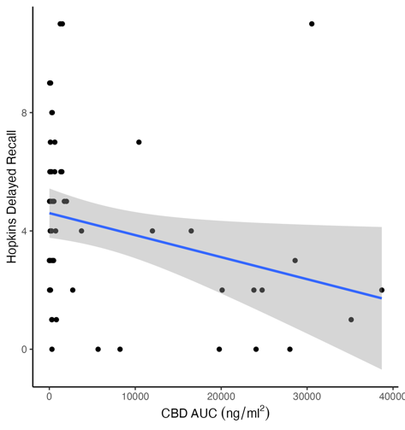
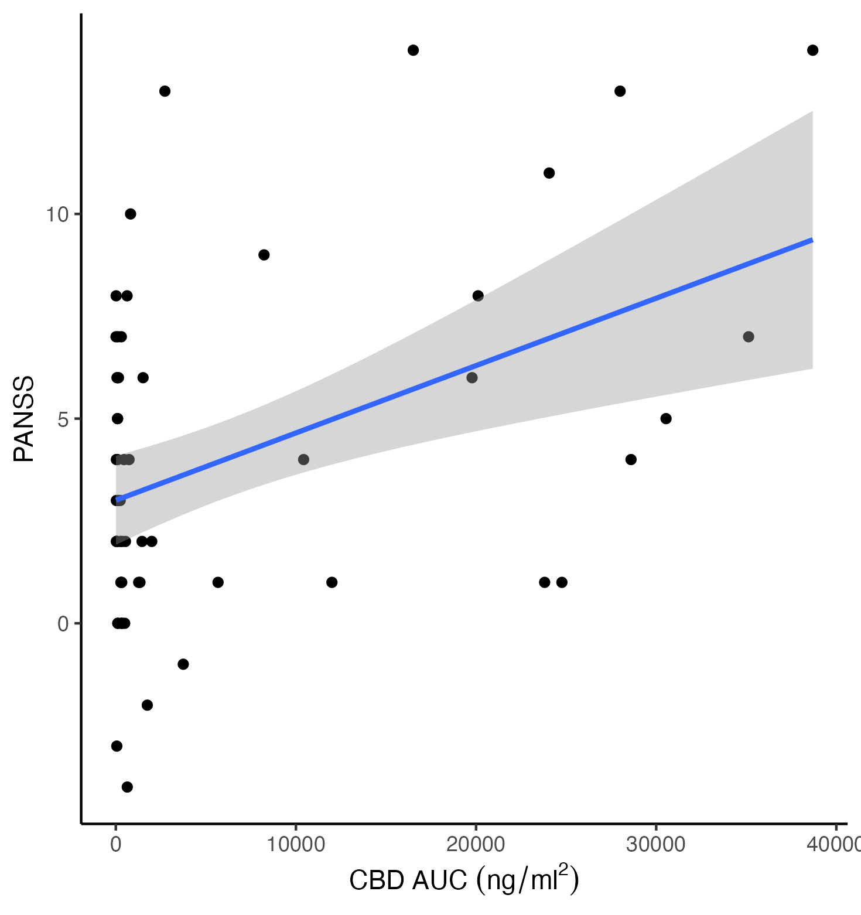
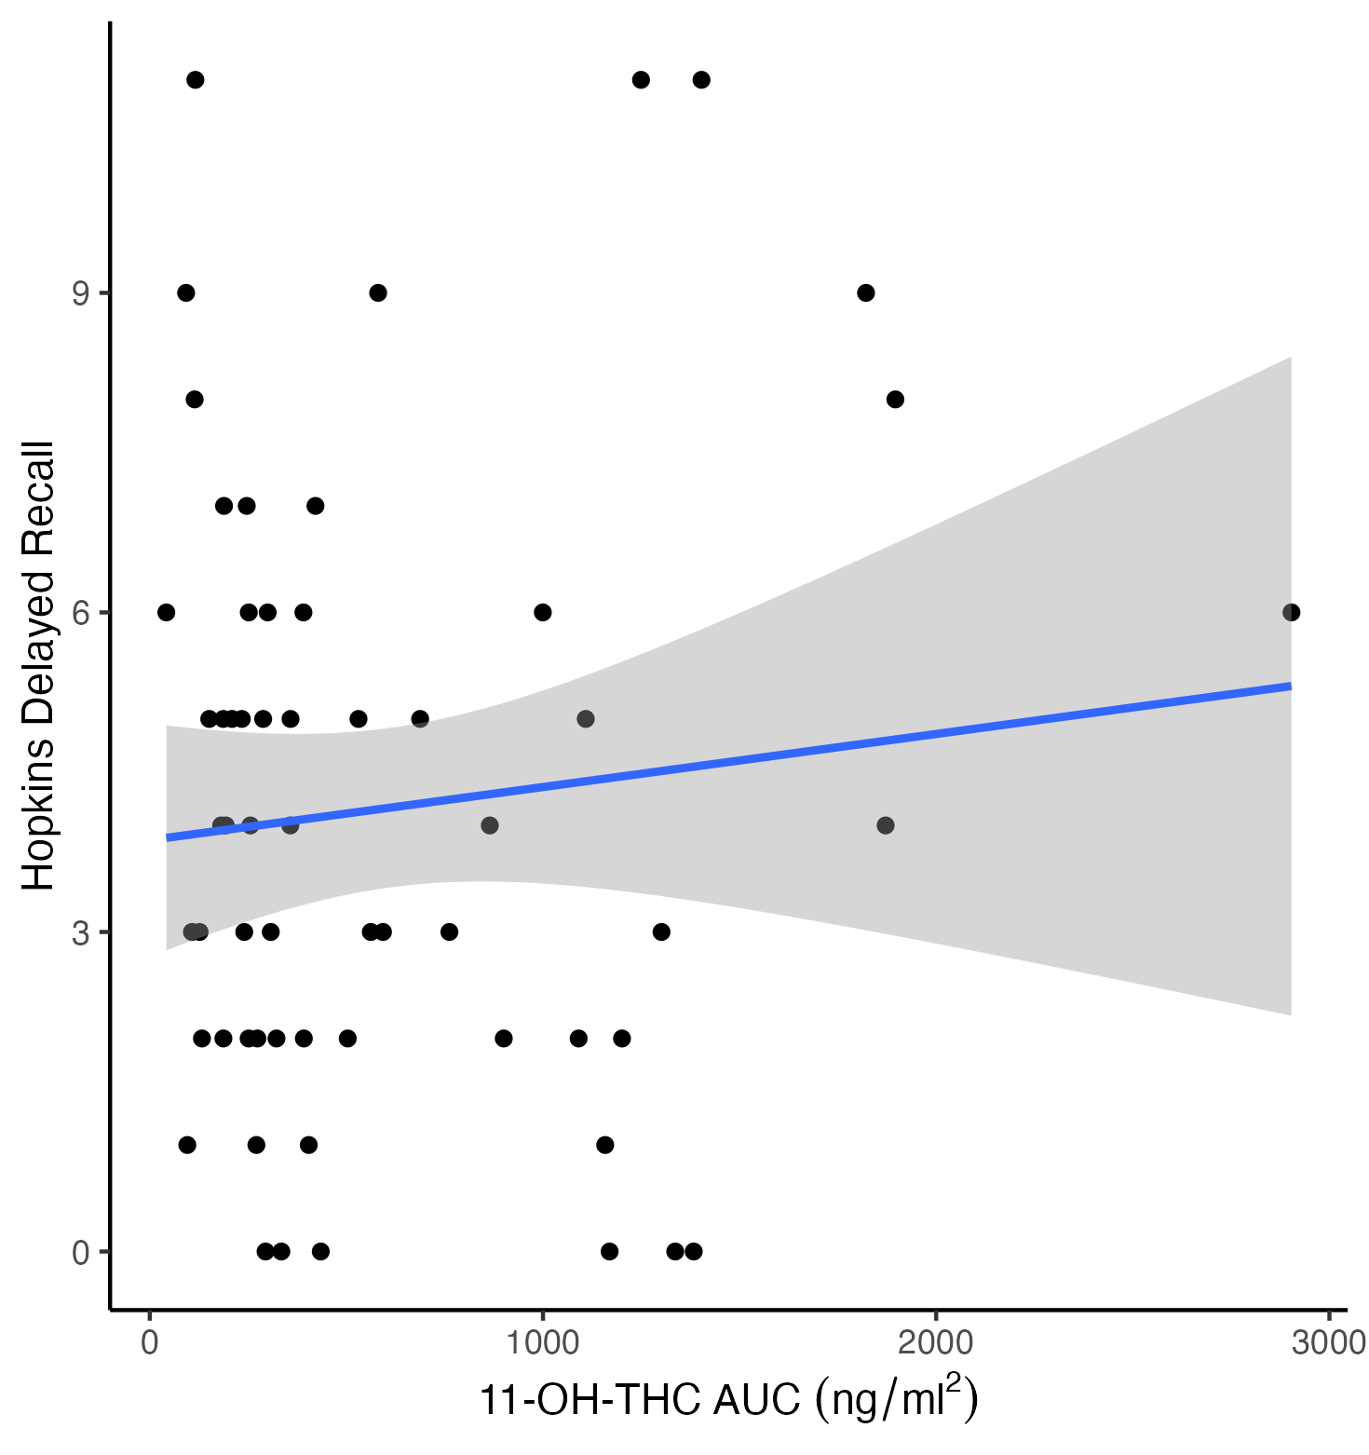
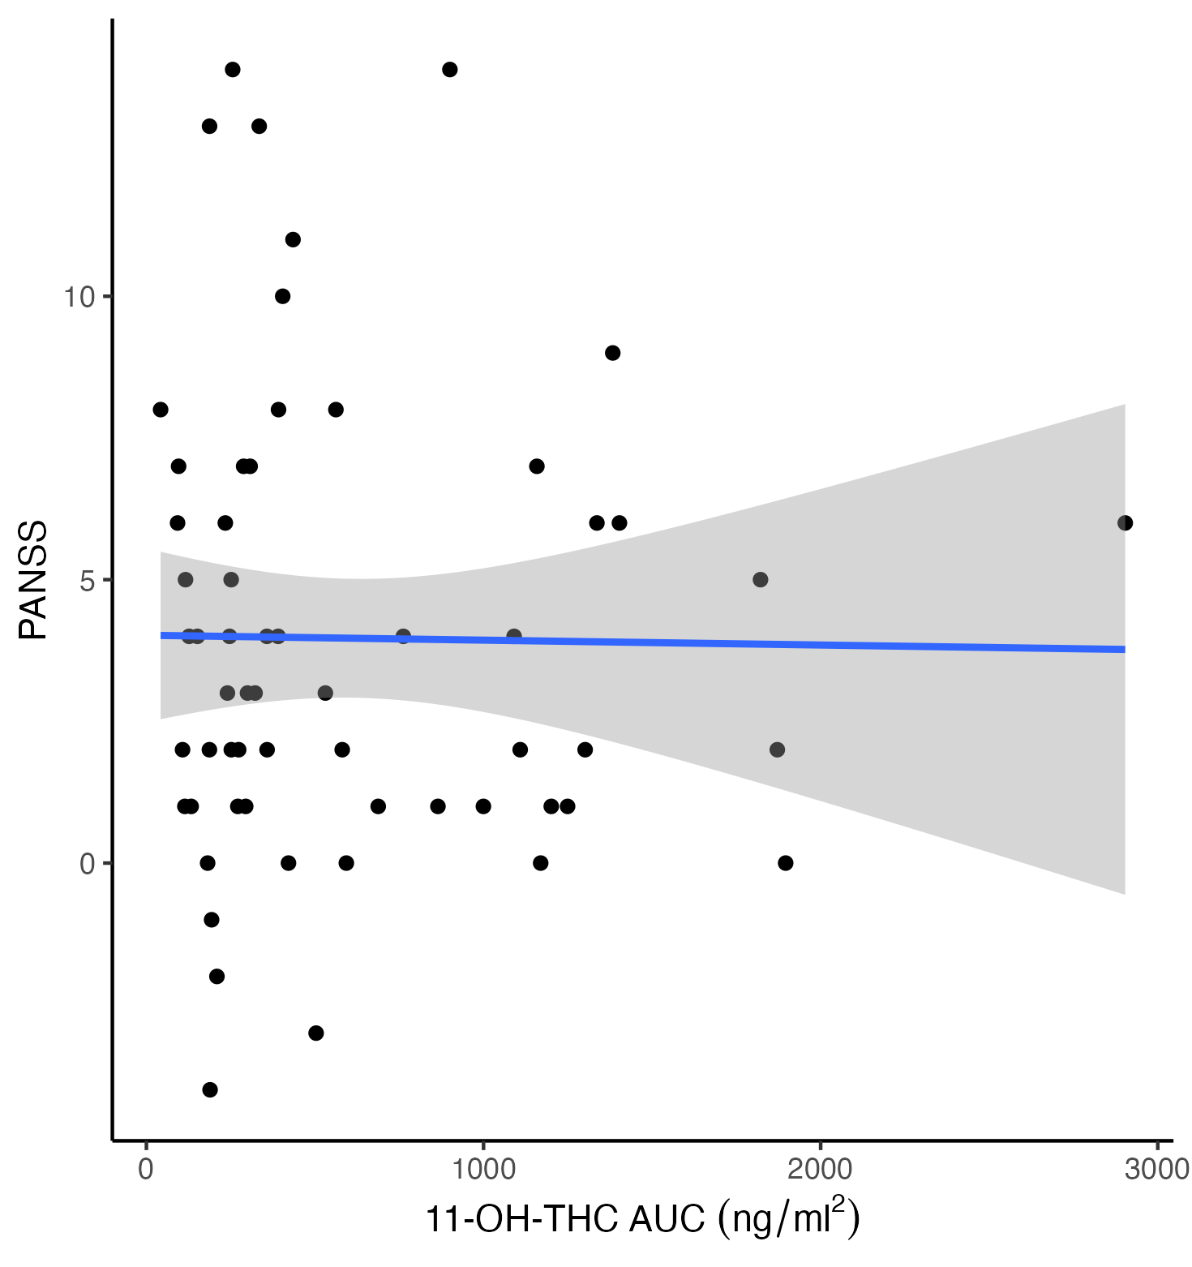
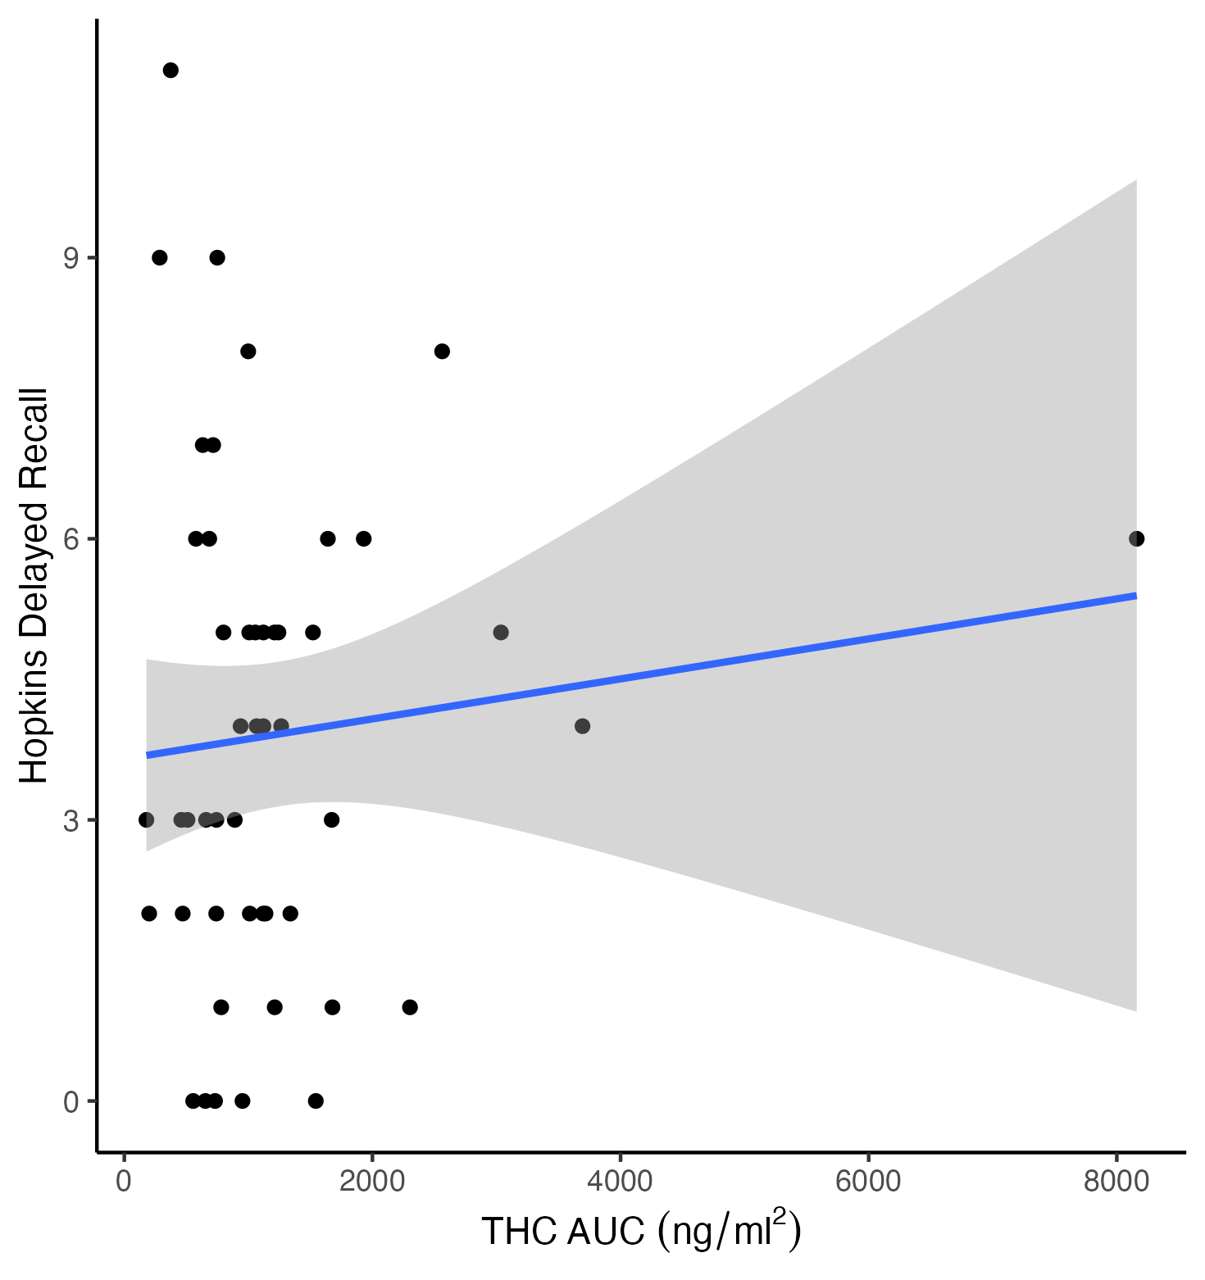
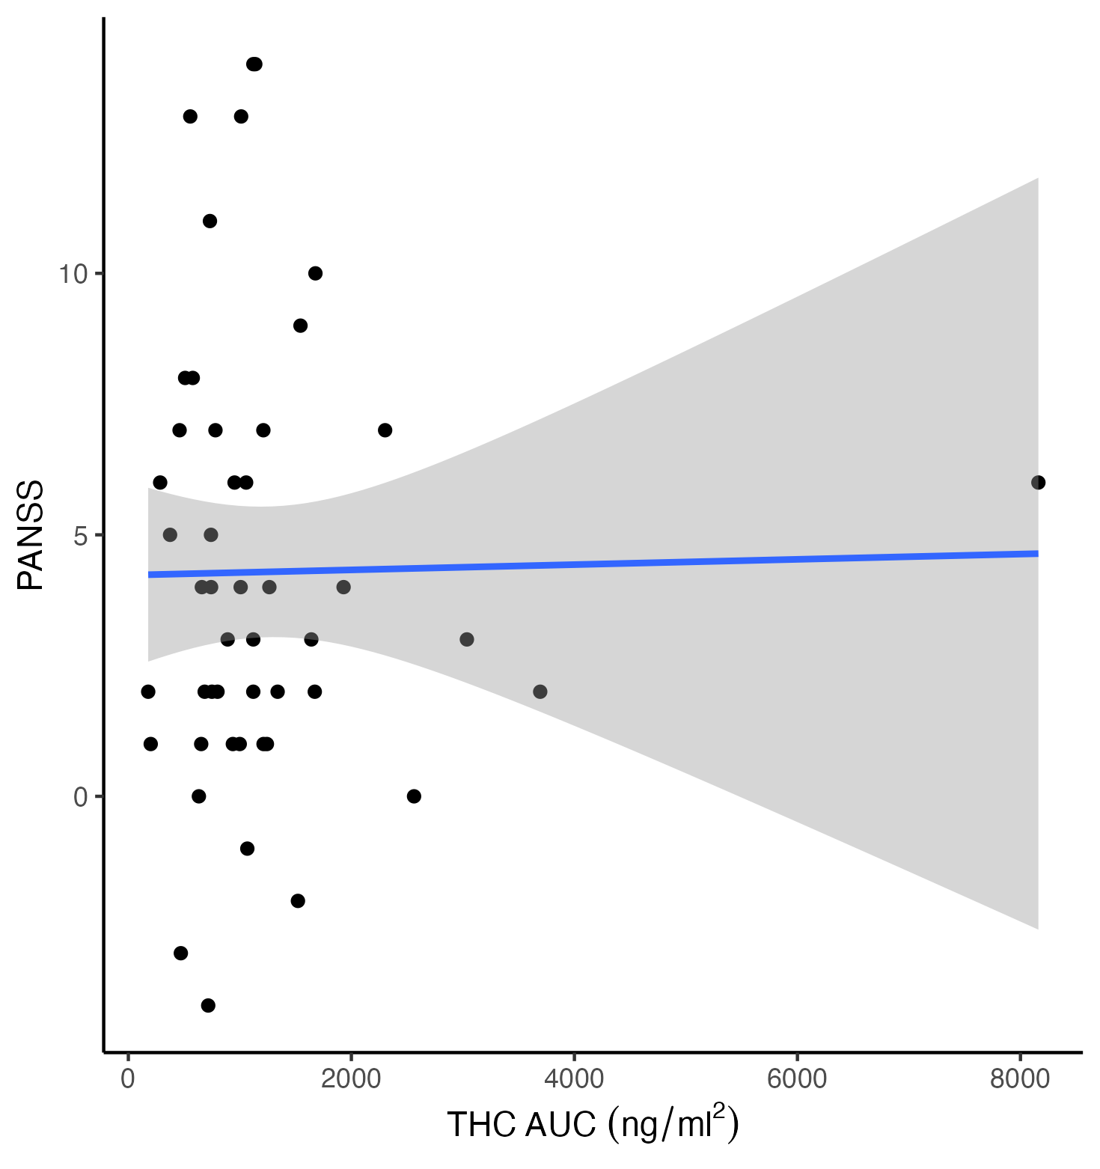
Figure S4. Correlation between plasma exposure of CBD, THC and 11-OH-THC and change in PANSS-P and Hopkins Verbal Learning Task – Delayed Recall. Shaded area = Standard Error.

