Supplement

Metabolomic profiling of cannabis use and cannabis intoxication in humans

Francisco Madrid-Gambinª, Noemí Haroª, Natasha L. Mason^{b}, Pablo Mallaroni^{b}, Eef L Theunissen ^{b}, Stefan W. Toennes ^{c}, Oscar J. Pozoª. Johannes G. Ramaekers ^{b}

ªApplied Metabolomics Research Group, Hospital del Mar Research Institute, 08003 Barcelona, Spain
^{b}Department of Neuropsychology and Psychopharmacology, Faculty of Psychology and Neuroscience, Maastricht University, 6200 MD, Maastricht, the Netherlands
^{c} Goethe University Frankfurt, University Hospital, Institute of Legal Medicine, Germany

Correspondence: j.ramaekers@maastrichtuniversity.nl

Table S1. Descriptive characteristics
Demographics | Occasional users  N = 18 | Chronic users  N = 17 | P value
Age (years)¹ | 22.3 ± 3.32 | 21.8 ± 2.2 | 0.557
Gender²  Male  Female | 7 (38.9%)  11 (61.1%) | 8 (47.1%)  9 (52.9%) | ​​​0.625
Cannabis use per month | 3.3 ± 2.6 | 19.8 ± 10.4 | <0.001*
¹P-values from independent t-test between occasional and chronic users are shown for quantitative variables, presented as mean ± standard deviation. ²Pearson’s Chi-squared test is shown for the categorical variable.

Table S2. List of targeted biomarkers
Family | Metabolite | Abbreviation
Corticosteroids | Cortisol | F
Corticosteroids | 20α-Dihydrocortisol | DHF20a
Corticosteroids | 20β-Dihydrocortisol | DHF20b
Corticosteroids | 5α-Tetrahydrocortisol | THF5a
Corticosteroids | 5β-Tetrahydrocortisol | THF5b
Corticosteroids | 6-Hydroxycortisol | OH6F
Corticosteroids | Cortisone | E
Corticosteroids | 20α-Dihydrocortisone | DHE20a
Corticosteroids | 20β-Dihydrocortisone | DHE20b
Corticosteroids | Corticosterone | B
Corticosteroids | 11-Dehydrocorticosterone | A
Corticosteroids | 11-Deoxycorticosterone | DOC
Corticosteroids | Testosterone | T
Corticosteroids | Androstenedione | AED
Corticosteroids | 11β-dehidrogenase | 11bHSD
Corticosteroids | 20α/20β-Dihydrocortisol | 20α/20β-DHF
Corticosteroids | 6-Hydroxycortisol/Cortisol | 6OHF/F
Energy metabolism | Lactate | Lactate
Energy metabolism | Citrate | Citrate
Energy metabolism | Succinate | Succinate
Energy metabolism | Fumarate | Fumarate
Energy metabolism | Malate | Malate
Energy metabolism | Fumarate/Succinate | Fum/Succ
Energy metabolism | Malate/Fumarate | Mal/Fum
Energy metabolism | Citrate/Malate | Cit/Mal
Energy metabolism | 3-hydroxyButyrate | 3OHBut
Energy metabolism | 2-hydroxyGlutarate | 2OHGlut
Energy metabolism | 2-hydroxyButyrate | 2OHBut
 | Isovalerate | Isovalerate
 | Valerate | Valerate
Amino Acid metabolism | Valine | Valine
Amino Acid metabolism | Leucine | Leucine
Amino Acid metabolism | Isoleucine | Isoleucine
Amino Acid metabolism | Methionine | Methionine
Amino Acid metabolism | Hippurate | Hippurate
Amino Acid metabolism | Phenylalanine | Phenylalanine
Amino Acid metabolism | Tryptophan | Tryptophan
Amino Acid metabolism | Tyrosine | Tyrosine
Amino Acid metabolism | Glutamate | Glutamate
Amino Acid metabolism | Glutamine | Glutamine
Amino Acid metabolism | Serotonin | 5HT
Amino Acid metabolism | HIAA5 | HIAA5
Amino Acid metabolism | Kynurenine | Kynurenine
Amino Acid metabolism | Kynurenate | Kynurenate
Amino Acid metabolism | Glutamate/Glutamine | Glu/Gln
Amino Acid metabolism | Valine/LNAA | Val/LNAA
Amino Acid metabolism | Leucine/LNAA | Leu/LNAA
Amino Acid metabolism | Isoleucine/LNAA | Ile/LNAA
Amino Acid metabolism | Tryptophan/LNAA | Trp/LNAA
Amino Acid metabolism | Phenylalanine/LNAA | Phe/LNAA
Amino Acid metabolism | Tyrosine/LNAA | Tyr/LNAA
Amino Acid metabolism | Serotonin/Tryptophan | Kyn/Trp
Amino Acid metabolism | Kynurenine/Tryptophan | X5HT/Trp
Amino Acid metabolism | Creatinine | Creatinine
Amino Acid metabolism | Creatine | Creatine
Acylglycerol | DAG 16:1 | DAG 16:1
Acylglycerol | DAG 16:0 | DAG 16:0
Acylglycerol | DAG 16:0 18:2 | DAG 16:0 18:2
Acylglycerol | DAG 18:1 16:0 | DAG 18:1 16:0
Acylglycerol | DAG 16:0 18:0 | DAG 16:0 18:0
Acylglycerol | DAG 18:2 | DAG 18:2
Acylglycerol | DAG 18:0 18:2 | DAG 18:0 18:2
Acylglycerol | DAG 18:1 | DAG 18:1
Acylglycerol | DAG 18:0 18:1 | DAG 18:0 18:1
Acylglycerol | DAG 18:0 | DAG 18:0
Acylglycerol | DAG 18:0 20:4 | DAG 18:0 20:4
Acylglycerol | MAG 16:0 | MAG 16:0
Acylglycerol | MAG/DAG 18:2 | MAG/DAG 18:2
Acylglycerol | MAG/DAG 18:1 | MAG/DAG 18:1
Acylglycerol | MAG/DAG 20:4 | MAG/DAG 20:4
Lysophosphatidylcholine | LPC 16:0 | LPC 16:0
Lysophosphatidylcholine | LPC 18:0 | LPC 18:0
Ceramides | Cer 18:1 14:0 | Cer 18:1 14:0
Ceramides | Cer 18:1 16:0 | Cer 18:1 16:0
Ceramides | Cer 18:1 18:0 | Cer 18:1 18:0
Ceramides | Cer 18:1 20:0 | Cer 18:1 20:0
Ceramides | Cer 18:1 22:0 | Cer 18:1 22:0
Ceramides | Cer 18:1 24:0 | Cer 18:1 24:0
Ceramides | Cer 18:1 24:1 | Cer 18:1 24:1
Ceramides | HexCer d18:1 16:0 | HexCer d18:1 16:0
Ceramides | HexCer d18:1 18:0 | HexCer d18:1 18:0
Ceramides | HexCer d18:1 22:0 | HexCer d18:1 22:0
Ceramides | HexCer d18:1 24:0 | HexCer d18:1 24:0
Ceramides | HexCer d18:1 18:1 | HexCer d18:1 18:1
Ceramides | HexCer d18:1 24:1 | HexCer d18:1 24:1
Ceramides | HexCer/Cer 16:0 | HexCer/Cer 16:0
Ceramides | HexCer/Cer 18:0 | HexCer/Cer 18:0
Ceramides | HexCer/Cer 22:0 | HexCer/Cer 22:0
Ceramides | HexCer/Cer 24:0 | HexCer/Cer 24:0
Ceramides | HexCer/Cer 24:1 | HexCer/Cer 24:1
Sphingolipid | Sphingomyelin | Sphingomyelin
Sphingolipid | Sphingosine | Sphingosine
 | Choline | Choline
 | Acetylcholine | Acetylcholine
 | Acetylcarnitine | Acetylcarnitine
 | Carnitine | Carnitine
 | Adenosine | Adenosine
 | Trimethylamine N-oxide | TMAO
 | Betaine | Betaine
 | Trimethylamine N-oxide/Choline | TMAO/Choline
 | Acetylcholine/Choline | Ach/Chol
Endocannabinoids | 2-Arachidonoylglycerol | 2-AG
Endocannabinoids | 2-Linoleoylglycerol | 2-LG
Endocannabinoids | 2-Oleoylglycerol | 2-OG
Endocannabinoids | Anandamide (N-Arachidonoylethanolamine) | AEA
Endocannabinoids | Palmitoylethanolamide | PEA
Endocannabinoids | Oleoylethanolamide | OEA
Endocannabinoids | Palmitoleoylethanolamide | POEA
Endocannabinoids | Stearoylethanolamide | SEA
Endocannabinoids | Linoleoylethanolamide | LEA
Endocannabinoids | Docosahexaenoylethanolamide | DHEA
Endocannabinoids | Dihomo-γ-linolenoylethanolamide | DGLEA
Endocannabinoids | Docosatetraenoylethanolamide | DEA
Table S3. Metabolic changes in occasional and chronic cannabis users after smoking cannabis.
Cannabis  user group | Metabolite | Family | Slopeª | Wald^{b} | P-value^{b} | FDR
Occasional | β-Hydroxybutyrate | ketone body | -0.821 | 7.44 | 0.006 | 0.033
 | Glutaric acid | AA metabolism | -0.017 | 7.41 | 0.006 | 0.033
 | Lactic acid | Energy metabolism | -4.080 | 6.44 | 0.011 | 0.033
 | α-Hydroxybutyrate | Energy metabolism | -0.849 | 6.43 | 0.011 | 0.040
 | α-Hydroxyglutarate | Citric acid cycle | -0.003 | 5.73 | 0.017 | 0.047
 | Malic acid | Citric acid cycle | -0.046 | 5.14 | 0.023 | 0.047
 | Succinic acid | Citric acid cycle | -0.033 | 4.87 | 0.027 | 0.047
 | Isocitric acid | Citric acid cycle | -0.001 | 4.69 | 0.030 | 0.047
 | Tryptophan | Tryptophan metabolism | -0.206 | 4.72 | 0.030 | 0.690
 | Citric acid | Citric acid cycle | -0.369 | 4.35 | 0.037 | 0.051
 | PEA | Endocannabinoid | 0.128 | 4.30 | 0.038 | 0.270
 | DEA | Endocannabinoid | 0.009 | 3.88 | 0.049 | 0.270
Chronic | Isoleucine | BCAA metabolism | -4.950 | 9.90 | 0.002 | 0.038
 | Tyrosine | AAA metabolism | -3.917 | 8.13 | 0.004 | 0.039
 | Leucine | BCAA metabolism | -3.281 | 7.87 | 0.005 | 0.039
 | Cortexolone | Steroid | -0.026 | 4.95 | 0.026 | 0.313
 | β-Hydroxybutyrate | ketone body | -0.599 | 4.88 | 0.027 | 0.298
ªSlope in logarithm format * 1000. ^{b}Wald score from GLMs as ratio of the estimated feature value to its standard error. ^{c}P-value from Treatment by Time interaction. Abbreviations: AAA, aromatic amino acid; BCAA, branched chain amino acid; DEA, docosatetraenoylethanolamide; FDR, false discovery rate; PEA, N-palmitoylethanolamine.

Table S4. Metabolites associated with psychomotor vigilance task performance in occasional cannabis users
 |  | Attention task 10 min after vaporization |  |  | Attention task 30 min after vaporization
Metabolite | Family | Beta | P-value | FDR | Beta | P-value | FDR
LPC 18.0 | LPC | 0.447 | 0.021 | 0.034 | 0.118 | 0.013 | 0.022
LPC 16.0 | LPC | 1.128 | 0.023 | 0.034 | 0.243 | 0.015 | 0.022
HexCer d18:1 24:0 | Ceramide | 0.737 | 0.005 | 0.028 | 0.155 | 0.022 | 0.046
HexCer d18:1 22:0 | Ceramide | 0.642 | 0.013 | 0.04 | 0.151 | 0.02 | 0.046
HexCer d18:1 24:1 | Ceramide | 0.495 | 0.108 | 0.217 | 0.17 | 0.023 | 0.046
DAG 18:0 | Diacylglycerol | -0.386 | 0.614 | 0.844 | 0.152 | 0.008 | 0.087
Cer 18:1 24:0 | Ceramide | 0.465 | 0.027 | 0.085 | 0.097 | 0.113 | 0.396
Cer 18:1 24:1 | Ceramide | 0.773 | 0.036 | 0.085 | 0.183 | 0.083 | 0.396
Cer 18:1 20:0 | Ceramide | 0.924 | 0.007 | 0.051 | 0.137 | 0.219 | 0.509
SEA | Endocannabinoid | -3.046 | 0.011 | 0.122 | 0.453 | 0.174 | 0.661
PEA | Endocannabinoid | -2.256 | 0.03 | 0.166 | 0.318 | 0.217 | 0.661
Abbreviations: LPC, lysophosphatidylcholine; PEA, N-palmitoylethanolamine; SEA, N-stearoylethanolamine

Table S5. Metabolites associated with psychomotor vigilance task performance in chronic cannabis users
 |  | Attention task 10 min after vaporization |  |  | Attention task 30 min after vaporization
Metabolite | Family | Beta | P-value | FDR | Beta | P-value | FDR
2-LG | Endocannabinoid | 0.454 | 0.001 | 0.009 | 0.195 | 0.444 | 0.869
20β-DHE | Steroid | 2.254 | 0.036 | 0.231 | 0.983 | 0.599 | 0.798
5α-THF | Steroid | 0.543 | 0.039 | 0.231 | 0.035 | 0.938 | 0.938
α-Ketobutyrate | Citric acid cycle | -0.902 | 0.026 | 0.405 | -0.682 | 0.295 | 0.8
DAG 18:0 20:4 | Diacylglycerol | -0.257 | 0.681 | 0.981 | -2.128 | 0.016 | 0.176
Kynurenine | TRP metabolism | 0.503 | 0.694 | 0.976 | 4.48 | 0.003 | 0.074
Abbreviations: 2-LG, 2-linoleoyl glycerol; 20β-DHE, 20β-dihydrocortisone; 5α-THF, 5α-tetrahydrocortisol; DAG, diacylglycerol; TRP, tryptophan.

Table S6. Metabolites associated with ratings of subjective high in occasional cannabis users
 |  | Subjective High 20 min after vaporization |  |  | Subjective High 40 min after vaporization
Metabolite | Family | Beta | P-value | FDR | Beta | P-value | FDR
Cer.18:1 20:0 | Ceramide | 0.579 | 0.018 | 0.123 | 0.077 | 0.827 | 0.931
Cer.18:1 24:0 | Ceramide | 0.295 | 0.040 | 0.140 | 0.017 | 0.931 | 0.931
Fumaric acid | Citric acid cycle | -0.170 | 0.684 | 0.999 | -1.170 | 0.009 | 0.149
HexCer.d18:1 22:0 | Ceramide | 0.419 | 0.006 | 0.025 | -0.160 | 0.484 | 0.832
HexCer.d18:1 24:0 | Ceramide | 0.414 | 0.008 | 0.025 | -0.219 | 0.339 | 0.832
HMB | BCAA metabolism | -1.080 | 0.026 | 0.440 | -0.950 | 0.148 | 0.419
LPC 16:0 | LPC | 0.536 | 0.035 | 0.035 | -0.532 | 0.114 | 0.228
LPC 18:0 | LPC | 0.258 | 0.033 | 0.035 | -0.158 | 0.345 | 0.345
Abbreviations: BCAA, branched-chain amino acid; HexCer; hexosylceramide; HMB, β-Hydroxy β-methylbutyric acid; LPC, lysophosphatidylcholine

Table S7. Metabolites associated with ratings of subjective high in chronic cannabis users
 |  | Subjective High 20 min after vaporization |  |  | Subjective High 40 min after vaporization
Metabolite | Family | Beta | P-value | FDR | Beta | P-value | FDR
Betaine | AA metabolism | -0.763 | 0.038 | 0.322 | -0.576 | 0.360 | 0.829
DAG 16.0 | Diacylglycerol | 1.564 | 0.042 | 0.175 | 1.705 | 0.179 | 0.492
DAG 16.0.18.0 | Diacylglycerol | 1.515 | 0.021 | 0.175 | 2.382 | 0.042 | 0.240
DAG 18.0.18.1 | Diacylglycerol | 1.201 | 0.048 | 0.175 | 0.605 | 0.521 | 0.637
Fumaric acid | Citric acid cycle | 0.014 | 0.949 | 0.982 | 0.800 | 0.008 | 0.138
Lactic acid | Citric acid cycle | -0.038 | 0.915 | 0.982 | 1.158 | 0.026 | 0.224
LPC 16.0 | LPC | -0.232 | 0.403 | 0.403 | -0.947 | 0.022 | 0.044
Testosterone | Steroid | 0.694 | 0.040 | 0.475 | 0.016 | 0.979 | 0.979
Valine | BCAA metabolism | -0.555 | 0.036 | 0.322 | -0.082 | 0.865 | 0.969
Abbreviations: AA, amino acid; DAG, diacylglycerol; LPC, lysophosphatidylcholine

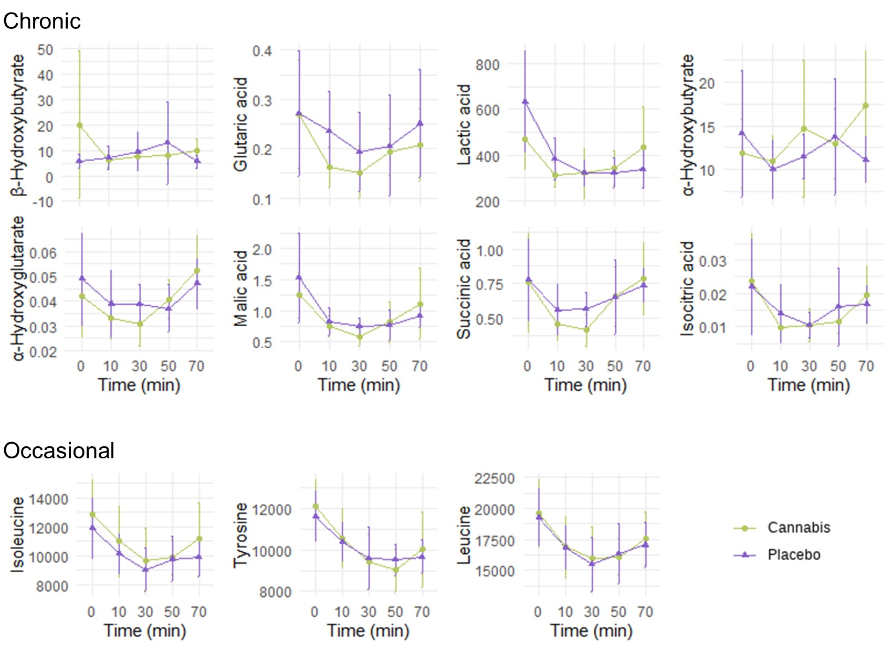
Figure S1. Kinetic profiles of non-significant, condition-specific metabolites complementary to Figure 2 of the main manuscript. The top panels display metabolites that showed significant changes over time in occasional cannabis users (Figure 2) but not in chronic users as shown here, while the bottom panel depicts metabolites that were significantly altered in chronic (Figure 2) but not in occasional users as shown here.

