Brain CB2 Receptor: A new Target in Medication Development for Treating Opioid Use Disorder in Rodents

Omar Soler-Cedeño¹, Hai-Ying Zhang², Emma Xiong¹, Guo-Hua Bi¹, Hannah Alton¹, Maia Maras¹, Qing-Rong Liu³, Pinaki Bhattacharjee⁴, Malliga R. Iyer⁴, Zheng-Xiong Xi^{1,#}

Supplementary Information

- Materials and Methods

- 11 Supplementary figures

Materials and Methods
Animals
Male Long-Evans rats (Charles River Laboratories, Raleigh, NC, USA) were used for i.v. drug self-administration and reinstatement test, and male and female DAT-cre mice with C57BL/6J background (breeders purchased from Jackson Laboratory, Bar Harbor, ME; B6.SJL-Slc6a3tm1.1(Cre)Bkmn/J; stock # 006660; bred at the NIDA IRP Breeding Center, Baltimore, MD, USA) were used for optical intracranial self-stimulation (oICSS). Male and female wildtype (C57/BL6J) mice and CB2R knockout-GFP reporter mice (CB2-KO-eGFP, generated in Ingenious Targeting Laboratory, Ronkonkoma, NY, USA) (https://www.genetargeting.com/) were used in immunocytochemistry, hot-plate analgesia, open-field locomotion, and heroin self-administration experiments. We selected male rats for the heroin self-administration and reinstatement experiments due to limited availability of MRI-2594. However, potential sex differences in MRI-2594’s pharmacological effects were evaluated in mice using three behavioral assays: heroin self-administration, hot-plate analgesia, and locomotor activity. All animals were housed individually in a climate-controlled room under a 12 h light/dark cycle (lights on at 1900 h, lights off at 0700 h). Food and water were available ad libitum throughout the experiments. All experimental procedures were conducted in accordance with the Guide for the Care and Use of Laboratory Animals (8th Edition, 2011) and were approved by the Animal Care and Use Committee of the National Institute on Drug Abuse of the U.S. National Institutes of Health.

Experiment 1: Intravenous heroin self-administration and reinstatement test in rats
Surgery: Right jugular vein intravenous catheterization surgery and heroin self-administration procedures were conducted in Long-Evans rats as previously described^{1, 2}. Briefly, animals were anaesthetized by an intraperitoneal (i.p.) injection of ketamine/xylazine (100/10 mg/kg), and catheters, constructed of micro-renathane (Braintree Scientific Inc., Braintree, MA, USA), were inserted into the right jugular vein. After being sutured into place, the catheter was passed subcutaneously to the top of the skull and exited and attached to a connector (a modified 24-g cannula; Plastics One, Roanoke, VA, USA). The connector was then mounted onto the skull using jeweler’s stainless-steel screws and dental acrylic. To prevent clogging, the catheters were flushed daily with a gentamicin-heparin-saline solution (30 IU/ml heparin) (ICN Biochemicals, Cleveland, OH, United States).
Self-administration under fixed-ratio (FR) reinforcement schedules: After recovery from surgery, animals were placed in the self-administration chambers (Model MED-008-CT-B1) and trained to self-administer heroin (0.05 mg/kg/infusion) daily under fixed-ratio (FR1 in the first week, FR2 in the following training sessions) schedules. Each press on the active lever resulted in single intravenous delivery of a volume of 80 µl heroin solution over 4.2 sec along with a combined light-tone cue above the lever. There was no time out after each drug infusion. Each training session lasted 3 hours or ended immediately when maximally allowed 50 infusions have been taken. Animals were trained until stable heroin self-administration was achieved, as defined by ≥15 heroin infusions per 3 h session; <20% variability in daily heroin infusions across three consecutive sessions; an active/inactive lever pressing ratio exceeding 2:1. Then, the animals were divided into 3 groups randomly. we evaluated the effects of MRI-2594 (3, 10, 30 mg/kg, i.p.) or vehicle (5% cremophor equivalent volume) on heroin self-administration under an FR2 reinforcement schedule. A between-subjects design was used in this experiment. After each test, the animals continued daily heroin self-administration until a stable baseline was reestablished.
Heroin-induced reinstatement of drug-seeking behavior: The procedures of heroin self-administration were the same as described above. After stable heroin self-administration was established, rats underwent extinction, during which heroin was replaced by saline, and the heroin-associated cue-light and tone were turned off. Active lever-pressing led only to saline infusion. Responding on inactive lever produced no consequences. Once rats reached extinction criteria (≤20 lever presses within their 3-hour session on 3 consecutive days), they were randomly divided into 3 dose group to test the effects of MRI-2594 on heroin-induced reinstatement of drug-seeking behavior. Rats were injected with one of the MRI-2594 doses (0, 10 or 30 mg/kg, 0.1 ml/100 g body weight, i.p.), 30 minutes prior to the onset of the session, and injected with heroin (1 mg/kg, i.p.) 15 min before the beginning of the session to reinstate lever responding. The presented data are based on the group assignment after the last extinction session, instead prior to the self-administration training.
Effects of intra-VTA or intra-NAc MRI-2594 on heroin self-administration in rats: To determine whether the effect of MRI-2594 on heroin self-administration was induced by activation of brain or peripheral CB2 receptors, we tested the effects of intranasal (200, 300 μg/30 μl/nostril), intra-VTA or intra-NAc (10, 20, 30 μg/1 μl/side) microinjections of MRI-2594 on heroin self-administration in rats. Intranasal drug administration was performed under inhalant isoflurane anesthesia using the Fluovac System (Harvard Apparatus)³. The procedures of intracranial guide cannula implantation surgery are the same as we reported previously ⁴. In this experiment, two additional groups of rats were placed in a stereotaxic frame and implanted bilaterally with guide cannulae into the NAc-shell (AP from bregma: +1.7, ML: ±2.0; DV: −5.5 mm, 6° from vertical) or ventral tegmental area (VTA; AP −5.2, ML: ±1.8; DV: −7.5 mm, 8°) under ketamine/xylazine anesthesia. Obturators were inserted into the guide cannulae. The self-administration head mount and microinjection guide cannulae were anchored to the skull using four stainless steel jewelers’ screws and dental acrylic. Bilateral drug microinjections were conducted via a 30-gauge injector through implanted guide cannula with the injector tip 0.25 mm below the tips of the guide cannula. A within-subjects design was used to evaluate the effects of intracranial administration of MRI-2594 on heroin self-administration. The sequency of 3 drug doses was counterbalanced with time intervals of 2-5 days between tests.
Cannula placements were verified after the completion of experiments by standard histologic localization techniques. The microinjection area was identified by the injection volume (0.5 µl, which may diffuse to an area of ∼1.2 mm² as assessed by blue dye microinjection) and the injection site (∼0.25 mm below the tip of a guide cannula)⁴.

Experiment 2: Heroin self-administration in wildtype and CB2-KO-eGFP mice
To test whether MRI-2594 effects are mediated by activation of CB2R, we trained WT and CB2R-KO-eGFP mice on heroin self-administration (SA) under a fixed-ratio 2 (FR2) schedule of reinforcement. The mouse SA procedures are the same as those described above in rats except a different mouse SA chamber system (Model ENV-307A, Med Associates) and a different injection volume (15 µl/infusion) were used ³. The effects of MRI-2594 (0, 10, and 30 mg/kg, 0.1 ml/10 g body weight, i.p.) on heroin SA under FR2 schedule were evaluated. The order of drug doses was counterbalanced. The time intervals between different dose tests were 3-5 days.

Experiment 3: Oral Sucrose Self-Administration
The procedures for oral sucrose self-administration testing were identical to the procedures used for heroin self-administration, except for the following: 1) no surgery was carried out in mice; 2) each session lasted for 3 hour with a maximal sucrose delivery of 100, and 3) active lever presses led to delivery of 0.1 ml of 5% sucrose solution into a liquid food tray on the operant chamber wall. The effects of MRI-2594 (0, 10, 30 mg/kg, i.p.) on oral sucrose self-administration maintained under FR2 reinforcement were evaluated.

Experiment 4: Hot-plate analgesic test in mice
MRI-2594 analgesic effects by itself: To test whether MRI-2594 itself produces analgesic effects, we injected MRI-2594 (0, 3, 10, and 30mg/kg) to WT and CB2-KO-eGFP mice and measured the latency to show pain-related behaviors, such as hind paw licking, shaking, withdrawal or jumping, on the hot-plate test, set at a temperature of 52º C and with a cut-off time of 60 seconds to avoid animal injury. Baseline measures were taken on each animal subject prior to MRI-2594 injections. Then, pain latencies were taken at 30, 60, 90, and 120 min after MRI-2594 injections. The experiment was conducted in a within-subjects design with MRI-2594 doses counterbalanced and at least 48 hours between test days to provide for drug washout.
Effects of pretreatment with MRI-2594 on oxycodone analgesia: To test whether MRI-2594 compromises oxycodone analgesic effects, we pretreated animals with MRI-2594 (0, 10, and 30 mg/kg) 15 min prior to injection of oxycodone (3 and 10 mg/kg) in an additional cohort of male and female WT mice, and then measured the latency to show pain-related behaviors on the hot-plate test, as described above. The order of drug doses was counterbalanced. The time intervals between different drug/dose tests were 3-5 days.

Experiment 5: Open-field locomotion in WT mice
Effects of MRI-2594 on locomotion by itself: To determine whether MRI-2594-induced reduction in heroin taking and seeking is due to drug-induced sedation or locomotor impairment, we observed the effects of MRI-2594 on open-field locomotion in male and female mice. The procedures for open-field locomotion testing were the same as we reported previously ³. Animals were given two consecutive days sessions (1 hr) in the open-field chambers for habituation and minimization of novelty exploratory behavior. Then, on the following test days, animals were placed in the open-field chambers for 1 hr prior i.p. injections for baseline locomotion measurements. After baseline, animals randomly received one dose of MRI-2594 (0, 10, 30 mg/kg, i.p.) and then were immediately placed in the open-field apparatus to monitor locomotor activities for 2 hrs. The experiment was conducted in a within-subjects design with MRI-2594 doses counterbalanced and at least 48 hours between test days for drug washout.
Effects of MRI-2594 pretreatment on oxycodone-induced hyperactivity: To test whether MRI-2594 pretreatment alters oxycodone-induced hyperactivity, we injected MRI-2594 (0, 3, 10, and 30 mg/kg) 15 min prior to oxycodone (2 mg/kg, i.p.) in an additional cohort of male WT mice. The order of drug doses was counterbalanced. The time intervals between different drug/dose tests were 3-5 days.

Exp. 6: Fiber photometry for DA measurement
Under ketamine/xylazine anesthesia (100/10 mg/kg, i.p.), mice were unilaterally infused with 0.3 μL of pAAV-DJ-hSyn-GRAB_{DA3m} into the nucleus accumbens (NAc; AP: +1.2 mm, ML: ±0.8 mm, DV: –4.5 mm from the skull surface). Following viral infusion, a 400-μm fiber optic cannula was implanted into the NAc and secured to the skull using dental cement. After 2–3 weeks of recovery period, mice were habituated to the fiber patch cord (MFP_400/430/LWMJ-0.48_1m_FCM-ZF1.25(F)_LAF; Doric Lenses, Quebec, Canada) for 3 consecutive days.
Fiber photometry recordings were conducted using a basic fiber photometry system (FPS_1S_GCaMP; Doric Lenses). A 465-nm LED light (∼30 μW; CLED465; Doric Lenses), modulated at 208.616 Hz, was passed through a filter cube (FMC4_AE(405)_E1(460–490)_F1(500–550)_S; Doric Lenses) and delivered to the NAc via the fiber patch cord connected to the implanted cannula. Fluorescence emission was transmitted back through the same patch cord to a photodetector using the same filter cube. Raw photometry signals were sampled at 12 Hz and de-interleaved to extract reference (405 nm) and signal (465 nm) channels using Doric Neuroscience Studio software (Doric Lenses). Once basal fluorescence levels stabilized, mice randomly received either vehicle, one of three doses of MRI-2594 (3, 10, or 30 mg/kg, i.p.), or cocaine (10 mg/kg, i.p.) as a positive control. Signal recording continued for an additional 5–10 minutes post-injection. The time intervals between drug injections were 2-7 days. The sequency of the drug doses was counterbalanced.
Drug-induced changes in DA signaling were analyzed using custom MATLAB® scripts. Raw fluorescence data were down-sampled by 100x and low-pass filtered at 12 Hz. ΔF/F₀ signals were calculated using the formula ΔF/F₀ = (F – F₀) / F₀, where F represents the fluorescence signal at a given time point and F₀ is the average baseline signal during the 60 seconds preceding drug administration. The area under the curve (AUC) following each drug injection was computed and analyzed.
At the end of the experiment, mice were euthanized, brains were harvested, and GFP IHC was performed to confirm viral expression and the accurate placement of the optical fiber ⁵.

Experiment 7: Optogenetic intracranial self-stimulation (oICSS) in DAT-Cre mice
The intracranial surgery and optical ICSS procedures used are the same as reported previously ⁶⁻⁸. Briefly, DAT-cre mice were anesthetized with a ketamine and xylazine mixture and placed in a stereotaxic device. Subjects received bilateral microinjections of an excitatory channelrhodopsin virus (AAV5-EF1α-DIO-ChR2-EYFP, University of North Carolina Gene Therapy Center) in the VTA (AP -3.28, ML ± 0.43, DV -4.41; 10° angle from the midline). Then, custom built ferrule fibers were implanted 0.5 mm above the virus injection sites and secured to the skull using dental cement ⁷. After four weeks of recovery from the intracranial surgery and viral expression, subjects were tested in operant chambers for oICSS. Initially, mice were placed on an FR1 schedule in which a single response on the active lever led to a 1-s pulse of laser stimulation (473 nm, 20 mW, 5 ms duration, 50 Hz) and a 1-s activation of the cue light above the active lever. Responses on the inactive lever had no programmed consequences. Daily sessions were 60 min in length. Once stable lever pressing was observed, a rate-frequency oICSS procedure was instituted. In this program, 6 stimulation frequencies (100, 50, 25, 10, 5, 1 Hz) were available in descending order during sessions, with a new frequency presented every 10 minutes.
After stable stimulation-response curve was achieved, mice randomly received one dose of MRI-2594 (0, 10, or 30 mg/kg, i.p.) or CB2 antagonist MRI-2687 (0, 10, or 30 mg/kg, i.p.) 15 min prior to the test session and allowed to lever press for oICSS. After each test, mice received additional oICSS sessions until a new baseline was established. The sequency of the drug doses was counterbalanced. After completion of the above behavioral experiment, immunohistochemistry was used to verify AAV-ChR2-eYFP expression in VTA DA neurons in DAT-cre mice using the methods we reported previously ⁵.

Experiment 8: GFP-Immunohistochemistry in CB2-KO-eGFP mice
Mice were anesthetized with ketamine/xylazine (100/10 mg/kg, i.p.) and intracardially perfused with ice-cold 0.9% saline then 4% PFA. Brains were removed and placed in 4% PFA overnight at 4°C. The following morning, the brain was transferred to 1× PBS and sliced in 40 μm coronal sections using a vibratome. Free floating sections were washed in 1× PBS washing buffer, containing 0.3% Triton X-100 (×3, 15 min each) and blocked in a 10% donkey serum and 0.3% Triton X-100 in 1× PBS for 2 hrs with agitation. Sections were incubated overnight at 4°C on a shaker with two primary antibodies in 1× PBS containing 3% donkey serum and 0.3% Triton X-100. The following antibodies were selected: Rabbit anti-GFP polyclonal antibody (1:500; Invitrogen, A-11122) and sheep anti-TH (1:1500; ThermoFisher Scientific, PA1-4679). Sections were washed in 0.3% Triton X-100 solution in 1× PBS (×3, 15 min each) and incubated with a cocktail of two fluorescent labeled secondary antibodies including Alexa Fluor 488 Donkey Anti-Sheep (1:500; ThermoFisher Scientific, A-11015) and Alexa Fluor 555 Donkey Anti-Rabbit (1:500; ThermoFisher Scientific, A-31572) for 2hrs at room temperature with agitation. After another round of washes (×3, 15 min each), sections were mounted on gelatin-coated slides and cover slipped after 2~3 drops of fluorescent mounting medium with DAPI (VECTASHIELD, H-1200, Vector Laboratories, Inc. Burlingame, CA 94010) was applied. The slides were kept at 4 °C refrigerator in the dark until imaging. Confocal mages were obtained using a Zeiss LSM510 confocal microscope (NINDS Light Imaging Facility) at 20× and 40× magnifications. For cell counting analyses, sections were acquired from 3 mice and 6 brain slices were selected from each brain. 2-4 images were taken per brain section. DAPI-positive cells that expressed Cnr2 in combination with TH were counted using ImageJ software.

Drugs
Heroin and oxycodone hydrochloride were obtained through the NIDA Pharmacy. MRI-2594 and MRI-2687 were obtained from the Section on Medicinal Chemistry, National Institute on Alcohol Abuse and Alcoholism, Intramural Research Program, Bethesda, MD, and was dissolved in 5% Cremophor EL.
Data analysis
All data are represented as the mean ± SEM. Animal group sizes were chosen based on a power analysis (n ≥ 6 per group) and extensive previous experience with the animal models used. To validate the use of parametric statistics, we ensured that the residuals were normally distributed (Shapiro Wilk Test for normality; p>0.05) and variances of the differences across all groups were equal (Levene's test for homogeneity for between-subject ANOVA, p>0.05). Statistical analysis was done using the independent values coming from individual animals in each group. One-way (or repeated measures, RM) ANOVA were utilized to analyze effects of different MRI-2594 doses on heroin self-administration in rats and mice. Two-way RM ANOVA was used to analyze the data in open-field locomotion, hot-plate analgesia, and oICSS. Two-way ANOVAs were utilized to analyze MRI-2594 on heroin-induced reinstatement tests. No data points were excluded from the analysis in any experiment. Where variation in group size occurred, this was due to animals being dropped from the experiment due to obstruction or clogging of i.v. catheters. Post hoc analyses were done using Student-Newman-Keuls method compared to vehicle/baseline control group. The value of p<0.05 was used as the minimally acceptable statistically significant difference value in all tests. All tests were performed using SigmaStat 12.5 for Windows. The investigators were blinded to the group allocation during the experiments and data analysis.

Supplementary Figure 1:
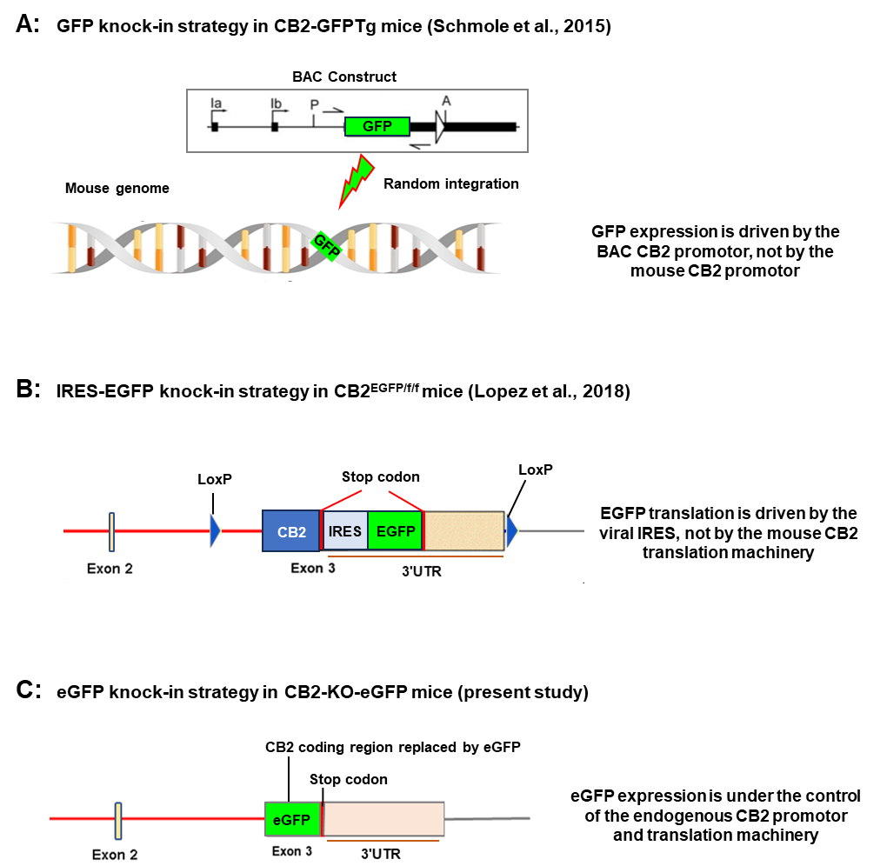

Figure S1: Schematics of GFP knock-in (KI) strategies used to generate three CB2-GFP reporter mouse strains. (A) CB2-GFPTg line ⁹: A GFP reporter cassette replaces the Cnr2 coding sequence within a bacterial artificial chromosome (BAC) containing the CB2 promoter and regulatory elements. The BAC construct is microinjected into mouse embryos and randomly integrated into the genome, enabling GFP expression under CB2 promoter control within the transgene. The endogenous Cnr2 gene may remain intact. If the BAC vector integrates into the mouse CB2 gene, it may disrupt endogenous CB2 expression but endogenous CB2R promotor would unlikely regulate BAC-driven CB2R expression. (B) CB2^{EGFP/f/f} mice ¹⁰: An IRES-EGFP cassette is inserted downstream of the Cnr2 coding sequence in the 3′ UTR, flanked by two loxP sites. This dual-function KI mouse can be used for both conditional CB2R deletion and CB2-EGFP reporter studies. While EGFP transcription is driven by the CB2 promoter, translation is initiated via a viral-derived IRES, decoupling it from native CB2R translational regulation due to a translation stop codon located upstream of the IRES-EGFP cassette. (C) CB2-KO-eGFP line: The entire Cnr2 coding sequency is replaced by eGFP via homologous recombination, producing a CB2 knockout (KO) and GFP reporter mouse, in which the GFP expression is under the control of the native CB2 promoter and regulatory elements.
Supplementary Figure 2.
Figure S2 (related to Fig. 1). Effects of MRI-2594 on inactive lever responses during reinstatement test in rats. A: Time courses of inactive lever responses during the last 3 sessions of heroin self-administration, the last 5 sessions of extinction, and reinstatement test. B: MRI-2594, at 10 and 30 mg/kg, i.p., did not significantly alter inactive lever presses.

Supplementary Figure 3:
Figure S3 (related to Fig. 1). Systemic administration of MRI-2594 has no effect on oral sucrose self-administration in mice.
Supplementary figure 4:

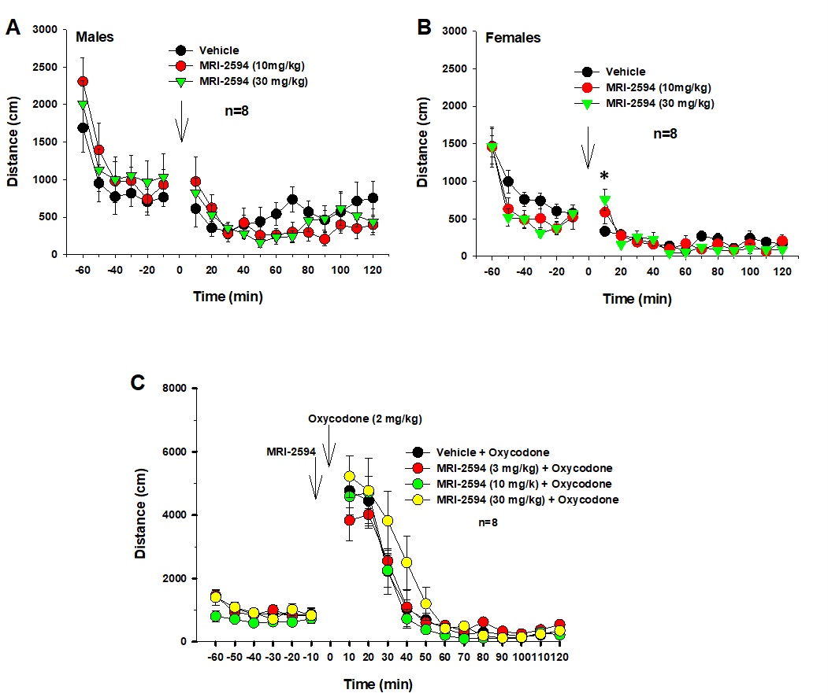
Figure S4 (related to Figure 1): Effects of MRI-2594 on open-field locomotion and oxycodone-induced hyerlocomotion in wildtype mice. A/B: Systemic administration of MRI-2594, at the doses that inhibited heroin self-administration, did not significantly alter open-field locomotion in both male (A) and female (B) mice. C: Pretreatment with MRI-2594 also failed to alter oxycodone-induced increase in locomotion.
Supplementary Figure 5:

Figure S5 (related to Figure 3A, B). Effects of intranasal microinjections of MRI-2594 on heroin self-administration in rats, as assessed by heroin infusions (A) or active lever responses (B).

Supplementary Figure 6:
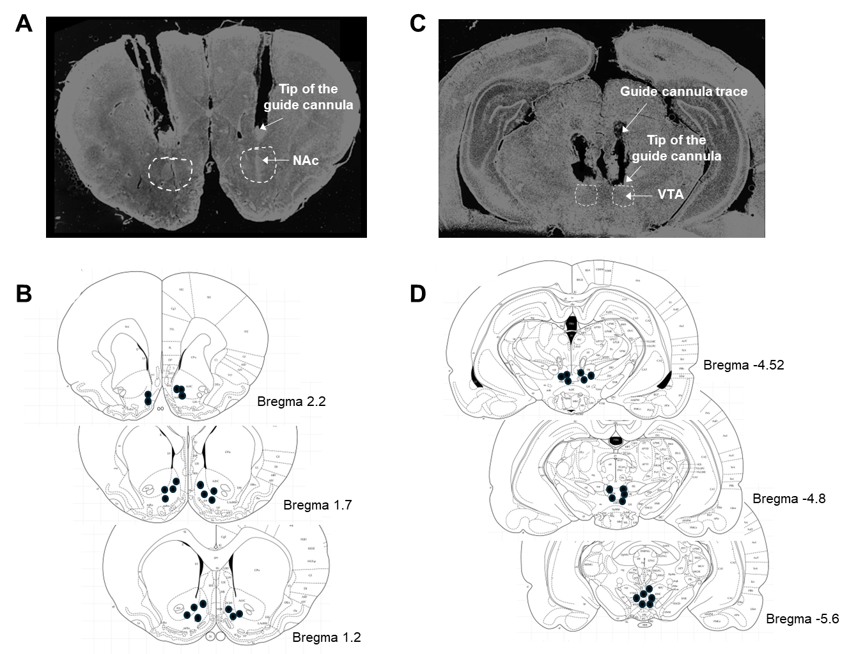

Figure S6 (related to Figure 3A, B). Histological examination results of intracranial microinjection in mouse brain. A–B: Representative coronal brain sections showing the tip of a microinjection guide cannula in the NAc (A) and the predicted injection areas in the NAc (B). C–D: Representative coronal brain sections showing the tip of a microinjection guide cannula in the VTA (C) and the predicted injection areas in the VTA (D).

Supplementary Figure 7:

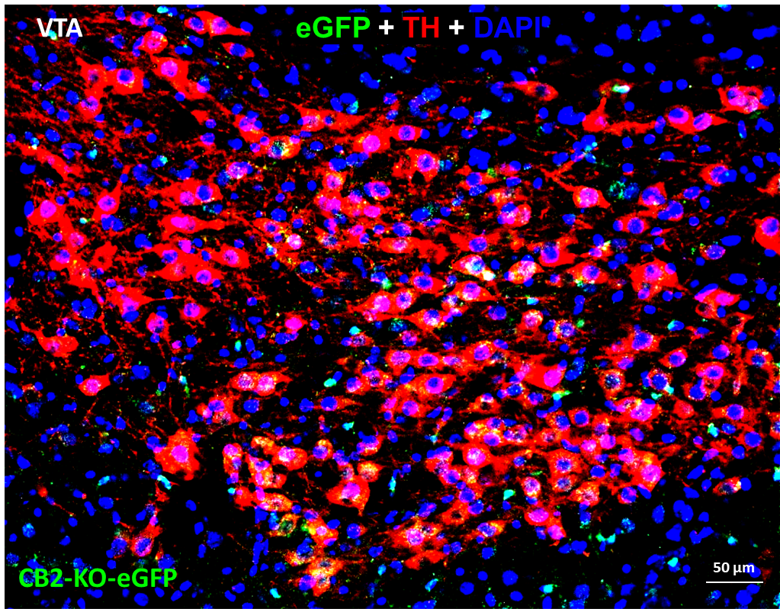

Figure S7 (related to Figure 5): High magnification image, as shown in Figure 5C (right panel), illustrating TH (red) and GFP (green) colocalization in VTA DA neurons.

Supplementary Figure 8:
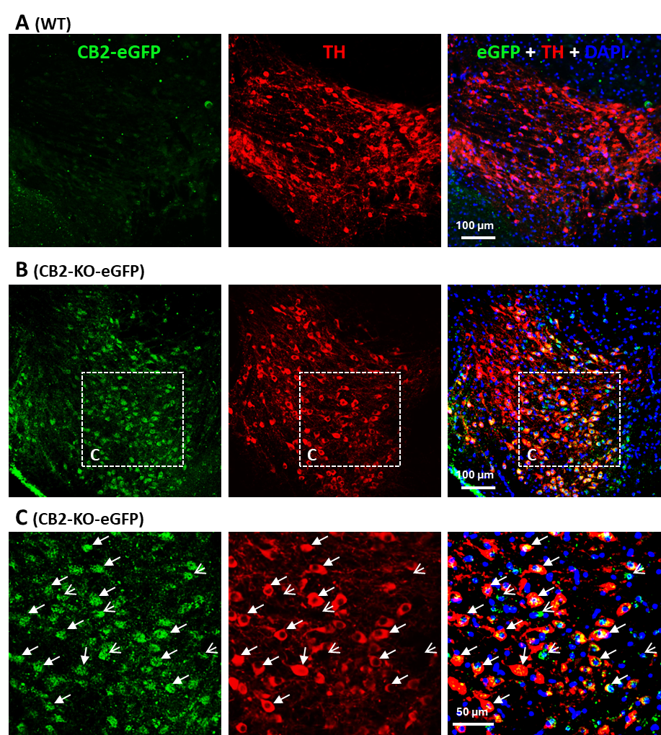
Figure S8 (related to Figure 5): Another set of images with reduced TH signal exposure to enhance visualization of the GFP signal in VTA DA neurons of CB2-KO-eGFP mice (B, C), not in WT mice (A). Notably, GFP is also detected in some TH-negative non-DA neurons (marked by open arrows) within the VTA.
Supplementary Figure 9:
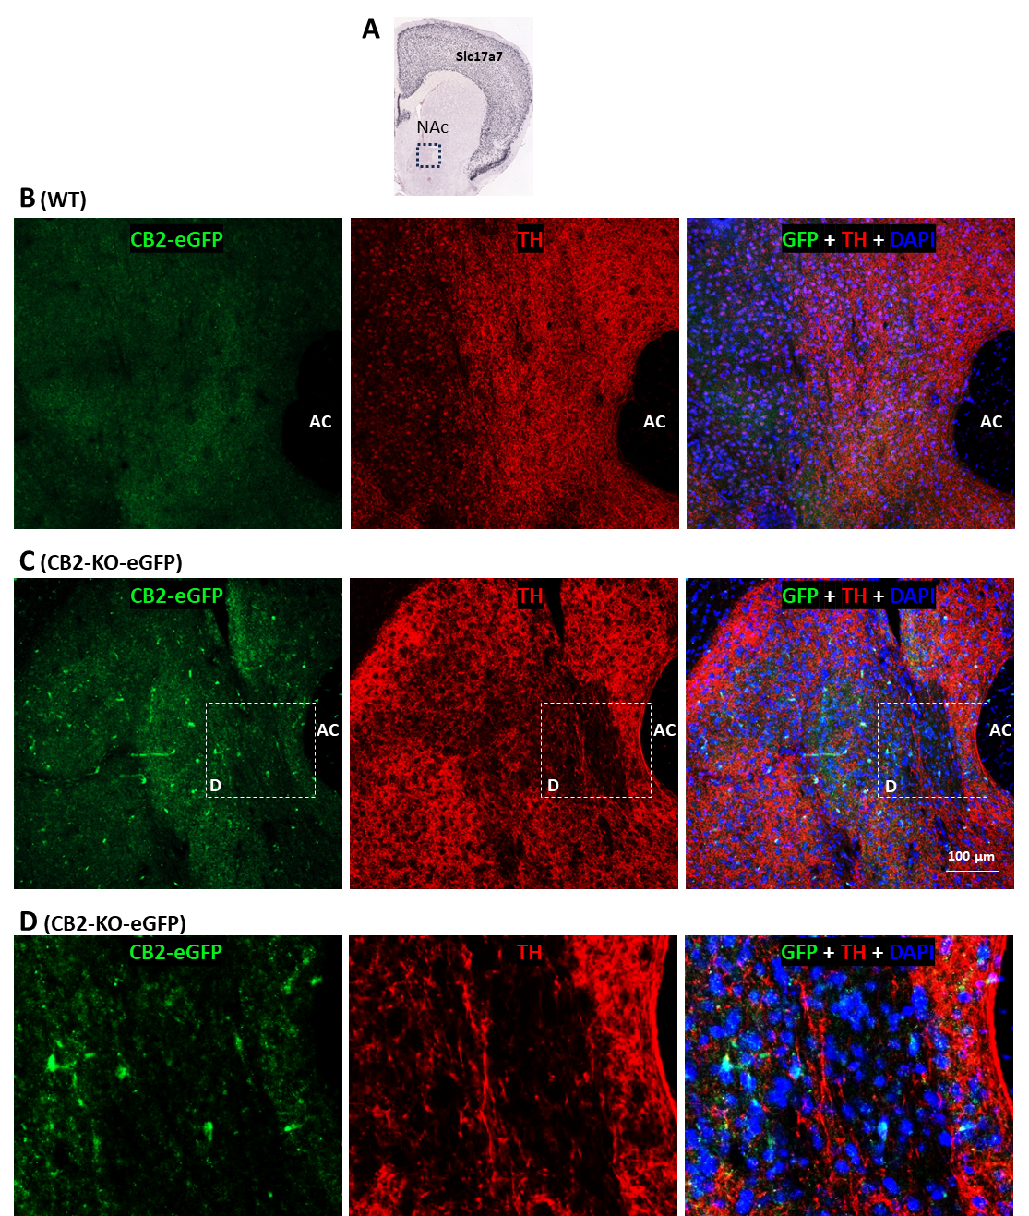
Figure S9 (related to Figure 5): CB2-driven eGFP expression in the NAc of CB2-KO-eGFP mice. Low-density eGFP signals were detected in some DAPI-labeled cells within the NAc. A: Schematic of the NAc region where images were taken. B: eGFP-immunostaining using an anti-GFP antibody (Invitrogen) showed no eGFP signal in WT mice. C: eGFP-immunostaining revealed eGFP expression in the NAc of CB2-KO-eGFP mice. D: Magnified views of the highlighted regions in (C), illustrating eGFP expression in NAc cells. Slc17a7: a gene that encodes vesicular glutamate transporter 1 (Vglut1), a glutamate neuronal marker.

Supplementary Figure 10:
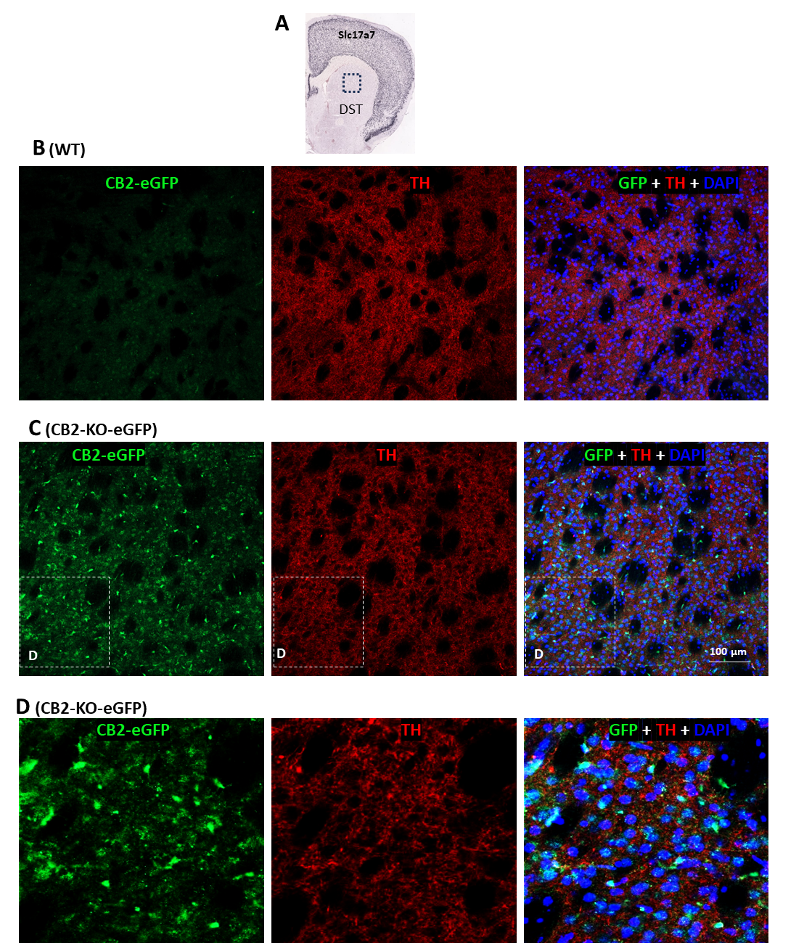
Figure S10 (related to Figure 5): CB2-driven GFP expression in the dorsal striatum (DST) of CB2-KO-eGFP mice. GFP-immunostaining signals were detected in some DAPI-labeled cells within the DST. A: Schematic of the DST region where images were taken. B: GFP-immunostaining using an anti-GFP antibody (Invitrogen) showed no GFP signal in WT mice. C: GFP-immunostaining revealed GFP expression in the DST of CB2-KO-eGFP mice. D: Magnified views of the highlighted regions in (C), illustrating GFP expression in DST cells. Slc17a7: a gene that encodes vesicular glutamate transporter 1 (Vglut1), a glutamate neuronal marker.

Supplementary Figure 11:
Figure S11 (related to Fig. 6). Acquisition and maintenance of heroin self-administration in WT and CB2-KO-eGFP mice, as assessed by active and inactive lever responses in males (A) and females (B). Active LP: Active lever presses; Inactive LP: Inactive lever presses.
References:
1. He XH, Jordan CJ, Vemuri K, Bi GH, Zhan J, Gardner EL et al. Cannabinoid CB(1) receptor neutral antagonist AM4113 inhibits heroin self-administration without depressive side effects in rats. Acta Pharmacol Sin 2019; 40(3): 365-373.

2. Xi ZX, Spiller K, Pak AC, Gilbert J, Dillon C, Li X et al. Cannabinoid CB1 receptor antagonists attenuate cocaine's rewarding effects: experiments with self-administration and brain-stimulation reward in rats. Neuropsychopharmacology 2008; 33(7): 1735-1745.

3. Xi ZX, Peng XQ, Li X, Song R, Zhang HY, Liu QR et al. Brain cannabinoid CB(2) receptors modulate cocaine's actions in mice. Nat Neurosci 2011; 14(9): 1160-1166.

4. Yang HJ, Hempel BJ, Bi GH, He Y, Zhang HY, Gardner EL et al. Elevation of Extracellular Glutamate by Blockade of Astrocyte Glutamate Transporters Inhibits Cocaine Reinforcement in Rats via a NMDA-GluN2B Receptor Mechanism. J Neurosci 2022; 42(11): 2327-2343.

5. Han X, He Y, Bi GH, Zhang HY, Song R, Liu QR et al. CB1 Receptor Activation on VgluT2-Expressing Glutamatergic Neurons Underlies Delta(9)-Tetrahydrocannabinol (Delta(9)-THC)-Induced Aversive Effects in Mice. Sci Rep 2017; 7(1): 12315.

6. Galaj E, Han X, Shen H, Jordan CJ, He Y, Humburg B et al. Dissecting the Role of GABA Neurons in the VTA versus SNr in Opioid Reward. J Neurosci 2020; 40(46): 8853-8869.

7. Humburg BA, Jordan CJ, Zhang HY, Shen H, Han X, Bi GH et al. Optogenetic brain-stimulation reward: A new procedure to re-evaluate the rewarding versus aversive effects of cannabinoids in dopamine transporter-Cre mice. Addict Biol 2021; 26(4): e13005.

8. Soler-Cedeno O, Alton H, Bi GH, Linz E, Ji L, Makriyannis A et al. AM6527, a neutral CB1 receptor antagonist, suppresses opioid taking and seeking, as well as cocaine seeking in rodents without aversive effects. Neuropsychopharmacology 2024; 49(11): 1678-1688.

9. Schmole AC, Lundt R, Gennequin B, Schrage H, Beins E, Kramer A et al. Expression Analysis of CB2-GFP BAC Transgenic Mice. PLoS One 2015; 10(9): e0138986.

10. Lopez A, Aparicio N, Pazos MR, Grande MT, Barreda-Manso MA, Benito-Cuesta I et al. Cannabinoid CB(2) receptors in the mouse brain: relevance for Alzheimer's disease. J Neuroinflammation 2018; 15(1): 158.

