Supplementary Information - Genetic influences and causal pathways shared between cannabis use disorder and other substance use traits

Marco Galimberti^{1,2}, Daniel F. Levey^{1,2}, Joseph D. Deak^{1,2}, Hang Zhou^{1,2}, Murray B. Stein^{3,4}, Joel Gelernter^{1,2,5*}

1: Department of Psychiatry, Yale University School of Medicine, New Haven, CT, USA
2: Veterans Affairs Connecticut Healthcare System, West Haven, CT, USA
3: Department of Psychiatry and School of Public Health, University of California San Diego, La Jolla, CA, USA
4: VA San Diego Healthcare System, San Diego, CA, USA
5: Departments of Genetics and Neuroscience, Yale University School of Medicine, New Haven, CT, USA
*: corresponding author

Supplementary Figures

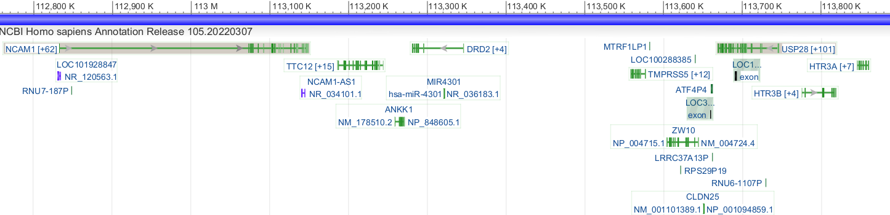
Supplementary Fig 1. | View of locus chr11:112755447-113889019. NIH Genome Data Viewer of locus chr11:112755447-113889019, using genome assembly GRCh37.p13.

